**Supplementary File**

C:\Users\Sandip Suresh Zode\Desktop\Figure 5.tif

Figure S1 (a) DSC heating scan and (b) PXRD pattern of as received ASP



Figure S2 Amount of ASP (circle) remained, and the amount of salicylic acid (SA, diamonds) appeared in ASP solution (3% w/w in 40% w/w TBA in water) at the end of 24 hrs at RT.

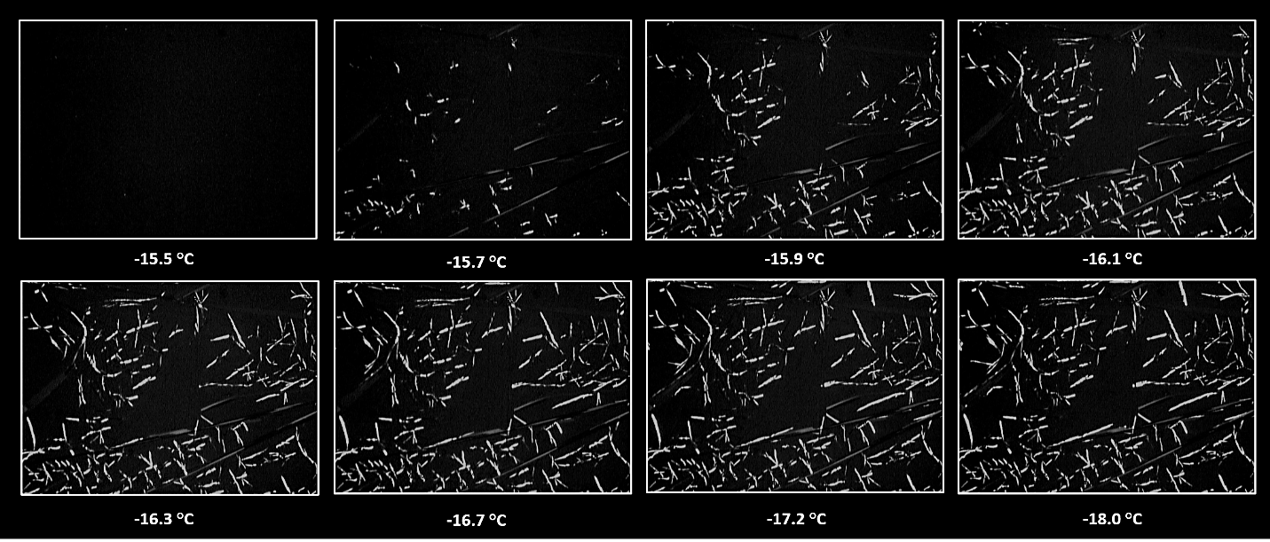

Figure S3 Microscopic images captured under cross polarized mode during freeze concentration of ASP solution (3% w/w in 40% W/W TBA) at cooling rate of 0.1°C/min (100 X magnification). Birefringence correspond to crystallization of ASP in frozen solution.

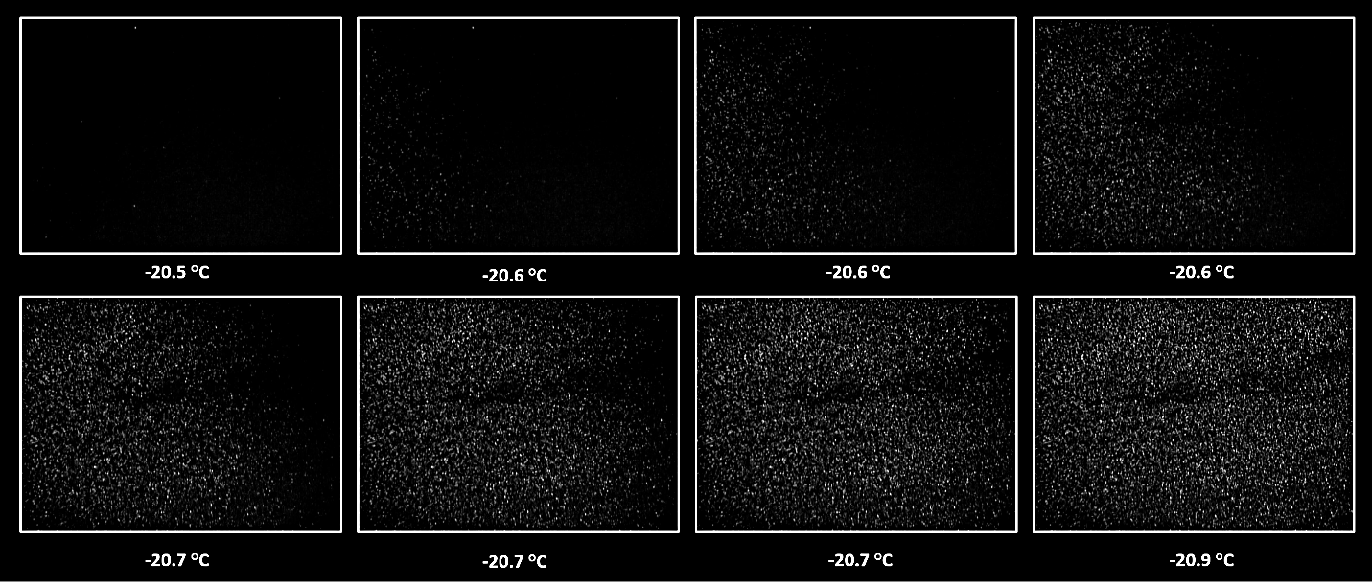

Figure S4 Microscopic images captured under cross polarized mode during freeze concentration of ASP solution (3% w/w in 40% W/W TBA) at cooling rate of 1°C/min (100 X magnification). Birefringence correspond to crystallization of ASP in frozen solution.

**E:\AKB Lab\PhD Project\Manuscript\Manuscript 2\Figures\Supplimentry\Figure S1.tif**

Figure S5 Microscopic images captured under cross polarized mode during freeze concentration of ASP solution (3% w/w in 40% W/W TBA) at cooling rate of 3°C/min (100 X magnification). Birefringence correspond to crystallization of ASP in frozen solution.

*E:\AKB Lab\PhD Project\Manuscript\Manuscript 2\Figures\Figure S4.tif*

*Figure S6 DSC heating curves obtained for freeze dried ASP (a) cycle 01, (b) cycle 02, (c) cycle 03 and (d) as received ASP respectively.*

E:\AKB Lab\PhD Project\Manuscript\Manuscript 2\Figures\Figure S5.tif

*Figure S7 PXRD patterns obtained for freeze dried ASP (a) cycle 01, (b) cycle 02, (c) cycle 3 and (d) as received ASP. The highlighted portion shows peaks pertaining to ASP form II.*