Supplementary material

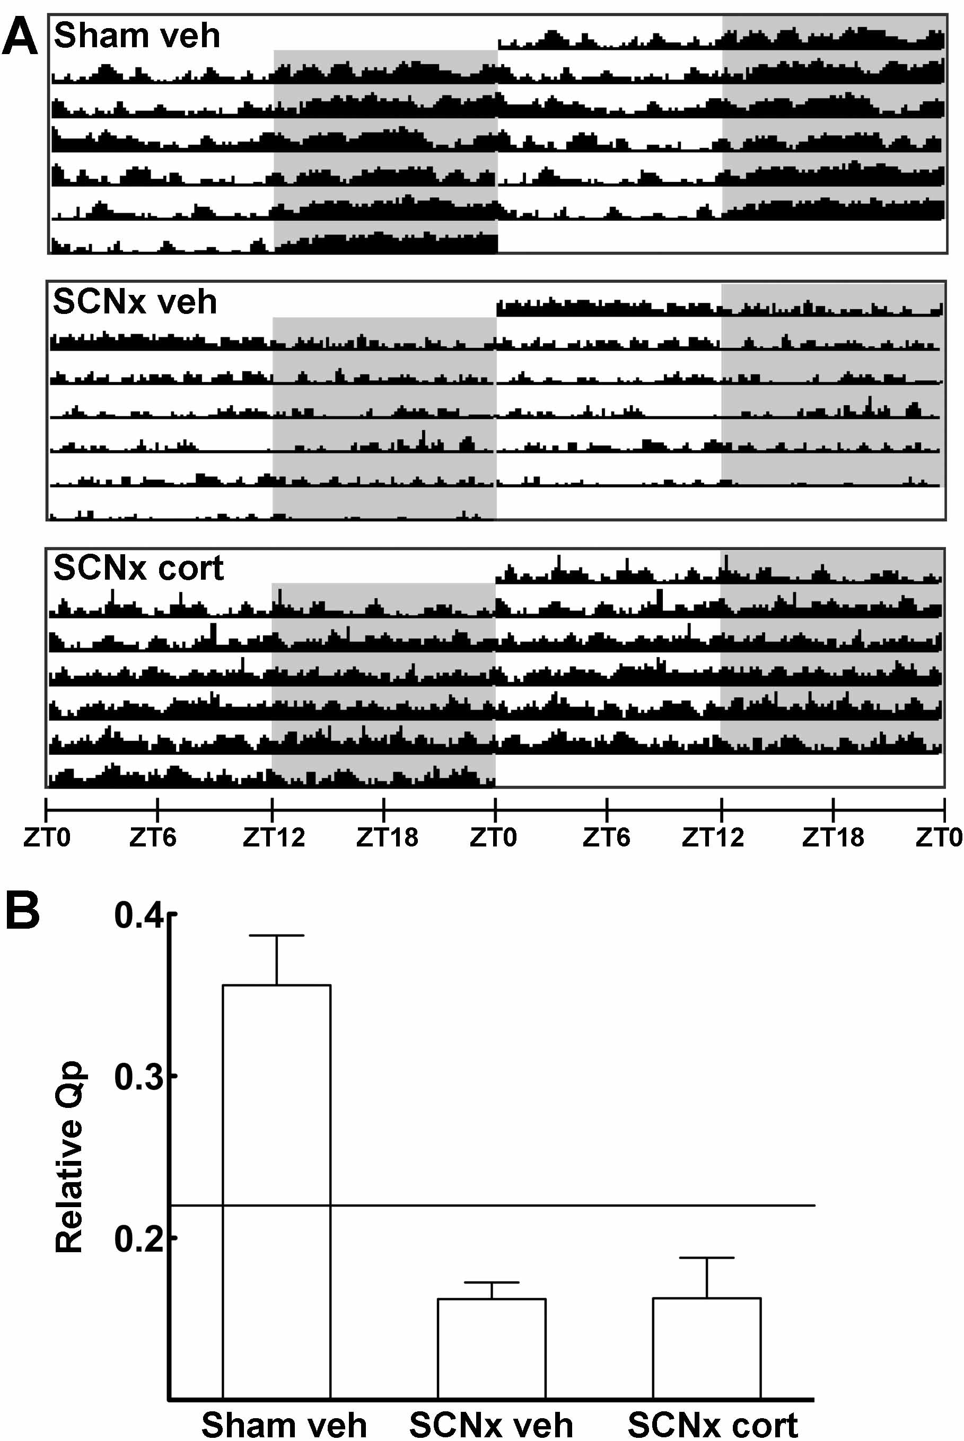

Figure S1. Daily rhythms in body temperature as determined by telemetric registrations. A) Representative double plotted actograms of body temperature in rats with intact SCN (Sham veh) or lesioned SCN without corticosterone (SCNx veh) or with corticosterone (SCNx cort) in the programmable micropump. Shaded areas indicate darkness. Temperature interval: 36-39 °C. ZT, Zeitgeber time. B) Robustness of daily rhythms in body temperature as determined by chi-square periodogram analyses. The relative Qp value was determined for a 24h period. The horizontal line indicates the minimal value representing statistical significance (p = 0.05). Notably, the telemetric transmitters were implanted subcutaneously in the neck region; therefore, values do not represent the actual core body temperature.

