Synthesis, and fungicidal activity of novel 1,2,4-triazol derivatives containing a pyrimidine moiety
Wen-Neng Wu^{a, #,} *, Yang-ming Jiang^{b, #}, Qiang-Fei ª, Hai-tang Duª
ªFood and Pharmaceutical Engineering Institute, Guiyang University, Guiyang 550003, PR China
^{b}State Key Laboratory of Functions and Applications of Medicinal Plants, Guizhou Medical University, Guiyang 550014, PR China
# author: contribute equally to this work
Email: wuwenneng123@126.com.

Supplemental Materials
Antibacterial Activity in Vitro
Antifungal biological assay
The antifungal activities of all synthesized compounds were screened and evaluated against three pathogenic fungi, including Botryosohaeria dothidea (B. dothidea), Phompsis sp. and Botrytis cinerea (B. cinerea) of kiwifruit soft rot disease, by the poison plate technique¹⁻³. All the compounds were dissolved in 1 mL dimethyl sulfoxide before mixing with 90 mL potato dextrose agar. The compounds were tested at a concentration of 50 μg/mL. All the fungi were cultivated in PDA at 27 ± 1 °C for 4 days to make new mycelium for antifungal assay. Then mycelia dishes of approximately 4 mm diameter were cut from culture medium, and one of them was picked up with a germfree inoculation needle and inoculated in the middle of PDA plate aseptically. The inoculated plates were fostered at 27 ± 1 °C for 3-4 days. DMSO in sterile distilled water served as negative control, while Pyrimethanil acted as positive controls. For each treatment, three replicates were conducted. The radial growth of the fungal colonies was measured and the data were statistically analyzed. The inhibition rate of the test compounds against eight pathogenic fungi were calculated by the formula, where C represents the diameter of fungi growth on untreated PDA, T represents the diameter of fungi on treated PDA, and I means the inhibition rate.
I (%) = [(C − T)/(C − 0.4)] × 100

Results and Discussion of antifungicidal activity
The target compounds 8 and 9a−9o were evaluated for their fungicidal activities in vitro against three kinds of plant pathogenic fungi of kiwifruit soft rot disease via the poison plate technique and the preliminary bioassay results were listed in Table S 1. As can be seen from Table S 1, the target compounds 8 and 9a−9o exhibited moderate to good fungicidal activities against the test fungi compared with the commercial Pyrimethanil. Especially, compounds 9l, 9n and 9n exhibited good fungicidal activities against B. dothidea (86.4%, 84.9%, 90.1%, respectively), Phompsis sp.(89.2%, 87.4%, 91.8%, respectively), and B. cinerea (88.5%, 82.6%, 89.5%, respectively) at 50 μg/mL, which were similar with Pyrimethanil (84.4%, 85.1% , 82.8% respectively). Moreover, compound 8 showed fungicidal activity against B. dothidea, Phompsis sp. and B. cinerea at 50 μg/mL, with inhibition rates of 80.6%, 83.6%, and 81.4%, respectively, which was less than that of Pyrimethanil.

Table S 1 The fungicidal activities of the title compounds (50 µg/mL)
Compounds | Inhibition (%)
 | B. dothidea | Phomopsis sp. | Botrytis cinerea
8 | 80.6±2.4 | 83.6±2.7 | 81.4±1.2
9a | 41.2±1.0 | 45.0±1.3 | 43.8±1.9
9b | 47.5±2.1 | 51.6±2.3 | 49.0±2.5
9c | 58.5±2.6 | 60.1±3.0 | 58.9±1.5
9d | 30.6±1.1 | 36.8±1.7 | 29.5±1.2
9e | 42.3±1.9 | 46.0±3.0 | 49.6±2.2
9f | 46.6±1.1 | 52.7±2.3 | 54.2±2.5
9g | 55.9±1.8 | 62.4±1.2 | 63.2±1.9
9h | 57.8±2.8 | 56.3±3.3 | 53.4±1.2
9i | 67.5±2.1 | 66.2±2.1 | 62.1±1.6
9j | 54.1±2.2 | 57.2±1.3 | 50.3±1.5
9k | 64.9±1.1 | 68.0±2.2 | 62.1±3.1
9l | 86.4±1.4 | 89.2±1.8 | 88.5±1.7
9m | 71.1±1.9 | 67.5±1.0 | 70.8±2.2
9n | 84.9±2.7 | 87.4±2.0 | 82.6±1.8
9o | 90.1±2.6 | 91.8±1.4 | 89.5±2.5
Pyrimethanil | 84.4±2.1 | 85.1±1.4 | 82.8±1.4

Based on the preliminary bioassays, the EC₅₀ values of the target compounds 8 and 9a−9o as well as the commercial Pyrimethanil against B. dothidea and Phompsis sp. were also tested and presented in Table S 2, Table S 3 and Table S 4. Table S 2, Table S 3 and Table S 4 showed that compounds 9l, 9n and 9o showed good activities against B. dothidea with EC₅₀ of 40.1, 48.2 and 33.6 μg/mL, respectively, which were better than that of Pyrimethanil (57.6 μg/mL). Meanwhile, compounds 9n and 9o exhibited good fungicidal activity against B. dothidea and B. cinerea with the EC₅₀ values of 25.4 and 55.1 μg/mL, respectively, which were similar with Pyrimethanil (32.1 and 62.8 μg/mL).

Table S 2.The EC₅₀ values of some of the target compounds against B. dothidea
Compounds. | Toxic regression equation | r | EC₅₀(μg/mL)
8 | y =0.92 x +4.45 | 0.99 | 61.2±1.0
9l | y = 0.67x + 3.68 | 0.99 | 40.1±1.4
9n | y = 1.24x + 4.18 | 0.99 | 48.2±1.9
9o | y = 0.88x + 5.62 | 0.99 | 33.6±2.1
Pyrimethanil | y = 1.01x + 6.25 | 0.99 | 57.6±1.8

Table S 3.The EC₅₀ values of the target compounds against Phompsis sp..
Compounds. | Toxic regression equation | r | EC₅₀(μg/mL)
8 | y =1.48x + 3.62 | 0.99 | 35.1±1.1
9l | y = 0.92x + 4.70 | 0.99 | 37.3±1.5
9n | y = 0.74x + 4.31 | 0.98 | 31.6±1.6
9o | y = 0.78x + 4.67 | 0.98 | 25.4±1.8
Pyrimethanil | y = 2.18x + 8.25 | 0.99 | 32.1±2.0

Table S 4 The EC₅₀ values of some of the target compounds against B. cinerea
Compounds. | Toxic regression equation | r | EC₅₀ (μg/mL)
8 | y =0.92 x +4.45 | 0.99 | 73.2±1.9
9l | y = 1.15x + 3.91 | 0.99 | 61.6±2.5
9n | y = 1.67x +3.82 | 0.99 | 67.5±1.4
9o | y = 1.32x + 4.64 | 0.99 | 55.1±3.1
Pyrimethanil | y = 1.46x +4.76 | 0.99 | 62.8±1.7

References
References
[1]Chattapadhyay, T. -K.; Dureja, P. Antifungal Activity of 4-Methyl-6-alkyl-2H-pyran-2-ones. J. Agric. Food Chem. 2006, 54: 2129−2133. DOI: 10.1021/jf052792s.
[2]Xu, W. -M.; He, J.; He, M.; Han, F. -F.; Chen, X. -H.; Pan, Z. -X.; Wang, J.; Tong, M. -G. Synthesis and Antifungal Activity of Novel Sulfone Derivatives Containing 1,3,4-Oxadiazole Moieties. Molecules. 2011, 16: 9129-9141. DOI: 10.3390/molecules16119129.
[3]Xu, W. -M.; Yang, S.; Bhadury, P.; He, J.; He, M.; Gao, L. -L.; Hu, D. -Y.; Song, B. -A.
Synthesis and Bioactivity of Novel Sulfone Derivatives Containing 2,4-Dichlorophenyl Substituted 1,3,4-Oxadiazole/thiadiazole Moiety as Chitinase Inhibitors. Pestic. Biochem. Phys. 2011,101: 6-15. DOI: 10.1016/j.pestbp.2011.05.006.

¹H NMR and ¹³C NMR spectra
Figure S 1: ¹H NMR of 9a
Figure S 2: ¹³C NMR of 9a
Figure S 3: ¹H NMR of 9b

Figure S 4: ¹³C NMR of 9b
Figure S 5: ¹H NMR of 9c
Figure S 6: ¹³C NMR of 9c

Figure S 7: ¹H NMR of 9d
Figure S 8: ¹³C NMR of 9d

Figure S 9: ¹H NMR of 9e
Figure S 10: ¹³C NMR of 9e
Figure S 11: ¹H NMR of 9f
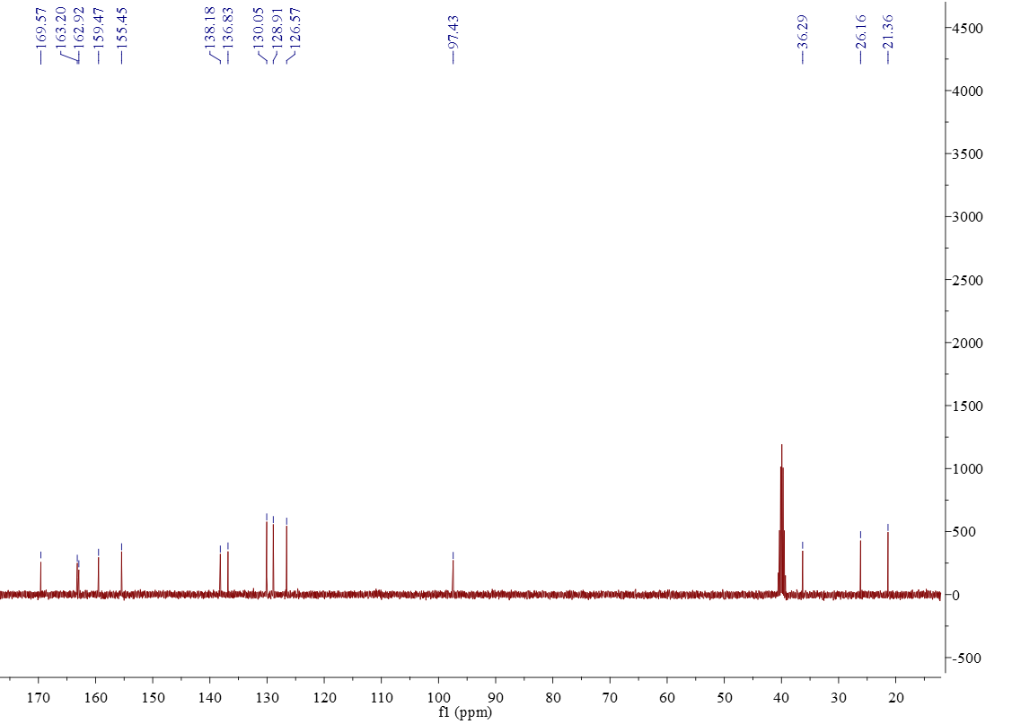

Figure S 12: ¹³C NMR of 9f
Figure S 13: ¹H NMR of 9g
Figure S 14: ¹³C NMR of 9g

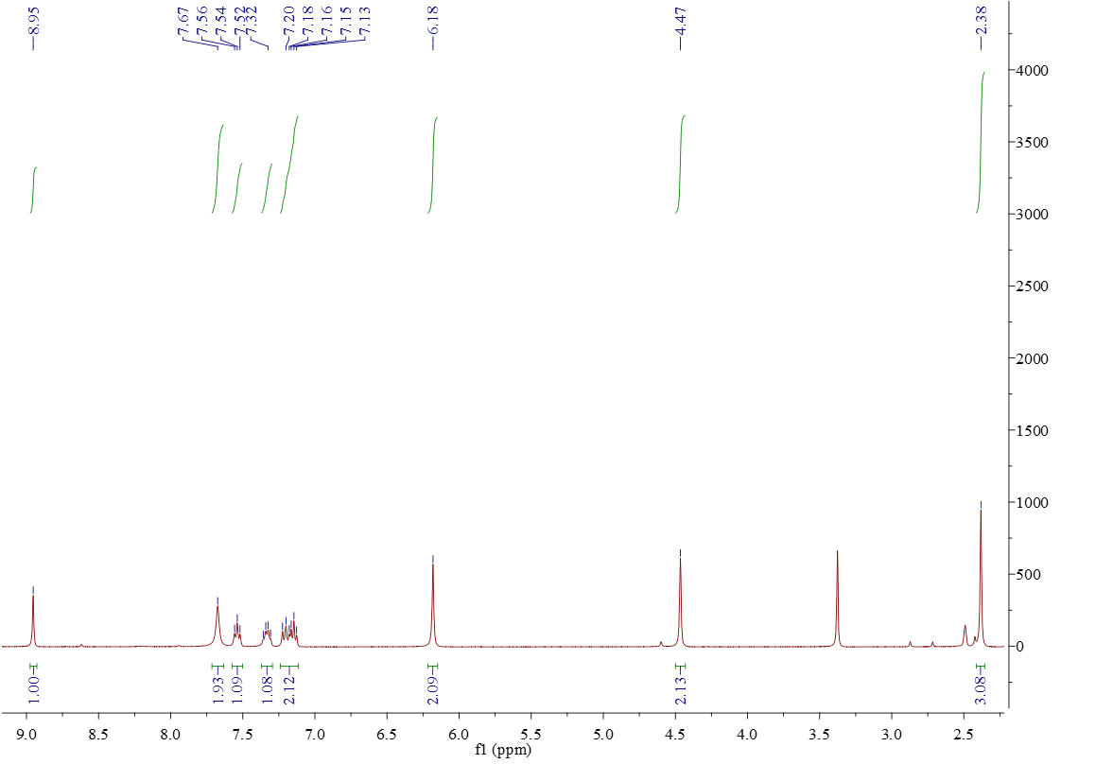
Figure S 15: ¹H NMR of 9h
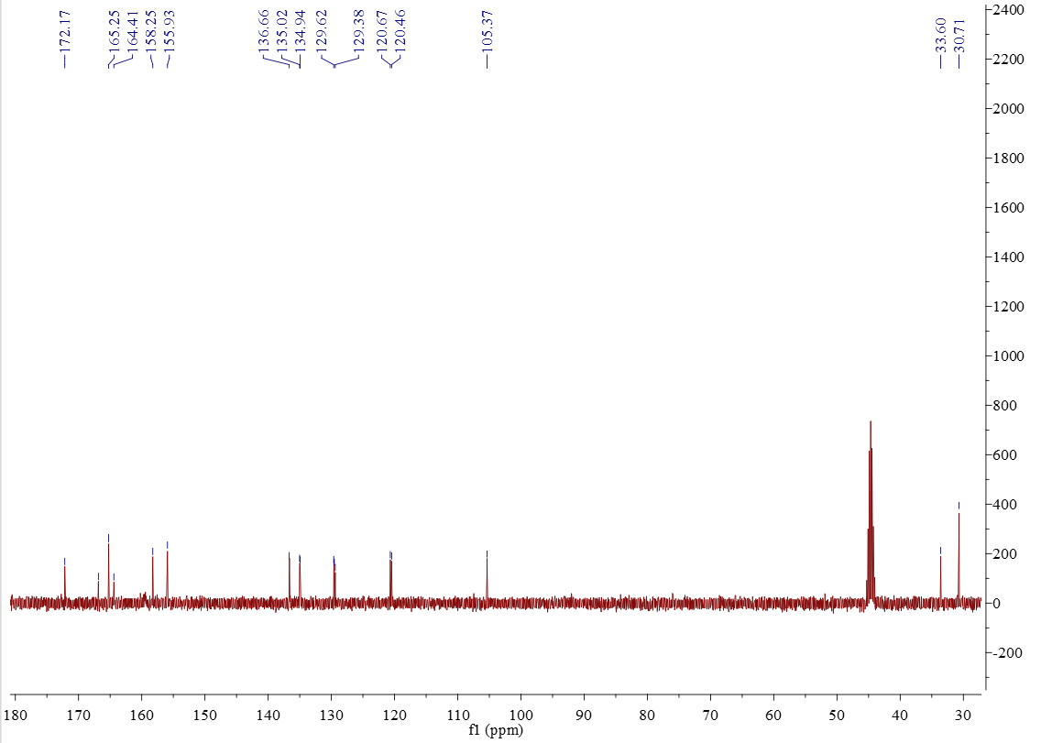
Figure S 16: ¹³C NMR of 9h

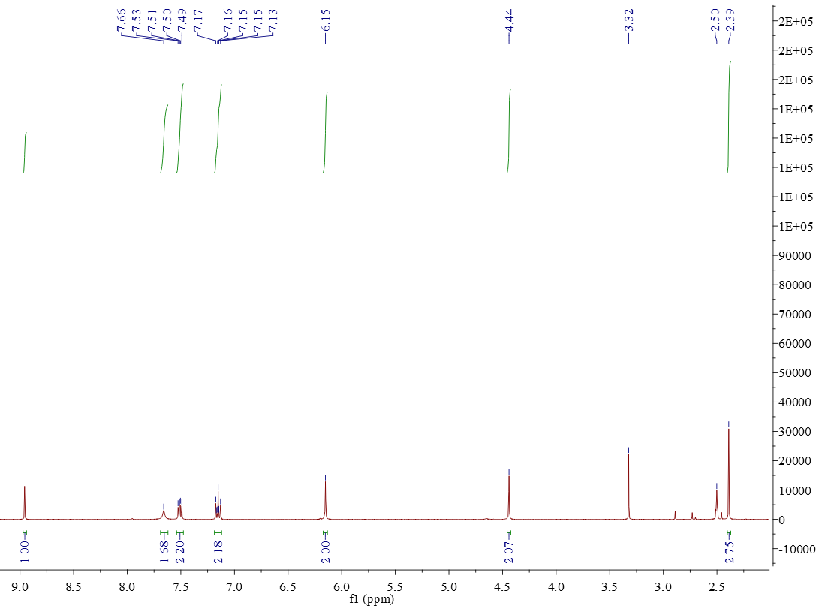
Figure S 17: ¹H NMR of 9i
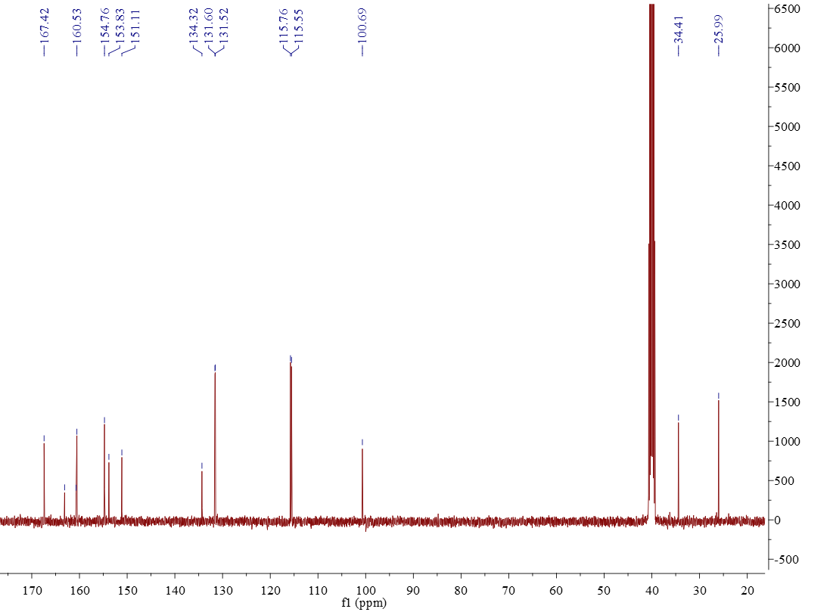
Figure S 18: ¹³C NMR of 9i

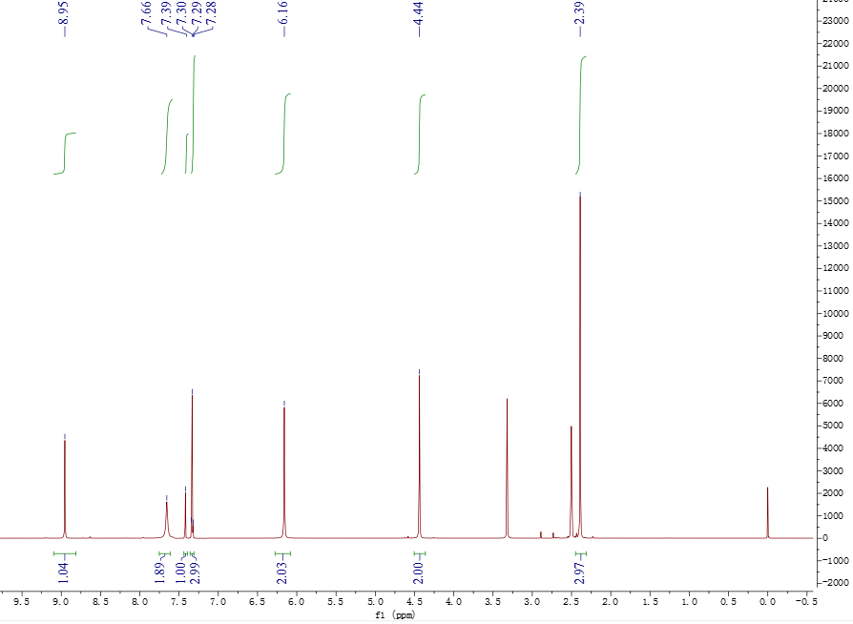
Figure S 19: ¹H NMR of 9j
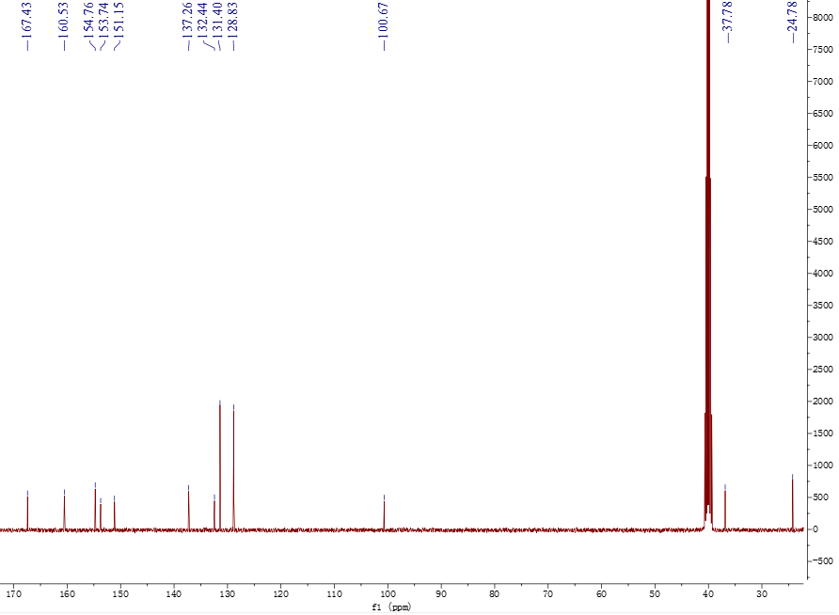
Figure S 20: ¹³C NMR of 9j
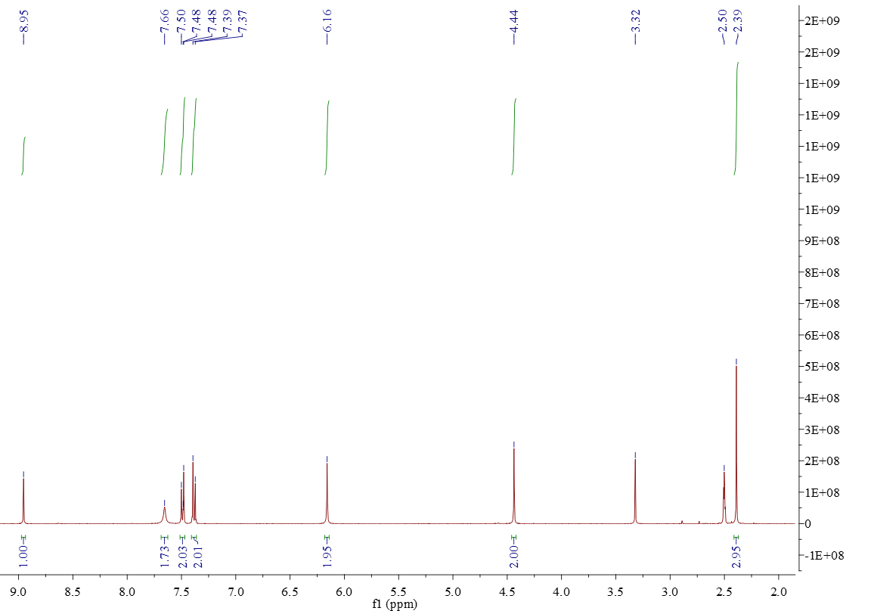
Figure S 21: ¹H NMR of 9k
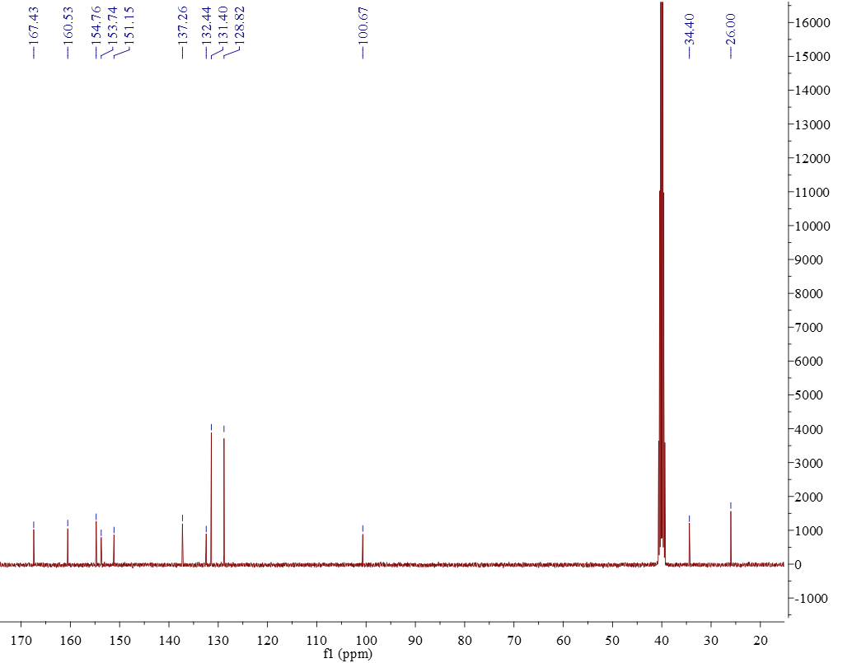
Figure S 22: ¹³C NMR of 9k

Figure S 23: ¹H NMR of 9l
Figure S 24: ¹³C NMR of 9l
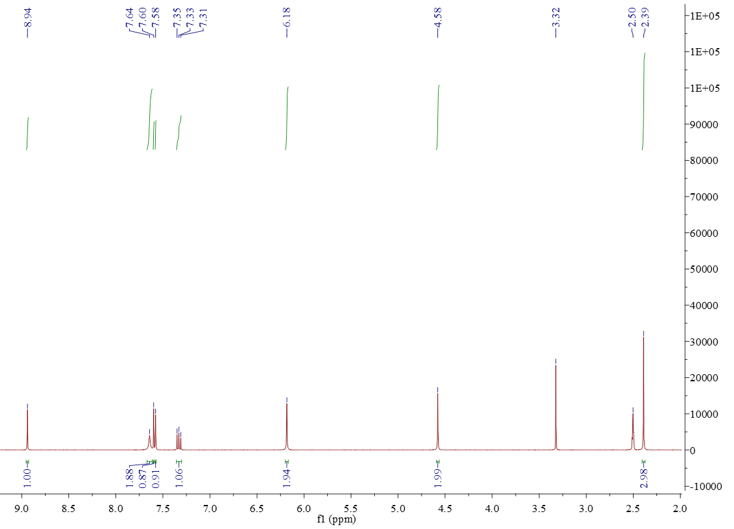
Figure S 25: ¹H NMR of 9m

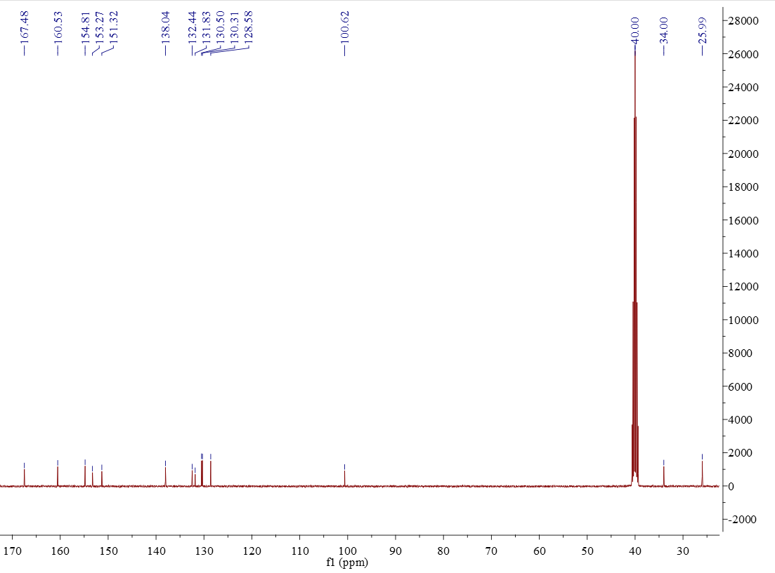
Figure S 26: ¹³C NMR of 9m

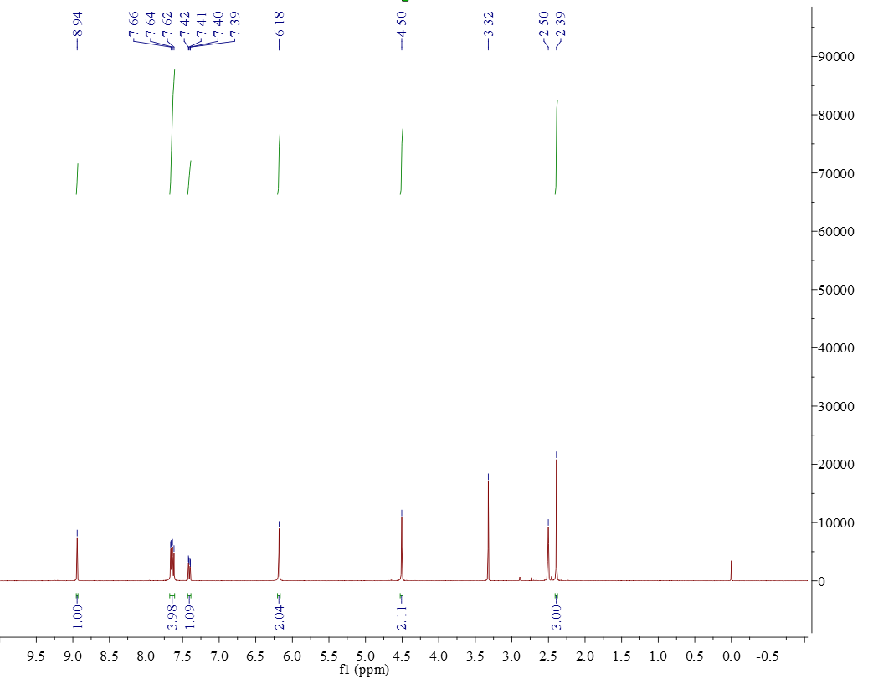
Figure S 27: ¹H NMR of 9n

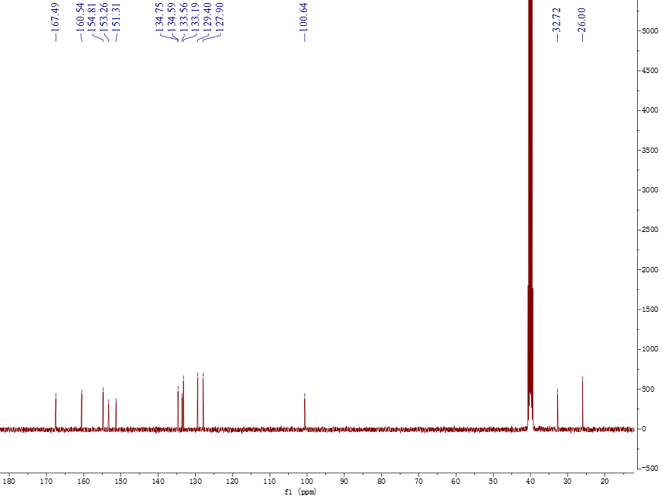

Figure S 28: ¹³C NMR of 9n

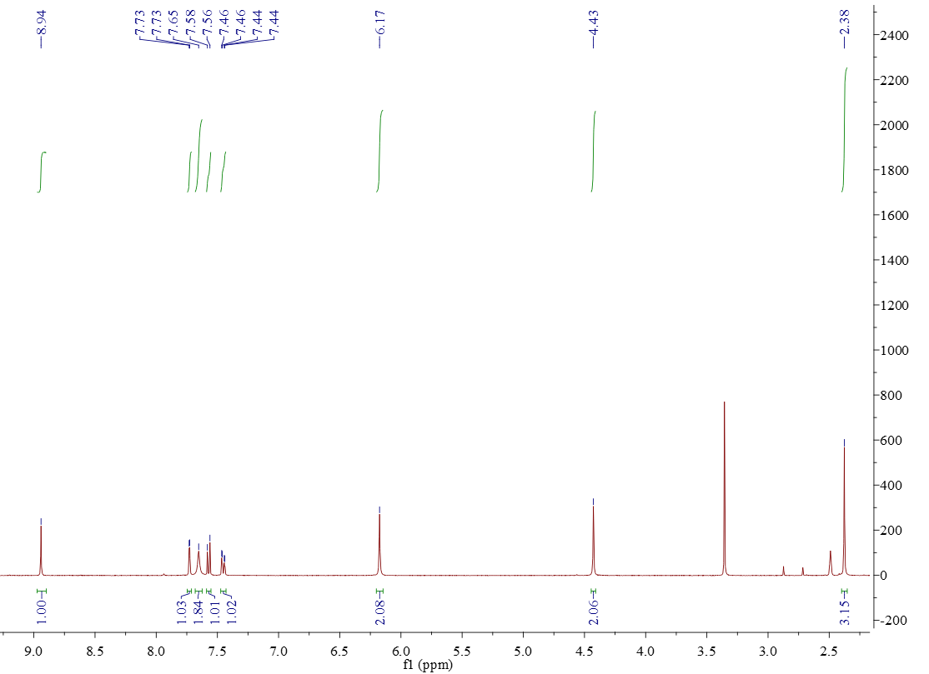
Figure S 29: ¹H NMR of 9o

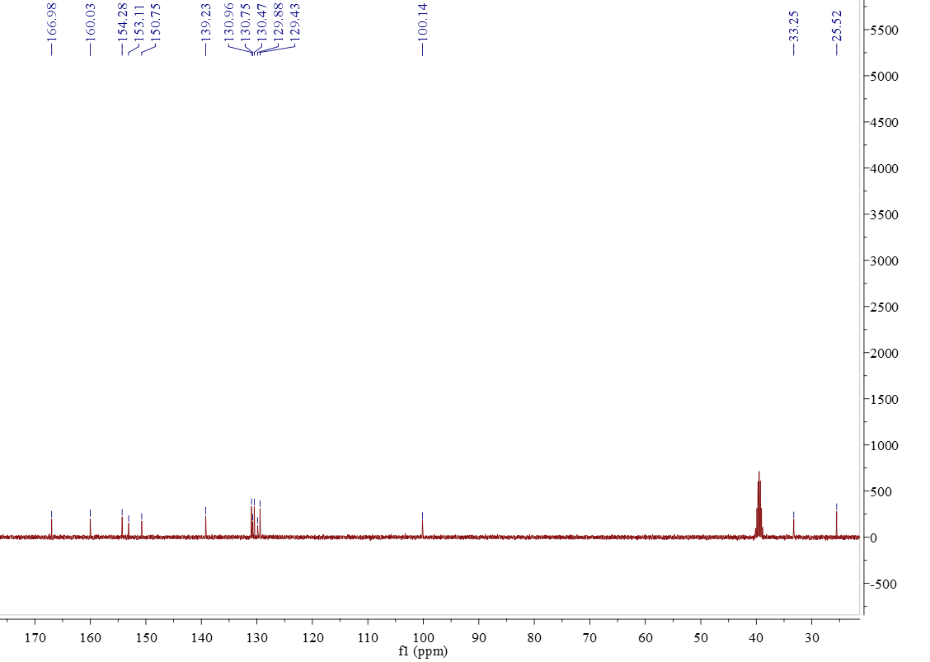

Figure S 30: ¹³C NMR of 9o

