Supplementary Material
Table S1. Intraoperative hemodynamic and physiological variables
Variable | Control | PD/PSSD | p value
Systolic blood pressure, mmHg | 113.5 (25.7) | 121.9 (27.9) | 0.47
Dyastolic blood pressure, mmHg | 61.6 (16.9) | 61.7 (15.52) | 0.99
Mean blood pressure, mmHg | 78.8 (17.8) | 81.8 (17.8) | 0.70
Heart rate, bmp | 78.3 (15.1) | 70.3 (12.9) | 0.20
Oximetry | 97.5 (2.6) | 98.8 (1.1) | 0.15
Data is shown as mean and standard deviation
mmHg: millimeter of mercury; bpm: beats per minute

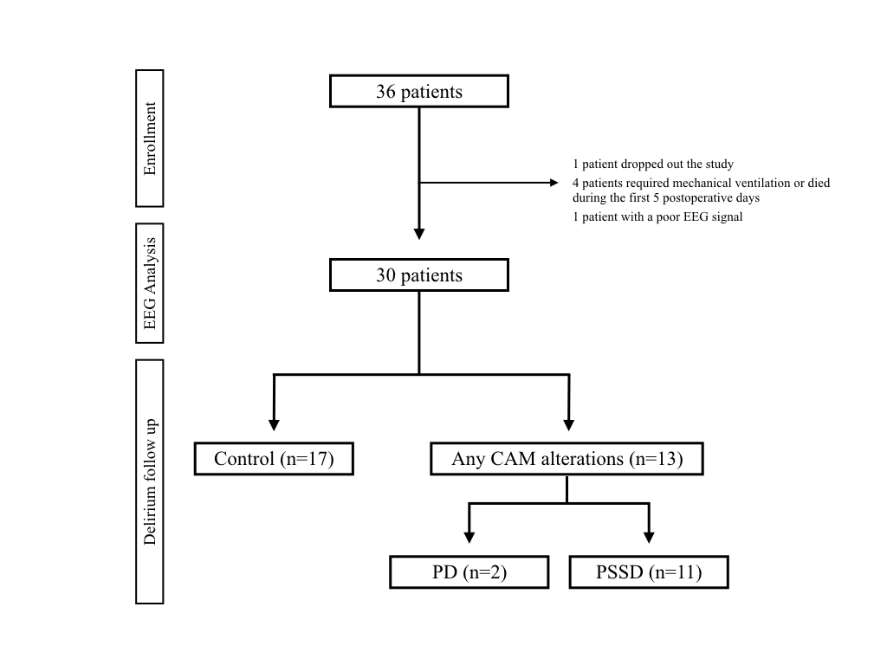

Supplementary Figure 1. Flow-chart of patients included in the study. EEG: electroencephalogram; CAM: Confusion Assessment Method; PD: Postoperative delirium; PSSD: Postoperative subsyndromal delirium.

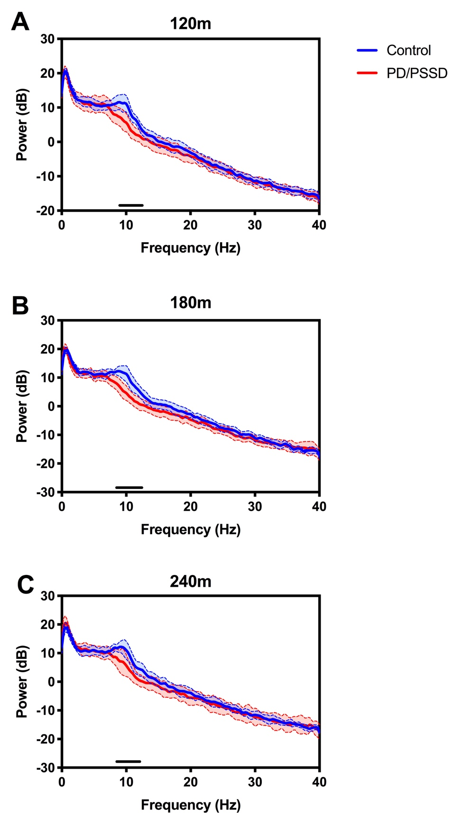
Supplementary Figure 2. Frequency analysis from EEG records of control and PD/PSSD patients. The average spectrum during anaesthesia from global EEG at 120 (A), 180 (B) and 240 (C) minutes. Spectrum represented as mean (thick central line) and 95% interval of confidence (coloured area). Power (dB) is shown from 1 to 40 Hz. Control patients are represented in blue and PD/PSSD patients in red. Each black line represents a statistical difference between the two groups (p<0.05). PD: Postoperative delirium; PSSD: Postoperative subsyndromal delirium; dB: decibels.

