Supplementary figure S2
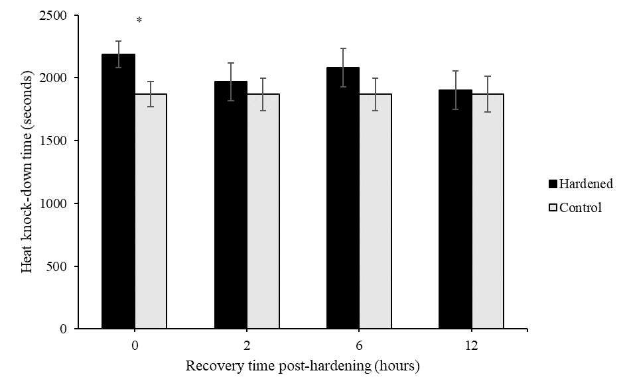
Figure S2: Effect of post-hardening recovery duration (0, 2, 6 and 12 hours) on mean heat knock-down time (HKDT) at 48 ◦C. Hardened individuals were exposed to 42°C for 1 hour tested for their HKDT after 0, 2, 6- or 12-hours recovery. Black bars represent corrected means of hardened samples (± SE) and grey bars represent corrected means of control samples (± SE). N= 10 per sample. * indicate significant differences between hardened individuals and corresponding control; * = P < 0.05, ** = P < 0.01, *** = P < 0.001.

