Supplemental Data

Methods
Nuclear Magnetic Resonance (NMR) on SAEC Exposed to SWCNTs
Approximately 1 × 10⁶ SAEC were plated and treated with SWCNTs (20 μg/mL) for 24 hours. Cells were collected for perchloric acid extraction to isolate metabolites. After extraction, the resultant supernatant was lyophilized and used for NMR spectroscopy. Briefly, Proton and J-HSQC spectra were collected with a CP TXI CryoProbe with an Avance II Console (14.1 T, Bruker Biospin, Billerca, MA), whereas ¹³C 1D conventional spectra were collected with a home-built superconducting (14.1 T, HTS)² probe. First slice of a NOESY pulse sequence (tnnoesy)³ was utilized to acquire proton spectra with 1 s relaxation delay (d1), 7211.54 Hz spectral width (sw), 100 ms mixing time, 64 scans (nt), and 4 s acquisition time (acq). The time-to-repeat was 5.1 s. For J-HSQC NMR, d1 used was 1 s with 64 scans, 7211.54 Hz in f2 and 150.93 Hz sw in f1 dimension, and acq of 0.20 s with GARP4 ¹³C decoupling. For conventional ¹³C spectra, d1 of 1.5 s, 240 ppm sw, and 1.4 s acq were used, with proton decoupling using WALTZ-16. All experiments were acquired at room temperature (25 ºC). Either MestReNova 11.0.0-17609 (Mestrelab Research,S.L., Santiago de Compostela, Spain) or TOPSPIN 3.5 (Bruker, Billerica, MA, USA) were used to process all NMR spectra. Online-based Bayesil software³ and/or peak areas w.r.t. DSS were utilized to analyze concentrations of metabolites quantitatively. The concentration levels of lactate, L-glutamic acid, and choline in SWCNT-treated SAEC are lower than control cells while the concentrations of ethylene glycol and an unknown chemical was higher. However, no other notable metabolites in the tricarboxylic acid (TCA) cycle were significantly affected by the SWCNT exposure (Supp. Tab. 3).

Supplemental Table 1. Leached metal concentrations in media (ppm).
Metal (ppm) | RPMI Media | SWCNTs Mixed in Media
Ag | <5 | <5
Al | <5 | <5
As | <5 | <5
Ba | <5 | <5
Ca | 12442.4 | 11850
Cd | <5 | <5
Co | <5 | <5
Cr | <5 | <5
Cu | <5 | <5
Fe | 10.609 | 9.7
K | 219184 | 209700
Mg | 7972.2 | 7490
Mo | <5 | 35 *
Na | 7436.6 | 6980
Ni | <5 | <5
Pb | <5 | <5
Se | 17.51 | 28 *
Si | 155.53 | 300 *
Sr | <5 | <5
Ti | <5 | <5
V | <5 | <5
Zn | 196.73 | 240 *

Supplemental Table 2. Information of influenza M2 and human primer sets
Genes | Forward (5’-3’) | Reverse (5’-3’)
GAPDH | GAAGGTGAAGGTCGGAGTC | GAAGATGGTGATGGGATTTC
M2 | CATTGGGATCTTGCACTTGATATT | AAACCGTATTTAAGGCGACGATAA
TLR3 | GTGCCAGAAACTTCCCATGT | TCCAGCTGAACCTGAGTTCC
RIG-I | CTCTTGGCTTCGAGATGGCTTC | CCTCTGCACTGTTGCTCAGGAC
MDA5 | AGGAGTCAAAGCCCACCATCTG | ATTGGTGACGAGACCATAACGGATA
MAVS | GTCACTTCCTGCTGAGA | TGCTCTGAATTCTCTCCT
NLRX1 | GCTCCATGGCTTAGAGCATC | ACGTACTTGCTGGGGATACG
MyD88 | AGGCACCAGCATACACACGTT | TTTTGTTCAGGGACATGGTTAGG
IFNβ1 | AAACTCATGAGCAGTCTGCA | AGGAGATCTTCAGTTTCGGAGG
IFIT2 | AAGAGTGCAGCTGCCTGAA | GGCATTTTAGTTGCCGTAGG
IFIT3 | GATGGTAACAACGAGGCAGCC | CAGGCGTAGTTTCCCCAAGTG
CCL5 | AGTGTGTGCCAACCCAGAGAAGAA | TGTGGTAGAATCTGGGCCCTTCAA
IL-8 | ACTGAGAGTGATTGAGAGTGGAC | AACCCTCTGCACCCAGTTTTC
SOD2 | GCCCTGGAACCTCACATCAA | GGTACTTCTCCTCGGTGACGTT
GPX1 | GGTTTTCATCTATGAGGGTGTTTCC | GCCTTGGTCTGGCAGAGACT
HMOX1 | CAGTGCCACCAAGTTCAAGC | GTTGAGCAGGAACGCAGTCTT
SFPD | GGCTACCTGGAAGCAGAAAT | CTCCACTGAGCTACACATGAC
MFN1 | TTGGAGCGGAGACTTAGCAT | TTCGATCAAGTTCCGGATTC
MFN2 | AGAGGCATCAGTGAGGTGCT | GCAGAACTTTGTCCCAGAGC

Supplemental Table 3. Compounds identified from NMR assay of SAEC treated with SWCNTs.
List of probable metabolites/compounds obtained from SAEC
Compound Name | Concentration (µM) in Control SAEC |  |  |  | Concentration (µM) in SAEC treated with SWCNTs |  |  |  | T-test
 | # 1 | # 2 | Avg. |  | # 1 | # 2 | Avg.
Acetic acid | 40.1 | 11.8 | 25.95 |  | 35 | 12.7 | 23.85 |  | 0.92
Betaine | 28 | 10.2 | 19.1 |  | 6.2 | 0 | 3.1 |  | 0.30
Dimethylamine | 15.5 | 3.7 | 9.6 |  | 14.8 | 4.1 | 9.45 |  | 0.99
Citric acid | 201 | 125.7 | 163.35 |  | 125.2 | 138.6 | 131.9 |  | 0.56
Choline | 31 | 18.9 | 24.95 |  | 7.3 | 9.6 | 8.45 |  | 0.21
D-Glucose | 332.9 | 6695.1 | 3514 |  | 174.7 | 2422.1 | 1298.4 |  | 0.61
Glycine | 54.2 | 82.8 | 68.5 |  | 34.5 | 0 | 17.25 |  | 0.15
L-Glutamic acid | 1325.2 | 1774.7 | 1549.95 |  | 764.9 | 727.2 | 746.05 |  | 0.17
Hypoxanthine | 3.2 | 0.8 | 2 |  | 1.7 | 0.8 | 1.25 |  | 0.64
Tyrosine | 4.7 | 26.9 | 15.8 |  | 4.4 | 3.2 | 3.8 |  | 0.47
L-Phenylalanine | 35.1 | 69.6 | 52.35 |  | 21.1 | 24.5 | 22.8 |  | 0.33
L-Alanine | 25 | 11 | 18 |  | 8.9 | 6.5 | 7.7 |  | 0.37
L-Proline | 212.8 | 122.1 | 167.45 |  | 91.3 | 75.7 | 83.5 |  | 0.31
L-Lactic acid | 596.2 | 154.3 | 375.25 |  | 219.2 | 52.3 | 135.75 |  | 0.46
Pyroglutamic acid | 50.3 | 67.6 | 58.95 |  | 31.2 | 25.4 | 28.3 |  | 0.15
3-Hydroxybutyric acid | 71.8 | 23.9 | 47.85 |  | 36.6 | 15.2 | 25.9 |  | 0.52
2-Hydroxyisovalerate | 6 | 7.5 | 6.75 |  | 7.7 | 7.9 | 7.8 |  | 0.39
Creatinine | 0 | 41.6 | 20.8 |  | 5.4 | 0 | 2.7 |  | 0.54
L-Glutamine | 790.2 | 1254.3 | 1022.25 |  | 389.5 | 489 | 439.25 |  | 0.23
L-Leucine | 39 | 247.5 | 143.25 |  | 31.7 | 94.2 | 62.95 |  | 0.58
Methionine | 35.6 | 60.9 | 48.25 |  | 20.6 | 19.8 | 20.2 |  | 0.27
Isopropyl alcohol | 11.7 | 10.4 | 11.05 |  | 6.5 | 4.9 | 5.7 |  | 0.04
Valine | 23.2 | 132 | 77.6 |  | 14.6 | 57.1 | 35.85 |  | 0.58
Continued
Acetone | 6.4 | 4.6 | 5.5 |  | 3.9 | 3.7 | 3.8 |  | 0.31
Isobutyric acid | 5.7 | 4.4 | 5.05 |  | 5.2 | 3.6 | 4.4 |  | 0.60
Methanol | 283 | 159.4 | 221.2 |  | 90.3 | 81.1 | 85.7 |  | 0.27
Propylene glycol | 1.4 | 1.3 | 1.35 |  | 1.5 | 1.4 | 1.45 |  | 0.29
Dimethyl sulfone | 40.5 | 56.1 | 48.3 |  | 12.2 | 104.2 | 58.2 |  | 0.87
EDTAmg | 115.8 | 6.3 | 61.05 |  | 77.3 | 30.7 | 54 |  | 0.92
2-Hydroxybutyric acid | 16.9 | 11.4 | 14.15 |  | 25.9 | 25 | 25.45 |  | 0.14
3-Hydroxyisobutyrate | 7.5 | 5.3 | 6.4 |  | 5.8 | 4.1 | 4.95 |  | 0.41
Carnitine | 142.7 | 51.7 | 97.2 |  | 65 | 19.7 | 42.35 |  | 0.43
Ethanol | 49 | 23.2 | 36.1 |  | 36.5 | 15.8 | 26.15 |  | 0.61
Glycerol | 72.8 | 108 | 90.4 |  | 4.7 | 19.1 | 11.9 |  | 0.10
Formate | 168.3 | 34.8 | 101.55 |  | 86.3 | 27.3 | 56.8 |  | 0.63
L-Threonine | 79 | 276.7 | 177.85 |  | 66.8 | 136.3 | 101.55 |  | 0.58
L-Lysine | 60.8 | 250.2 | 155.5 |  | 36.5 | 38.1 | 37.3 |  | 0.43
Aspartate | 337.4 | 128.3 | 232.85 |  | 262.3 | 117.7 | 190 |  | 0.77
Myo-inositol | 50.1 | 288.6 | 169.35 |  | 28.7 | 26.6 | 27.65 |  | 0.45
Acetoacetate | 20.8 | 8.7 | 14.75 |  | 8.9 | 9.3 | 9.1 |  | 0.52
Pyruvic acid | 0 | 18.6 | 9.3 |  | 1.6 | 5.6 | 3.6 |  | 0.65
Succinate | 25.7 | 7.2 | 16.45 |  | 11.1 | 10.6 | 10.85 |  | 0.65
Urea | 2413.7 | 2947.5 | 2680.6 |  | 481.7 | 1199.6 | 840.65 |  | 0.06
Creatine | 0 | 26.7 | 13.35 |  | 9 | 3.2 | 6.1 |  | 0.68
Isoleucine | 22.5 | 308.2 | 165.35 |  | 26.2 | 131.5 | 78.85 |  | 0.65
L-Histidine | 0 | 197.8 | 98.9 |  | 0 | 46.4 | 23.2 |  | 0.58
Xanthine | 56.9 | 11.5 | 34.2 |  | 29.8 | 9 | 19.4 |  | 0.63
Fructose | 0 | 350.1 | 175.05 |  | 0.6 | 35.2 | 17.9 |  | 0.53
Malonate | 235.5 | 251.6 | 243.55 |  | 137.9 | 94.7 | 116.3 |  | 0.08
L-Ornithine | 110.4 | 263.7 | 187.05 |  | 80.8 | 86.3 | 83.55 |  | 0.41
Continued
L-Arginine | 196.3 | 387.4 | 291.85 |  | 55.8 | 186.5 | 121.15 |  | 0.29
3-Hydroxyisovaleric acid | 3.7 | 19.5 | 11.6 |  | 0 | 1.6 | 0.8 |  | 0.40
1-Methylhistidine | 56.2 | 254.2 | 155.2 |  | 131.1 | 212.4 | 171.75 |  | 0.90
Tryptophan | 48.1 | 47.3 | 47.7 |  | 16.7 | 22.5 | 19.6 |  | 0.06
L-Serine | 0 | 403.3 | 201.65 |  | 0.2 | 38.6 | 19.4 |  | 0.53
L-Asparagine | 100.7 | 473.6 | 287.15 |  | 95.1 | 193.3 | 144.2 |  | 0.58
Mannose | 39.2 | 174.8 | 107 |  | 69.7 | 82.3 | 76 |  | 0.73
L-Cystine | 87.3 | 221 | 154.15 |  | 74.8 | 67.5 | 71.15 |  | 0.43
L-Cysteine | 61.5 | 172.7 | 117.1 |  | 49.8 | 0 | 24.9 |  | 0.32

Supplemental Figure 1. Hydrodynamic radius (HDR) of SWCNTs in RPMI media. SWCNTs (10 μg/mL) was incubated with RPMI media at 37 ºC for 24 hours. The average HDR was measured with an ALV/CGS-3 compact goniometer system at every 30 s for 24 hours. A cumulant fit was used to estimate the HDR scattering intensity and the data were graphed as average HDR over 24 hours.
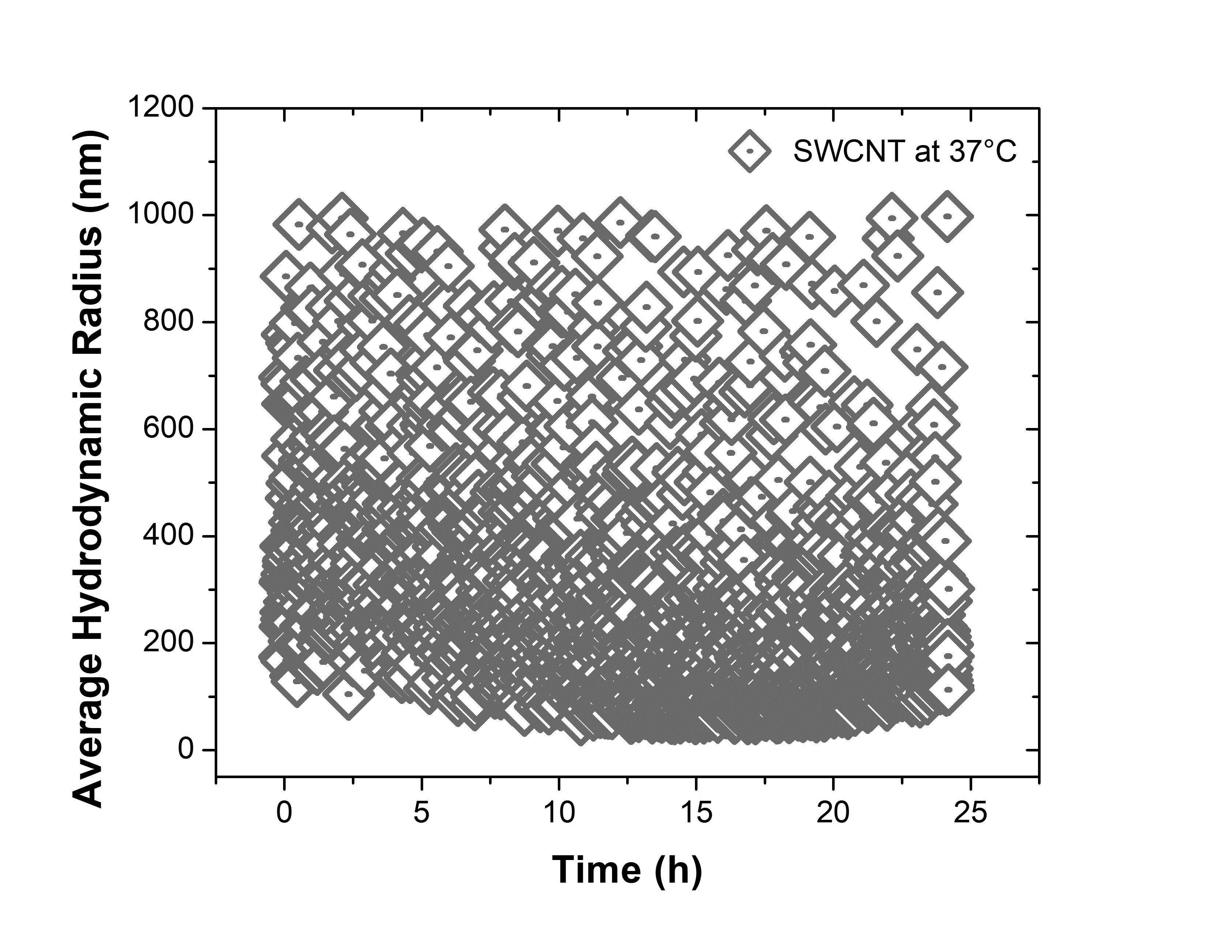

Supplemental Figure 2. Expression level comparison of immune genes in SAEC exposed to IAV over time. SAEC were exposed to IAV at MOI=0.5 for 2, 4, 8, 12, 18, and 24 hours. Here, we only show Control 2 hour, IAV 2-hour, and IAV 24-hour groups. Cells were collected for RNA extraction and mRNA expression of immune genes were measured by qPCR. Fold change was calculated using 2-hour control of TLR3 as calibrant. Data were presented as Mean±SD. Stars “*” above each bar represent statistically significant differences compared to control 2h treatment (P<0.05).

Supplemental Figure 3. Time-course changes in ROS production induced by SWCNTs. A DCFDA method was used to determine the ROS production in SAEC exposed to different doses (μg/mL) of SWCNTs for 2, 4 and 6 hours. Positive control (50 μM H₂O₂) wells were also included. A total of 3 samples per group were graphed and data presented as $Mean±SD$. Stars “*” above each bar indicate statistically significant differences from control of each time point (P<0.05).

Supplemental Figure 4. ROS production induced by SWCNTs 24 hours following exposure (A) and 4 hours after SWCNTs+IAV exposure (B). SAEC were first exposed to different doses (μg/mL) of SWCNTs for 24 hours and then DCFDA dye was applied to measure the ROS (A). SAEC were first exposed to dye for 45 min and then to SWCNTs (50 μg/mL) and different doses of IAV (MOI) for 4 hours (B). Positive control (50 μM H₂O₂) wells were also included. The data are presented as $Mean±SD$. Stars “*” above each bar indicate statistically significant differences from control (P<0.05).

