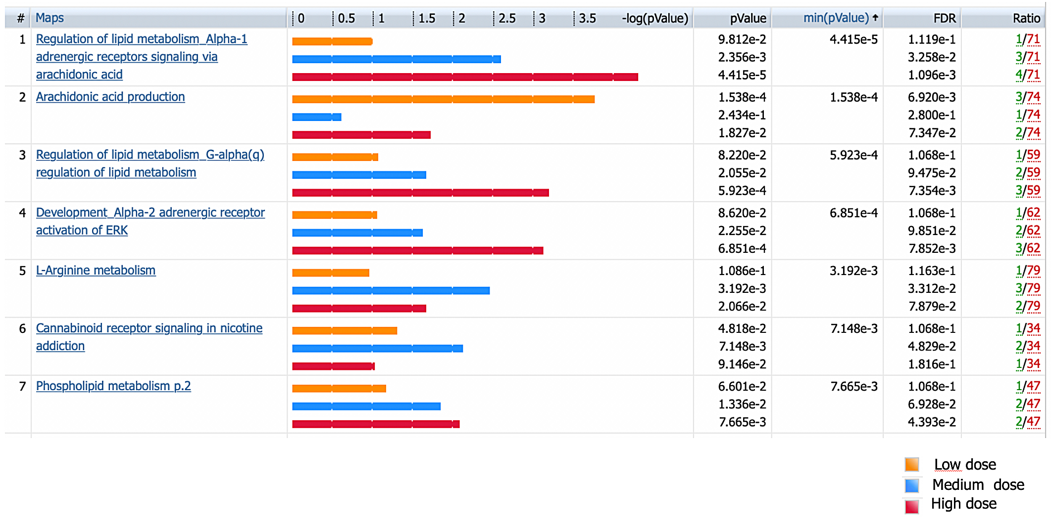

Figure S1: Enriched MetaCore Pathway Maps by metabolites levels differentially modulated (p<0.05) by Low, Medium and High doses of CPM. Only the top enriched maps with FDR q-value<0.05 in at least one dose group are shown.

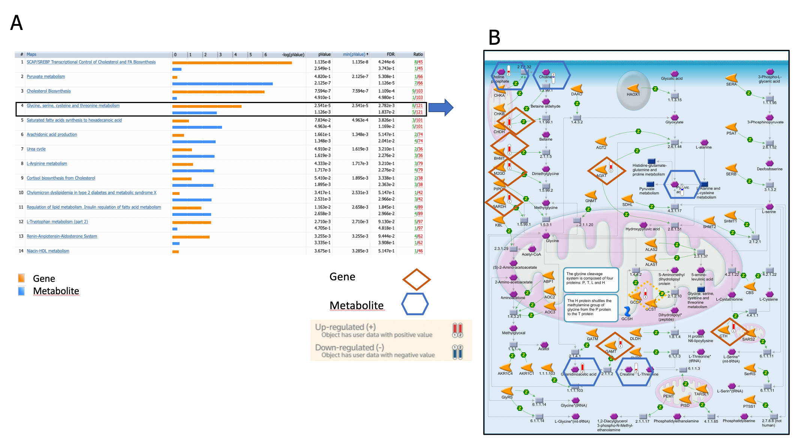

Figure S2. A) Comparison of enriched MetaCore Pathway Maps in differentially modulated genes and metabolites levels. B) Map of MetaCore Pathway Map «Glycine, serine, cysteine and threonine metabolism” in A) significantly (FDR < 0.05) enriched in both genes and metabolites differentially modulated by CPM
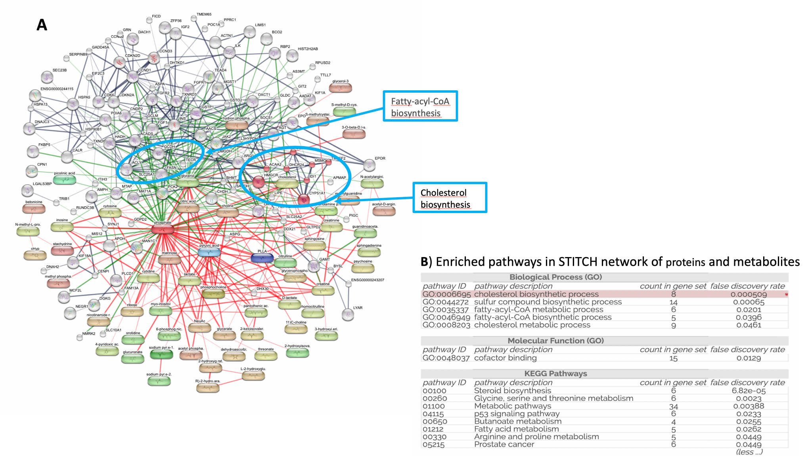

Figure S3: STITCH network of proteins and metabolites. A) Network of proteins encoding the differentially expressed genes (human orthologs) and modulated metabolites generated using the STICTH database. The manually highlighted subnetworks represent two of the top enriched pathways cholesterol and fatty-acyl-COA biosynthesis. B) Disconnected network elements were removed to enhance visualization.
in Atlantic cod. A combined list of differentially affected metabolites (p< 0.05) and genes differentially regulated (FDR q-value<0.1) by the three doses were used in pathway enrichment analysis in MetaCore.
Table S1. Summary of RNA-seq data quality.

Sample name | Raw reads | Clean reads | Clean bases | Error rate (%) | Q20 (%) | Q30 (%) | GC content (%)
Control1 | 65576444 | 63995400 | 9.6G | 0.03 | 96.58 | 91.66 | 55.04
Control2 | 56694022 | 55466278 | 8.3G | 0.03 | 95.92 | 90.23 | 55.2
Control3 | 55953646 | 54723942 | 8.2G | 0.03 | 95.98 | 90.41 | 55.24
Control4 | 53775298 | 52679576 | 7.9G | 0.03 | 96.64 | 91.78 | 54.4
Control5 | 46376694 | 45485480 | 6.8G | 0.03 | 94.47 | 86.75 | 54.36
Control6 | 49922212 | 48875480 | 7.3G | 0.03 | 95.77 | 89.95 | 54.68
Control7 | 51522790 | 50286894 | 7.5G | 0.03 | 96.16 | 90.79 | 54.46
Control8 | 50097642 | 49027618 | 7.4G | 0.03 | 96.19 | 90.82 | 54.9
Control9 | 59175062 | 57644194 | 8.6G | 0.03 | 95.63 | 89.69 | 54.81
Low1 | 40593684 | 39870928 | 6G | 0.03 | 96.55 | 91.55 | 54.46
Low2 | 47173564 | 46113498 | 6.9G | 0.03 | 96.56 | 91.57 | 55.37
Low3 | 54891476 | 53539560 | 8G | 0.03 | 96.16 | 90.72 | 55.56
Low4 | 48811242 | 47679876 | 7.2G | 0.03 | 96.68 | 91.83 | 55.02
Low5 | 49752314 | 48752566 | 7.3G | 0.03 | 96.37 | 91.17 | 54.86
Low6 | 55145282 | 54025988 | 8.1G | 0.03 | 96.57 | 91.71 | 54.74
Low7 | 53091940 | 52102198 | 7.8G | 0.03 | 96.67 | 91.84 | 54.83
Low8 | 51448038 | 50395272 | 7.6G | 0.03 | 96.15 | 90.77 | 54.59
Low9 | 46980424 | 46045010 | 6.9G | 0.03 | 96.36 | 91.2 | 54.49
Medium1 | 53631780 | 52521740 | 7.9G | 0.03 | 96.26 | 90.94 | 54.48
Medium2 | 54930862 | 53694802 | 8.1G | 0.03 | 96.42 | 91.41 | 55.06
Medium3 | 56336298 | 55005684 | 8.3G | 0.03 | 96.02 | 90.5 | 54.58
Medium4 | 50464826 | 49258072 | 7.4G | 0.03 | 96.51 | 91.51 | 55.02
Medium5 | 46229698 | 45209048 | 6.8G | 0.03 | 96.69 | 91.97 | 54.45
Medium6 | 52915630 | 51567724 | 7.7G | 0.03 | 96.79 | 92.18 | 55.01
Medium7 | 42988646 | 41832960 | 6.3G | 0.03 | 96.19 | 90.83 | 55.18
Medium8 | 48148256 | 46850922 | 7G | 0.03 | 96.61 | 91.78 | 55.46
Medium9 | 49018040 | 47846546 | 7.2G | 0.03 | 96.16 | 90.81 | 54.82
High1 | 42856660 | 41892404 | 6.3G | 0.03 | 96.23 | 91.02 | 55.29
High2 | 54531896 | 53272770 | 8G | 0.03 | 96.42 | 91.39 | 55.76
High3 | 45335296 | 44294488 | 6.6G | 0.03 | 96.76 | 92.09 | 54.81
High4 | 53611394 | 52130546 | 7.8G | 0.03 | 95.86 | 90.2 | 55.22
High5 | 49916788 | 48562270 | 7.3G | 0.03 | 96.35 | 91.25 | 54.88
High6 | 45376706 | 44188488 | 6.6G | 0.03 | 96.54 | 91.61 | 55.19
High7 | 40374966 | 39380886 | 5.9G | 0.03 | 97.23 | 93.08 | 54.56
High8 | 54106310 | 52801704 | 7.9G | 0.03 | 96.93 | 92.41 | 54.85
High9 | 52067772 | 50531076 | 7.6G | 0.03 | 96.21 | 90.9 | 55.58

Table S2. Enriched Wikipathways (Enrichr tool) using genes differentially regulated by Low, Medium and High dose groups.

Term | Overlap | P-value | Adjusted P-value | Z-score | Combined Score | Genes
Low dose
EPO Receptor Signaling WP581 | 2/26 | 2.42983E-05 | 0.000874739 | -2.578037155 | 27.39191247 | SOCS1;EPO
Leptin Insulin Overlap WP3935 | 1/17 | 0.00508981 | 0.032525699 | -3.218920015 | 16.99755491 | SOCS1
TP53 Network WP1742 | 1/19 | 0.005687189 | 0.032525699 | -3.200698772 | 16.54613776 | GADD45A
Imatinib and Chronic Myeloid Leukemia WP3640 | 1/20 | 0.005985766 | 0.032525699 | -2.541995307 | 13.0108748 | GADD45A
The human immune response to tuberculosis WP4197 | 1/23 | 0.006881051 | 0.032525699 | -2.514968176 | 12.52198614 | SOCS1
Spinal Cord Injury WP2431 | 2/118 | 0.000509794 | 0.007418982 | -1.457169444 | 11.04753612 | ZFP36;GADD45A
Type II interferon signaling (IFNG) WP619 | 1/37 | 0.011050164 | 0.032525699 | -2.320503793 | 10.45458898 | SOCS1
ATM Signaling Pathway WP2516 | 1/40 | 0.011941645 | 0.032525699 | -2.230531128 | 9.876174872 | GADD45A
Differentiation Pathway WP2848 | 1/48 | 0.014315655 | 0.032525699 | -2.109546557 | 8.95798187 | EPO
Endometrial cancer WP4155 | 1/63 | 0.018754112 | 0.032525699 | -1.992755438 | 7.923877621 | GADD45A
Adipogenesis WP236 | 2/130 | 0.000618248 | 0.007418982 | -1.064850842 | 7.867778353 | SOCS1;GADD45A
Photodynamic therapy-induced HIF-1 survival signaling WP3614 | 1/37 | 0.011050164 | 0.032525699 | -1.71141043 | 7.710434551 | EPO
Kit receptor signaling pathway WP304 | 1/59 | 0.017572155 | 0.032525699 | -1.819323047 | 7.352684421 | SOCS1
Oxidative Damage WP3941 | 1/40 | 0.011941645 | 0.032525699 | -1.642868189 | 7.274165924 | GADD45A
G1 to S cell cycle control WP45 | 1/64 | 0.019049416 | 0.032525699 | -1.835729705 | 7.270809209 | GADD45A
Interferon type I signaling pathways WP585 | 1/54 | 0.016093041 | 0.032525699 | -1.757077043 | 7.255618302 | SOCS1
IL-4 Signaling Pathway WP395 | 1/54 | 0.016093041 | 0.032525699 | -1.752565575 | 7.236988789 | SOCS1
Preimplantation Embryo WP3527 | 1/58 | 0.017276481 | 0.032525699 | -1.569362809 | 6.369116458 | ZFP36
Hematopoietic Stem Cell Differentiation WP2849 | 1/55 | 0.016389012 | 0.032525699 | -1.542918482 | 6.343160298 | EPO
miRNA Regulation of DNA Damage Response WP1530 | 1/71 | 0.021114471 | 0.032525699 | -1.48515307 | 5.729418534 | GADD45A
Non-small cell lung cancer WP4255 | 1/66 | 0.019639802 | 0.032525699 | -1.426378266 | 5.605947676 | GADD45A
Genotoxicity pathway WP4286 | 1/63 | 0.018754112 | 0.032525699 | -1.342193668 | 5.337021375 | GADD45A
Viral Acute Myocarditis WP4298 | 1/84 | 0.024939962 | 0.034532255 | -1.414028248 | 5.219579649 | SOCS1
Pancreatic adenocarcinoma pathway WP4263 | 1/89 | 0.026407984 | 0.035210645 | -1.348216311 | 4.899537942 | GADD45A
DNA Damage Response WP707 | 1/68 | 0.020229891 | 0.032525699 | -1.185520487 | 4.624234088 | GADD45A
Chromosomal and microsatellite instability in colorectal cancer WP4216 | 1/73 | 0.021703821 | 0.032525699 | -1.155669768 | 4.426523729 | GADD45A
Prolactin Signaling Pathway WP2037 | 1/76 | 0.022587291 | 0.032525699 | -1.13271086 | 4.293390853 | SOCS1
Cell Cycle WP179 | 1/120 | 0.035468668 | 0.045602573 | -0.93249053 | 3.113684316 | GADD45A
Medium dose
Glycolysis and Gluconeogenesis WP534 | 2/45 | 0.000916601 | 0.020783363 | -1.926464818 | 13.47531071 | MDH1;GOT2
One carbon metabolism and related pathways WP3940 | 2/52 | 0.001222551 | 0.020783363 | -1.616504961 | 10.84160106 | DMGDH;SARDH
Amino Acid metabolism WP3925 | 2/91 | 0.003688396 | 0.035518692 | -1.409167722 | 7.894951761 | MDH1;GOT2
Human Complement System WP2806 | 2/97 | 0.00417867 | 0.035518692 | -0.937750809 | 5.136776085 | C3;GNAI2
High dose
Cholesterol Biosynthesis Pathway WP197 | 4/15 | 2.82777E-07 | 2.37533E-05 | -3.28660533 | 49.55742732 | SQLE;CYP51A1;MSMO1;HMGCR
Sterol Regulatory Element-Binding Proteins (SREBP) signalling WP1982 | 5/69 | 7.32652E-06 | 0.000307714 | -1.592362926 | 18.82811557 | MBTPS1;ACLY;SQLE;CYP51A1;HMGCR
Tryptophan metabolism WP465 | 3/46 | 0.000767728 | 0.021496394 | -2.237236276 | 16.04562541 | OGDH;DHCR24;CYP7B1
TCA Cycle and Deficiency of Pyruvate Dehydrogenase complex (PDHc) WP2453 | 2/16 | 0.001739132 | 0.02932352 | -2.966415742 | 18.84970144 | ACLY;OGDH
Oxidation by Cytochrome P450 WP43 | 3/61 | 0.001745448 | 0.02932352 | -1.37619553 | 8.73986582 | CYP2U1;CYP51A1;CYP7B1
Fatty Acid Biosynthesis WP357 | 2/22 | 0.003297491 | 0.046164874 | -2.340160154 | 13.37306378 | ACLY;ACAA2
Statin Pathway WP430 | 2/29 | 0.00569424 | 0.048009911 | -2.675285292 | 13.82667718 | SQLE;HMGCR
Lipid Metabolism Pathway WP3965 | 2/29 | 0.00569424 | 0.048009911 | -2.131849644 | 11.01803868 | LIPE;ACLY
Amino Acid metabolism WP3925 | 3/91 | 0.005419463 | 0.048009911 | -1.373460951 | 7.166387524 | ACLY;MARS2;OGDH
Metapathway biotransformation Phase I and II WP702 | 4/183 | 0.005715466 | 0.048009911 | -0.963147992 | 4.974254381 | CYP2U1;GSTO2;CYP51A1;CYP7B1

Table S3. Pathways enriched by both differentially expressed genes and altered metabolites as determined with the IMPaLA integrated transcriptomics and metabolomics pathway analysis tool.

Pathway name | Pathway source | Number of measured genes | Measured genes | Number of all pathway genes | P-genes | Q-genes | Number of measured metabolites | Measured metabolites | Number of all pathway metabolites | P-metabolites | Q-metabolites | P-joint | Q-joint
Metabolism | Reactome | 56 | AS3MT;GSTP1;FAH;MAT1A;FASN;LIPE;CNDP2;SLC10A1;ACLY;MGST1;ACADS;DMGDH;SPR;GCLM;GLDC;SLC25A2;SCD;SLC25A1;TECR;CHDH;DHCR24;CYP24A1;SQLE;EBP;CYP51A1;RBP2;AACS;SRM;TM7SF2;THEM5;GAMT;AADAT;CYP2U1;OXCT1;OAT;GCDH;ACAA2;BCO2;HMGCR;PLCD1;HADH;SYNJ1;SARDH;IDI1;GSTO2;DCK;LSS;ASPA;MSMO1;DHTKD1;AK7;CTH;ASPG;NMRK2;BHMT;ARG1 | 1972 | 9.1e-09 | 4.18e-05 | 41 | C00158;C00159;C00116;C00074;C00249;C00794;C00170;C03150;C00588;C00581;C00187;C00186;C16537;C00009;C16513;C00270;C00319;C01885;C00022;C06428;C00354;C00791;C00141;C00258;C00670;C00294;C00847;C00864;C01595;C00475;C05382;C00121;C00191;C00114;C00137;C00059;C00300;C00327;C00345;C01233;C00346 | 1384 | 8.62e-05 | 368 | 2.27e-11 | 1.12e-08
Metabolism of lipids | Reactome | 25 | OXCT1;FASN;LIPE;SLC10A1;ACLY;ACADS;SCD;SLC25A1;TECR;SYNJ1;DHCR24;CYP24A1;SQLE;EBP;CYP51A1;AACS;TM7SF2;THEM5;CYP2U1;LSS;ACAA2;MSMO1;HMGCR;HADH;IDI1 | 664 | 1.23e-05 | 0.0189 | 18 | C00114;C00158;C00116;C00009;C00187;C00249;C00670;C01233;C00588;C16513;C00270;C00059;C01595;C00319;C01885;C00137;C06428;C00346 | 620 | 0.0268 | 1 | 5.27e-06 | 0.0013
Metabolism of amino acids and derivatives | Reactome | 18 | GAMT;SARDH;SRM;DHTKD1;DMGDH;FAH;ASPG;GLDC;SLC25A2;OAT;MAT1A;CTH;CHDH;GCDH;BHMT;ASPA;AADAT;ARG1 | 342 | 7.63e-06 | 0.0175 | 10 | C00114;C00009;C00022;C00791;C00170;C00059;C00300;C00327;C00581;C00141 | 285 | 557 | 1 | 5.68e-05 | 0.00935
Fatty acid metabolism | Reactome | 10 | ACADS;THEM5;CYP2U1;SCD;SLC25A1;ACAA2;FASN;TECR;HADH;ACLY | 189 | 0.00195 | 578 | 6 | C00158;C00009;C00249;C16513;C01595;C06428 | 367 | 0.0313 | 1 | 0.000653 | 0.0807

