Susan E. Parks, Dana A. Cusano, Sofie M. Van Parijs, Douglas P. Nowacek (2019)

Acoustic crypsis in communication by North Atlantic right whale mother-calf pairs on the calving grounds. Published in Biology Letters

**Supplemental Figure 1.** A figure showing the distribution of call RL and background noise levels by individual ID. Lactating females are denoted with circles, other age/sex classes are denoted by squares.

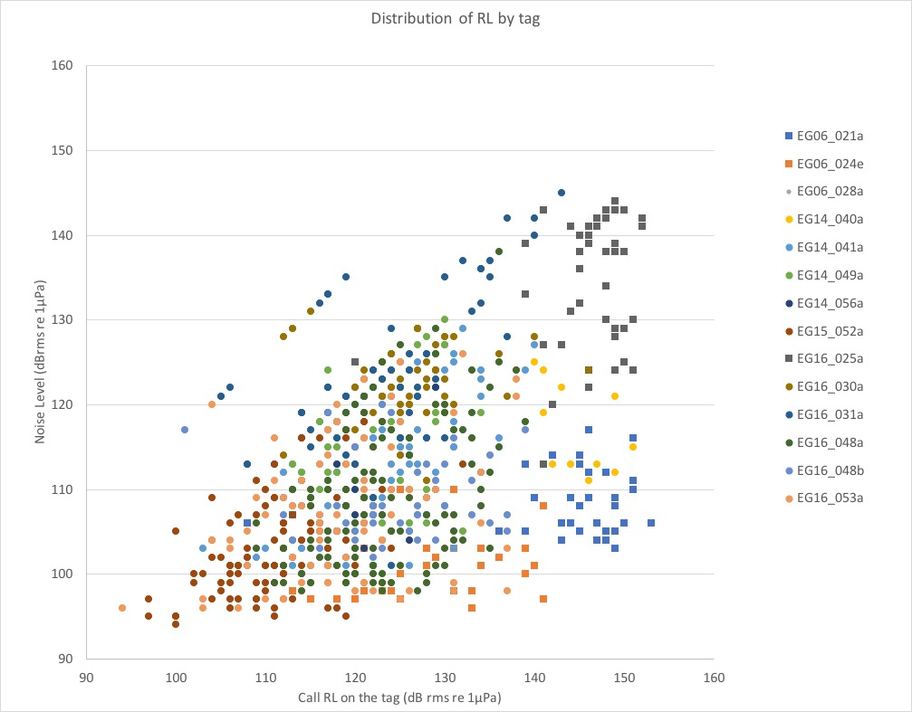

**Supplemental Figure 2.** A plot showing the k-means density plots by call RL for high and low amplitude clusters.

