Table 1S.- Correlation between Melipona Honey concentration and inhibition growth percentage of C. albicans
Percentage | Media (IC 95%) | Standard deviation (σ)
0% | 0 | 0
5% | 43.38 ± 9.17 | 3.69
10% | 48.05±7.69 | 3.09
15% | 53.04±5.01 | 2.01
20% | 81.58±10.47 | 4.21
25% | 91.05±4.5 | 1.82
30% | 95.65±4.08 | 1.64
35% | 98.92±2.44 | 0.98

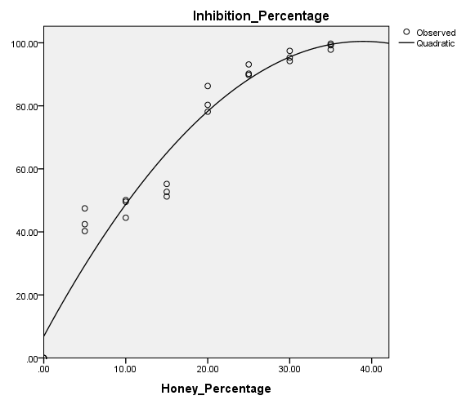
Figure 1S. Growth inhibition percentage of C. albicans related to honey content in the YPG medium. Continuous line, predicted values according to a quadratic model (R²=0.946, p<0.001). It was observed an abrupt increment of growth inhibition percentage between 15 and 20 % of Melipona honey.

