**Figure Captions**

Figure 1 Scanning electron microscopy images of (a) expandable graphite powder, (b) expanded graphite (EG) powder magnified by 50×.

Figure 2 The fabrication process of paraffin/EG composites.

Figure 3 [Scanning electron microscopy](https://www.sciencedirect.com/topics/materials-science/scanning-electron-microscopy) images of paraffin/EG composites (a) 2wt% EG, (b) 5wt% EG, (c) 10wt% EG, (d) 15wt% EG and (e) 20wt% EG before the thermal cycles; (f) 2wt% EG, (g) 5wt% EG, (h) 10wt% EG, (i) 15wt% EG and (j) 20wt% EG after 100 thermal cycles.

Figure 4 DSC heat flow measurements for the paraffin/EG composites with different mass fractions of EG: (a) before thermal cycling, (b) after 100 thermal cycles.

Figure 5 XRD patterns of paraffin, EG and paraffin/10wt%EG composite.

Figure 6 Thermal gravimetric analysis weight loss curves of the prepared paraffin/EG composites.

Figure 7 Measured thermal conductivities of the paraffin/EG composites with different mass fractions of EG before and after cycling.

Figure 8 The curve fits of electrical conductivity of the paraffin/EG composites with different mass fractions of EG (Points indicate experimental the measurements).

Figure 9 The heat storage and release processes of paraffin/EG composites: (a) heat storage processes, (b) heat release processes.

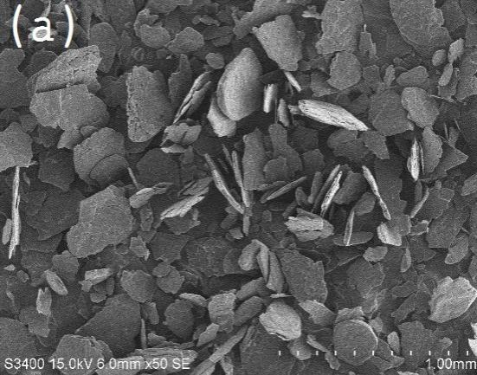

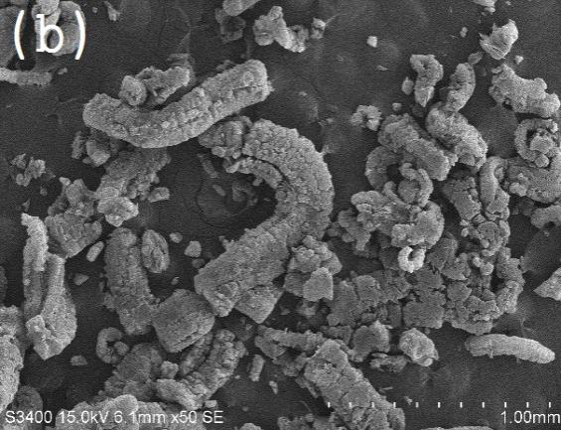

Figure 1 Scanning electron microscopy images of (a) expandable graphite powder, (b) expanded graphite (EG) powder magnified by 50 ×.



Figure 2 The fabrication process of paraffin/EG composites.

|  |  |  |
| --- | --- | --- |
| 2wt% | 2 | 2-1 |
| 5wt% | 5%_m001 | 5 |
| 10wt% | 10%_m003 | 10 |
| 15wt% | 15%_m001 | 15 |
| 20wt% | 20%_m004 | 20%(50)_m001 |

Figure 3 [Scanning electron microscopy](https://www.sciencedirect.com/topics/materials-science/scanning-electron-microscopy) images of paraffin/EG composites (a) 2wt% EG, (b) 5wt% EG, (c) 10wt% EG, (d) 15wt% EG and (e) 20wt% EG before the thermal cycles; (f) 2wt% EG, (g) 5wt% EG, (h) 10wt% EG, (i) 15wt% EG and (j) 20wt% EG after 100 thermal cycles.



(a)



(b)

Figure 4 DSC heat flow measurements for the paraffin/EG composites with different mass fractions of EG: (a) before thermal cycling, (b) after 100 thermal cycles.



Figure 5 XRD patterns of paraffin, EG and paraffin/10wt%EG composite.



(a)



(b)

Figure 6 Thermal gravimetric analysis weight loss curves of the prepared paraffin/EG composites.



Figure 7 Measured thermal conductivities of the paraffin/EG composites with different mass fractions of EG before and after cycling.



Figure 8 The curve fits of electrical conductivity of the paraffin/EG composites with different mass fractions of EG (Points indicate experimental the measurements).



(a)



(b)

Figure 9 The heat storage and release processes of paraffin/EG composites: (a) heat storage processes, (b) heat release processes.