**Parental coordination of chick provisioning in a planktivorous Arctic seabird under divergent conditions on foraging grounds**

Running title: *Coordinated provisioning and environmental conditions*

Antoine Grissot1*, Marcelo Araya-Salas2,3, Dariusz Jakubas1, Dorota Kidawa1, Rafał Boehnke4, Katarzyna Błachowiak-Samołyk4, Katarzyna Wojczulanis-Jakubas1

**Supplementary Information**

**Table S1.** Detailed information on abiotic data used in analyses, and dates of data collection

|  |  |  |  |  |  |  |
| --- | --- | --- | --- | --- | --- | --- |
| Colony | Year | Date of diet sampling | | Distance to the ice edge [km] | SST Data | |
| day-month | Julian  date | Period –  Julian dates | Data Type |
| Magdalenefjorden | 2009 | 27-Jul | 208 | 81 | 209-216 | 8 d composite |
| 04-Aug | 216 | 80 |
| 2010 | 23-Jul | 204 | 111 | 201-208 |
| 01-Aug | 213 | 101 | 209-216 |
| 06-Aug | 218 | 103 |
| Hornsund | 2016 | 21-Jul | 203 | 480 | 201-208 | 8 d composite |
| 27-Jul | 209 | 458 |
| 2017 | 22-Jul | 203 | 290 | 182-212 | monthly for July |
| 25-Jul | 206 | 282 |
| 27-Jul | 208 | 288 |
| 29-Jul | 210 | 290 | 209-216 | 8 d composite |
| 30-Jul | 211 | 320 |
| 01-Aug | 213 | 305 |
| 04-Aug | 216 | 355 |
| 2018 | 21-Jul | 202 | 440 | 213-243 | monthly for August |

.

**Table S2.** Coordination and environmental data. Also available in xlsx

**Table S2.** cont.



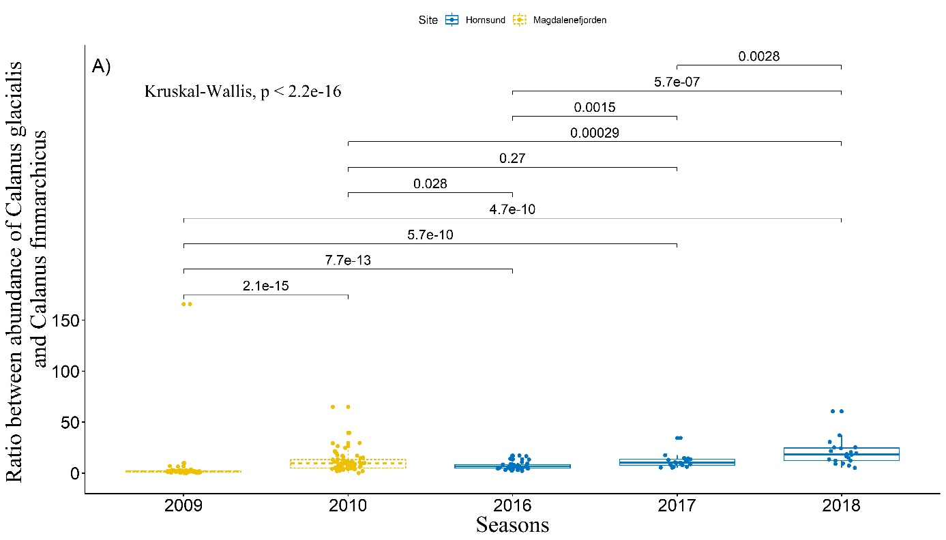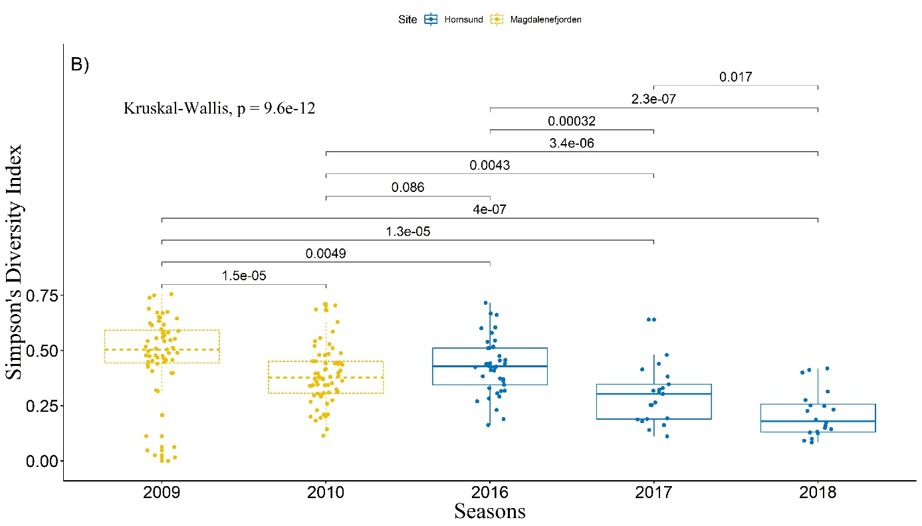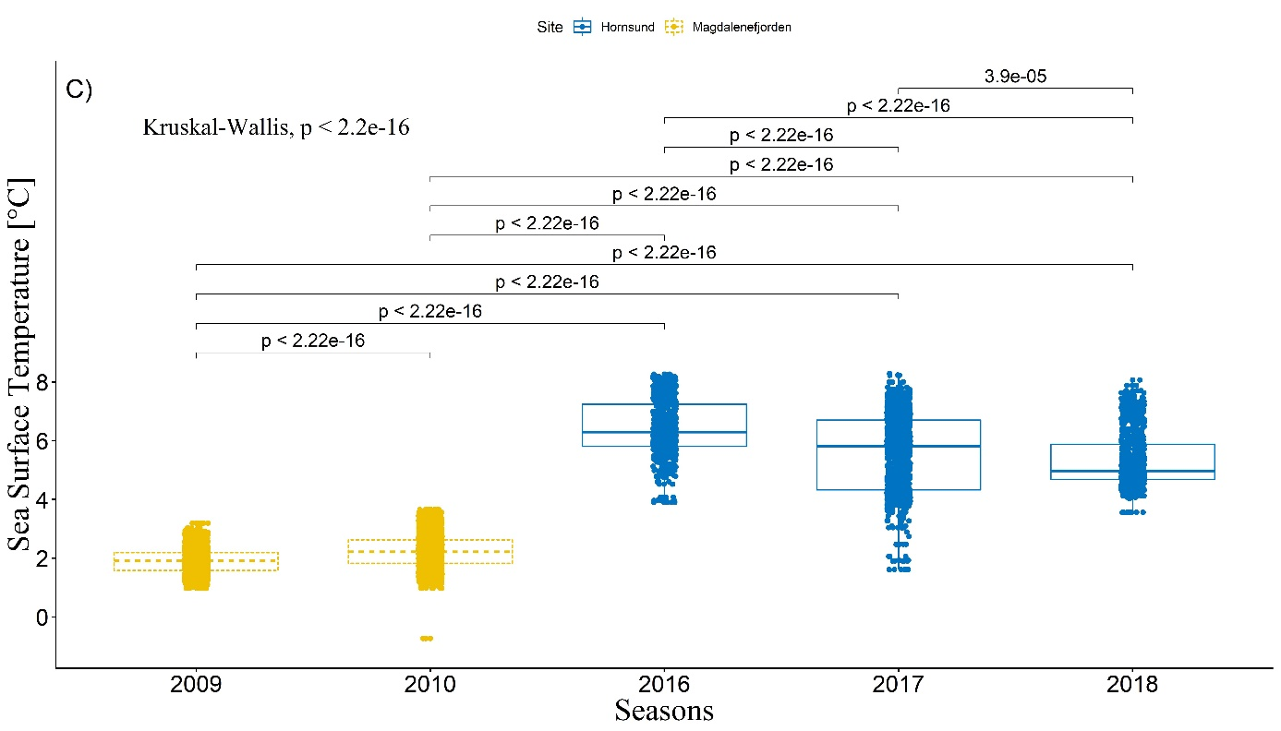**Figure S1.** Environmental conditions during the studied breeding seasons (A: *Calanus glacialis/Calanus finmarchicus* ratio; B: Simpson’s Diversity Index; C: Sea Surface Temperature [SST]). Values above the lines represent p values from t-tests comparing particular pairs of seasons. Boxplots show the median (bold line inside the box), the first (25%) and third (75%) quartile (box), and the lowest and highest values within 1.5 interquartile range (whiskers). Dots represent the raw data points.