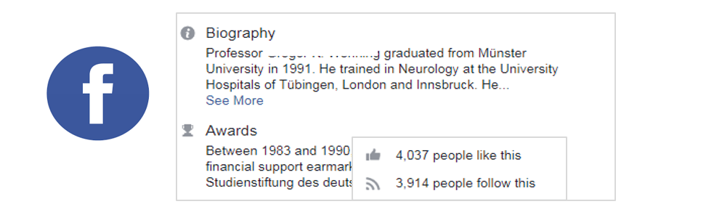

https://bit.ly/2SKkLkl
Figure 1: A Facebook profile of an academic user, showing a link to a research paper

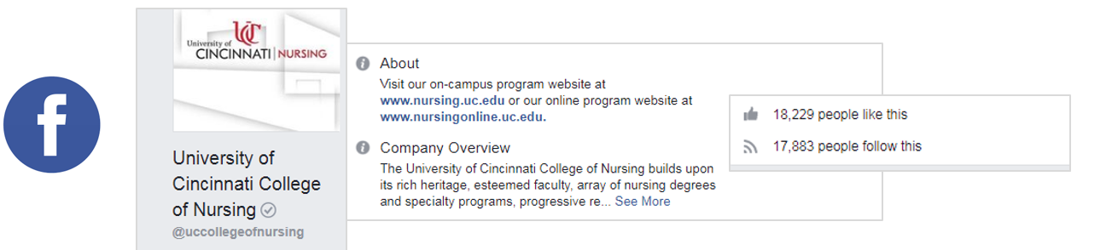
https://bit.ly/2SJS6fb
Figure 2: A Facebook profile of an academic organization, showing a link to a scholarly paper.

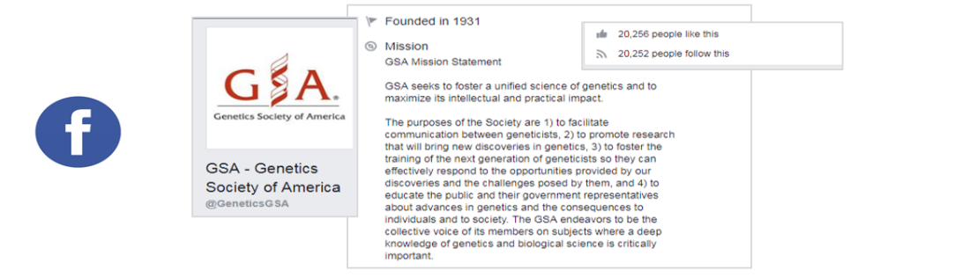

https://bit.ly/2K8ZVan
Figure 3: A Facebook profile of a society, showing a link to an academic article.

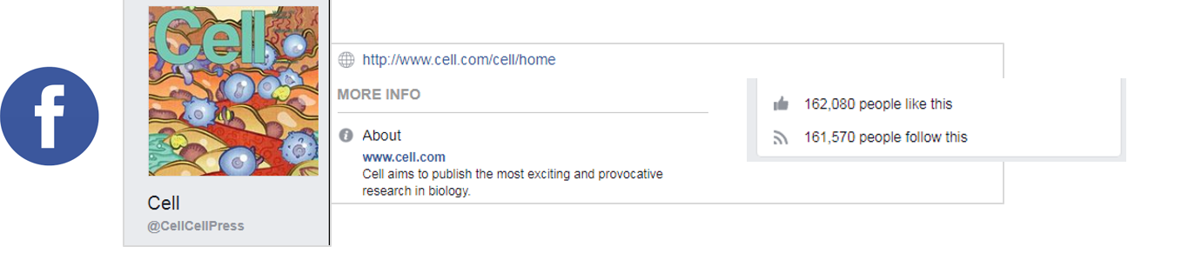
https://bit.ly/2YnbZd7
Figure 4: A Facebook profile of a journal, showing a link to a research article.

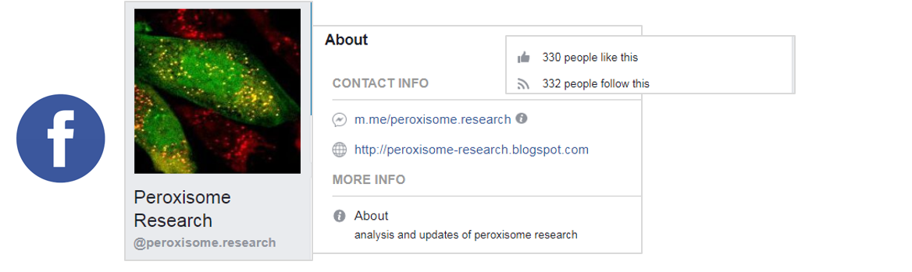
https://bit.ly/2K0KxOA
Figure 5: A Facebook profile of a blogger, showing a link to an academic paper.

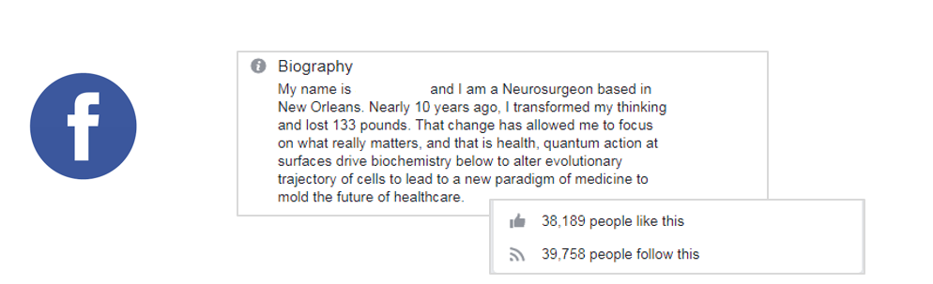
https://bit.ly/2YtHjLf
Figure 6: A Facebook profile of a neurosurgeon, showing a link to a scientific article.

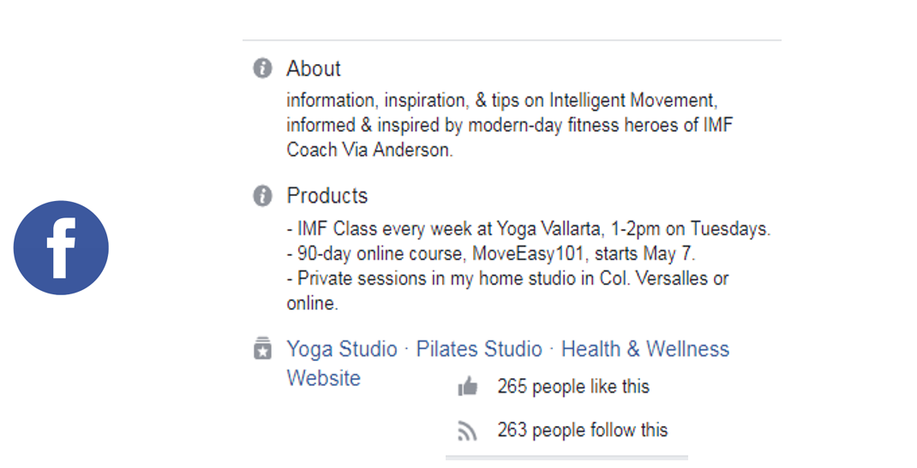
https://bit.ly/2SKDtbl
Figure 7: A Facebook profile of a yoga instructor, showing a link to a research article.

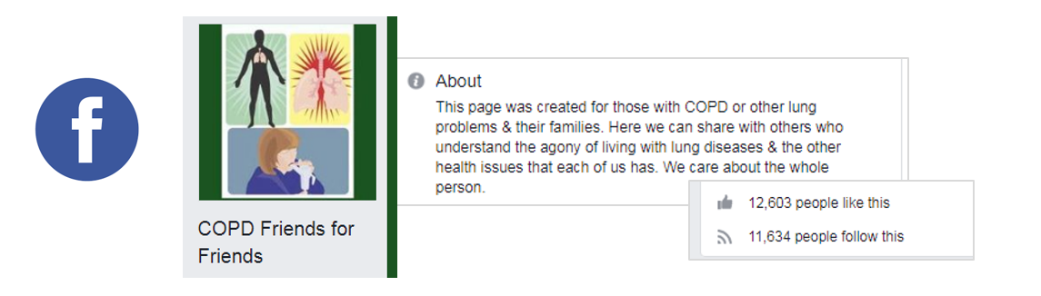
https://bit.ly/2Mn6LvO
Figure 8: A Facebook profile of an online community, showing a link to a scholarly article.

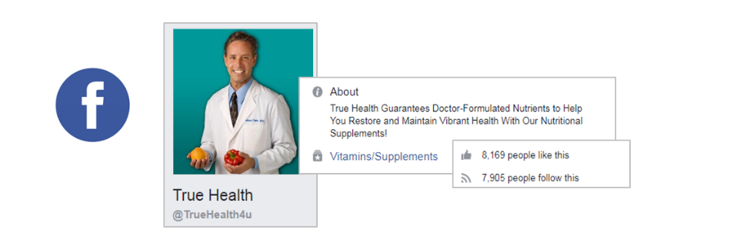

https://bit.ly/2Mjhszc
Figure 9: A Facebook profile of a commercial organization, showing a link to an academic paper.

