Supplementary Material

eFigure 1a. AHA Recommendations for screening for depression in patients with CHD.
eFigure 1b. NICE stepped-care model for “Depression in Adults with a Chronic Physical Health Problem”.
eFigure 2. Study Flow Chart.
eFigure 3. Course of depressive symptoms among clinically depressed patients by treatment status.
eTable 1. Depression treatment rates at baseline and follow-up. Follow-up sample N = 837.

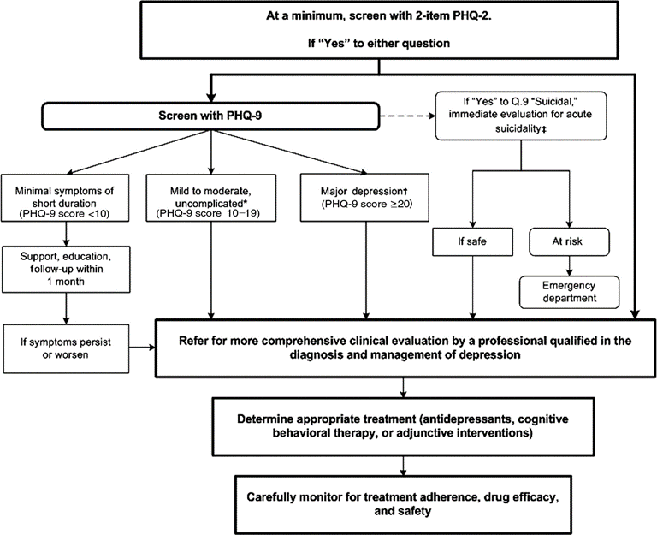

eFigure 1a. AHA Recommendations for screening for depression in patients with CHD.
AHA = American Heart Association, PHQ = Patient Health Questionnaire.

Reprinted with permission.
Circulation.2008; 118: 1769-1775
© 2008 American Heart Association, Inc.

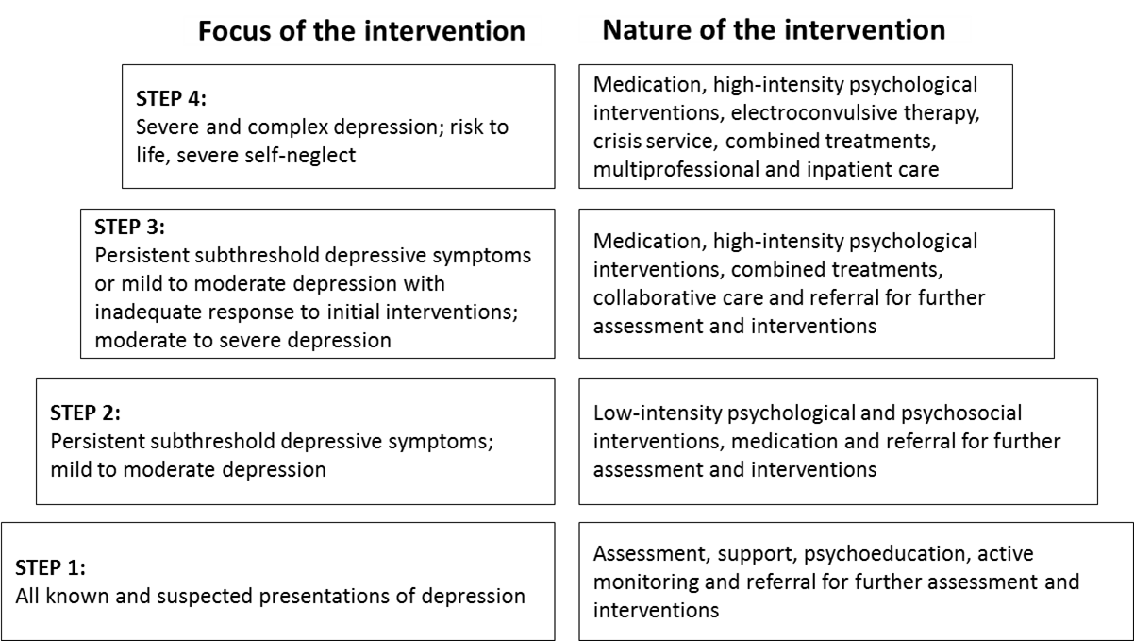

eFigure 1b. NICE stepped-care model for “Depression in Adults with a Chronic Physical Health Problem”.
NICE = National Institute for Health and Care Excellence.

© NICE (2009) Depression in adults with a chronic physical health problem: recognition and management. Available from www.nice.org.uk/guidance/cg91 All rights reserved. Subject to Notice of rights
NICE guidance is prepared for the National Health Service in England. All NICE guidance is subject to regular review and may be updated or withdrawn. NICE accepts no responsibility for the use of its content in this product/publication.
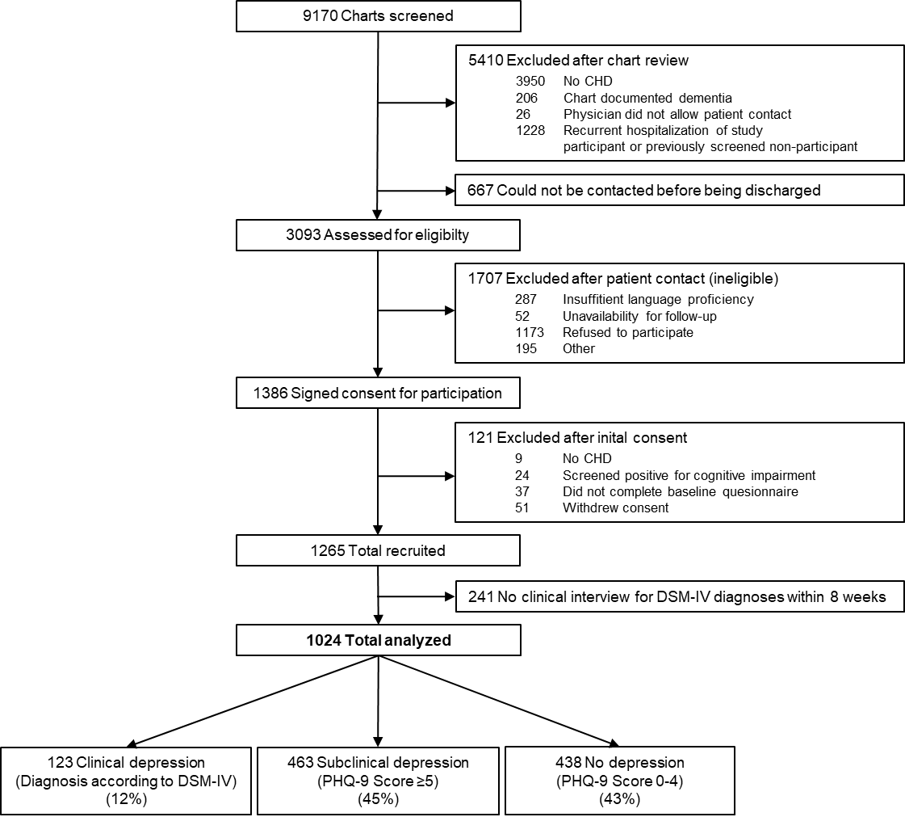

eFigure 2. Study Flow Chart.
CHD = Coronary Heart Disease, DSM-IV = DSM-IV = Diagnostic and Statistical Manual of Mental Disorders, PHQ = Patient Health Questionnaire.

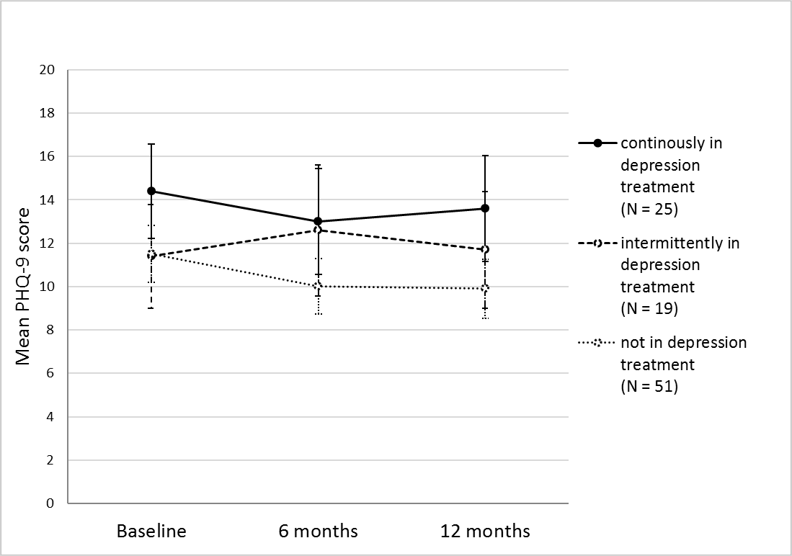

eFigure 3. Course of depressive symptoms among clinically depressed patients by treatment status
PHQ = Patient Health Questionnaire.
eTable 1
Depression treatment rates at baseline and follow-up. Follow-up sample N = 837.
Treatment, No. (%)ª | Baseline | 6-months follow-up | 12-months follow-up
No depression treatment | 767 (91.6) | 747 (89.5) | 735 (88.2)
Psychotherapy^{b} | 15 (1.8) | 19 (2.3) | 21 (2.5)
Antidepressant medication | 42 (5.0) | 44 (5.3) | 46 (5.5)
Both psychotherapy and antidepressant medication | 13 (1.6) | 25 (3.0) | 31 (3.7)
Any depression treatment | 70 (8.4) | 88 (10.5) | 98 (11.8)
ª Because of rounding, proportions may not total 100.
^{b} Patients who did not provide information on whether they received psychotherapy (<3% at all time points) were classified as not in psychotherapy, in case information on whether or not they received antidepressant medication was available. This reduced the number of missings to <0.5%.

