(Q11) Please rate your knowledge of the educational preparation of DNP graduates. | (Q12) Please rate your level of agreement with the following statement:  In the United States, the DNP is considered to be one of two terminal degrees in nursing that differs from the PhD in that it is practiced focused, rather than research focused.
Round One  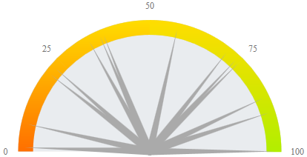  Round Two  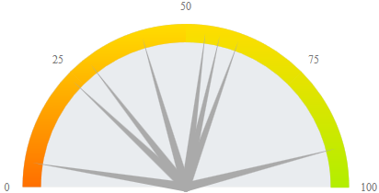  Round n Mean Median Mode Range  1 15 53.6 57 90 99  2 8 45.4 47.5 none 87 | Round One  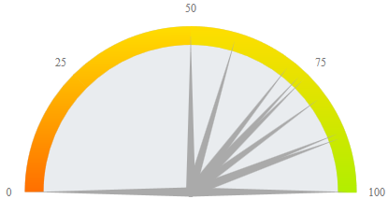  Round Two  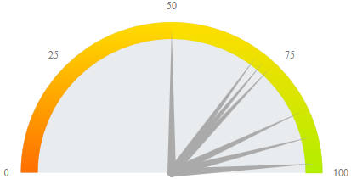  Round n Mean Median Mode Range  1 15 49.5 50 50 100  2 8 78.5 80 86 48
(Q13) Please rate your level of agreement with the following statement:
DNP prepared faculty will substantially contribute to scholarship within the nursing profession.
Round One |  |  |  |  | Round Two
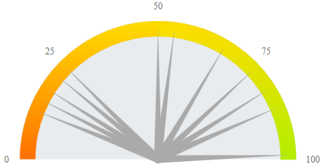 |  |  |  |  | 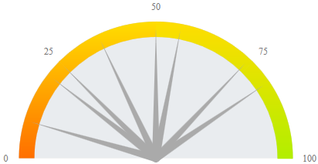
Round Three
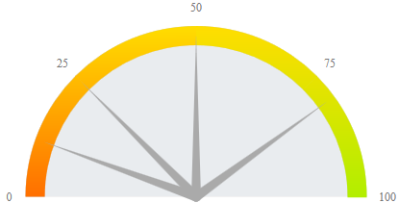
 | Round | n | Mean | Median |  | Mode | Range
 | 1 | 15 | 42.6 | 50 |  | 50 | 87
 | 2 | 8 | 44 | 43 |  | none | 72
 | 3 | 5 | 43.2 | 50 |  | 50 | 69

(Q14) Please rate your level of agreement with the following statement:  Collaboration between PhD and DNP prepared nurses will assist in bridging the gap between scientific discovery and its application to nursing practice. | (Q15) Please rate your level of agreement with the following statement:  Evidence from the United States of America suggests that the DNP is one solution to the shortage of doctoral prepared nursing faculty.
Round One  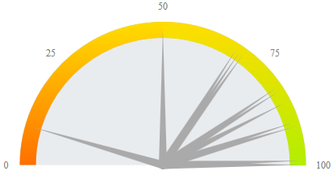  Round Two  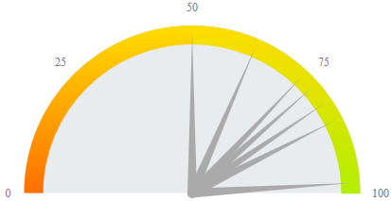  Round n Mean Median Mode Range  1 15 74.1 82 85 82 91  2 8 72.3 75.5 50 48 | Round One  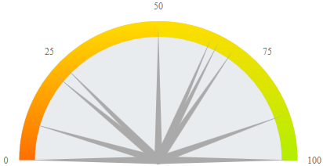  Round Two  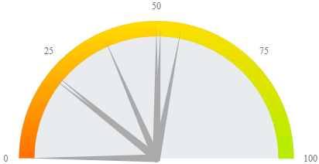  Round n Mean Median Mode Range  1 15 49.5 50 50 100  2 8 35.9 43.5 50 56
(Q16) Please rate your level of agreement with the following statement:
The requirements for tenure and promotion should be the same for PhD- and DNP- prepared nursing faculty.
Round One |  |  |  |  | Round Two
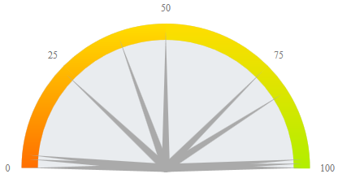 |  |  |  |  | 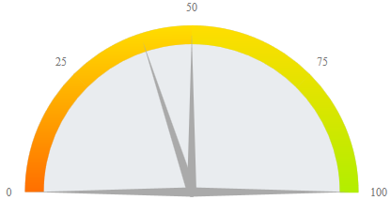
Round Three
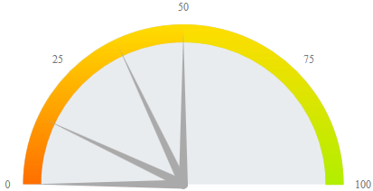
 | Round | n | Mean | Median |  | Mode | Range
 | 1 | 15 | 51.5 | 50 |  | 50 | 100
 | 2 | 8 | 48.8 | 50 |  | 50 | 100
 | 3 | 4 | 28.5 | 32 |  | 50 | 50

