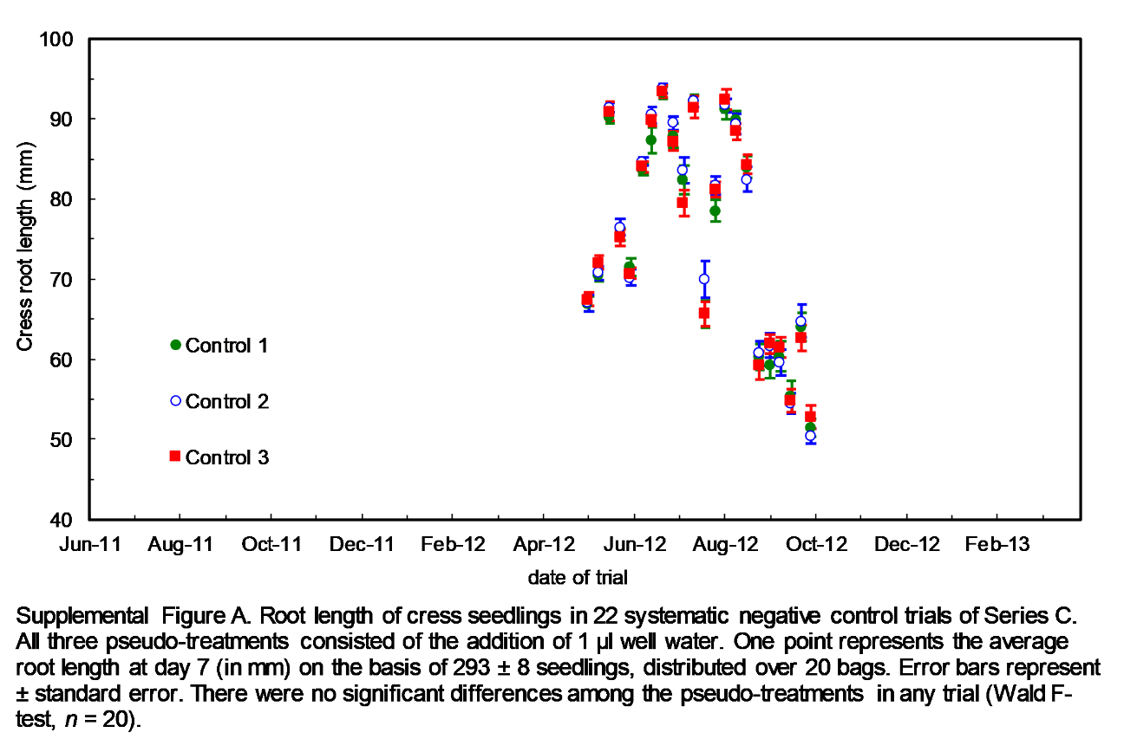
Supplemental Figure A. Root length of cress seedlings in 22 systematic negative control trials of Series C. All three pseudo-treatments (green filled circle, blue open circle, red square) consisted of the addition of 1 µl well-water. One point represents the average root length at day 7 (in mm) on the basis of 293 ± 8 seedlings, distributed over 20 bags. Error bars represent ± standard error. There were no significant differences among the pseudo-treatments in each trial (Wald F-test, n = 20).

