**Supplementary Material**

**Relationship between Carbon- and Oxygen-based Primary Productivity in the Arctic Ocean, Svalbard Archipelago**

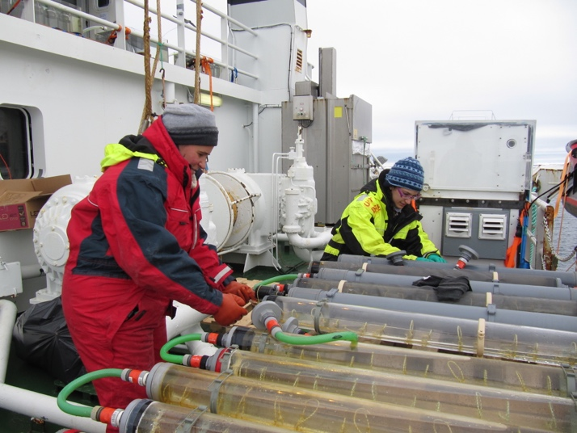

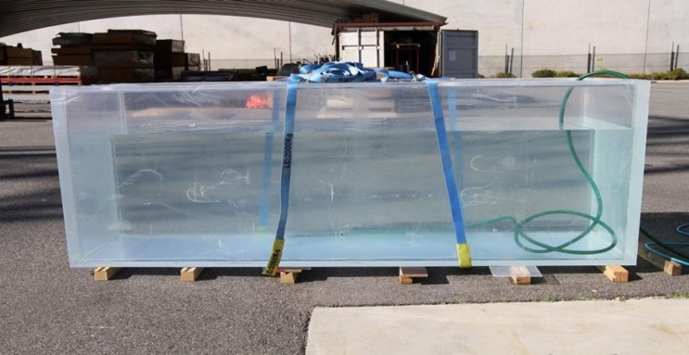

**Figure S1**: Images showing on-deck incubation systems employed during May and August. Top: incubation system employed for the O2 methods. Bottom: incubators employed for the 14C incubations. Incubators were fed with water from the ship’s flow through system, with 14C incubators placed on deck above O2 incubators (see top image).

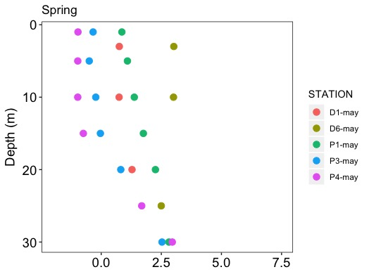

**Figure S2**: Temperature profiles (°C) at sampling stations during May 2014. Circles indicate the depths of sample collection. Running seawater for incubations originated from 6 m depth.



**Figure S3**: Same as Figure S2 for August 2014 sampling



**Figure S4** – Profiles of volumetric productivity rates analyzed in this study for stations sampled during the May 2014 cruise for 14C-POC (black circle), 14C-TOC (red circle), GPP-DO (blue circle), and GPP-18O (orange circle), expressed in mmol C or O2 m-3 d-1. Sampling locations are shown in Fig. 1. Points and error bars indicate mean ± SE in all panels. Rectangles identify the depths where concurrent determinations were taken.

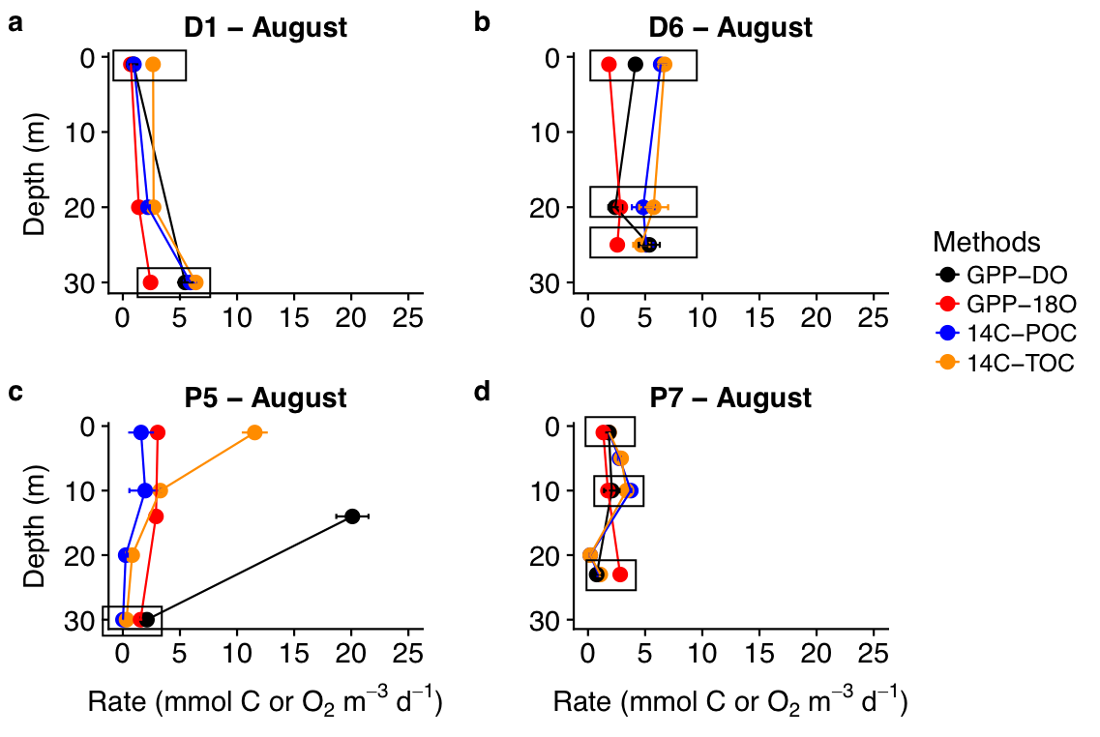

**Figure S5**: Same as Figure S4 for August incubations. Station P6 is not included as no GPP-DO determinations are available.

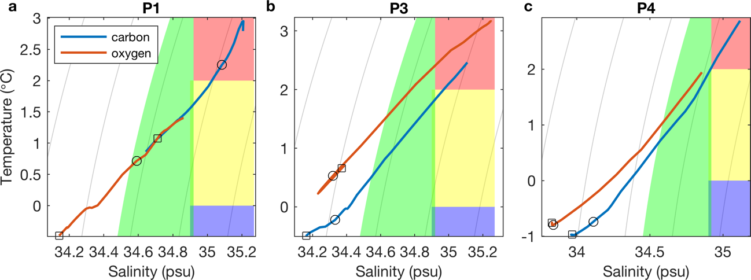

**Figure S6**: Temperature-salinity diagrams for the upper 30 m of stations a) P1, b) P3, and c) P4 sampled during May 2014. Curves correspond to CTD profiles sampled for 14C methods (blue) and O methods (red), with grey lines denoting isopycnals. From all the samples considered, the square and circle symbols denote the physical properties associated with matching samples included in this study. Color patches indicate water masses as defined for the May and August cruises in Randelhoff *et al*. (2018). These include Atlantic Water (red; salinity S > 34.92 and T > 2 ºC), cold Atlantic Water (yellow; 0 < T < 2 ºC, S > 34.9), Intermediate Water (blue; T < 0 ºC, S > 34.9), Arctic Water (green; density ρθ > 27.7 kg m-3, S < 34.92), and surface water (white). Please note the change in axes.

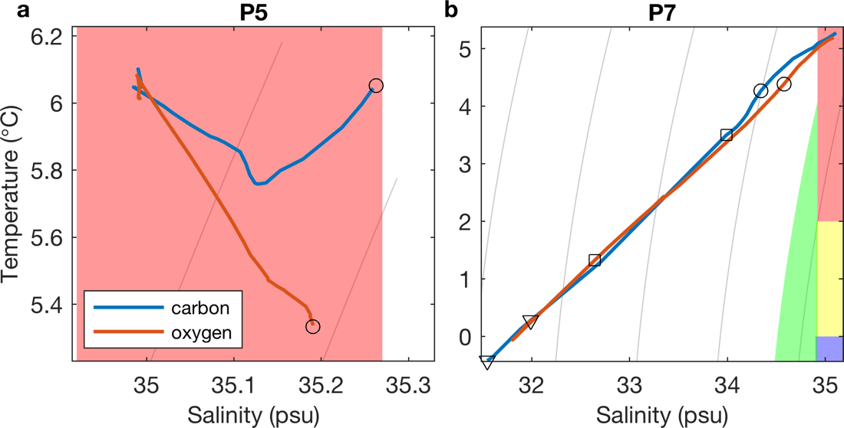

**Figure S7**: Same as Fig. S6 for stations sampled in August. Please note changes in axis with respect to Figure S6.

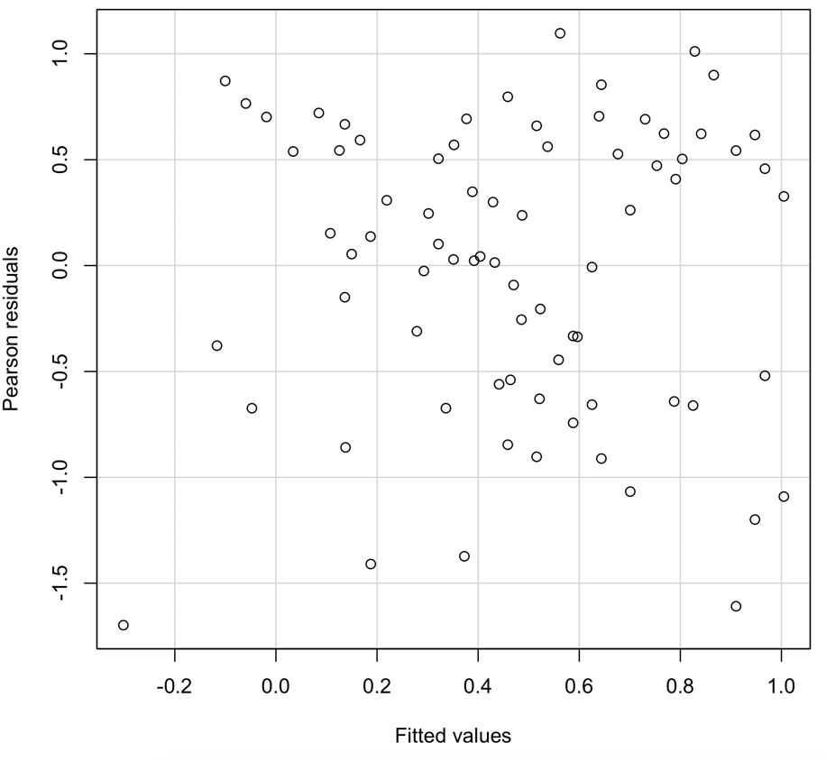

**Figure S8** – Residuals of 4-way ANOVA (linear model), with treatments including methods, seasons, depths, and casts and with log10 PP rates as the response variable.

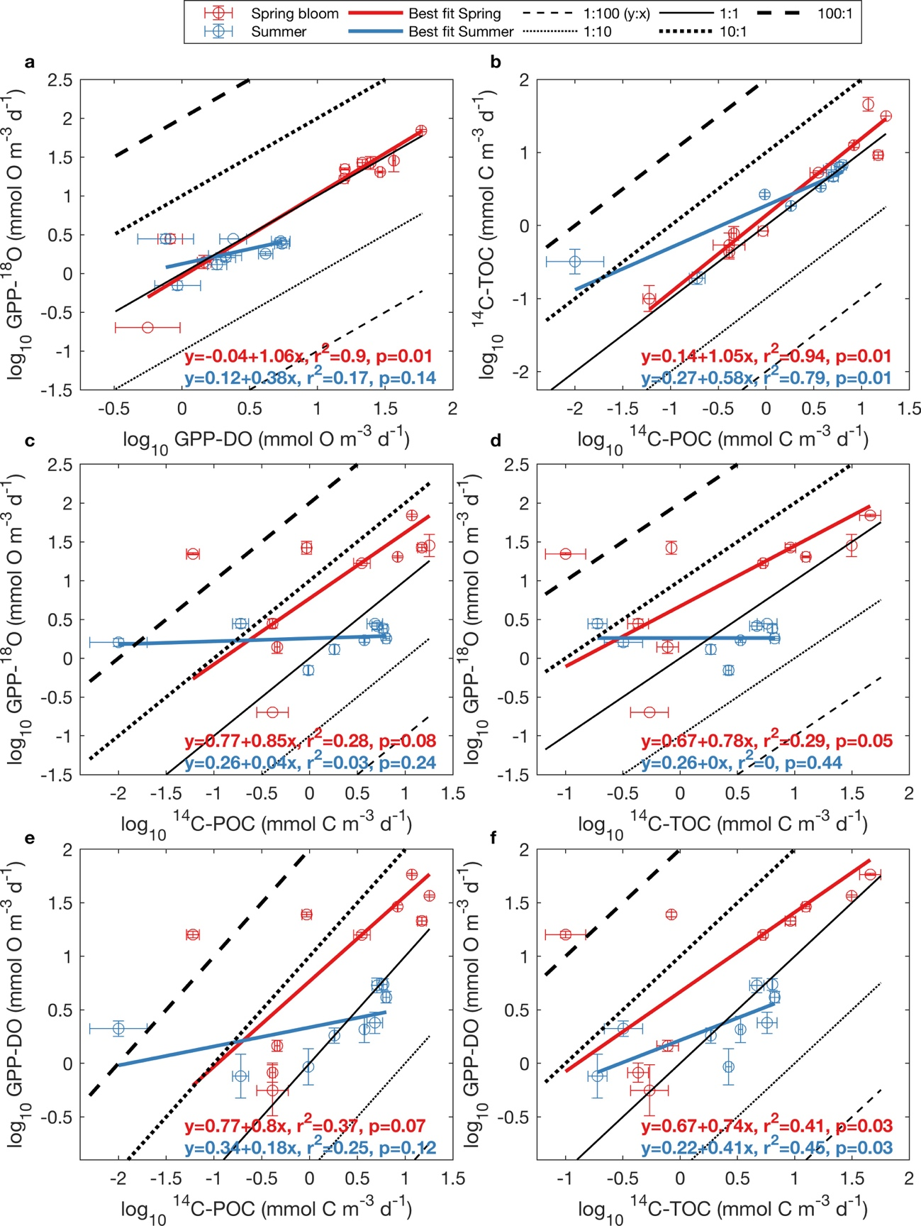

**Figure S9** - Log-log relationship between oxygen- and carbon-based methods for May (red dots and red lines) and August (blue dots and blue lines), presented as average + standard error for each depth (Fig. 2). a) GPP-18O vs GPP-DO, b) 14C-TOC vs 14C-POC, c) GPP-18O vs 14C-POC, d) GPP-DO vs 14C-POC, e) GPP-18O vs 14C-TOC and f) GPP-DO vs 14C-TOC. All rates are volumetric in units of mmol O m-3 d-1 for oxygen and mmol C m-3 d-1 for carbon. Black and grey lines represent ratios of y to x ranging from 1:100 to 100:1, with the solid black line indicating a 1:1 relationship. p-values correspond to permutational probabilities on the slope. Note the change in scale in the Y-axes.

**Table S1:** Database of the PP volumetric data measured with the 14C method, the O2 mass balance method and the 18O method during May and August 2014 at different depths. The data includes all depths used in the comparison analyses. Samples collected in P1 originated from different water masses (Fig. S6a). This station was omitted from the comparison analysis.



**Table S2:** Shapiro-Wilk test to assess the normality of the log10-transformed PP rates during May, August and for all of our data (both May and August). The acronyms of the PP rates are listed in Table 1. Asterisk (*) indicates a significance p-value (p < 0.05).



**Table** S3: Reduced major axis regression results relating log10-transformed primary production data derived from different methods. Equations are of the form log10 y = a + b log10 x, where a and b represent the slope and intercept respectively. Confidence intervals on the slope and intercept (2.5 % and 97.5%) are indicated in parentheses. Regressions for which the slope and intercept confidence intervals do not include 1 and 0 respectively are indicated by bold font. p-values for 2-tailed tests of significance of the correlation coefficient (r) are indicated by p (corr coeff), while permutational probabilities p on the slope are shown under p (slope, perm).

