**Supporting Information**

**Three new phenylspirodrimane derivatives with inhibitory effect towards potassium channel Kv1.3 from the fungus *Stachybotrys chartarum***

Jia-Min Feng a, b, Min Li a, Jin-Lian Zhao a, b, Xiao-Na Jia a,b, Ji-Mei Liu a, b, Min Zhang a, b, Ri-Dao Chen a, b, Ke-Bo Xie a, b, Da-Wei Chen a, b, Hai-Bo Yu a, *, and Jun-Gui Dai a, b *

a State Key Laboratory of Bioactive Substance and Function of Natural Medicines, and b Key Laboratory of Biosynthesis of Natural Products of National Health Commission, Institute of Materia Medica, Chinese Academy of Medical Sciences and Peking Union Medical College, Beijing 100050, China

* Corresponding authors. Tel: +86-10-63035173, Fax: +86-10-63017757, E-mail address: haiboyu@imm.ac.cn (H., Yu); Tel: +86-10-63165195; fax: +86-10-63017757, E-mail address: jgdai@imm.ac.cn (J., Dai)

**Table of Contents**

Figure S1. 1H NMR spectrum of compound 1 in acetone-*d*6at 500 MHz S4

Figure S2. 13C NMR spectrum of compound 1 in acetone-*d*6 at 125 MHz S4

Figure S3. DEPT spectrum of compound 1 in acetone-*d*6 at 125 MHz S5

Figure S4. 1H−1H COSY spectrum of compound 1 in acetone-*d*6 S5

Figure S5. HSQC spectrum of compound 1 in acetone-*d*6 S6

Figure S6. HMBC spectrum of compound 1 in acetone-*d*6 S6

Figure S7. NOE difference spectrum of compound 1 in acetone-*d*6 S7

Figure S8. HR-ESI-MS spectra of compound 1 S8

Figure S9. IR spectrum of compound 1 S8

Figure S10. UV spectrum of compound 1 S9

Figure S11. ECD spectrum of compound 1 S10

Figure S12. 1H NMR spectrum of compound 2 in acetone-*d*6at 600 MHz S11

Figure S13. 13C NMR spectrum of compound 2 in acetone-*d*6 at 150 MHz S11

Figure S14. DEPT spectrum of compound 2 in acetone-*d*6at 150 MHz S12

Figure S15. 1H−1H COSY spectrum of compound 2 in acetone-*d*6 S12

Figure S16. HSQC spectrum of compound 2 in acetone-*d*6 S13

Figure S17. HMBC spectrum of compound 2 in acetone-*d6* S13

Figure S18. NOE difference spectrum of compound 2 in acetone-*d6* S14

Figure S19. HR-ESI-MS spectra of compound 2 S15

Figure S20. IR spectrum of compound 2 S15

Figure S21. UV spectrum of compound 2 S16

Figure S22. ECD spectrum of compound 2 S17

Figure S23. 1H NMR spectrum of compound 3 in acetone-*d*6at 600 MHz S18

Figure S24. 13C NMR spectrum of compound 3 in acetone-*d*6at 150 MHz S18

Figure S25. DEPT spectrum of compound 3 in acetone-*d*6at 150 MHz S19

Figure S26. 1H−1H COSY spectrum of compound 3 in acetone-*d*6 S19

Figure S27. HSQC spectrum of compound 3 in acetone-*d*6 S20

Figure S28. HMBC spectrum of compound 3 in acetone-*d*6 S20

Figure S29. NOE difference spectrum of compound 3 in acetone-*d6* S21

Figure S30. HR-ESI-MS spectra of compound 3 S22

Figure S31 IR spectrum of compound 3 S23

Figure S32. UV spectrum of compound 3 S24

Figure S33. ECD spectrum of compound 3 S25

Figure S34. ECD spectrum of compound 4 S26

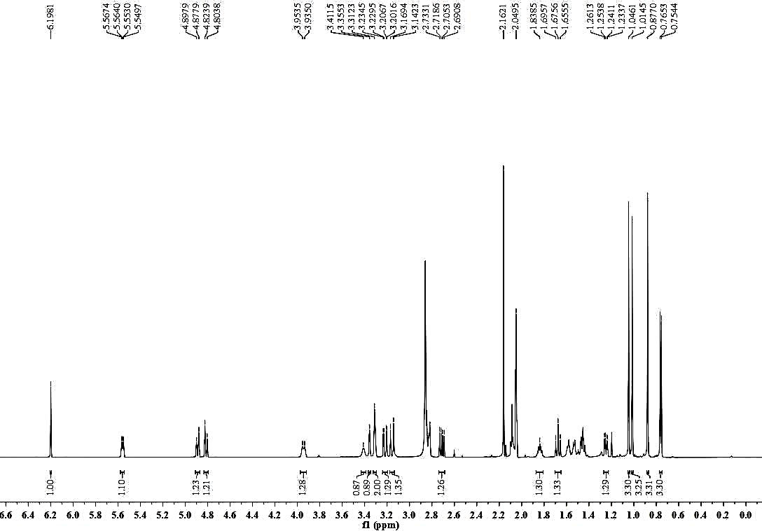**Figure S1**. 1H NMR spectrum of compound **1** in acetone-*d*6at 600 MHz



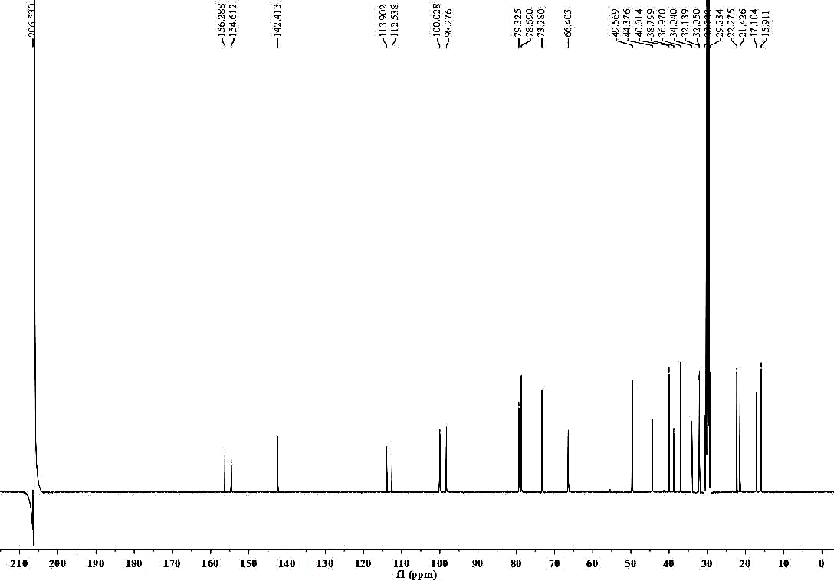



**Figure S2**. 13C NMR spectrum of compound **1** in acetone-*d*6 at 150 MHz

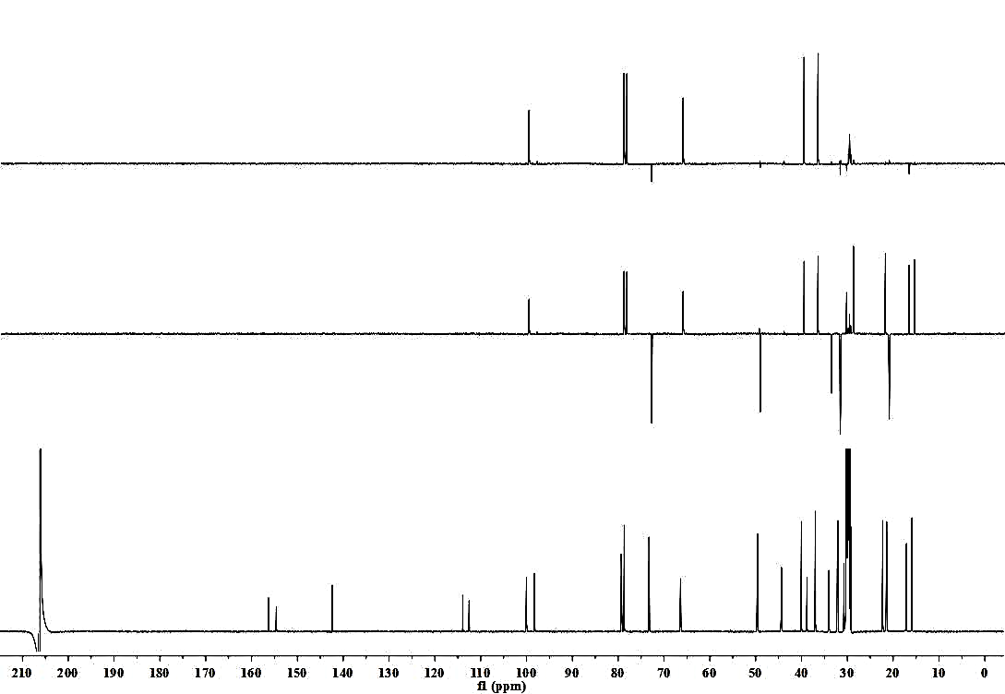



**Figure S3**. DEPT spectrum of compound **1** in acetone-*d*6at 150 MHz

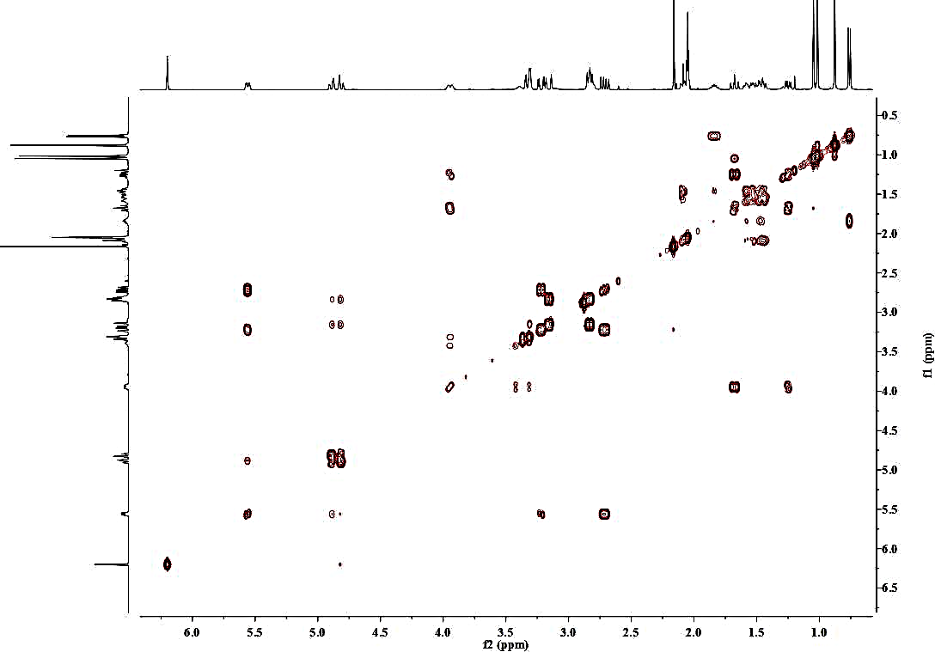



**Figure S4**. 1H-1H COSY spectrum of compound **1** in acetone-*d*6

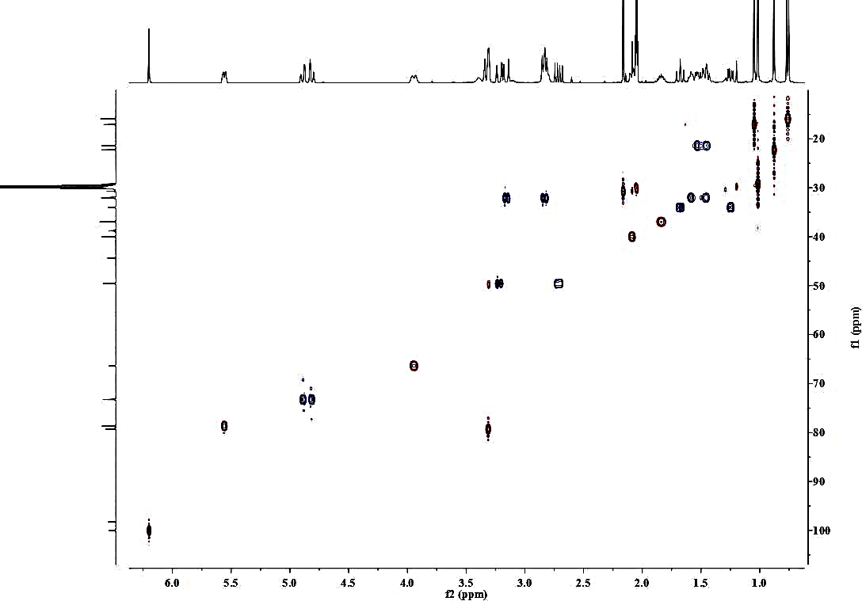



**Figure S5**. HSQC spectrum of compound **1** in acetone-*d*6

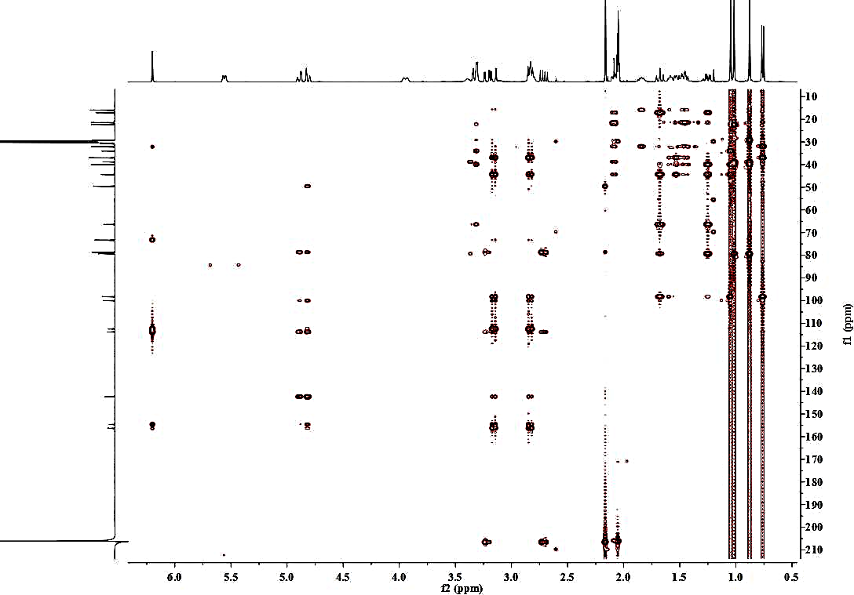



**Figure S6**. HMBC spectrum of compound **1** in acetone-*d*6

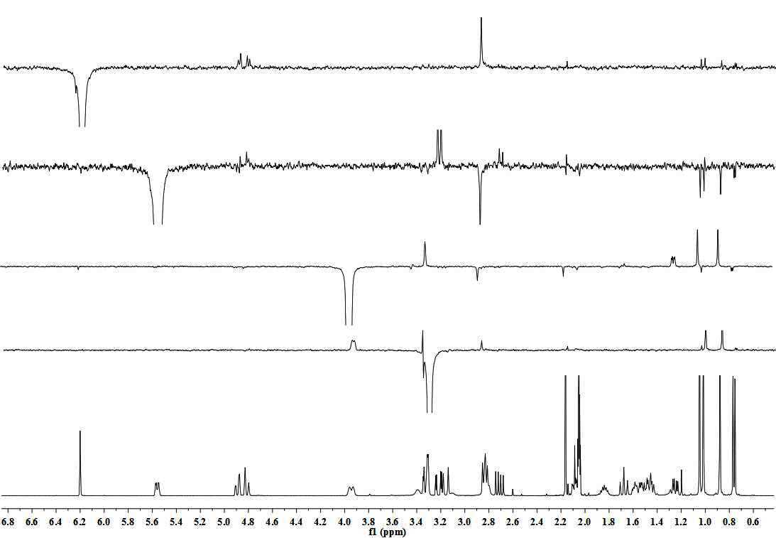



H2-1a

H3-15

H2-7’

H-3’

H-9’b

H-8’

H3-14

H-3

H-2

H3-14

H3-13

H-3

H3-14

H3-15

H3-12

H3-15

H3-15

H3-14

**Figure S7**. NOE difference spectrum of compound **1** in acetone-*d*6

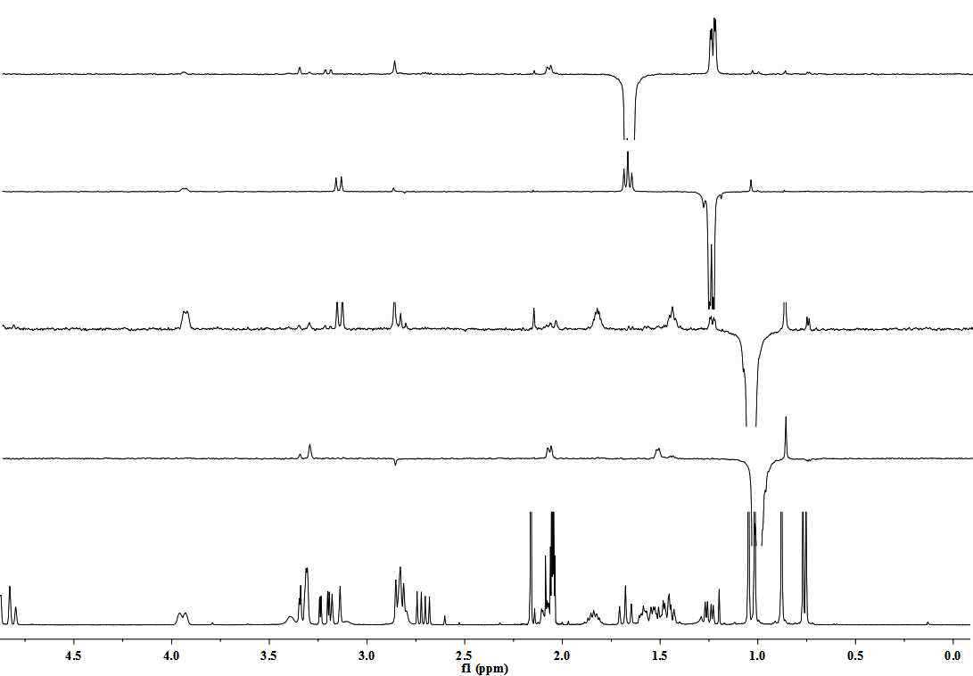



H-5

H-3

H3-14

H3-13

H-8

H-11b

H-11b

H-2

H3-14

H3-15

H3-15

H2-1b

H2-1a

H-5

H2-1a

H2-1b

**Figure S7**. NOE difference spectrum of compound **1** in acetone-*d*6





**Figure S8**. HR-ESI-MS spectrum of compound **1**

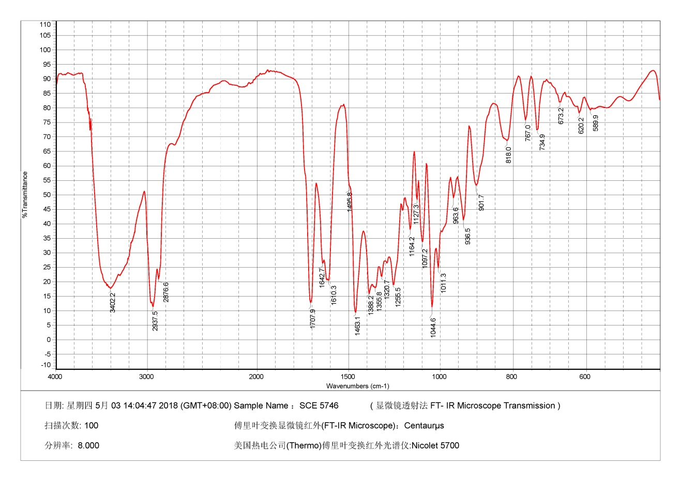



**Figure S9**. IR spectrum of compound **1**

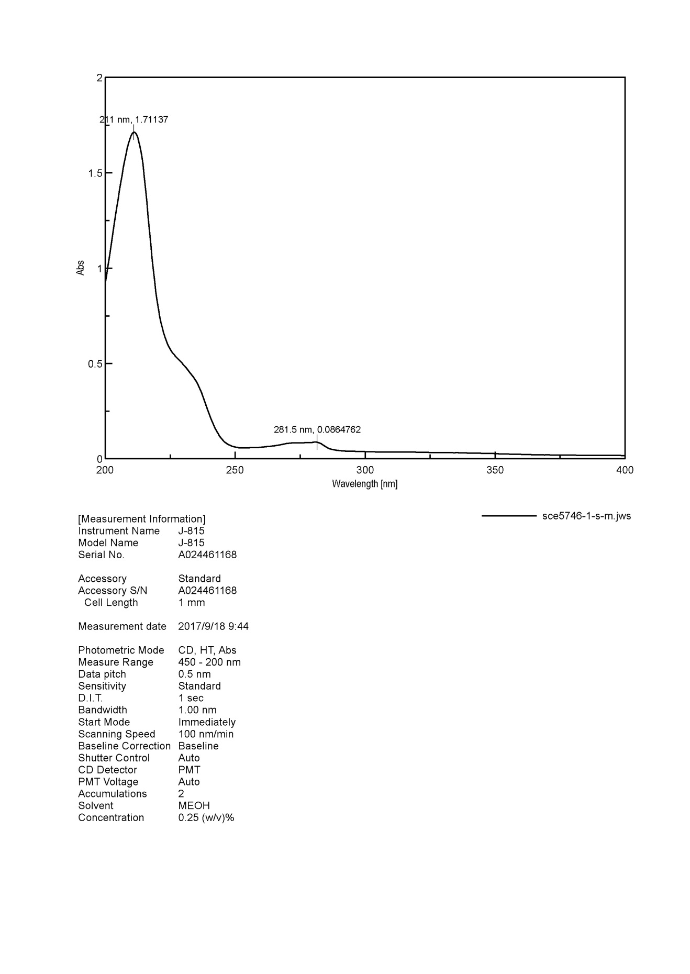



**Figure S10**. UV spectrum of compound **1**

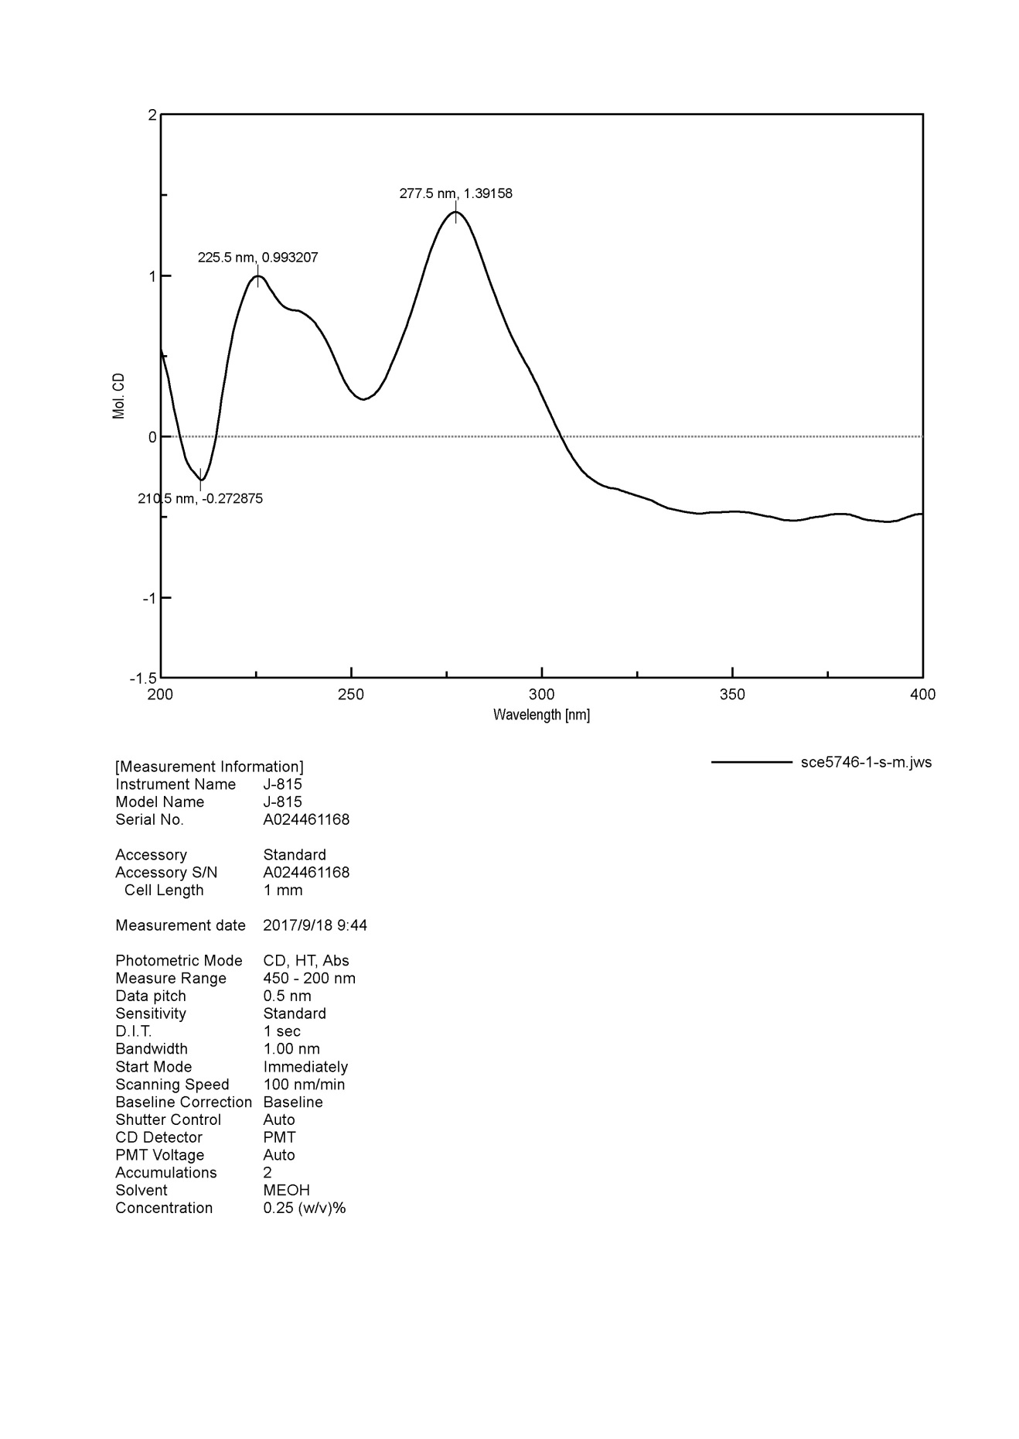



**Figure S11**. ECD spectrum of compound **1**

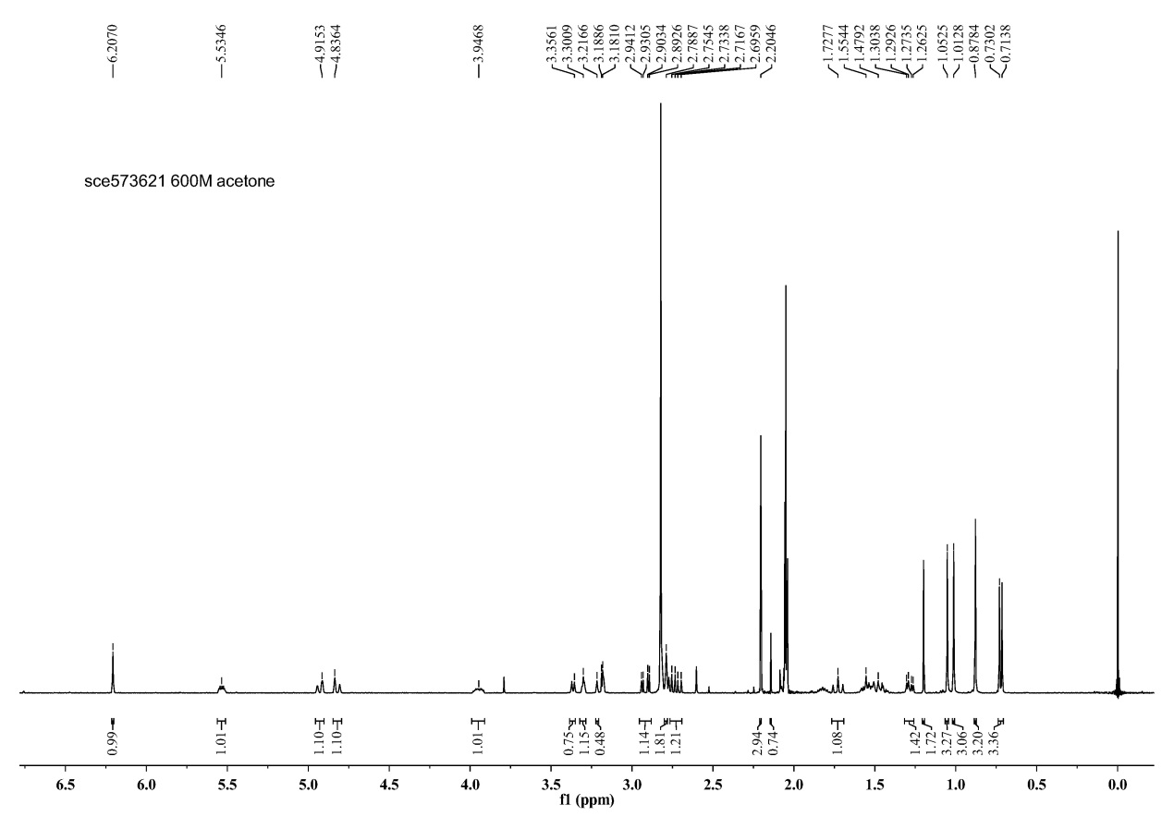



**Figure S12.** 1H NMR spectrum of compound **2** in acetone-*d*6 at 600 MHz

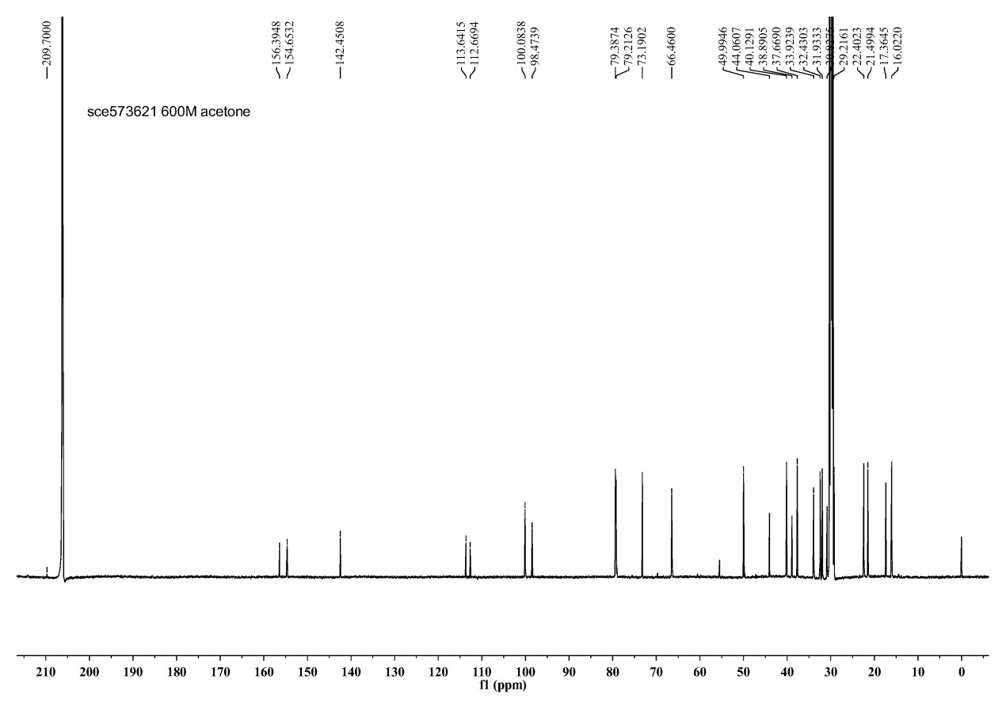



**Figure S13**. 13C NMR spectrum of compound **2** in acetone-*d*6 at 125 MHz

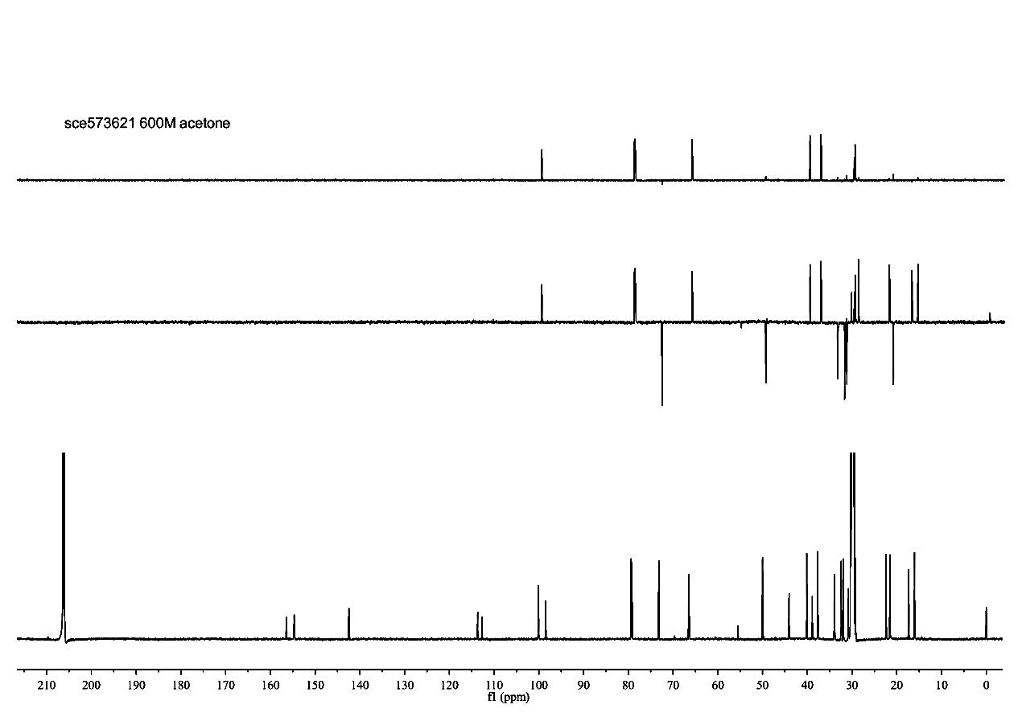



**Figure S14**. DEPT spectrum of compound **2** in acetone-*d*6at 125 MHz

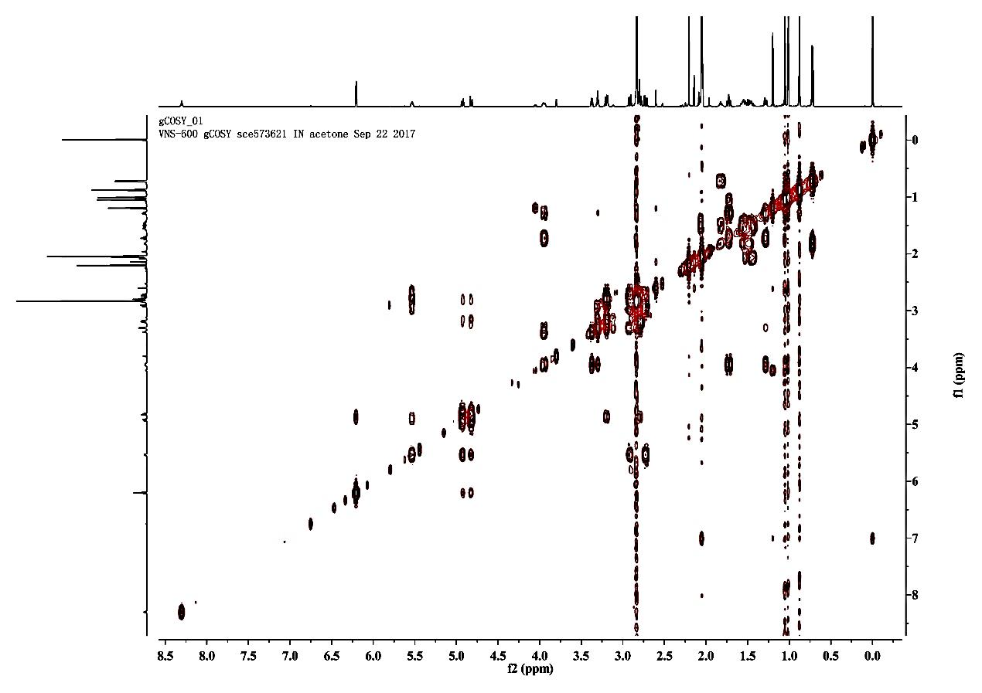



**Figure S15**. 1H−1H COSY spectrum of compound **2** in acetone-*d*6

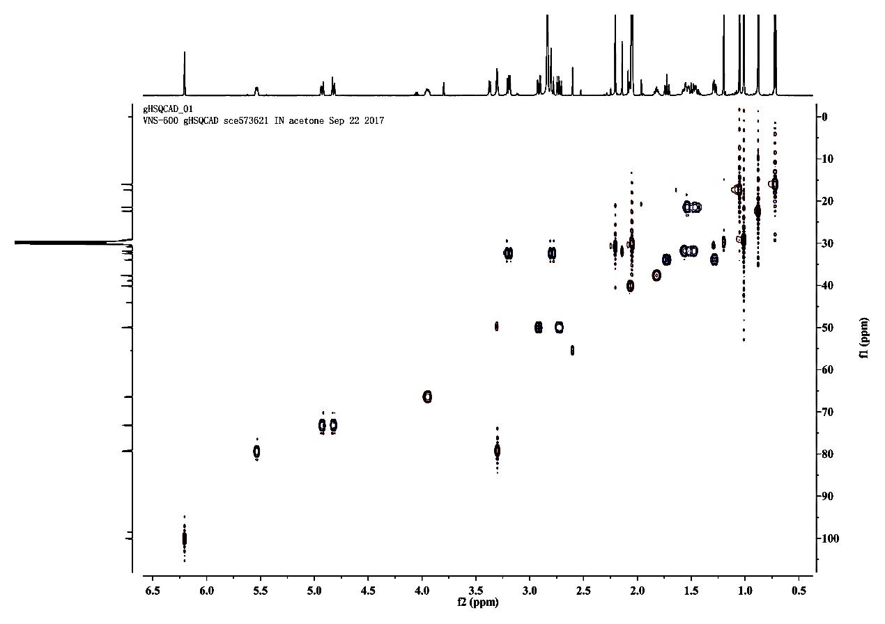



**Figure S16**. HSQC spectrum of compound **2** in acetone-*d*6

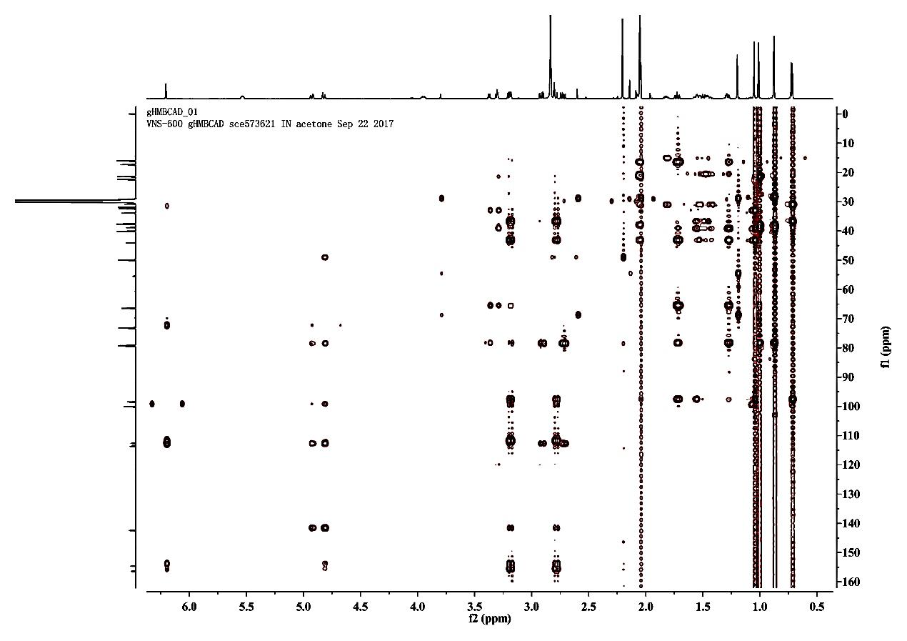



**Figure S17**. HMBC spectrum of compound **2** in acetone-*d*6

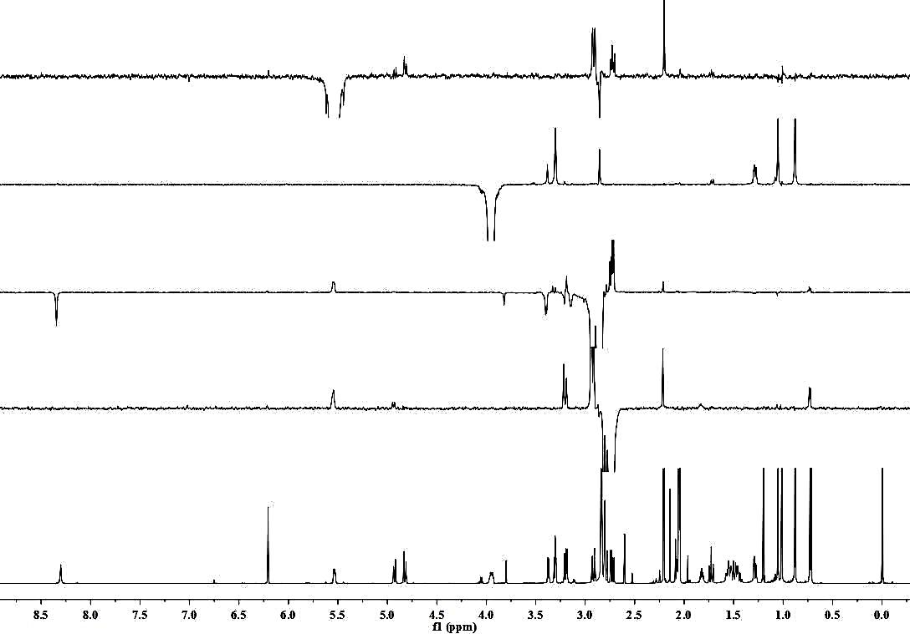



H2-1a

H3-12

H-8’

H2-9’b

H2-9’a

H-8’

H2-9’a

H2-9’b

H3-14

H3-15

H-3

H-2

H3-11’

H2-9’

H2-7’

H-8’

**Figure S18**. NOE difference spectrum of compound **2** in acetone-*d*6

H2-1a

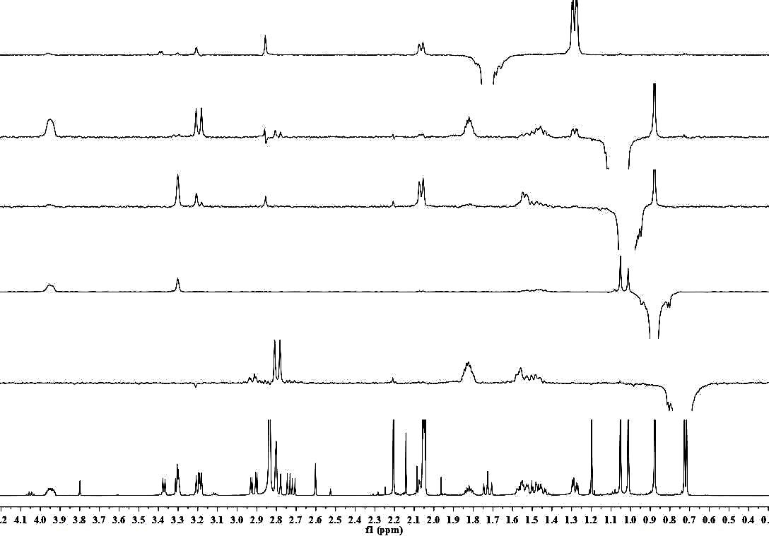



H-8

H2-11a

H2-11b

H3-12

H3-14

H-2

H-2

H-3

H3-15

H3-14

H3-13

H-5

H3-14

H3-15

H-8

H2-1b

H-5

**Figure S18**. NOE difference spectrum of compound **2** in acetone-*d*6

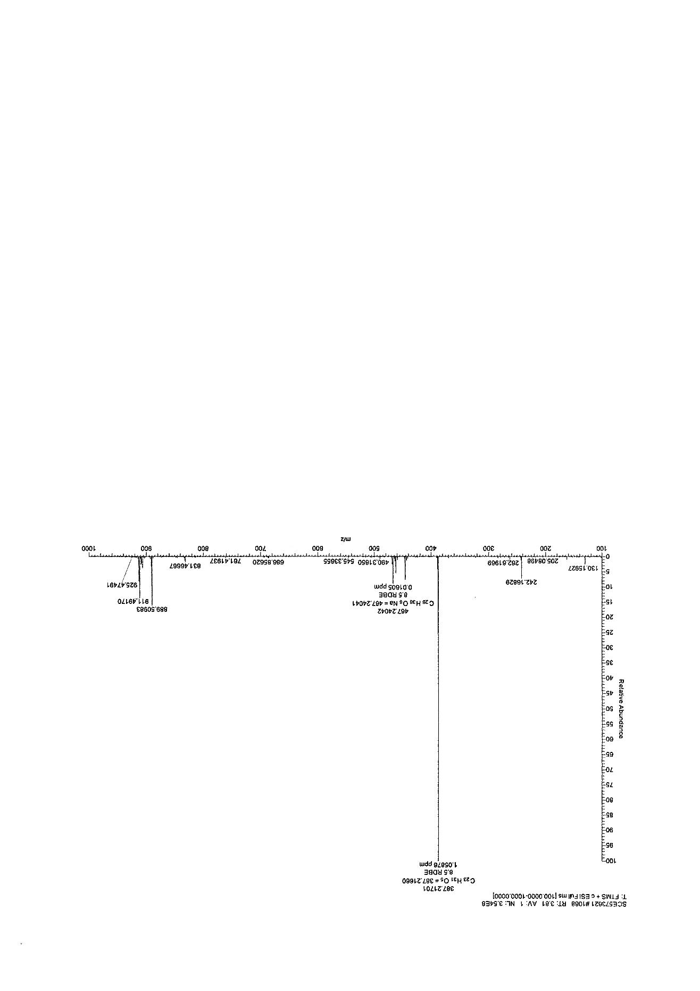



**Figure S19**. HR-ESI-MS spectrum of compound **2**

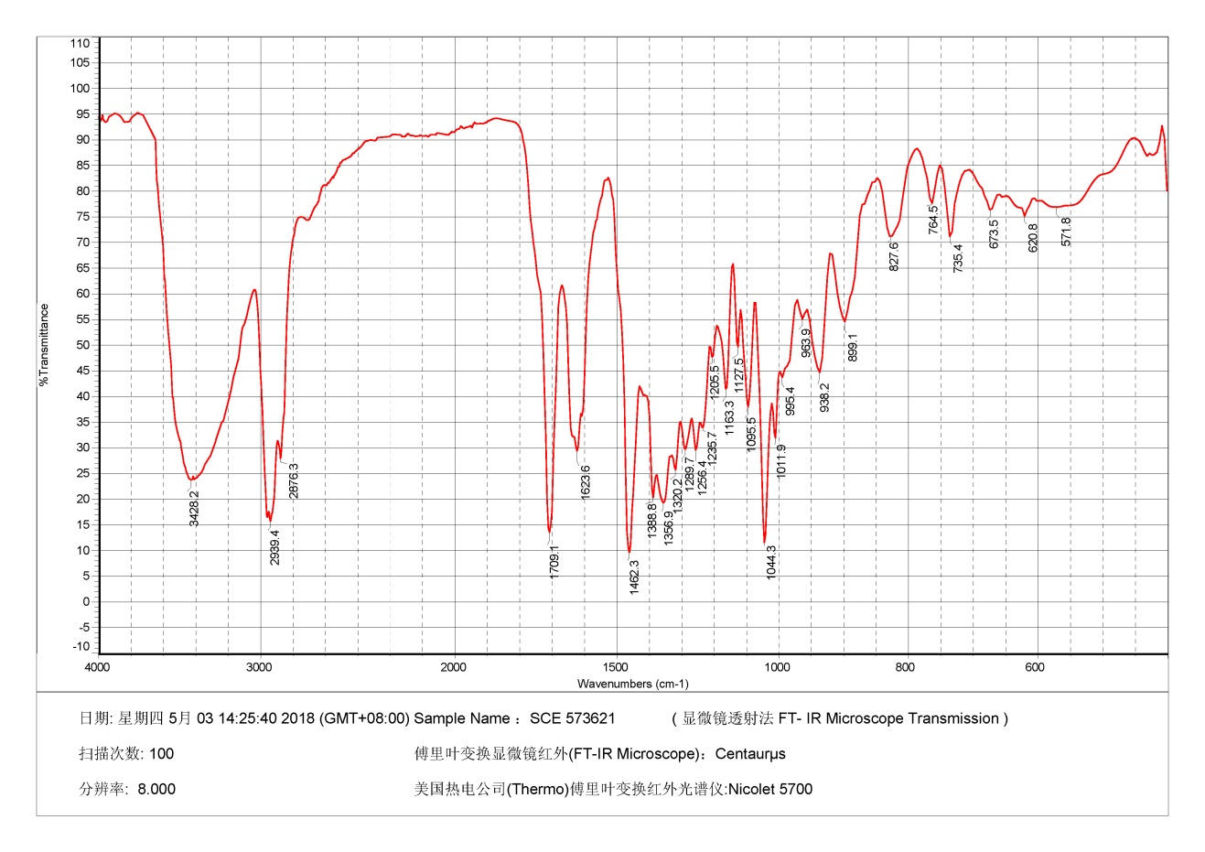



**Figure S20**. IR spectrum of compound **2**

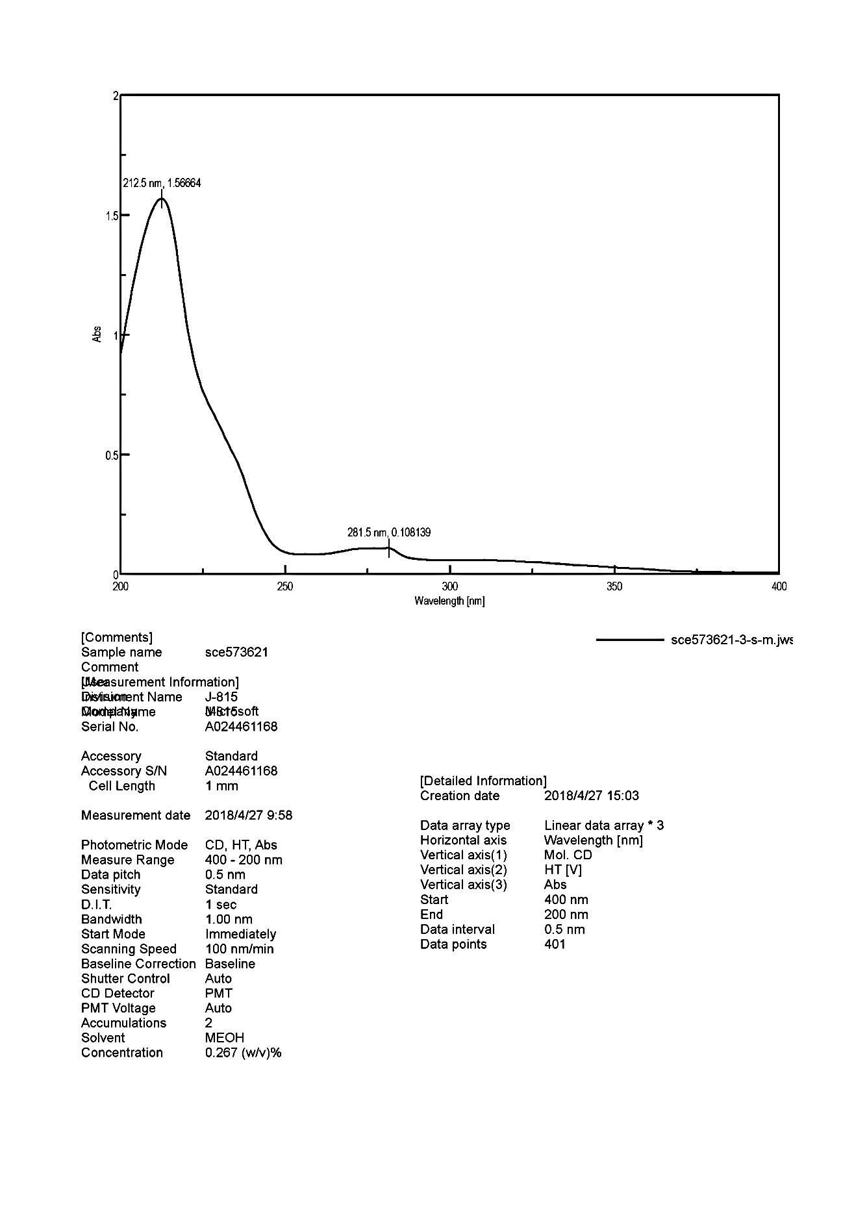



**Figure S21**. UV spectrum of compound **2**

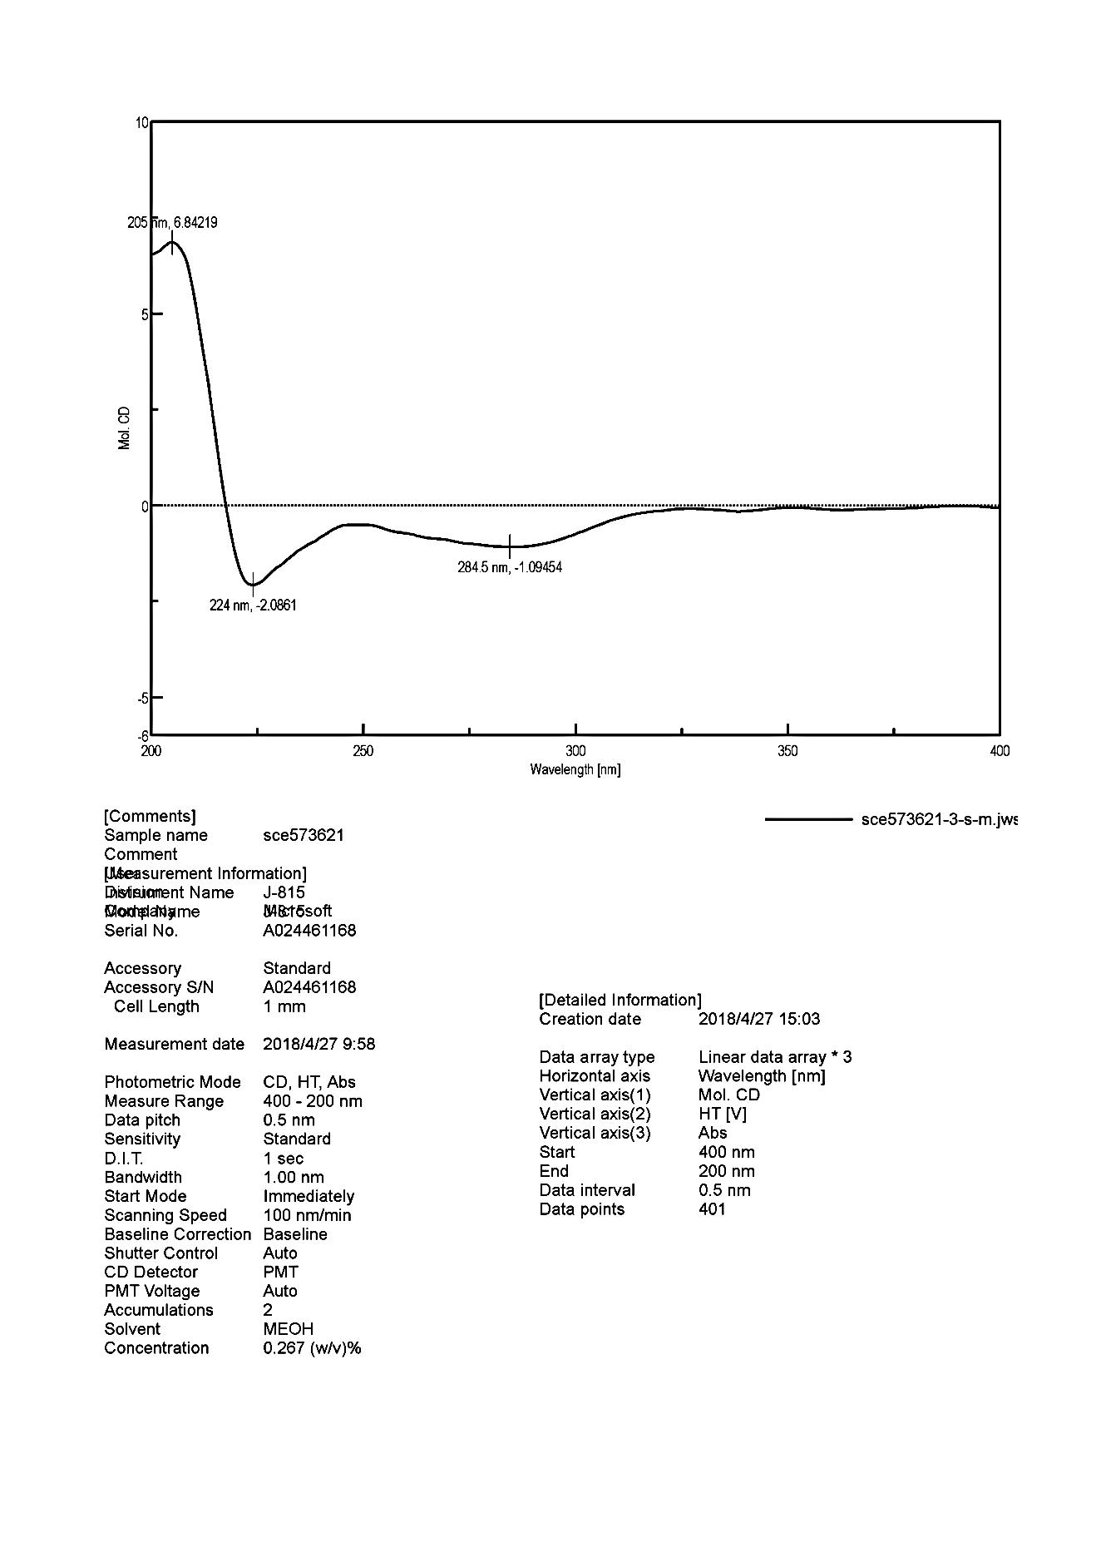



**Figure S22**. ECD spectrum of compound **2**

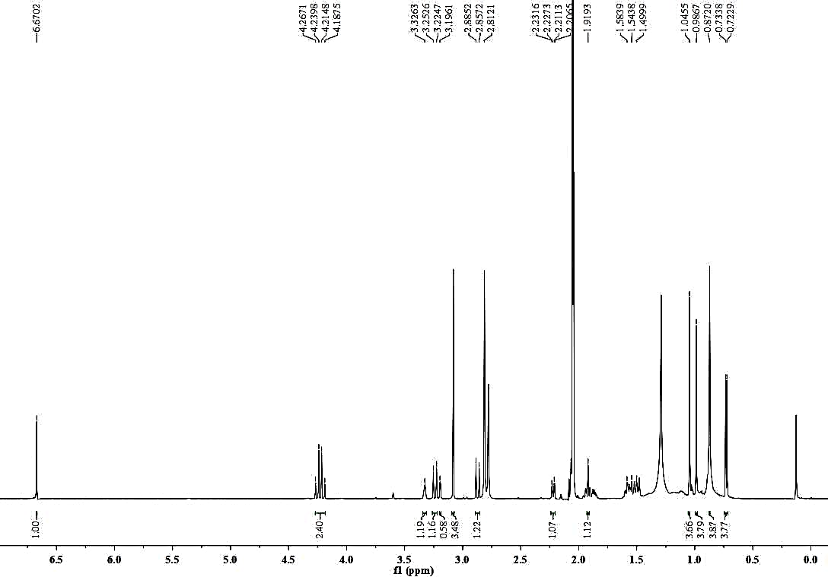



**Figure S23**. 1H NMR spectrum of compound **3** in acetone-*d*6at 600 MHz

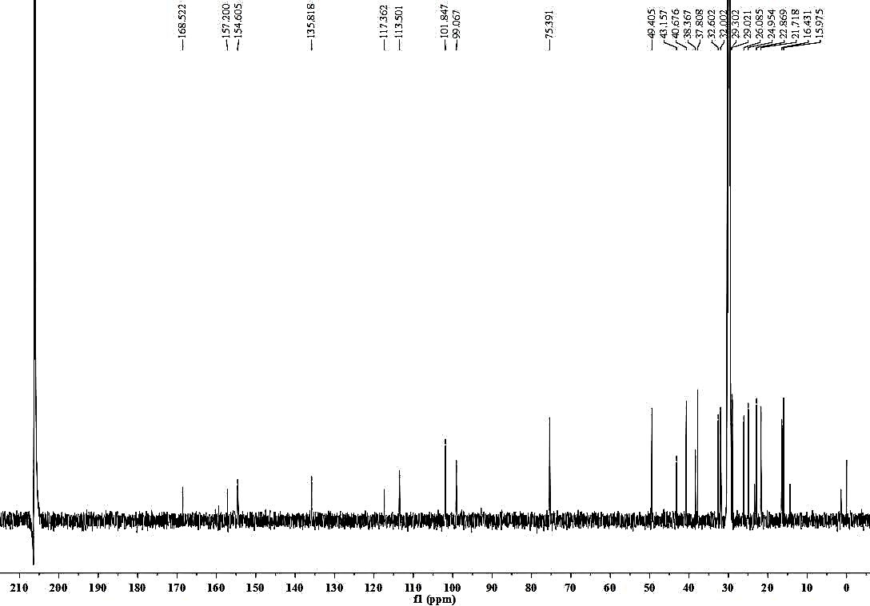



**Figure S24**. 13C NMR spectrum of compound **3** in acetone-*d*6at 150 MHz

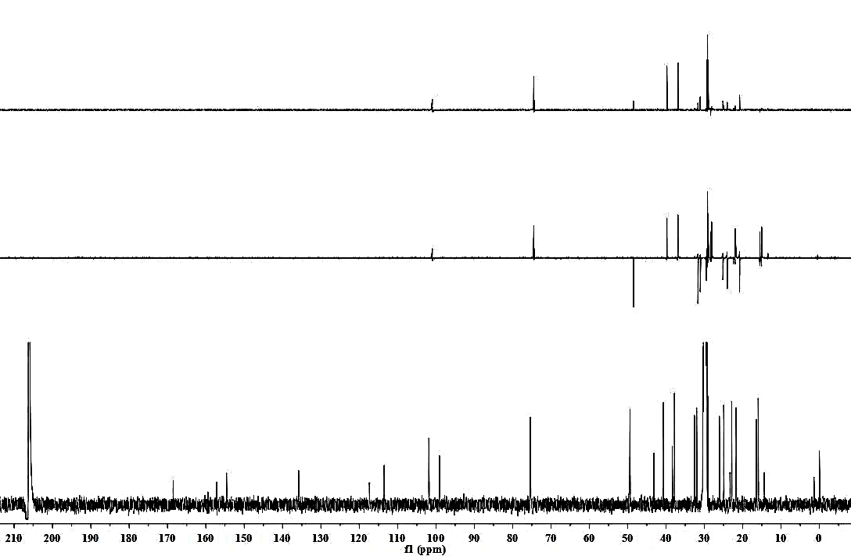



**Figure S25**. DEPT spectrum of compound **3** in acetone-*d*6at 150 MHz

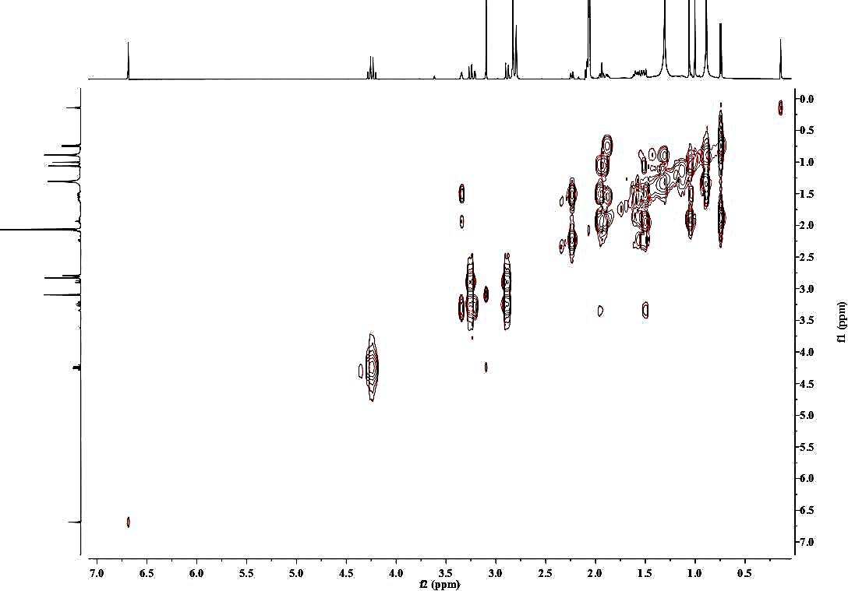



**Figure S26**. 1H-1H COSY spectrum of compound **3** in acetone-*d*6

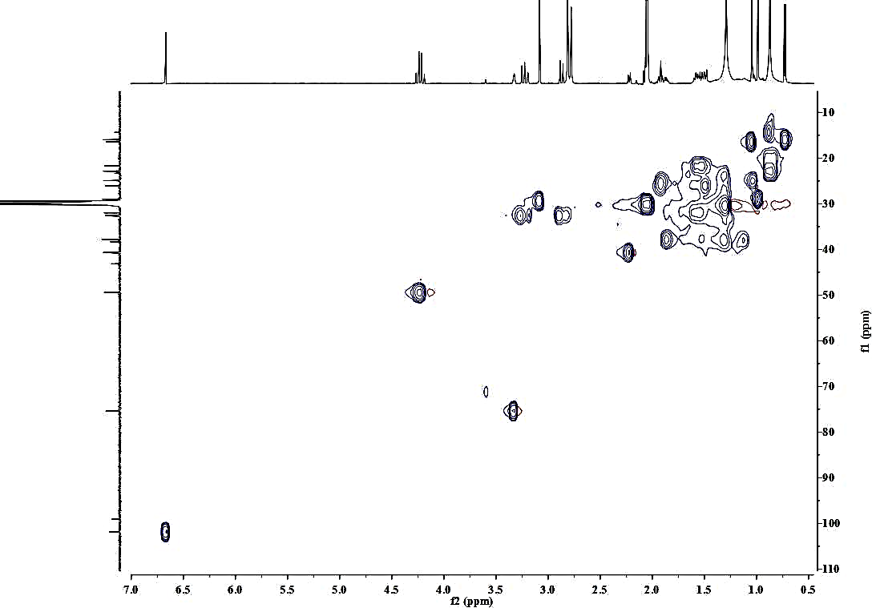



**Figure S27**. HSQC spectrum of compound **3** in acetone-*d*6

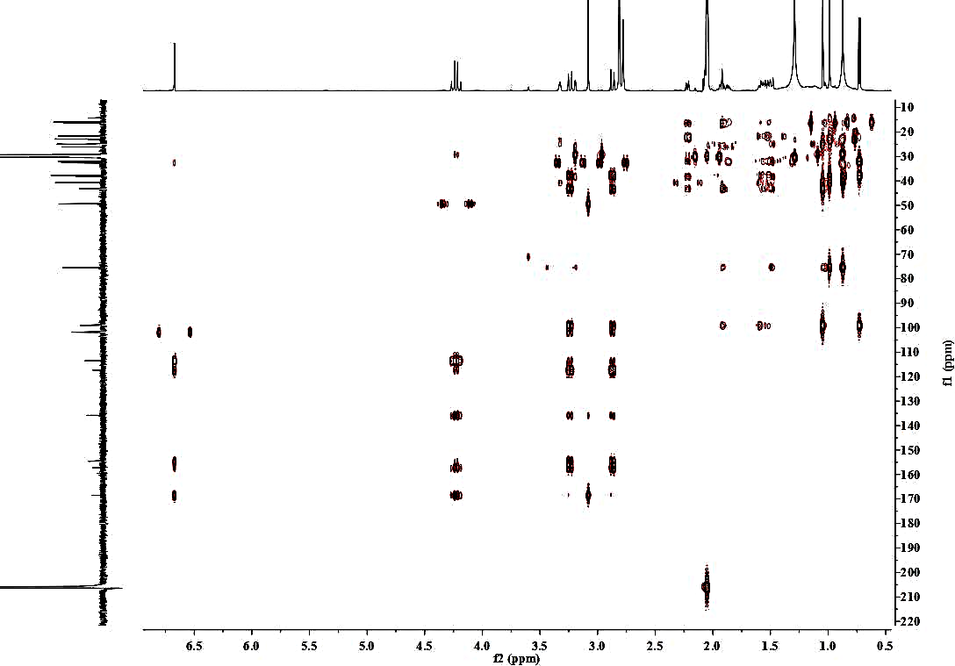



**Figure S28**. HMBC spectrum of compound **3** in acetone-*d*6

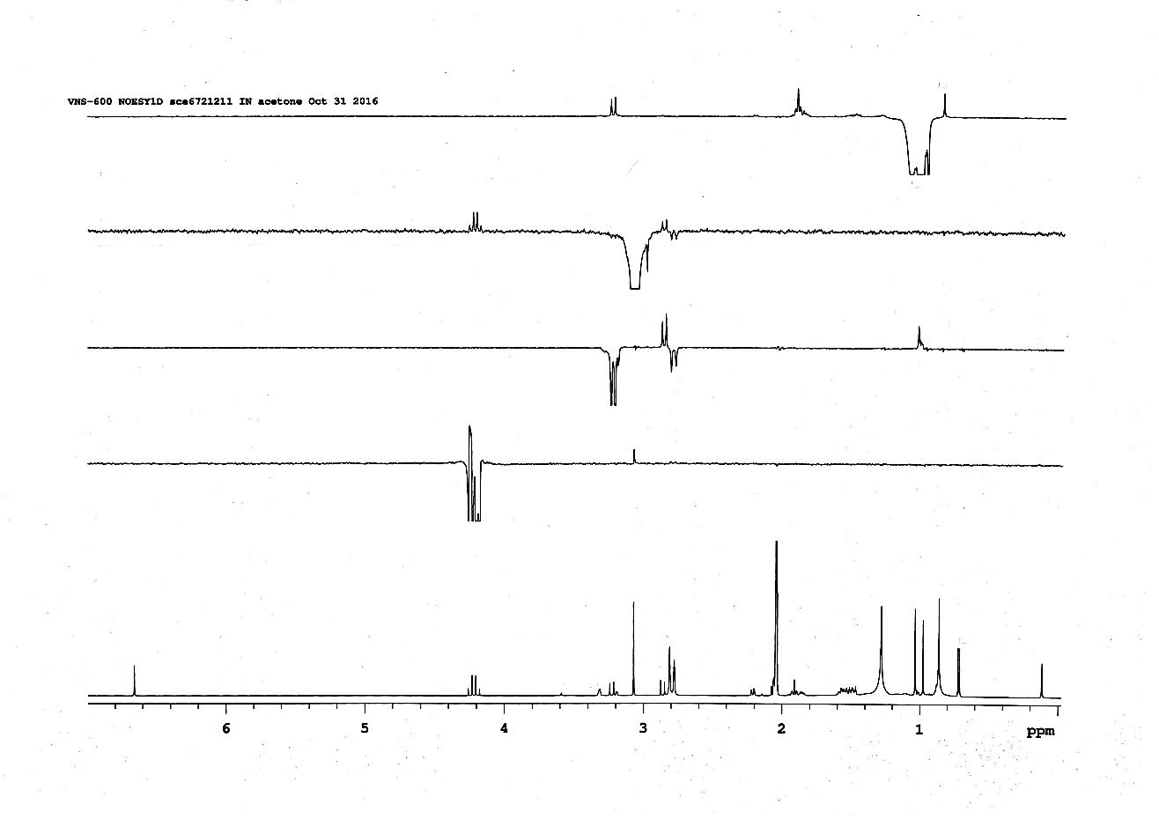



H2-11b

H3-14

H3-15

H2-8’

H3-9’

H3-15

H2-11a

H2-11b

H3-9’

H2-8’

**Figure S29**. NOE difference spectrum of compound **3** in acetone-*d*6

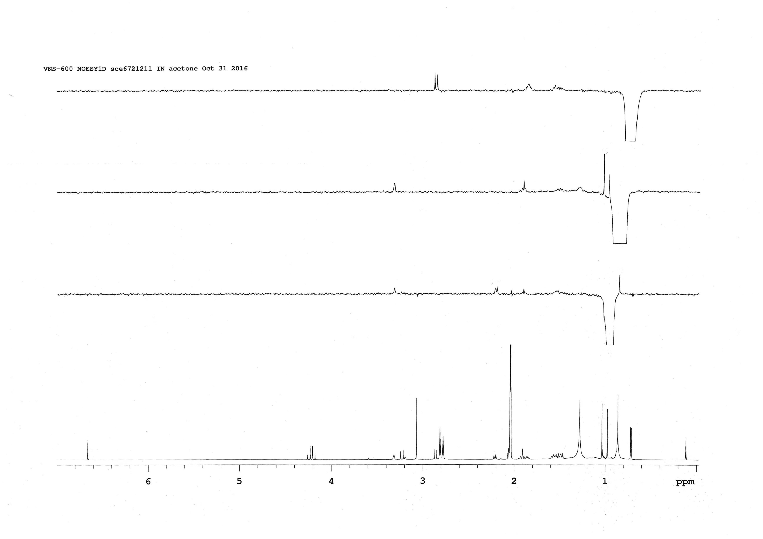



H2-11a

H3-12

H-3

H3-15

H3-14

H-5

H3-14

H3-13

**Figure S29**. NOE difference spectrum of compound **3** in acetone-*d*6

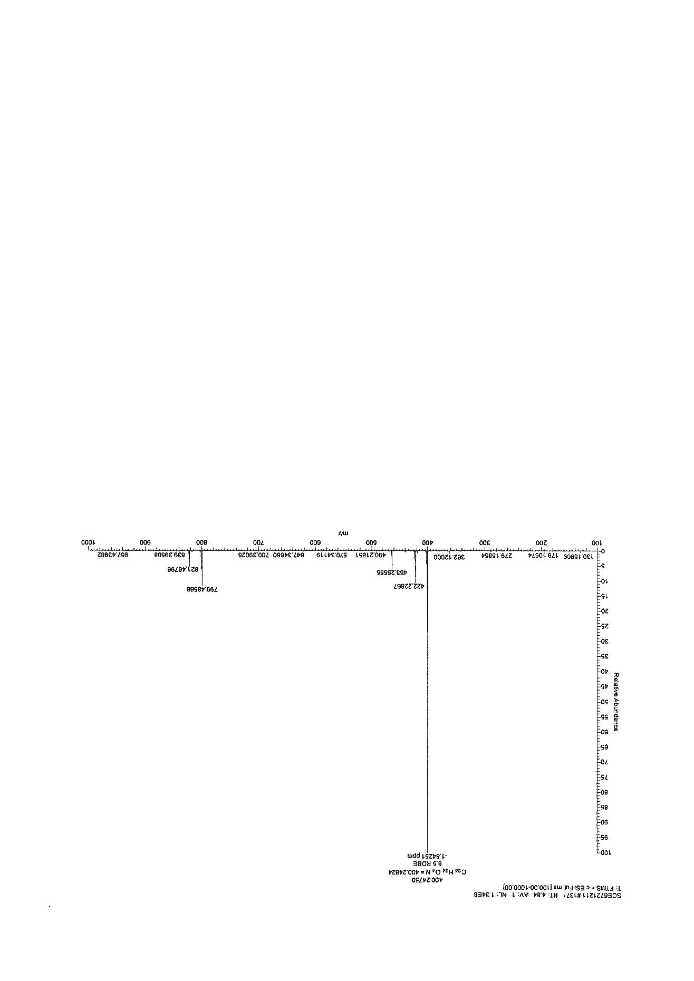



**Figure S30**. HR- ESI-MS spectrum of compound **3**

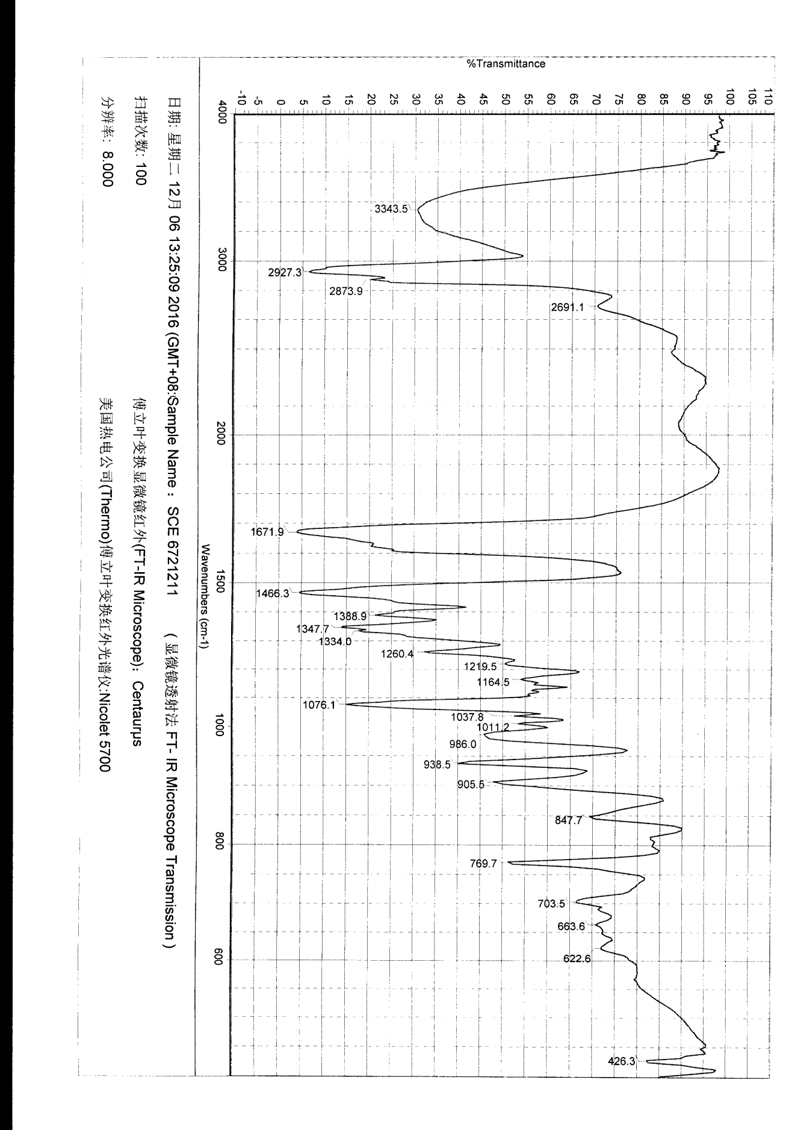



**Figure S31**. IR spectrum of compound **3**

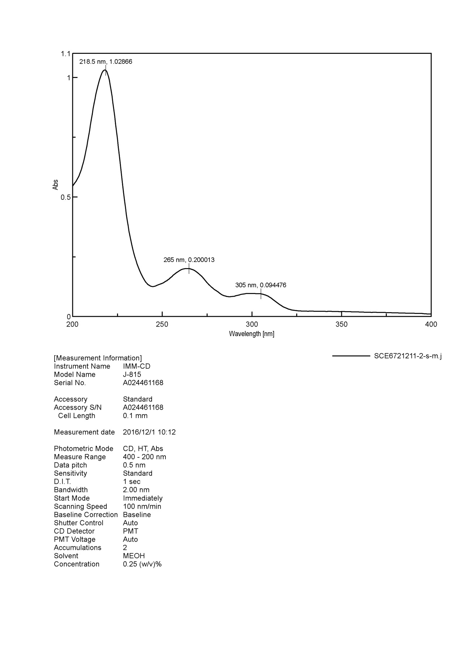



**Figure S32**. UV spectrum of compound **3**

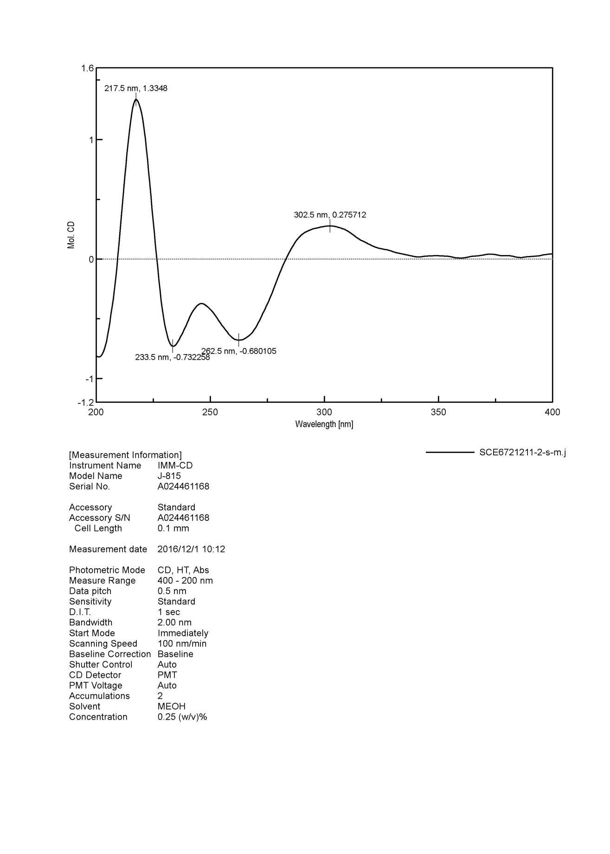



**Figure S33**. ECD spectrum of compound **3**

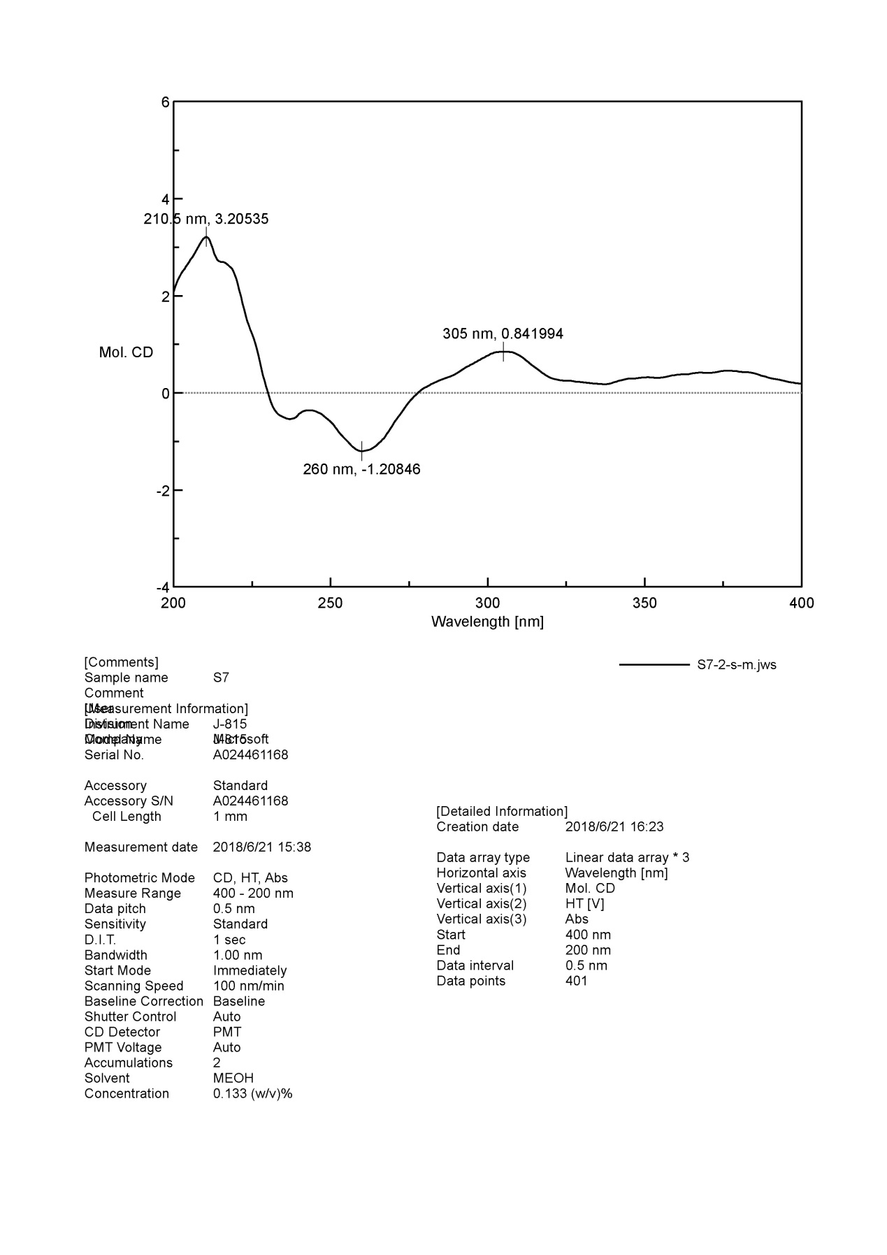



**Figure S34**. ECD spectrum of compound **4**