Longitudinal Change of Sleep Timing: Association between Chronotype and Longevity in Older Adults
Altug Didikoglu, Asri Maharani, Antony Payton, Neil Pendleton and Maria Merce Canal

Supplementary Materials
Figure S1: Longitudinal project timeline
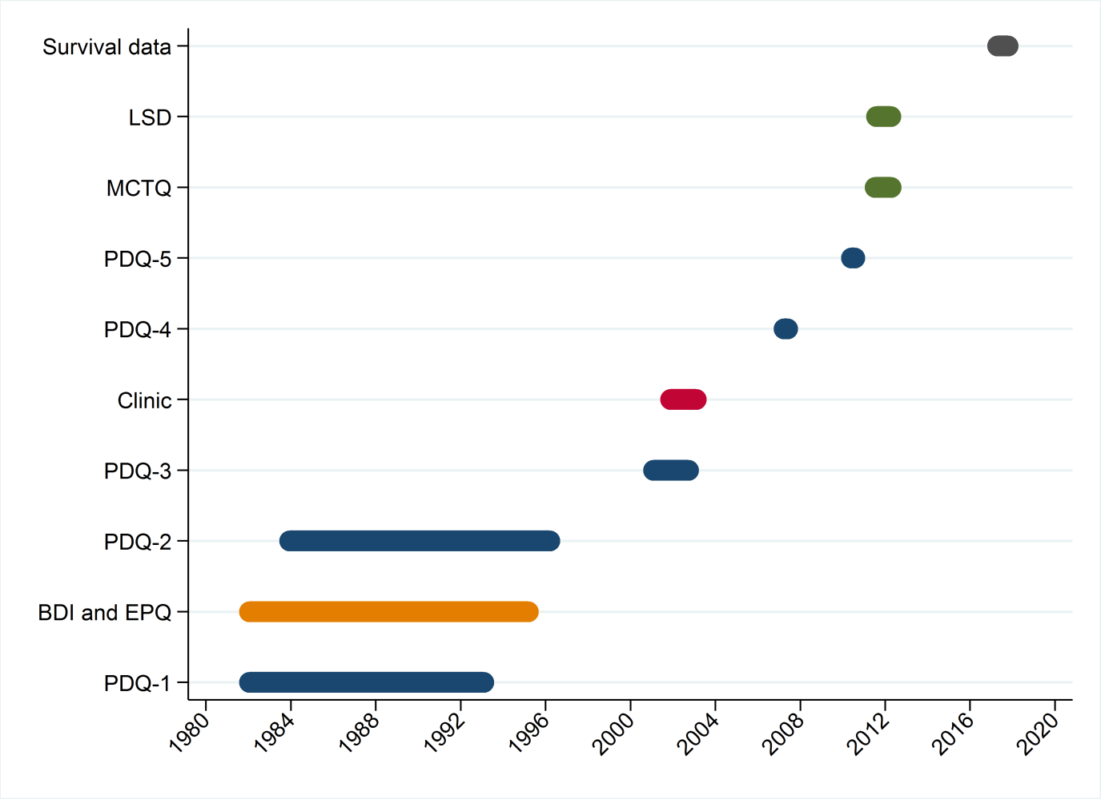
PDQ: Personal Details Questionnaire (blue)
BDI: Beck Depression Inventory (orange)
EPQ: Eysenck Personality Questionnaire (orange)
Clinical data (red)
MCTQ: Munich Chronotype Questionnaire (green)
LSD: Loughborough Sleep Diary (green)
NHS Death Certificates (grey)

Table S1: Outliers
Outliers were excluded if the data was out of ‘3*interquartile range’ or had coding error.
Getting up (n=10,459) | Going to bed (n=10,376) | Sleep duration (n=10,300)
4:30-11:00 (n=9) | 19:00-3:00 (n=9) | 2.5-12 (n=20)
12.50  11.50  4.25  4.00 X 4  3.50  2.50 | 18 X 3  4.5  4  3.75  3.5 X 3 | 20.00  2.00 X 13  1.50  1.00 X 5

Table S2: Personal Details Questionnaires – Time independent variables
 |  | wave-1
 |  | size(n) | freq.(%)
sex |  | 6371 | *
 | male | 1917 | 30.09
 | female | 4454 | 69.91
social class |  | 5893 | *
 | professional occupations | 289 | 4.90
 | intermediate occupations | 2000 | 33.94
 | skilled non-manual occupations | 1686 | 28.61
 | skilled manual occupations | 1396 | 23.69
 | partly skilled occupations | 468 | 7.94
 | unskilled occupations | 54 | 0.92
education level |  | 5744 | *
 | pre-primary education | 0 | 0.00
 | primary education | 0 | 0.00
 | lower secondary education | 2313 | 40.27
 | upper secondary education | 1048 | 18.25
 | post secondary non-tertiary education | 1163 | 20.25
 | tertiary education first stage | 1195 | 20.80
 | tertiary education second stage | 25 | 0.44
birth season |  | 6369
 | short day length | 3142 | 49.33
 | long day length | 3227 | 50.67
* ( χ2 goodness of fit test p-value < 0.05)

Table S3: Personal Details Questionnaires – Time dependent variables
 |  | wave-1 |  | wave-2 |  | wave-3 |  | wave-4 |  | wave-5
 | attendance (n) | 6375 |  | 3176 |  | 624 |  | 751 |  | 575
 |  | size(n) | mean±SD | size(n) | mean±SD | size(n) | mean±SD | size(n) | mean±SD | size(n) | mean±SD
age (years) |  | 6355 | 65.19±7.45 | 3150 | 67.87±6.82 | 621 | 76.23±5.70 | 750 | 80.56±5.34 | 572 | 82.88±5.20
 |  | size(n) | freq.(%) | size(n) | freq.(%) | size(n) | freq.(%) | size(n) | freq.(%) | size(n) | freq.(%)
marital status |  | 5692 | * | 2945 | * | 579 | * | 745 |  | 570
 | single, widowed, divorced, separated | 2365 | 41.55 | 1254 | 42.58 | 252 | 43.52 | 376 | 50.47 | 298 | 52.28
 | married, living with someone | 3327 | 58.45 | 1691 | 57.42 | 327 | 56.48 | 369 | 49.53 | 272 | 47.72
working status |  | 5651 | * | 2935 | * | 579 | * | 743 | * | 565 | *
 | unemployed, housewife, retired | 4756 | 84.16 | 2552 | 86.95 | 545 | 94.13 | 653 | 87.89 | 485 | 85.84
 | employed | 895 | 15.84 | 383 | 13.05 | 34 | 5.87 | 90 | 12.11 | 80 | 14.16
smoking |  | 5669 | * | 2952 | * | 574 | * | 745 | * | 564 | *
 | no | 4661 | 82.22 | 2520 | 85.37 | 543 | 94.60 | 720 | 96.64 | 542 | 96.10
 | yes | 1008 | 17.78 | 432 | 14.63 | 31 | 5.40 | 25 | 3.36 | 22 | 3.90
alcohol drinking |  | 5444 | * | 2903 | * | 558 | * | 735 | * | 559 | *
 | no | 1025 | 18.83 | 1002 | 34.52 | 125 | 22.40 | 215 | 29.25 | 176 | 31.48
 | less than once in a day | 3909 | 71.80 | 1628 | 56.08 | 382 | 68.46 | 382 | 51.97 | 290 | 51.88
 | once in a day or more | 510 | 9.37 | 273 | 9.40 | 51 | 9.14 | 138 | 18.78 | 93 | 16.64
current health |  | 5659 | * | 2899 | * | 578 | * | 734 | * | 562 | *
 | very bad | 27 | 0.48 | 10 | 0.34 | 0 | 0.00 | 4 | 0.54 | 4 | 0.71
 | bad | 165 | 2.92 | 70 | 2.41 | 15 | 2.60 | 40 | 5.45 | 28 | 4.98
 | fair | 1418 | 25.06 | 950 | 32.77 | 140 | 24.22 | 235 | 32.02 | 187 | 33.27
 | good | 2642 | 46.69 | 1380 | 47.60 | 312 | 53.98 | 346 | 47.14 | 241 | 42.88
 | very good | 1407 | 24.86 | 489 | 16.87 | 111 | 19.20 | 109 | 14.85 | 102 | 18.15
usage of sleep medication |  | 5635 | * | 2978 | * | 575 | * | 716 | * | 558 | *
 | no | 4954 | 87.91 | 2642 | 88.72 | 533 | 92.70 | 672 | 93.85 | 525 | 94.09
 | yes | 681 | 12.09 | 336 | 11.28 | 42 | 7.30 | 44 | 6.15 | 33 | 5.91
test season |  | 6358 | * | 3150 | * | 621 | * | 751 |  | 572
 | short day length | 3661 | 57.58 | 1244 | 39.49 | 453 | 72.95 | 0 | 0.00 | 0 | 0.00
 | long day length | 2697 | 42.42 | 1906 | 60.51 | 168 | 27.05 | 751 | 100.00 | 572 | 100.00
* ( χ2 goodness of fit test p-value < 0.05)

Table S4: Results of the Munich ChronoType Questionnaire
Munich ChronoType Questionnaire (MCTQ)
 |  | Sample size(n) | mean±SD
age |  | 450 | 83.63±5.11
MCTQ
 | midsleep in weekdays | 394 | 3:21±00:47
 | midsleep in free days (corrected) | 382 | 3:24±00:46

Table S5: Correlation between the MCTQ scores and the PDQ sleep variables
PDQ (wave-5) | MCTQ | statistics
get up time | wake weekdays | 0.57**
 | wake free days | 0.57**
go bed time | sleep onset weekdays | 0.63**
 | sleep onset free days | 0.62**
midsleep | midsleep in free days (corrected) | 0.70**
PDQ (Personal Details Questionnaire), MCTQ (Munich Chronotype Questionnaire)
Pearson’s correlation; * (p-value < 0.05) ** (p-value < 0.001)

Table S6: Correlation between the Loughborough Sleep Diary variables and the PDQ sleep variables
PDQ (wave-5) | LSD | statistics
get up time | LSD average get up time | 0.80**
get up time | LSD average wake time | 0.60**
go bed time | LSD average go to bed time | 0.79**
go bed time | LSD average sleep onset time | 0.62**
PDQ (Personal Details Questionnaire), LSD (Loughborough Sleep Diary)
Pearson’s correlation; * (p-value < 0.05) ** (p-value < 0.001)

Table S7. Latent class analysis for sleep midpoint (1 – 5 class models)
Model | BIC | ΔBIC | Proportion of classes |  |  |  |  | Mean probability of belonging to cluster
1-class | 18181.38 |  | 1.00 |  |  |  |  | 1
2-class | 16822.71 | -1358.67 | 0.38 | 0.62 |  |  |  | 0.85 | 0.88
3-class | 15713.07 | -1109.64 | 0.54 | 0.31 | 0.16 |  |  | 0.81 | 0.88 | 0.87
4-class | 15206.41 | -506.652 | 0.07 | 0.39 | 0.20 | 0.34 |  | 0.88 | 0.77 | 0.87 | 0.81
5-class | 15116.09 | -90.3278 | 0.35 | 0.06 | 0.10 | 0.19 | 0.31 | 0.76 | 0.87 | 0.85 | 0.71 | 0.81

Figure S2: Change of midsleep time across age for different test season groups in unemployed subgroup
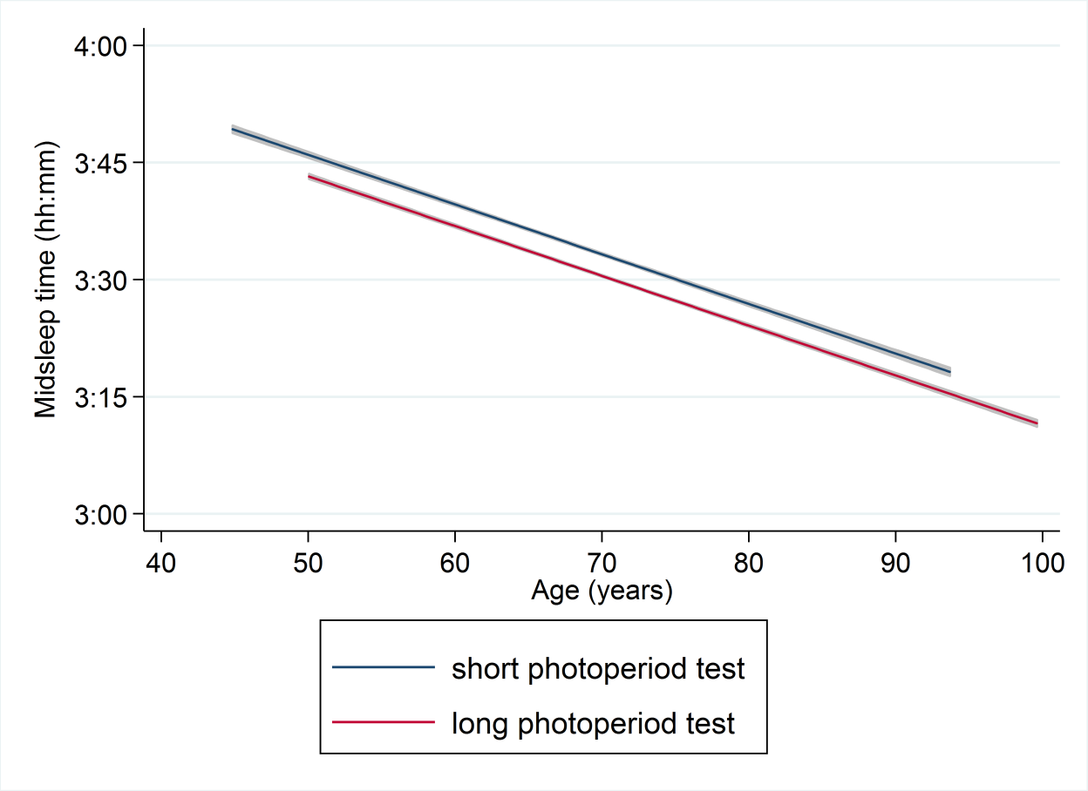
Change of midsleep point across age for different test season groups. The graph includes the unemployed/retired/housewife participants. The blue line represents chronotype of participants whose tests were performed in short photoperiod season. The red line represents chronotype of participants with long photoperiod test season. Fit lines produced by linear mixed models (covariates: sex, working status, marital status, social class, education level, sleep medication, subjective health rating, test season, birth season, sleep duration, smoking, alcohol drinking).

Table S8: Latent class analysis for sleep midpoint
 |  |  | chronotype clusters
 |  |  | M. | E. | I.
sample size |  |  | 1631 | 842 | 2874
constant |  | * | 3.47 | 4.60 | 4.25
age |  |  | -0.008 | -0.004 | -0.009
variance |  | * | 0.20 | 0.31 | 0.11
covariates |  |  | (regression coefficients)
gender
 | female |  | -0.01 | -0.03 | 0.04
birth season |  | *
 | long daylength |  | 0.05 | -0.08 | 0.03
test season |  | *
 | long daylength |  | 0.09 | -0.11 | 0.02
social class (ref.: professional)
 | intermediate occupations |  | -0.08 | -0.12 | 0.20
 | skilled non-manual occupations |  | -0.08 | -0.15 | 0.23
 | skilled manual occupations |  | -0.11 | 0.05 | 0.05
 | partly skilled occupations |  | 0.02 | 0.05 | -0.08
 | unskilled occupations |  | 0.22 | 0.52 | -0.75
education level (ref.: lower secondary) |  | *
 | upper-secondary education |  | -0.41 | 0.82 | -0.41
 | post-secondary non-tertiary education |  | -0.54 | 0.82 | -0.28
 | tertiary education first stage |  | -0.25 | 0.59 | -0.34
 | tertiary education second stage |  | 1.57 | -2.85 | 1.28
working status |  | *
 | employed |  | 0.31 | -0.12 | -0.19
marital status |  | *
 | married, living with someone |  | -0.02 | -0.11 | 0.13
smoking |  | *
 | non-smoking |  | 0.10 | -0.25 | 0.15
alcohol drinking (ref.: not drinking) |  | *
 | less than once in a day |  | -0.06 | -0.08 | 0.14
 | once in a day or more |  | -0.23 | 0.34 | -0.11
current health (ref.: very bad) |  | *
 | Bad |  | 0.02 | 0.02 | -0.04
 | Fair |  | -0.11 | -0.05 | 0.15
 | Good |  | -0.08 | -0.26 | 0.34
 | Very good |  | 0.08 | -0.23 | 0.15
usage of sleep medication |  | *
 | not using |  | 0.06 | -0.11 | 0.05
Number of cases=5347, number of replications=9440, log-likelihood=-7620.47, BIC= 15713.07, AIC= 15350.93
M. (morning-type, earlier sleep midpoint), E. (evening-type, later sleep midpoint), I. (intermediate sleep midpoint)
* (Wald test p-value < 0.05)

Table S9: Comparison of daily habits between chronotype latent classes
Data collected in the first wave. Bivariate comparisons using ANOVA for continuous variable (means reported in the table), Chi-squared test for categorical variables (frequencies reported).
 | Morning-type |  | Intermediate | Evening-type | p-value
Sample size | 1631 | 2874 |  | 842
Eysenck personality score
Extraversion personality | 11.26 | 11.54 |  | 11.95 | 0.038
Neuroticism personality | 10.37 | 10.40 |  | 10.64 | 0.617
Psychoticism personality | 1.82 | 1.67 |  | 2.23 | 0.000
Number of children | 1.93 | 1.87 |  | 1.87 | 0.350
Number of people in household | 1.90 | 1.85 |  | 1.82 | 0.074
Main occupation
Managers, directors and senior official | 11.34 | 12.06 |  | 11.99 | 0.765
Professional | 19.45 | 17.49 |  | 14.87 | 0.017
Associate professional and technical | 19.27 | 18.86 |  | 17.15 | 0.425
Administrative and secretarial | 23.23 | 26.39 |  | 29.38 | 0.003
Skilled trades | 5.39 | 5.89 |  | 6.12 | 0.710
Caring, leisure and other service | 3.97 | 3.65 |  | 4.56 | 0.479
Sales and customer service | 4.46 | 6.03 |  | 3.96 | 0.016
Process, plant and machine operatives | 4.52 | 4.31 |  | 6.59 | 0.021
Elementary | 8.36 | 5.33 |  | 5.40 | 0.000
Further education (yes) | 49.56 | 49.29 |  | 51.46 | 0.544
Total education years (years) | 13.77 | 13.49 |  | 13.43 | 0.014
General health and depression
Number of medication taken in a day | 0.81 | 0.88 |  | 1.03 | 0.000
Beck Depression Inventory score | 7.78 | 7.23 |  | 8.00 | 0.001
Mild to severe depression (yes) | 29.76 | 26.59 |  | 31.84 | 0.007
Have you ever smoked (yes) | 59.34 | 63.43 |  | 73.17 | 0.000
How many years did you smoked (years) | 15.03 | 16.69 |  | 23.05 | 0.000
Have you ever drink alcohol (yes) | 81.68 | 88.05 |  | 88.57 | 0.000
Total daily difficulty score (0-12) | 1.22 | 1.15 |  | 1.67 | 0.000
Difficulty doing household tasks (no) | 82.35 | 83.65 |  | 73.78 | 0.000
Difficulty doing thing around house (no) | 84.38 | 85.12 |  | 77.51 | 0.000
Difficulty bathing self (no) | 95.09 | 95.44 |  | 92.59 | 0.005
Difficulty household cleaning (no) | 81.46 | 82.50 |  | 75.93 | 0.000
Difficulty doing laundry (no) | 92.39 | 93.30 |  | 88.90 | 0.000
Difficulty preparing meals (no) | 95.03 | 96.19 |  | 94.48 | 0.063
Difficulty dressing (no) | 97.06 | 97.50 |  | 94.71 | 0.000
Difficulty climbing stairs (no) | 78.76 | 80.75 |  | 71.91 | 0.000
Difficulty going outdoors (no) | 95.78 | 95.48 |  | 92.96 | 0.006
Difficulty cutting toenails (no) | 77.71 | 77.19 |  | 71.13 | 0.001
Difficulty getting about locally (no) | 93.13 | 93.55 |  | 88.86 | 0.000
Difficulty travelling long distances (no) | 87.47 | 88.15 |  | 84.43 | 0.022
Daily activities
Activity: Resting, napping (hours per month) | 120.77 | 131.98 |  | 145.36 | 0.000
Activity: Requiring little physical effort (hpm) | 70.88 | 68.29 |  | 73.36 | 0.007
Activity: Non-strenuous hobbies (hpm) | 25.23 | 24.97 |  | 24.67 | 0.938
Activity: Personal care/cooking and eating (hpm) | 81.08 | 84.25 |  | 81.60 | 0.032
Activity: Light housework/gardening (hpm) | 36.48 | 37.38 |  | 37.28 | 0.561
Activity: Heavy housework/gardening (hpm) | 24.53 | 24.76 |  | 22.27 | 0.055
Activity: Outings (hpm) | 41.55 | 39.57 |  | 38.77 | 0.147
Activity: Visiting friends and relatives (hpm) | 29.93 | 32.07 |  | 30.50 | 0.212
Activity: Using public transport (hpm) | 12.89 | 12.49 |  | 13.07 | 0.747
Activity: Driving a car (hpm) | 13.45 | 12.49 |  | 12.08 | 0.294
Activity: Socializing and entertaining (hpm) | 27.45 | 30.61 |  | 33.91 | 0.000
Activity: Going on holiday (weeks per year) | 2.39 | 2.69 |  | 2.43 | 0.011
Activity: Light exercise (hpm) | 25.79 | 26.83 |  | 24.31 | 0.073
Activity: Strenuous exercise (hpm) | 3.72 | 2.83 |  | 2.72 | 0.004
Doing exercise (yes) | 83.31 | 85.52 |  | 78.47 | 0.000
Do you keep any pets (yes) | 29.15 | 25.11 |  | 30.46 | 0.001
Meal times and sleep
Getting up time (hh:mm) | 7:10 | 8:00 |  | 8:41 | 0.000
Going to bed time (hh:mm) | 22:39 | 23:18 |  | 00:14 | 0.000
Sleep duration (hours) | 6.95 | 7.03 |  | 6.86 | 0.001
How many times do you wake during night | 1.38 | 1.36 |  | 1.32 | 0.541
Do you have sleeping difficulty (yes) | 31.63 | 35.03 |  | 43.01 | 0.000
Breakfast time (hh:mm) | 7:52 | 8:31 |  | 9:09 | 0.000
Lunch time (hh:mm) | 12:31 | 12:39 |  | 12:55 | 0.000
Dinner time (hh:mm) | 17:49 | 17:50 |  | 18:07 | 0.000
Table S10. Depression and chronotype clusters
 |  |  |  | BDI score
Constant |  |  |  | 12.52[9.44/15.59]**
Chronotype latent classes (ref.: morning-type)
 | intermediate |  |  | -0.39[-0.75/-0.03]*
 | evening |  |  | -0.18[-0.67/0.30]
Gender
 | female |  |  | 1.26[0.88/1.64]**
Age |  |  |  | -0.01[-0.04/0.01]
Birth season
 | long photoperiod |  |  | -0.07[-0.38/0.24]
Test season
 | long photoperiod |  |  | -0.28[-0.59/0.04]
Social class (ref.: professional)
 | intermediate occupations |  |  | 0.13[-0.63/0.90]
 | skilled non-manual occupations |  |  | 0.88[0.03/1.74]*
 | skilled manual occupations |  |  | 0.63[-0.22/1.49]
 | partly skilled occupations |  |  | 0.88[-0.12/1.89]
 | unskilled occupations |  |  | 2.78[0.80/4.76]*
Education level (ref.: lower secondary)
 | upper-secondary education |  |  | -0.43[-0.88/0.02]
 | post-secondary non-tertiary edu. |  |  | -0.59[-1.03/-0.14]*
 | tertiary education first stage |  |  | -0.62[-1.14/-0.09]*
 | tertiary education second stage |  |  | 1.18[-1.13/3.48]
Working status
 | employed |  |  | 0.33[-0.14/0.80]
Marital status
 | married, living with someone |  |  | -0.88[-1.22/-0.54]**
General health rating (ref.: very bad)
 | Bad |  |  | 1.14[-1.48/3.76]
 | Fair |  |  | -2.07[-4.53/0.40]
 | Good |  |  | -4.90[-7.36/-2.45]**
 | Very good |  |  | -6.53[-9.00/-4.07]**
Results were reported as regression coefficient [95% Confidence interval]. Ref.: Reference variable. BDI: Beck Depression Inventory
Linear regression, number of observations= 4774, F(21,4752)=38.53, p-value<0.001, R-squared=0.146
* (regression p-value < 0.05), ** (regression p-value < 0.001)
 |  | Morning-type | Intermediate |  | Evening-type
No depression |  | 70.24% | 73.41% |  | 68.16%
Mild to moderate |  | 22.96% | 22.22% |  | 25.63%
Moderate to severe |  | 5.50% | 3.53% |  | 5.68%
Severe |  | 1.29% | 0.84% |  | 0.53%
Chi²(6)=20.51, p=0.002

Figure S3: Sensitivity analysis for clinical investigation subgroup
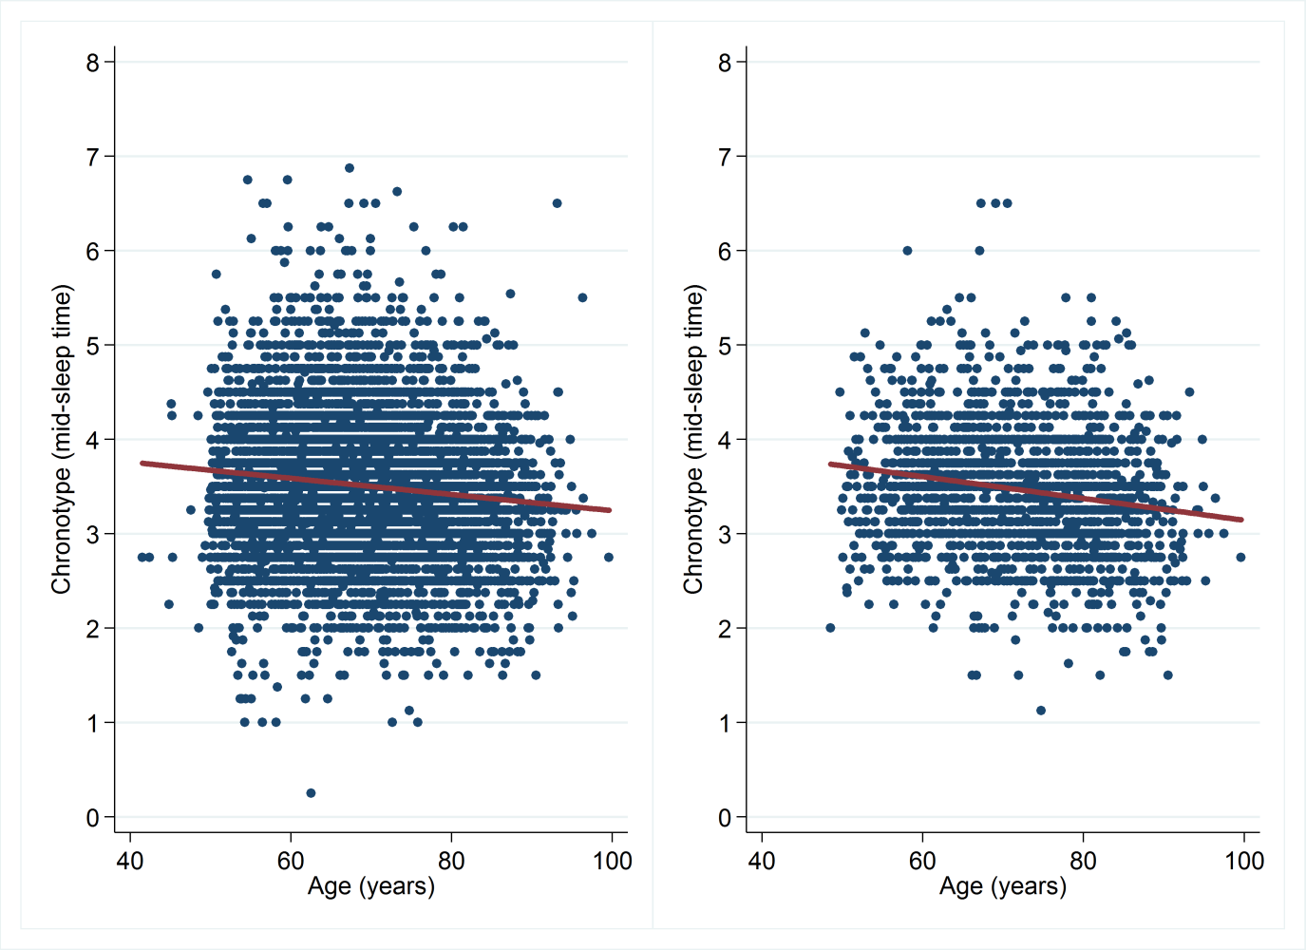
The first graph includes all participants. The second graph shows the longitudinal decline of the chronotype for individuals who attended clinical investigation. Blue dots show all available chronotype data. Red lines are fit lines produced by linear mixed models (covariates: sex, working status, marital status, social class, education level, sleep medication, subjective health rating, test season, birth season, sleep duration, smoking, alcohol drinking). The first model: Slope of the fit line is -0.010, p<0.001 (number of participants=5284, number of available data=9260, Wald(24)=564.40, p<0.001). The second model: Slope of the fit line is -0.012, p<0.001 (number of participants=544, number of available data=1898, Wald(24)=227.27, p<0.001).

Table S11. Results of clinic investigation
Sample size | 555
Age | 76.16±5.51
 | mean±SD
systolic blood pressure [mmHg] | 155.63±22.16
diastolic blood pressure [mmHg] | 81.58±11.59
heart rate | 74.69±12.53
weight [kg] | 68.90±13.11
body mass index [kg/m²] | 26.09±4.13
waist circumferences [cm] | 86.11±11.92
glycosylated haemoglobin (HbA1c) [%] | 5.49±0.59
total cholesterol [mmol/L] | 5.63±1.12
high-density lipoprotein cholesterol [mmol/L] | 1.56±0.46
total cholesterol/HDL | 3.83±1.07

Table S12: Results of logistic regression analysis for high blood pressure risk, high blood sugar risk, obesity risk and high cholesterol risk
 | High blood pressure (a) | High blood sugar (b) | Obesity (c) | High  cholesterol (d)
constant | 0.02[0.00/0.38]* | 0.03[0.00/8.81] | 1.74[0.15/19.96] | 28.69[0.96/853.17]
age | 1.06[1.02/1.10]* | 1.01[0.94/1.08] | 0.99[0.96/1.03] | 0.97[0.93/1.01]
gender (female) | 1.12[0.73/1.73] | 0.92[0.40/2.12] | 0.90[0.62/1.31] | 1.29[0.78/2.12]
chronotype cluster
(ref: morning-type)
intermediate | 1.52[0.98/2.35] | 1.09[0.42/2.86] | 1.14[0.78/1.67] | 1.61[0.96/2.71]
evening-type | 1.88[1.02/3.47]* | 2.11[0.71/6.30] | 1.21[0.73/2.02] | 1.59[0.77/3.31]
Presented as odds ratio[95%CI]
* (regression p-value < 0.05), ** (regression p-value < 0.001)
a. Logistic regression; number of observation=529; likelihood-ratio chi-squared(4)=16.26, p=0.0027; pseudo R-squared=0.027
b. Logistic regression; number of observation=443; likelihood-ratio chi-squared(4)=2.15, p=0.71; pseudo R-squared=0.011
c. Logistic regression; number of observation=531; likelihood-ratio chi-squared(4)=1.13, p=0.89; pseudo R-squared=0.002
d. Logistic regression; number of observation=445; likelihood-ratio chi-squared(4)=5.90, p=0.21; pseudo R-squared=0.014

Table S13: Life table of the cohort
year | number at start | deaths | withdrawn | survival | std.error | [95% conf. int.]
0 1 | 5987 | 45 | 0 | 0.9925 | 0.0011 | 0.9899 0.9944
1 2 | 5942 | 88 | 0 | 0.9778 | 0.0019 | 0.9737 0.9812
2 3 | 5854 | 91 | 0 | 0.9626 | 0.0025 | 0.9575 0.9671
3 4 | 5763 | 90 | 0 | 0.9476 | 0.0029 | 0.9416 0.9529
4 5 | 5673 | 119 | 0 | 0.9277 | 0.0033 | 0.9208 0.9340
5 6 | 5554 | 119 | 0 | 0.9078 | 0.0037 | 0.9002 0.9149
6 7 | 5435 | 163 | 0 | 0.8806 | 0.0042 | 0.8721 0.8885
7 8 | 5272 | 146 | 0 | 0.8562 | 0.0045 | 0.8470 0.8648
8 9 | 5126 | 153 | 0 | 0.8306 | 0.0048 | 0.8209 0.8399
9 10 | 4973 | 149 | 0 | 0.8057 | 0.0051 | 0.7955 0.8155
10 11 | 4824 | 165 | 0 | 0.7782 | 0.0054 | 0.7674 0.7885
11 12 | 4659 | 171 | 0 | 0.7496 | 0.0056 | 0.7385 0.7604
12 13 | 4488 | 171 | 0 | 0.7211 | 0.0058 | 0.7095 0.7322
13 14 | 4317 | 199 | 0 | 0.6878 | 0.006 | 0.6759 0.6994
14 15 | 4118 | 174 | 0 | 0.6588 | 0.0061 | 0.6466 0.6706
15 16 | 3944 | 184 | 0 | 0.628 | 0.0062 | 0.6156 0.6401
16 17 | 3760 | 206 | 0 | 0.5936 | 0.0063 | 0.5811 0.6059
17 18 | 3554 | 189 | 0 | 0.5621 | 0.0064 | 0.5494 0.5745
18 19 | 3365 | 198 | 0 | 0.529 | 0.0065 | 0.5163 0.5415
19 20 | 3167 | 191 | 0 | 0.4971 | 0.0065 | 0.4843 0.5097
20 21 | 2976 | 203 | 0 | 0.4632 | 0.0064 | 0.4505 0.4757
21 22 | 2773 | 211 | 0 | 0.4279 | 0.0064 | 0.4154 0.4404
22 23 | 2562 | 177 | 0 | 0.3984 | 0.0063 | 0.3859 0.4107
23 24 | 2385 | 213 | 0 | 0.3628 | 0.0062 | 0.3506 0.3750
24 25 | 2172 | 183 | 17 | 0.3321 | 0.0061 | 0.3202 0.3441
25 26 | 1972 | 185 | 32 | 0.3007 | 0.0059 | 0.2891 0.3124
26 27 | 1755 | 158 | 58 | 0.2732 | 0.0058 | 0.2619 0.2845
27 28 | 1539 | 145 | 179 | 0.2458 | 0.0056 | 0.2349 0.2569
28 29 | 1215 | 146 | 173 | 0.214 | 0.0055 | 0.2034 0.2249
29 30 | 896 | 105 | 67 | 0.188 | 0.0054 | 0.1776 0.1986
30 31 | 724 | 84 | 20 | 0.1659 | 0.0053 | 0.1557 0.1763
31 32 | 620 | 64 | 143 | 0.1465 | 0.0052 | 0.1365 0.1568
32 33 | 413 | 37 | 227 | 0.1284 | 0.0053 | 0.1182 0.1390
33 34 | 149 | 18 | 18 | 0.1119 | 0.0059 | 0.1007 0.1238
34 35 | 113 | 6 | 106 | 0.1007 | 0.0068 | 0.0878 0.1146
35 36 | 1 | 1 | 0 | 0

Figure S4: Survival graph of the whole cohort during the follow-up years

Table S14: Life table of the morning cluster
year | number at start | deaths | withdrawn | survival | std.error | [95% conf. int.]
0 1 | 1569 | 8 | 0 | 0.9949 | 0.0018 | 0.9898 0.9974
1 2 | 1561 | 18 | 0 | 0.9834 | 0.0032 | 0.9758 0.9887
2 3 | 1543 | 15 | 0 | 0.9739 | 0.004 | 0.9647 0.9807
3 4 | 1528 | 14 | 0 | 0.9649 | 0.0046 | 0.9546 0.9730
4 5 | 1514 | 17 | 0 | 0.9541 | 0.0053 | 0.9425 0.9634
5 6 | 1497 | 29 | 0 | 0.9356 | 0.0062 | 0.9223 0.9467
6 7 | 1468 | 37 | 0 | 0.912 | 0.0072 | 0.8969 0.9250
7 8 | 1431 | 37 | 0 | 0.8885 | 0.0079 | 0.8718 0.9031
8 9 | 1394 | 33 | 0 | 0.8674 | 0.0086 | 0.8496 0.8833
9 10 | 1361 | 40 | 0 | 0.8419 | 0.0092 | 0.8229 0.8591
10 11 | 1321 | 35 | 0 | 0.8196 | 0.0097 | 0.7997 0.8378
11 12 | 1286 | 43 | 0 | 0.7922 | 0.0102 | 0.7713 0.8115
12 13 | 1243 | 42 | 0 | 0.7655 | 0.0107 | 0.7437 0.7856
13 14 | 1201 | 37 | 0 | 0.7419 | 0.011 | 0.7195 0.7628
14 15 | 1164 | 42 | 0 | 0.7151 | 0.0114 | 0.6921 0.7368
15 16 | 1122 | 42 | 0 | 0.6883 | 0.0117 | 0.6648 0.7106
16 17 | 1080 | 58 | 0 | 0.6514 | 0.012 | 0.6272 0.6744
17 18 | 1022 | 45 | 0 | 0.6227 | 0.0122 | 0.5982 0.6462
18 19 | 977 | 46 | 0 | 0.5934 | 0.0124 | 0.5686 0.6172
19 20 | 931 | 56 | 0 | 0.5577 | 0.0125 | 0.5327 0.5819
20 21 | 875 | 55 | 0 | 0.5226 | 0.0126 | 0.4976 0.5470
21 22 | 820 | 55 | 0 | 0.4876 | 0.0126 | 0.4626 0.5120
22 23 | 765 | 42 | 0 | 0.4608 | 0.0126 | 0.4360 0.4853
23 24 | 723 | 55 | 0 | 0.4257 | 0.0125 | 0.4012 0.4501
24 25 | 668 | 41 | 3 | 0.3996 | 0.0124 | 0.3753 0.4237
25 26 | 624 | 51 | 10 | 0.3666 | 0.0122 | 0.3428 0.3905
26 27 | 563 | 46 | 18 | 0.3362 | 0.012 | 0.3128 0.3597
27 28 | 499 | 39 | 62 | 0.3082 | 0.0118 | 0.2852 0.3314
28 29 | 398 | 39 | 49 | 0.276 | 0.0116 | 0.2535 0.2990
29 30 | 310 | 35 | 17 | 0.244 | 0.0115 | 0.2218 0.2667
30 31 | 258 | 24 | 8 | 0.2209 | 0.0113 | 0.1991 0.2434
31 32 | 226 | 15 | 46 | 0.2046 | 0.0112 | 0.1830 0.2270
32 33 | 165 | 11 | 93 | 0.1856 | 0.0116 | 0.1635 0.2088
33 34 | 61 | 6 | 6 | 0.1664 | 0.0127 | 0.1423 0.1922
34 35 | 49 | 1 | 47 | 0.1599 | 0.0138 | 0.1339 0.1879
35 36 | 1 | 1 | 0 | 0

Table S15: Life table of the intermediate chronotype cluster
year | number at start | deaths | withdrawn | survival | std.error | [95% conf. int.]
0 1 | 2808 | 20 | 0 | 0.9929 | 0.0016 | 0.989 | 0.9954
1 2 | 2788 | 35 | 0 | 0.9804 | 0.0026 | 0.9746 | 0.9849
2 3 | 2753 | 36 | 0 | 0.9676 | 0.0033 | 0.9603 | 0.9735
3 4 | 2717 | 44 | 0 | 0.9519 | 0.004 | 0.9433 | 0.9592
4 5 | 2673 | 55 | 0 | 0.9323 | 0.0047 | 0.9224 | 0.941
5 6 | 2618 | 54 | 0 | 0.9131 | 0.0053 | 0.9021 | 0.9229
6 7 | 2564 | 71 | 0 | 0.8878 | 0.006 | 0.8756 | 0.8989
7 8 | 2493 | 66 | 0 | 0.8643 | 0.0065 | 0.8511 | 0.8765
8 9 | 2427 | 74 | 0 | 0.838 | 0.007 | 0.8238 | 0.8511
9 10 | 2353 | 61 | 0 | 0.8162 | 0.0073 | 0.8014 | 0.8301
10 11 | 2292 | 76 | 0 | 0.7892 | 0.0077 | 0.7736 | 0.8038
11 12 | 2216 | 78 | 0 | 0.7614 | 0.008 | 0.7452 | 0.7767
12 13 | 2138 | 78 | 0 | 0.7336 | 0.0083 | 0.7169 | 0.7496
13 14 | 2060 | 95 | 0 | 0.6998 | 0.0086 | 0.6825 | 0.7164
14 15 | 1965 | 86 | 0 | 0.6692 | 0.0089 | 0.6514 | 0.6862
15 16 | 1879 | 109 | 0 | 0.6303 | 0.0091 | 0.6122 | 0.6479
16 17 | 1770 | 95 | 0 | 0.5965 | 0.0093 | 0.5781 | 0.6144
17 18 | 1675 | 79 | 0 | 0.5684 | 0.0093 | 0.5498 | 0.5865
18 19 | 1596 | 97 | 0 | 0.5338 | 0.0094 | 0.5152 | 0.5521
19 20 | 1499 | 87 | 0 | 0.5028 | 0.0094 | 0.4842 | 0.5212
20 21 | 1412 | 98 | 0 | 0.4679 | 0.0094 | 0.4494 | 0.4863
21 22 | 1314 | 102 | 0 | 0.4316 | 0.0093 | 0.4132 | 0.4499
22 23 | 1212 | 85 | 0 | 0.4014 | 0.0093 | 0.3832 | 0.4194
23 24 | 1127 | 95 | 0 | 0.3675 | 0.0091 | 0.3497 | 0.3853
24 25 | 1032 | 98 | 9 | 0.3325 | 0.0089 | 0.3151 | 0.3499
25 26 | 925 | 92 | 20 | 0.299 | 0.0087 | 0.2822 | 0.3161
26 27 | 813 | 67 | 26 | 0.274 | 0.0085 | 0.2575 | 0.2907
27 28 | 720 | 76 | 78 | 0.2434 | 0.0082 | 0.2275 | 0.2596
28 29 | 566 | 81 | 91 | 0.2055 | 0.0079 | 0.1902 | 0.2213
29 30 | 394 | 48 | 37 | 0.1793 | 0.0078 | 0.1643 | 0.1948
30 31 | 309 | 42 | 9 | 0.1545 | 0.0076 | 0.14 | 0.1697
31 32 | 258 | 35 | 59 | 0.1309 | 0.0074 | 0.1168 | 0.1458
32 33 | 164 | 19 | 85 | 0.1104 | 0.0076 | 0.0961 | 0.1258
33 34 | 60 | 8 | 10 | 0.0943 | 0.0083 | 0.0788 | 0.1115
34 35 | 42 | 5 | 37 | 0.0743 | 0.0103 | 0.0557 | 0.0962

Table S16: Life table of the evening cluster
year | number at start | deaths | withdrawn | survival | std.error | [95% conf. int.]
0 1 | 820 | 6 | 0 | 0.9927 | 0.003 | 0.9838 | 0.9967
1 2 | 814 | 8 | 0 | 0.9829 | 0.0045 | 0.9713 | 0.9899
2 3 | 806 | 12 | 0 | 0.9683 | 0.0061 | 0.9538 | 0.9783
3 4 | 794 | 15 | 0 | 0.95 | 0.0076 | 0.9327 | 0.9629
4 5 | 779 | 27 | 0 | 0.9171 | 0.0096 | 0.896 | 0.934
5 6 | 752 | 9 | 0 | 0.9061 | 0.0102 | 0.884 | 0.9242
6 7 | 743 | 29 | 0 | 0.8707 | 0.0117 | 0.8458 | 0.8919
7 8 | 714 | 20 | 0 | 0.8463 | 0.0126 | 0.8198 | 0.8693
8 9 | 694 | 21 | 0 | 0.8207 | 0.0134 | 0.7927 | 0.8453
9 10 | 673 | 26 | 0 | 0.789 | 0.0142 | 0.7595 | 0.8154
10 11 | 647 | 33 | 0 | 0.7488 | 0.0151 | 0.7176 | 0.777
11 12 | 614 | 26 | 0 | 0.7171 | 0.0157 | 0.6849 | 0.7466
12 13 | 588 | 25 | 0 | 0.6866 | 0.0162 | 0.6536 | 0.7171
13 14 | 563 | 36 | 0 | 0.6427 | 0.0167 | 0.6088 | 0.6744
14 15 | 527 | 20 | 0 | 0.6183 | 0.017 | 0.5841 | 0.6506
15 16 | 507 | 12 | 0 | 0.6037 | 0.0171 | 0.5693 | 0.6362
16 17 | 495 | 22 | 0 | 0.5768 | 0.0173 | 0.5422 | 0.6098
17 18 | 473 | 33 | 0 | 0.5366 | 0.0174 | 0.5018 | 0.57
18 19 | 440 | 32 | 0 | 0.4976 | 0.0175 | 0.4629 | 0.5312
19 20 | 408 | 28 | 0 | 0.4634 | 0.0174 | 0.4289 | 0.4971
20 21 | 380 | 30 | 0 | 0.4268 | 0.0173 | 0.3928 | 0.4604
21 22 | 350 | 26 | 0 | 0.3951 | 0.0171 | 0.3616 | 0.4284
22 23 | 324 | 33 | 0 | 0.3549 | 0.0167 | 0.3222 | 0.3876
23 24 | 291 | 33 | 0 | 0.3146 | 0.0162 | 0.2831 | 0.3466
24 25 | 258 | 19 | 5 | 0.2912 | 0.0159 | 0.2605 | 0.3226
25 26 | 234 | 24 | 1 | 0.2613 | 0.0154 | 0.2317 | 0.2918
26 27 | 209 | 28 | 3 | 0.226 | 0.0147 | 0.1979 | 0.2554
27 28 | 178 | 13 | 19 | 0.2086 | 0.0143 | 0.1813 | 0.2373
28 29 | 146 | 15 | 17 | 0.1858 | 0.0139 | 0.1594 | 0.2139
29 30 | 114 | 18 | 5 | 0.1558 | 0.0133 | 0.1308 | 0.183
30 31 | 91 | 13 | 0 | 0.1336 | 0.0128 | 0.1097 | 0.1598
31 32 | 78 | 8 | 29 | 0.1168 | 0.0125 | 0.0937 | 0.1425
32 33 | 41 | 4 | 30 | 0.0988 | 0.0134 | 0.0745 | 0.127
33 34 | 7 | 2 | 1 | 0.0684 | 0.0201 | 0.0359 | 0.115
34 35 | 4 | 0 | 4 | 0.0684 | 0.0201 | 0.0359 | 0.115

