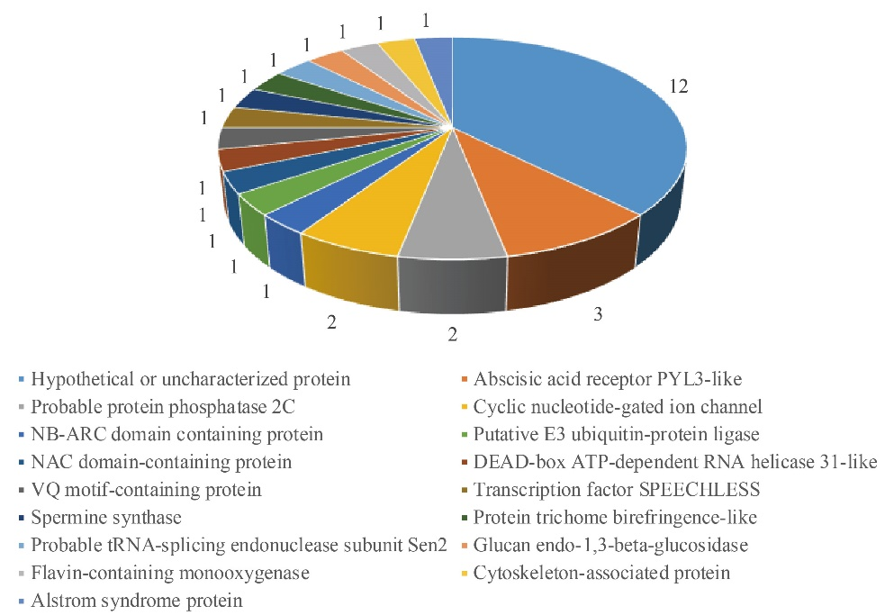
Additional file 7: Figure S1. Classification of the 32 candidate genes in the most possible location interval (439.154 kb) of qRBSDV-6.3.

