The roles of suspension-feeding and flux-feeding zooplankton as gatekeepers of particle flux into the mesopelagic ocean in the Northeast Pacific

Michael R. Stukel^{1,2,*}, Mark D. Ohman³, Thomas B. Kelly¹, Tristan Biard⁴

¹Dept. of Earth, Ocean, and Atmospheric Science, Florida State University, Tallahassee, FL 32308
²Center for Ocean-Atmospheric Prediction Studies, Florida State University, Tallahassee, FL 32308
³Scripps Institution of Oceanography, University of California San Diego, San Diego, CA 92093
⁴Laboratoire d’Océanologie et Géosciences, Wimereux, France 62930
* Correspondence:
Michael R. Stukel
mstukel@fsu.edu

Keywords: biological pump, carbon export, remineralization length scale, mesozooplankton ecology, pteropods, marine biogeochemistry, sinking particles, marine snow

Supplemental Material
Online Supplementary Appendix S1 – Detailed data analyses
Carbon flux attenuation calculations – Both sediment trap and ²³⁸U-²³⁴Th deficiency methodologies have inherent shortcomings that can introduce uncertainty and bias to carbon flux measurements. Surface-tethered sediment traps suffer from hydrodynamic biases related to shear across the trap mouth, potential dissolution of organic carbon and other chemical constituents of sinking particles, and difficulties of accurately identifying and removing swimming mesozooplankton from the sediment traps (Baker et al., 1988; Buesseler et al., 2007). For ²³⁴Th, uncertainties are derived primarily from uncertainty in the appropriate C:²³⁴Th ratio to apply to convert ²³⁴Th flux to carbon flux and uncertainty in the model used to convert water column ²³⁴Th activity measurements to ²³⁴Th flux measurements (Buesseler et al., 2006; Savoye et al., 2006). Specifically, most studies are forced (due to a lack of repeat measurements, full three-dimensional coverage of ²³⁴Th activity, and/or measurements of horizontal and vertical currents and diffusivity) to assume the system is at steady-state with no horizontal advection or upwelling. Accounting for upwelling, advection, or non-steady state conditions (when possible) often leads to substantially different estimates of local export, but has a lesser impact when integrated over larger spatial regions and longer temporal periods (Buesseler et al., 1992; Dunne and Murray, 1999; Resplandy et al., 2012; Stukel et al., 2015).
The CCE has high meso- and submesoscale variability, pronounced horizontal currents, and temporal variaibility in upwelling. We thus believe that sediment traps give a better estimate of contemporaneous export flux on short time scales than ²³⁴Th-approaches in our study region. Our believe that the sediment traps have no substantial over- or under-collection bias is supported by a total of 56 paired sediment trap and ²³⁸U-²³⁴Th deficiency measurements showing good agreement (see results section 3.1). Consequently, we use sediment trap values of carbon flux at deployment depths (typically near the base of the euphotic zone and at 100 m) and utilize ²³⁸U-²³⁴Th measurements to generate smooth profiles of carbon flux attenuation above, between, and below sediment trap deployment depths.
Carbon flux attenuation (CFA) as a function of depth was calculated for each Lagrangian cycle from Eq. 2 in the manuscript:
$CFA=\frac{∂\left(CTh(D)\right)}{∂z}\int_{0}^{D}{\left(λ_{234}×Def(z)\right)}dz+λ_{234}×Def(D)×CTh(D)$ (2)
To calculate the terms in Eq. 2, we first averaged and smoothed all ²³⁴Th, ²³⁸U-²³⁴Th deficiency, and POC profiles from an individual Lagrangian cycle using locally-estimated scatterplot smoothing (LOESS). LOESS smoothing was accomplished using the fLOESS function in Matlab (with a span of 0.9). fLOESS uses a second-order polynomial to smooth the data. Data points were then interpolated to create smooth profiles. Since on many cycles, POC measurements were only made in the euphotic zone, we extended these profiles to 200 m depth by assuming (from analyses in Stukel et al., 2019) that suspended POC decreases with depth at a rate of 1.5% m⁻¹. This extension of the POC profiles was only used for quantifying C:^{234Th} variability with depth from Eq. 3. Results were not sensitive to varying the rate at which POC decreases with depth, because most POC was in the euphotic zone.
Def(D) and the integral of Def(D) were simply calculated from the smoothed deficiency profiles. CTh(D) and ∂CTh(D)/∂z were calculated using Eq. S1:
$\log_{10}\left(CTh\left(D\right)\right)=m×\log_{10}\left({}_{}^{v}{C:{{}_{}^{234}{Th}}_{tot}}\right)+b$ (S1)
For Lagrangian cycles during which sediment traps were deployed at multiple depths (two or three), we calculated the parameters m and b independently for each Lagrangian cycle. When sediment traps were only deployed at a single depth, we used the regional mean value for m calculated by Stukel et al. (2019): m = 0.43 ± 0.03. Equations 2 and 3 were then combined to calculate smooth profiles of carbon flux attenuation above the shallowest sediment trap depth, between sediment trap depths, and below the deepest sediment trap depth (to 150 m depth). Because the ²³⁴Th-²³⁸U deficiency measurements and sediment trap measurements did not perfectly match, there was a difference between carbon flux attenuation calculated from Eqs. 2 and 3 and carbon flux attenuation calculated by comparing sediment traps at different depths. Because we found that the sediment traps gave a more accurate estimate of carbon export, we thus adjusted the carbon flux attenuation estimates from Eq. 2 between sediment trap depths, by adding (or subtracting) a constant amount to the values calculated in Eq. 2 (between the sediment trap depths). This yielded smooth profiles of carbon flux attenuation that were entirely consistent with sediment trap data.
To generate smooth profiles of carbon flux, we combined carbon flux attenuation profiles with the carbon flux estimates made by the sediment traps. Carbon flux was extended above and below the sediment trap depths iteratively using the equation:
$Flux\left(z-∆z\right)=Flux\left(z\right)×e^{-b∆z}$ (S2)
where Δz equals one meter and b = -CFA(z)/Flux(z). Eq. S2 was used, because it ensures that flux can never go negative. If we had instead calculated flux as Flux(z-Δz) = Flux(z) – CFA(z), carbon flux would have been negative at a depth shallower than 150 m for one profile, because of anomalously high ²³⁴Th (i.e., strongly negative deficiency) at depth.

Online Supplementary Appendix S2 – Cruise Conditions
Ecological conditions encountered on these cycles were highly variable. On P0704 and P0810 our goal was to quantify ecological and biogeochemical rates in homogeneous water parcels (i.e., regions with low mesoscale variability) across the range of conditions found in the CCE domain. Consequently, cycles varied from high chlorophyll (Chl), coastal bloom conditions (surface Chl > 5 µg Chl a L⁻¹) to exceedingly oligotrophic areas (surface Chl <0.1 µg Chl a L⁻¹) (Landry et al., 2012; Stukel et al., 2013). The P1408 and P1604 cruises used similar sampling plans to investigate spatial variability during the North Pacific Warm Anomaly in 2014 and subsequent 2015-2016 El Niño (Bond et al., 2015; Jacox et al., 2016). During the P1408 cruise, upwelling was suppressed throughout the study region and warm, low-nutrient conditions predominated on all experimental cycles. The P1604 cruise took place at the end of the El Niño when offshore conditions were still warm, nutrient-poor, and community composition was likely highly impacted by the El Niño. However, spring upwelling conditions commenced near the coast and the final two cycles were conducted in cold, upwelling-influenced waters with high phytoplankton and zooplankton biomass (Morrow et al., 2018; Nickels and Ohman, 2018).
The P1106 and P1208 cruises were planned to investigate the impact of mesoscale fronts on plankton communities and consequently had very different sampling plans. These cruises interspersed five (P1208) or six (P1106) shorter Lagrangian cycles (2.25 – 3.25 day duration) with transect sampling and spatial mapping of mesoscale features. Experimental cycles conducted on these cruises were thus conducted within a relatively restricted spatial domain in the vicinity of a specific mesoscale feature (Fig. 1). Despite this restricted spatial domain substantial intra-cruise variability in system productivity was encountered. Mean surface Chl varied by more than an order of magnitude on cycles during P1106 as did vertically-integrated primary productivity with concomitant impacts on plankton communities and carbon export (Brzezinski et al., 2015; Krause et al., 2015). The P1208 cruise showed similarly variable phytoplankton biomass and productivity paired with substantial variability in mesozooplankton biomass and grazing and carbon flux out of the base of the euphotic zone (Stukel et al., 2017). Although intra-cruise variability in plankton communities was almost as high on these cruises as the non-front cruises that covered greater spatial extents, the close proximity of these different communities complicate the interpretation of subsurface flux attenuation patterns. Specifically, given the impact that horizontal currents can have in driving spatial decoupling of particle production and export (i.e., the concept of the ‘statistical funnel' of sinking particles; Siegel and Deuser, 1997) we caution against attempting to interpret changes in flux between sediment traps deployed directly above and below each other as necessarily reflecting particle flux attenuation related to particles produced immediately above the sediment traps. Instead we suggest that our data are more appropriately interpreted as quantifying the variability in potential carbon flux attenuation within our study site. We thus avoid considering results of carbon flux on any particular cycle, but instead divide our Lagrangian experiments into oligotrophic cycles or high biomass cycles (>0.5 µg Chl a L⁻¹) and separate analyses based on these criteria.

Supplementary Figures
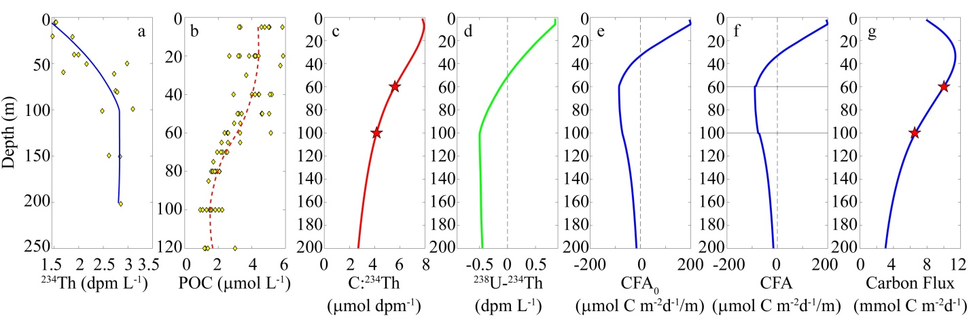
Supplementary Figure S1 – Explanation of carbon flux attenuation (CFA) calculation steps. a) Smooth ²³⁴Th data from 2-3 casts per cycle (yellow diamonds are discrete measurements). b) Smooth POC data (yellow diamonds are discrete measurements). c) Compute C:^{234Th} ratio from eq. S1 and measured C:²³⁴Th ratios in the sediment trap (red starts). d) Compute ²³⁸U-²³⁴Th disequilibrium from smoothed ²³⁴Th profiles, salinity profiles, and salinity-²³⁸U relationship. e) Compute CFA₀ from Eq. 2. f) Adjust CFA₀ in region between sediment trap depths (black horizontal lines) to ensure that it perfectly matches sediment trap measurements. g) Compute smooth profiles of carbon flux from CFA and sediment trap measurements (red stars).

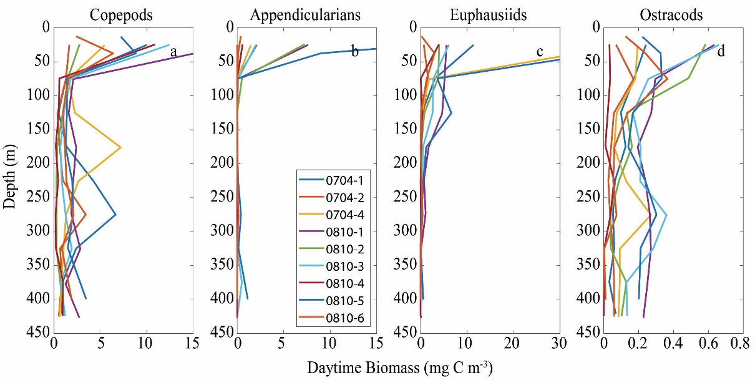
Supplementary Figure S2 – Biomass of suspension-feeding mesozooplankton captured in nighttime MOCNESS tows.

Baker, E.T., Milburn, H.B., and Tennant, D.A. (1988). Field assessment of sediment trap efficiency under varying flow conditions. Journal of Marine Research 46, 573-592.
Bond, N.A., Cronin, M.F., Freeland, H., and Mantua, N. (2015). Causes and impacts of the 2014 warm anomaly in the NE Pacific. Geophysical Research Letters 42, 3414-3420.
Brzezinski, M.A., Krause, J.W., Bundy, R.M., Barbeau, K.A., Franks, P., Goericke, R., Landry, M.R., and Stukel, M.R. (2015). Enhanced silica ballasting from iron stress sustains carbon export in a frontal zone within the California Current. Journal of Geophysical Research: Oceans 120, 4654–4669.
Buesseler, K.O., Antia, A.N., Chen, M., Fowler, S.W., Gardner, W.D., Gustafsson, O., Harada, K., Michaels, A.F., Van Der Loeff, M.R., Sarin, M., Steinberg, D.K., and Trull, T. (2007). An assessment of the use of sediment traps for estimating upper ocean particle fluxes. Journal of Marine Research 65, 345-416.
Buesseler, K.O., Bacon, M.P., Cochran, J.K., and Livingston, H.D. (1992). Carbon and nitrogen export during the JGOFS North Atlantic Bloom Experiment estimated from ²³⁴Th:²³⁸U disequilibria. Deep-Sea Research 39, 1115-1137.
Buesseler, K.O., Benitez-Nelson, C.R., Moran, S.B., Burd, A., Charette, M., Cochran, J.K., Coppola, L., Fisher, N.S., Fowler, S.W., Gardner, W., Guo, L.D., Gustafsson, O., Lamborg, C., Masque, P., Miquel, J.C., Passow, U., Santschi, P.H., Savoye, N., Stewart, G., and Trull, T. (2006). An assessment of particulate organic carbon to thorium-234 ratios in the ocean and their impact on the application of ²³⁴Th as a POC flux proxy. Marine Chemistry 100, 213-233.
Dunne, J.P., and Murray, J.W. (1999). Sensitivity of Th-234 export to physical processes in the central equatorial Pacific. Deep-Sea Research I 46, 831-854.
Jacox, M.G., Hazen, E.L., Zaba, K.D., Rudnick, D.L., Edwards, C.A., Moore, A.M., and Bograd, S.J. (2016). Impacts of the 2015–2016 El Niño on the California Current System: Early assessment and comparison to past events. Geophysical Research Letters 43, 7072-7080.
Krause, J.W., Brzezinski, M.A., Goericke, R., Landry, M.R., Ohman, M.D., Stukel, M.R., and Taylor, A.G. (2015). Variability in diatom contributions to biomass, organic matter production and export across a frontal gradient in the California Current Ecosystem. J. Geophys. Res. Oceans 120, 1032-1047.
Landry, M.R., Ohman, M.D., Goericke, R., Stukel, M.R., Barbeau, K.A., Bundy, R., and Kahru, M. (2012). Pelagic community responses to a deep-water front in the California Current Ecosystem: overview of the A-Front Study. Journal of Plankton Research 34, 739-748.
Morrow, R.M., Ohman, M.D., Goericke, R., Kelly, T.B., Stephens, B.M., and Stukel, M.R. (2018). Primary Productivity, Mesozooplankton Grazing, and the Biological Pump in the California Current Ecosystem: Variability and Response to El Niño. Deep-Sea Research I 140, 52-62.
Nickels, C.F., and Ohman, M.D. (2018). CCEIII: Persistent functional relationships between copepod egg production rates and food concentration through anomalously warm conditions in the California Current Ecosystem. Deep Sea Research I 140, 26-35.
Resplandy, L., Martin, A.P., Le Moigne, F., Martin, P., Aquilina, A., Memery, L., Levy, M., and Sanders, R. (2012). How does dynamical spatial variability impact 234Th-derived estimates of organic export? Deep-Sea Research I 68, 24-45.
Savoye, N., Benitez-Nelson, C., Burd, A.B., Cochran, J.K., Charette, M., Buesseler, K.O., Jackson, G.A., Roy-Barman, M., Schmidt, S., and Elskens, M. (2006). ²³⁴Th sorption and export models in the water column: A review. Marine Chemistry 100, 234-249.
Siegel, D.A., and Deuser, W.G. (1997). Trajectories of sinking particles in the Sargasso Sea: modeling of statistical funnels above deep-ocean sediment traps. Deep Sea Research I 44, 1519-1541.
Stukel, M.R., Aluwihare, L.I., Barbeau, K.A., Chekalyuk, A.M., Goericke, R., Miller, A.J., Ohman, M.D., Ruacho, A., Song, H., Stephens, B.M., and Landry, M.R. (2017). Mesoscale ocean fronts enhance carbon export due to gravitational sinking and subduction. Proceedings of the National Academy of Sciences 114, 1252-1257.
Stukel, M.R., Asher, E., Coutos, N., Schofield, O., Strebel, S., Tortell, P.D., and Ducklow, H.W. (2015). The imbalance of new and export production in the Western Antarctic Peninsula, a potentially "leaky" ecosystem. Global Biogeochemical Cycles 29, 1400-1420.
Stukel, M.R., Kelly, T.B., Aluwihare, L.I., Barbeau, K.A., Goericke, R., Krause, J.W., Landry, M.R., and Ohman, M.D. (2019). The Carbon:²³⁴Thorium ratios of sinking particles in the California Current Ecosystem 1: Relationships with plankton ecosystem dynamics. . Marine Chemistry.
Stukel, M.R., Ohman, M.D., Benitez-Nelson, C.R., and Landry, M.R. (2013). Contributions of mesozooplankton to vertical carbon export in a coastal upwelling system. Marine Ecology Progress Series 491, 47-65.

