Online Supplemental Material

Abrupt decrease in the diversity of Euglossini bees (Hymenoptera: Apidae) in a montane rainforest
Alessandra Ribeiro Pintoª, Guilherme do Carmo Silveira^{b}, Maria Cristina Gaglianone^{c}, Leandro Freitasª*
ª Jardim Botânico do Rio de Janeiro (JBRJ), Rua Pacheco Leão, 915, CEP 22460030, Rio de Janeiro, RJ, Brazil; ^{b} Instituto Federal de Educação, Ciência e Tecnologia Sudeste de Minas Gerais, Rua Técnico Panamá, 45, CEP 36240-000, Santos Dumont, MG, Brazil; ^{c} Universidade Estadual do Norte Fluminense Darcy Ribeiro, Laboratório de Ciências Ambientais, CEP 28013620, Campos dos Goytacazes, RJ, Brazil
*Corresponding author. Email: lfreitas.jbot@gmail.com

Figure S1. Climatic data from the Teresópolis automatic station during study time. Monthly averages of minimum (Min) and maximum (Max) temperatures, and monthly rainfall (Rain).
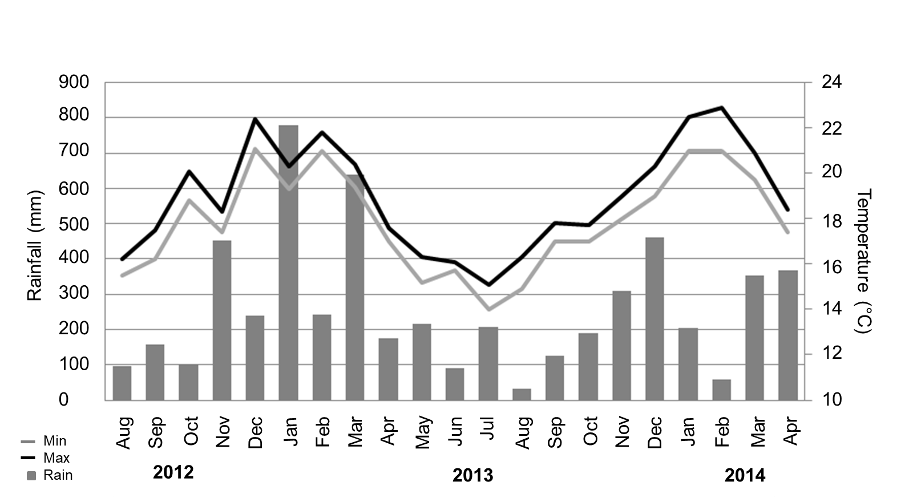

Table S1. Orchid species bearing scent-flowers, probably pollinated by Euglossini males, from the region of the study. Occurrence in the montane forests of the Serra dos Órgãos (“Teresópolis”) and in the study area (“PARNASO”, 900 up 1500 m of altitude).
Species | Teresópolis | PARNASO 900-1500 m
Bifrenaria atropurpurea Lindl. | X | X
Bifrenaria aureofulva Lindl.
Bifrenaria leucorrhoda Rchb.f.
Bifrenaria racemosa (Hook.) Lindl. | X
Bifrenaria stefanae V.P.Castro | X | X
Bifrenaria vitellina (Lindl.) Lindl.
Catasetum cernuum (Lindl.) Rchb.f.
Cirrhaea dependens (Lodd.) Loudon
Cirrhaea loddigesii Lindl. | X
Cirrhaea fuscolutea Lindl. | X | X
Dichaea anchorifera Rchb.f.
Dichaea cogniauxiana Schltr. | X | X
Dichaea pendula (Aubl.) Cogn. | X | X
Dichaea trulla Rchb.f. | X
Encyclia oncidioides (Lindl.) Schltr. | X | X
Encyclia patens Hook. | X
Eulophia alta (L.) Fawc. & Rendle | X
Gongora bufonia Lindl.
Neogardneria murrayana (Gardner ex Hook.) Schltr.
Notylia lyrata S.Moore | X
Promenaea stapelioides (Link & Otto) Lindl. | X | X
Promenaea xanthina Lindl. | X | X
Prosthechea widgrenii (Lindl.) W.E.Higgins
Prosthechea fragrans (Sw.) W.E.Higgins | X | X
Scuticaria hadwenii (Lindl.) Planch. | X
Warrea warreana (Lodd. ex Lindl.) C.Schweinf. | X | X
Zygopetalum pedicellatum (Thunb.) Garay | X | X

