Supplementary material

Table S1. Elevations, latitude, longitude and soil characteristics of the 18 sites, sorted by vegetation type (Veg type) and elevation. Coordinates are expressed as northings (NS) and eastings (EW) in the Swiss national coordinate system. Short: short-grass vegetation, Tall: tall-grass vegetation, C: carbon, N: nitrogen, OM: organic matter. Soil temp: soil temperature, Soil moist: soil moisture.

|  |  |  |  |  |  |  |  |  |  |  |  |  |
| --- | --- | --- | --- | --- | --- | --- | --- | --- | --- | --- | --- | --- |
| **Veg type** | **Altitude** | **Latitude** | **Longitude** | **Soil C:N** | **Soil OM** | **Soil pH** | **Sand** | **Silt** | **Clay** | **Soil textural class** | **Soil**  **temp** | **Soil**  **moist** |
|  | (m) | NS | EW | ratio | (%) |  | (%) | (%) | (%) |  | °C | % vol. |
| Short | 1975 | 46°39’49.09” | 10°14’31.87” | 24.581 | 9.52 | 7.70 | 55.4 | 39.4 | 5.2 | sandy loam | 13.8 | 31.9 |
| Short | 1980 | 46°39’50.39” | 10°14’27.92” | 26.444 | 9.47 | 7.69 | 58.2 | 36.6 | 5.2 | sandy loam | 13.8 | 28.4 |
| Short | 2032 | 46°39’55.52” | 10°11’22.69” | 15.675 | 12.93 | 7.74 | 48.2 | 38.6 | 13.2 | loam | 14.8 | 27.5 |
| Short | 2079 | 46°39’53.50” | 10°14’17.29” | 15.293 | 11.22 | 7.28 | 44.6 | 39.0 | 16.4 | loam | 13.3 | 29.0 |
| Short | 2091 | 46°40’26.03” | 10°13’55.17” | 30.834 | 7.15 | 7.50 | 82.4 | 17.6 | 0.0 | loamy sand | 14.0 | 25.0 |
| Short | 2133 | 46°40’19.97” | 10°14’43.90” | 26.666 | 6.20 | 7.81 | 40.4 | 49.2 | 10.4 | loam | 12.7 | 43.0 |
| Short | 2170 | 46°42’23.13” | 10°16’17.14” | 16.565 | 28.71 | 6.59 | 57.5 | 37.7 | 4.8 | sandy loam | 10.7 | 42.4 |
| Short | 2181 | 46°42’23.71” | 10°16’14.95” | 26.622 | 8.43 | 7.18 | 60.8 | 37.0 | 2.2 | sandy loam | 11.8 | 29.5 |
| Short | 2275 | 46°40’29.54” | 10°14’39.78” | 20.975 | 7.28 | 7.10 | 46.0 | 31.6 | 22.4 | loam | 11.5 | 40.3 |
| Tall | 1981 | 46°40’29.54” | 10°14’32.39” | 25.283 | 12.81 | 7.60 | 56.0 | 34.4 | 9.6 | sandy loam | 12.1 | 23.1 |
| Tall | 1986 | 46°39’51.41” | 10°14’28.24” | 21.626 | 15.84 | 7.60 | 53.4 | 37.2 | 9.4 | sandy loam | 12.3 | 26.4 |
| Tall | 2060 | 46°39’56.43” | 10°11’22.49” | 15.513 | 13.42 | 7.63 | 48.2 | 39.6 | 12.2 | loam | 14.6 | 25.0 |
| Tall | 2075 | 46°40’24.71” | 10°13’56.68” | 23.554 | 13.25 | 7.60 | 59.2 | 37.6 | 3.2 | sandy loam | 12.4 | 25.7 |
| Tall | 2112 | 46°39’52.47” | 10°11’16.75” | 14.493 | 8.67 | 7.12 | 39.5 | 32.7 | 27.8 | clay loam | 11.6 | 29.0 |
| Tall | 2140 | 46°40’21.06” | 10°14’46.67” | 33.332 | 5.72 | 7.84 | 60.4 | 36.2 | 3.4 | sandy loam | 13.0 | 28.1 |
| Tall | 2162 | 46°42’24.93” | 10°16’15.84” | 30.832 | 8.87 | 7.40 | 53.6 | 41.0 | 5.4 | sandy loam | 10.8 | 41.8 |
| Tall | 2176 | 46°42’23.95” | 10°16’15.93” | 20.988 | 11.70 | 7.40 | 49.8 | 41.0 | 9.2 | loam | 10.7 | 42.5 |
| Tall | 2299 | 46°40’32.48” | 10°14’41.25 | 14.292 | 9.86 | 6.33 | 49.8 | 28.6 | 21.6 | loam | 10.7 | 44.0 |

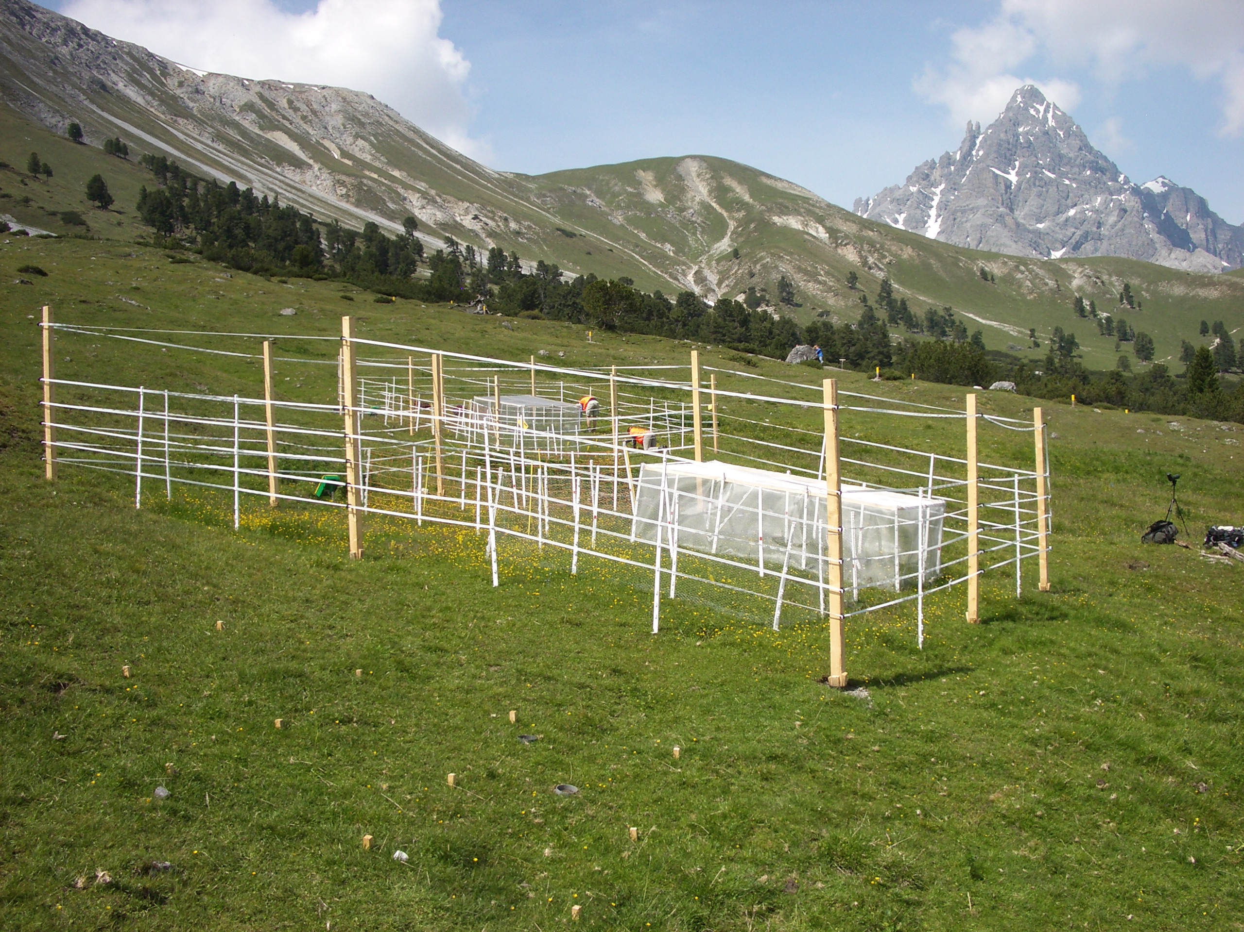

**Figure S1.** Experimental setup of the size-selective exclosures used to progressively exclude vertebrate and invertebrate consumers. Photo of one of our 18 exclosure setups in the field.



**Figure S2:** Extent of the intraspecific species trait variance including specific leaf area (SLA), leaf carbon (C) concentration, leaf nitrogen (N) concentration and leaf phosphorus (P) concentration in the two vegetation types, A) Short- and B) tall-grass vegetation. F1 = *Galium anisophyllon*, F2 = *Crepis alpestris*, L1 = *Lotus corniculatus,* L2 = *Trifolium repens*, G1 = *Festuca rubra*, G2 = *Briza media*, S1= *Carex sempervirens*, and S2 = *Carex caryophyllea*. A violin plot is a combination of both a boxplot and a kernel density plot, which is a non-parametric method for estimating the probability density function of a random variable.

Figure S3: PCAs for all four-leaf traits collected from each of the species from the A) short-grass, and B) tall-grass vegetation.



Figure S4: Functional distance between species based on all four-leaf traits. Densities of Mahalanobis distances are calculated between individuals from the species *Carex caryophyllea* and individuals of all other focal species in both the A) short-grass vegetation, and B) tall-grass vegetation. Small differences infer pairs of individuals show similar traits.



Figure S5: Functional distance between species based on all four-leaf traits. Densities of Mahalanobis distances are calculated between individuals from the species *Galium anisophyllon* and individuals of all other focal species in both the A) short-grass vegetation, and B) tall-grass vegetation. Small differences infer pairs of individuals show similar traits.



Figure S6: Functional distance between species based on all four-leaf traits. Densities of Mahalanobis distances are calculated between individuals from the species *Crepis alpestris* and individuals of all other focal species in both the A) short-grass vegetation, and B) tall-grass vegetation. Small differences infer pairs of individuals show similar traits.



Figure S7: Functional distance between species based on all four-leaf traits. Densities of Mahalanobis distances are calculated between individuals from the species *Festuca rubra* and individuals of all other focal species in both the A) short-grass vegetation, and B) tall-grass vegetation. Small differences infer pairs of individuals show similar traits.



Figure S8: Functional distance between species based on all four-leaf traits. Densities of Mahalanobis distances are calculated between individuals from the species *Briza media* and individuals of all other focal species in both the A) short-grass vegetation, and B) tall-grass vegetation. Small differences infer pairs of individuals show similar traits.



Figure S9: Functional distance between species based on all four-leaf traits. Densities of Mahalanobis distances are calculated between individuals from the species *Lotus corniculatus* and individuals of all other focal species in both the A) short-grass vegetation, and B) tall-grass vegetation. Small differences infer pairs of individuals show similar traits.



Figure S10: Functional distance between species based on all four-leaf traits. Densities of Mahalanobis distances are calculated between individuals from the species *Trifolium repens* and individuals of all other focal species in both the A) short-grass vegetation, and B) tall-grass vegetation. Small differences infer pairs of individuals show similar traits.