Section 5:
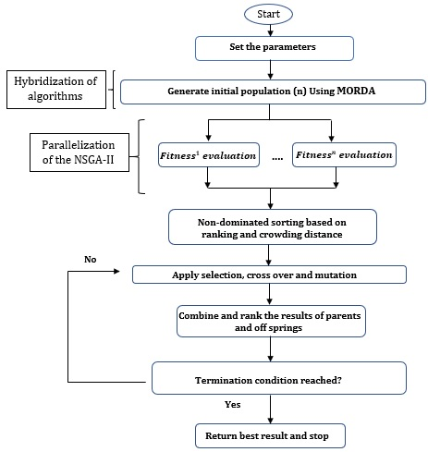
Section 5. The flowchart of the proposed HRDPGA

