**Electronic supplementary material**

**Description of the stochastic population model**

At any temporal point in a given simulation run the population is described by a cohort of juveniles, sub-adults at all stages, non-breeding adults (i.e. those that skip breeding) and failed and successful adult breeders. Those individuals may belong to one of the two habitats that typify our simulated scenario. Growth from one stage to the next one, shift between habitats and the birth and establishment of new individuals are all computed by stochastically drawing from corresponding binomial distributions. See Figure S1 for a graphic overview of all possible state transitions and Table S1 for parameters definition.

1. The first calculation, for a given temporal step $t$ and for each habitat, is to calculate how many full adults will become non-breeders and how many will be (successful or failed) breeders:
$$A_{h,t}^{b}=Bin\left(A_{h,t},p_{h}^{b}\right)$$

2. Then, we enter the breeding algorithm, which runs recursively $m$ times within a loop. Within this loop only juvenile recruitment and survival, as well as habitat shift for successful and failed adult breeders are evaluated.
   1. Within the loop, at the beginning of a given brooding event $i$, the number of adults that breed successfully is decided for each habitat by randomly drawing from a binomial distribution:
 $$A_{h,t}^{b_{s}}=Bin\left(A_{h,t}^{b},1-p_{h}^{b_{f}}\right)$$

  2. That, in turn, allows us to calculate the number of adults that fail to breed:
 $$A_{h,t}^{b_{f}}=A_{h,t}^{b}{-A}_{h,t}^{b_{s}}$$

  3. Then, the number of juveniles that are bred and survive until the next year are updated at each loop step as:
 $$J_{h,t}=J_{h,t}+Bin\left(A_{h,t}^{b_{s}}∙q,p_{h,S_{j}}\right)$$

  4. Next, after hatching has taken place, part of the successful or failed adult population may move between habitats. We model those actions by stochastically drawing from a binomial distribution the number of adults that change habitat:

$$∆_{1→2}^{x}=Bin\left(A_{1,t}^{x},p_{1→2}^{x}\right)$$

$$∆_{2→1}^{x}=Bin\left(A_{2,t}^{x},p_{2→1}^{x}\right)$$

Where, in this case, .

* 1. Then, the number of successful and failed breeders will be updated:

$$A_{1,t}^{x}=A_{1,t}^{x}-∆_{1→2}^{x}+∆_{2→1}^{x}$$

$$A_{2,t}^{x}=A_{2,t}^{x}-∆_{2→1}^{x}+∆_{1→2}^{x}$$

And thus, with the new calculation:

$$A_{1,t}^{b}=A_{1,t}^{b_{s}}+A_{1,t}^{b_{f}}$$

$$A_{2,t}^{b}=A_{2,t}^{b_{s}}+A_{2,t}^{b_{f}}$$

Then the algorithm goes back to point a) above $m$ times, after which it jumps from e) above to point 3 just below.

1. When the simulation includes sub-adults (i.e. age of first reproduction >1), we must account for the fact that they may also move between habitats:
$$∆_{1→2}^{r}=Bin\left(S_{1,t}^{r},p_{1→2}^{r}\right)$$

$$∆_{1→2}^{r}=Bin\left(S_{2,t}^{r},p_{2→1}^{r}\right)$$

2. Moreover, sub-adults are also affected by survival, which is modeled by stochastically drawing from a binomial distribution:
$$S_{1,t+1}^{r}=Bin\left(S_{1,t+1}^{r}-∆_{1→2}^{r}+∆_{2→1}^{r},p_{1,S_{sa}}\right)$$

$$S_{2,t+1}^{r}=Bin\left(S_{2,t+1}^{r}-∆_{2→1}^{r}+∆_{1→2}^{r},p_{{2,S}_{sa}}\right)$$

3. Then, we also allow non-breeders to change habitats by stochastically drawing from a binomial distribution:
$$∆_{1→2,t}^{nb}=Bin\left(A_{1,t}^{nb},p_{1→2}^{nb}\right)$$

$$∆_{2→1,t}^{nb}=Bin\left(A_{1,t}^{nb},p_{2→1}^{nb}\right)$$

4. Consequently, the population at $t+1$ of those non-breeding adults must be updated as follows:
$$A_{1,t+1}^{nb}=A_{1,t}^{nb}-∆_{1→2}^{nb}+∆_{2→1}^{nb}$$

$$A_{2,t+1}^{nb}=A_{2,t}^{nb}-∆_{2→1}^{nb}+∆_{1→2}^{nb}$$

5. Next, we account for survival probability of all types of adults:

$$A_{h,t+1}^{x}=Bin\left(A_{h,t+1}^{x},p_{h,S_{x}}\right)$$

where, in this case, $x∈\left\{b_{s},b_{f},nb\right\}$. Values $A_{h,t+1}^{x}$ inside the binomial correspond to those at the end of the breeding loop when $x=b_{s}$ or $x=b_{f}$.

1. Total adult population is then:
$$A_{h,t+1}=\sum_{x∈\left\{b_{s},b_{f},nb\right\}}{A_{h,t+1}^{x}}$$

2. Finally, populations are updated simply by moving up one stage and juveniles become adults or sub-adults according to the age of first reproduction.

**Exploration of the parameter space**

The range of demographic parameters comes from empirical data from birds. With the chosen parameters we estimated juvenile survival $p_{1,S_{j}}$ for a given deterministic growth rate λ corresponding to the Leslie matrix model by solving the Euler-Lotka equation:

$$p_{1,S_{j}}=\frac{{p_{1,S_{sa}}}^{1-AFR}\left(λ^{1+AFR}-p_{1,S_{b}}*λ^{AFR}\right)}{q*λ}$$

where AFR is the age at first reproduction and other notation follows Table S1. Once demographic parameters in habitat 1 are defined we modify the habitat 2 parameters according to the different scenarios. In Scenario 1, the parameters in habitat 2 are the same than in habitat 1. In Scenario 2 we increase adult and subadult mortality *n* times (1.5 in Scenario 2.1 and 2 in Scenario 2.2). To increase *p* probabilities *n* times we apply $p^{n}$ and therefore, adult survival in habitat 2 is:

$$p_{2,S_{b}}=1-{\left(1-p_{1,S_{b}}\right)}^{1/n}$$

For Scenario 3 we apply the increase in breeding fail as follows:

$$p_{2}^{b_{f}}=1-{\left(1-p_{1}^{b_{f}}\right)}^{1/n}$$

table S1. Notation followed to describe the stochastic population model.

|  |  |
| --- | --- |
| **Symbol** | **Definition** |
| $$q$$ | Number of offsprings per brood in habitat $h$. |
| $$m$$ | Number of broods per year. |
| $$n_{Sa}$$ | Number of sub-adult stages. |
| $$x$$ | Labels $x$ may take the values $\left\{j,sa,b,nb,b_{s},b_{f}\right\}$, where these values refer to juveniles, subadults, adults (i.e. sum of all types), non-breeding adults, successful breeders and failed breeders, respectively. |
| $$h$$ | Index for habitat type, $h=\{1,2\}$ |
| $$r$$ | Label for subadult stage, $r∈\left\{r_{1}⋯r_{n_{Sa}}\right\}$. |
| $$t$$ | Subindex for time steps, measured in years, $t=\left\{1⋯50\right\}$ |
| $$p_{h}^{b}$$ | Probability for an individual to become a breeder (successful or not) in habitat $h$. |
| $$p_{h}^{b_{f}}$$ | Probability for a possible breeder individual to be a failed breeder in habitat $h$. |
| $$p_{h,S_{x}}$$ | Probability of survival in habitat $h$ for individuals $x$. |
| $$p_{1→2}^{x}$$ $$p_{2→1}^{x}$$ | Probability for an adult to move from habitat type 1 to 2, or vice versa. |
| $$p_{1→2}^{r}$$ $$p_{2→1}^{r}$$ | Probability for a stage-r subadult to move from habitat type 1 to 2, or vice versa. |
| $$J_{h,t}$$ | Number of juveniles that have born in habitat $h$ at time step $t$. |
| $$S_{h,t}^{r}$$ | Number of stage- $r$ subadults in habitat $h$ in year $t$. |
| $$A_{h,t}$$ | Total number of adults in habitat $h$ at time $t$. |
| $$A_{h,t}^{x}$$ | Number of adults of type $x$ in habitat $h$ at time step $t$. |
| $$∆_{1→2}^{x}$$ $$∆_{2→1t}^{x}$$ | Number of adults that will move from habitat type 1 to habitat 2, or viceversa. |
| $$∆_{1→2}^{r}$$ $$∆_{2→1}^{r}$$ | Number of sub-adults at time $t$ that will move from habitat type 1 to habitat 2, or viceversa. |

|  |
| --- |
|  |
| figure S1. Flowchart of the stochastic simulation model. Notation is the same as in Table S1 above.    figure S2. Simulations of probability of population persistence as a function of behavioural responses for different initial population sizes according to different life histories (fast and slow). See figure 1 for details. In this case we shown the results for simulations with strong behavioural responses.    figure S3. Final population size (Ntf, median and 95% confidence interval of the 10000 replicates) of the simulations shown in figure 1. Black dashed lines show the initial population size. |

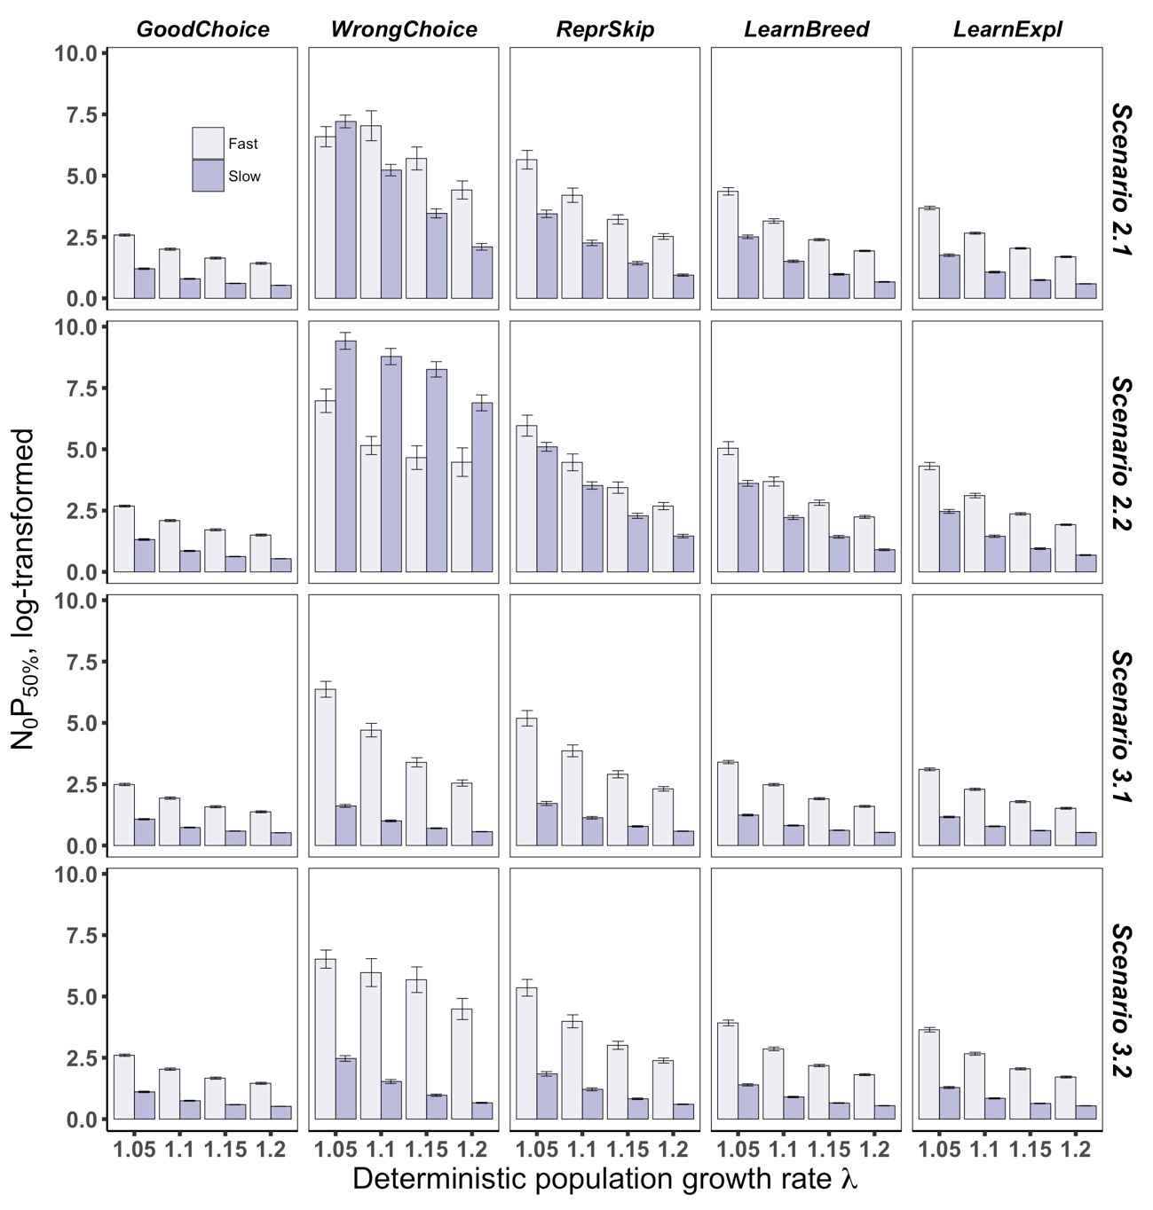

figure S4. Effects of behavioural responses on population persistence in novel environments as a function of the position of the animal along the fast-slow continuum. Population persistence is estimated as *N0P50%* and behavioural responses are strong. The position of the animal along the fast-slow continuum is assessed as the relative sensitivity (i.e. elasticity) of population growth to changes in fecundity, with slow-lived strategies exhibiting low elasticities and fast-lived strategies exhibiting high elasticities. For details on abbreviation, see fig. 1.

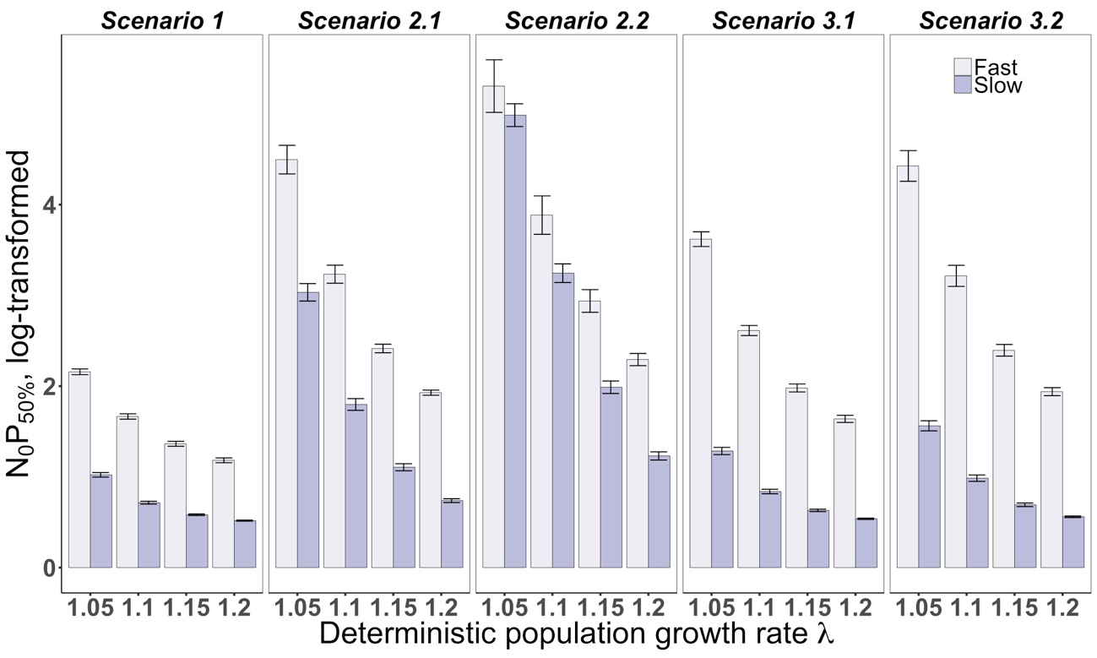

figure S5. Population persistence in novel environments as a function of the position of the animal along the fast-slow continuum for different environment al scenarios. Population persistence is estimated as *N0P50%*.

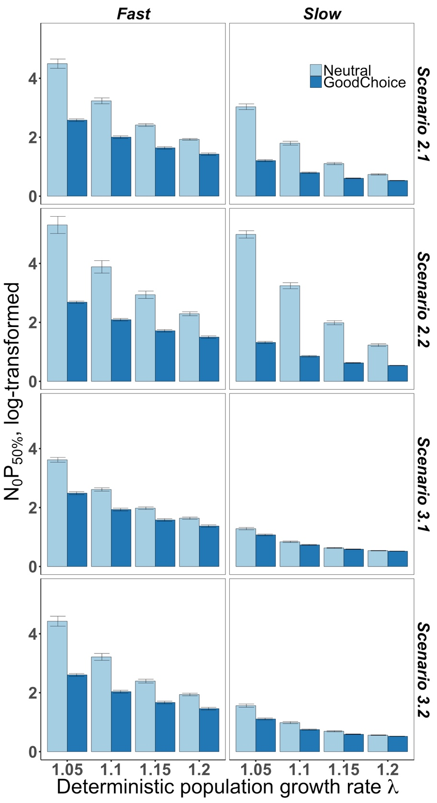

figure S6. Influence of habitat matching choice on population persistence in novel environments as a function of the position of the species along the fast-slow continuum. Benefits and costs of the behaviour under different environmental scenarios are reflected in differences in *N0P50%* between simulations where individuals’ behaviour is either considered neutral or to reflect an innate preference for the high-quality habitat.

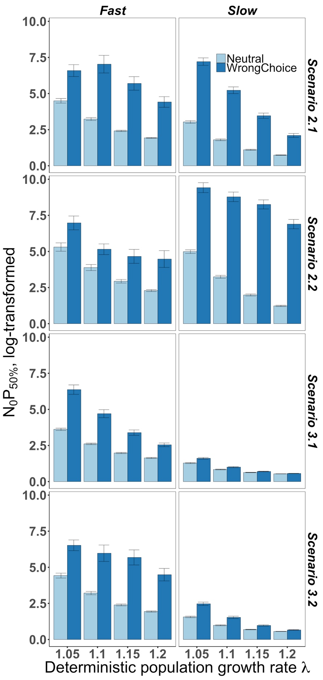

figure S7. Influence of an inappropriate habitat matching choice on population persistence in novel environments as a function of the position of the species along the fast-slow continuum. Benefits and costs of the behaviour under different environmental scenarios are reflected in differences in *N0P50%* between simulations where individuals’ behaviour is either considered neutral or to reflect an innate preference for the low-quality habitat.

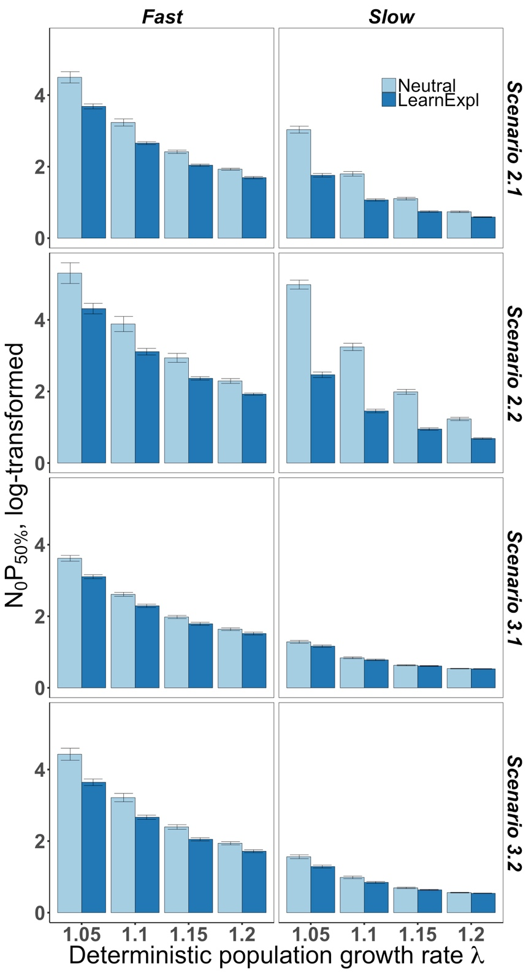

figure S8. Influence of learning through exploration on population persistence in novel environments as a function of the position of the species along the fast-slow continuum. Benefits and costs of the behaviour under different environmental scenarios are reflected in differences in *N0P50%* between simulations where individuals show (LearnExpl) or do not show (Neutral) a decreased preference for the low-quality habitat after exploring any of the two habitats.

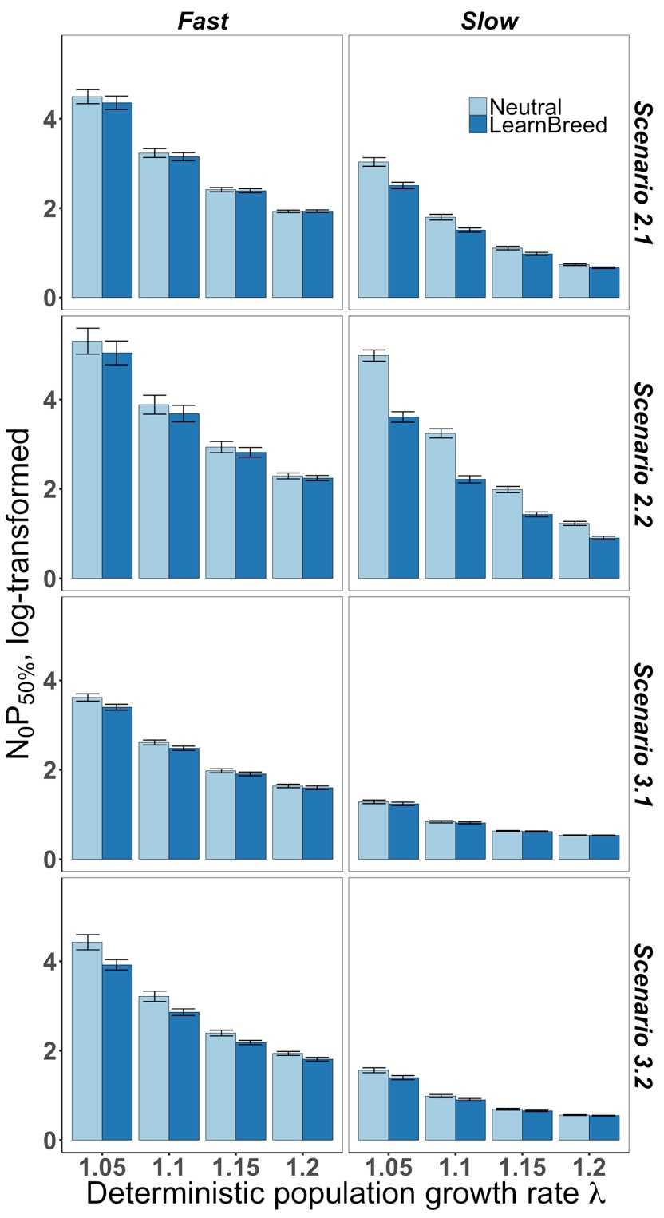

figure S9. Influence of learning from a breeding experienceon population persistence in novel environments as a function of the position of the species along the fast-slow continuum. Benefits and costs of the behaviour under different environmental scenarios are reflected in differences in *N0P50%* between simulations where individuals’ decision about changing habitat depends (LearnBreed) or not (Neutral) on the success of the past breeding attempt.

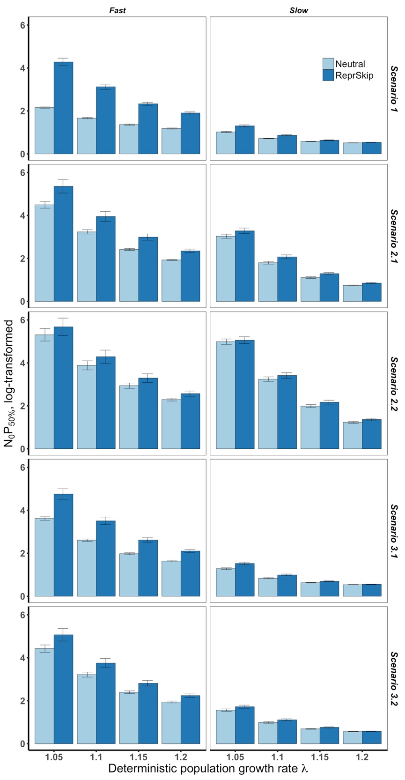

figure S10. Influence of a reproductive skipon population persistence in novel environments as a function of the position of the species along the fast-slow continuum. Benefits and costs of the behaviour under different environmental scenarios are reflected in differences in *N0P50%* between simulations where individuals either have the option (ReprSkip) or not (Neutral) to skip a reproductive event.

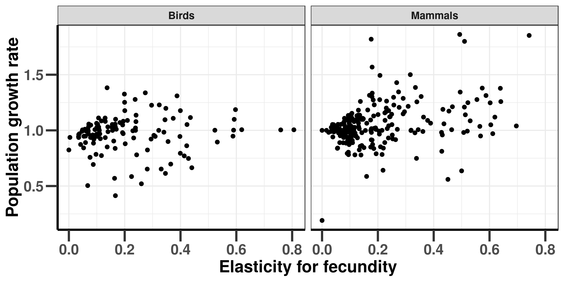

figure S11. Relationship between the fast-slow continuum and population grow rate (λ) in wild populations of birds and mammals suggesting that population growth rate is not higher for fast-lived strategies than for slow-lived strategies. Data come from COMADRE [57]. The fast-slow continuum is defined as the elasticity of population growth to changes in net fecundity, based on demographic analysis using the popbio R-package [58].