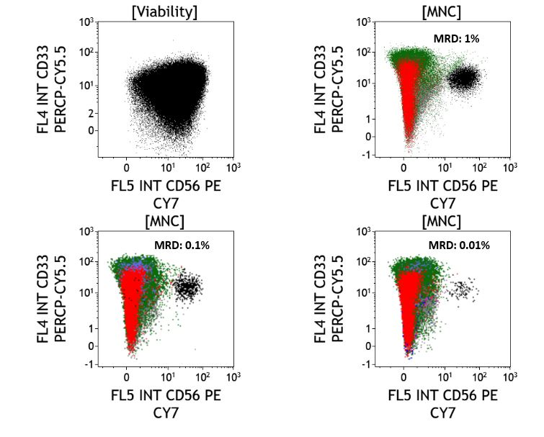
Supplementary Figure 1: Limit of Detection experiment for the 8 colour FCM MRD assay. The plot on upper left represents the leukemic sample. The upper right plot shows dilution at 1%, the lower left and right plots show dilution at 0.1 and 0.01%.

PI MRD Positive (n=108*) | Did Not Relapse (68) | Relapsed (40) | p value
Favorable Cytogenetics | 22 | 11 | p=0.88
Intermediate Cytogenetics | 36 | 19
Poor Cytogenetics | 10 | 10
FLT3-ITD Positive | 14 | 8
FLT3-ITD Negative | 54 | 32
NPM1 Positive | 13 | 12
NPM1 Negative | 55 | 28
CEBPA Positive | 5 | 2
CEBPA Negative | 62 | 35
PI MRD Negative (n=191) | Did Not Relapse (151) | Relapsed (41)
Favorable Cytogenetics | 55 | 14 | p=0.47
Intermediate Cytogenetics | 86 | 20
Poor Cytogenetics | 9 | 7
FLT3-ITD Positive | 35 | 10
FLT3-ITD Negative | 114 | 31
NPM1 Positive | 47 | 18
NPM1 Negative | 102 | 23
CEBPA Positive | 14 | 3
CEBPA Negative | 128 | 33
Supplementary Table 1: Differences in characteristics of patients who were post induction MRD positive and relapsed/ post induction MRD positive and did not relapse as well as patients who were post induction MRD negative and relapsed/ post induction MRD negative and did not relapse. *One patient was excluded from this analysis as he died during the consolidation phase of therapy

