Appendix

Table A. Inclusion and exclusion criteria for endoscopic lung volume reduction using one-way valves

Inclusion | Exclusion
40-75 years of age | Immobile/very low/no potential for rehabilitation after intervention
Emphysema with hyperinflation | Pulmonary hypertension, infections, bronchiectasis
FEV₁ 15-45 % of the expected value (%P) | Asthma/non-treatable chronic purulent bronchitis
TLC ≥ 125 %P | Smoking within the last 6 months
RV > 200 %P | Daily treatment of oral steroid > 10 mg
DL_{CO} > 15 % | Thoracic deformities, prior pulmonary surgery, and severe pleural affection
MRC = 3-5 | Latex allergy
pO₂ > 6.0 kPa, pCO₂ < 7.5 kPa | Severe co-morbidity: malignant disease, symptomatic ischemic heart disease, kidney disease requiring hemodialysis, liver cirrhosis, severe malnutrition, obesity, osteoporosis

Figure A. Lung segmentation on CT.
Upper left: The initial lung segmentation into right and left lung. Upper right: Defining the interlobar fissure between lower and middle/upper lobe on right lung. Lower left: Defining the interlobar fissure between upper and lower lobe on left side. Lower right: The 3D presentation of the lobar quantification.

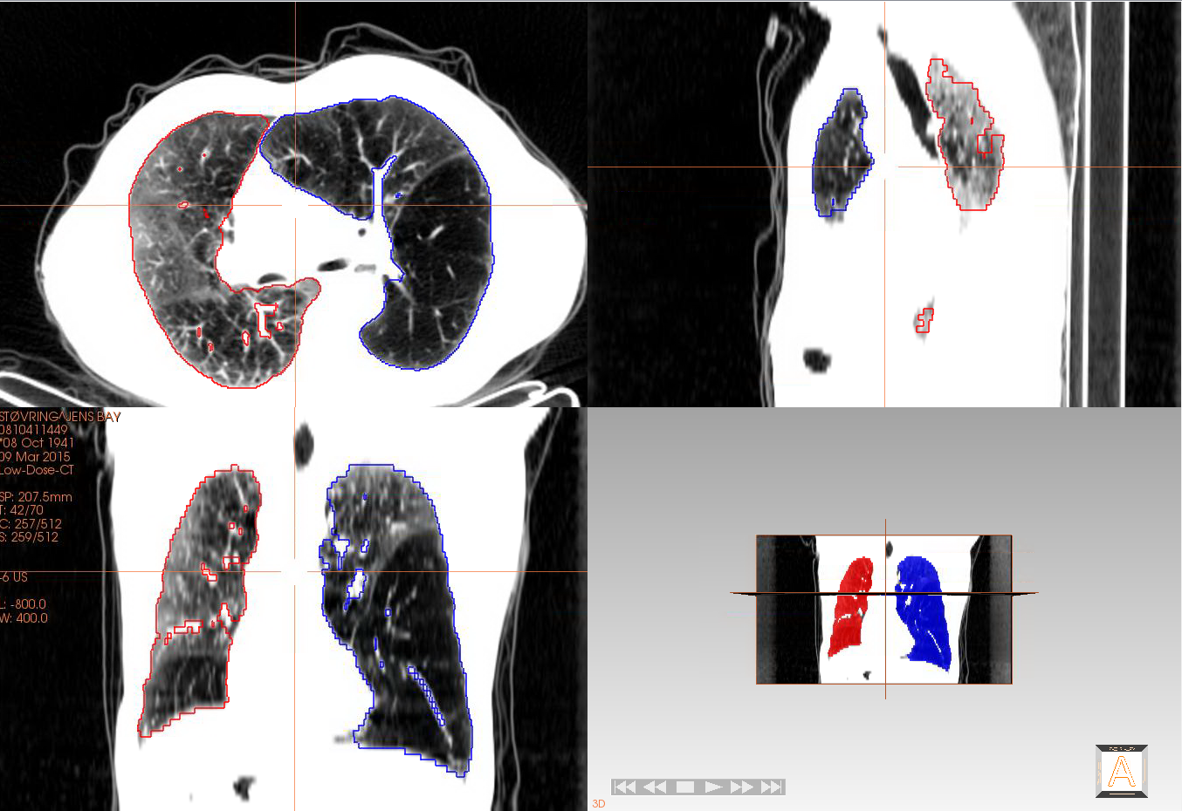 |  | 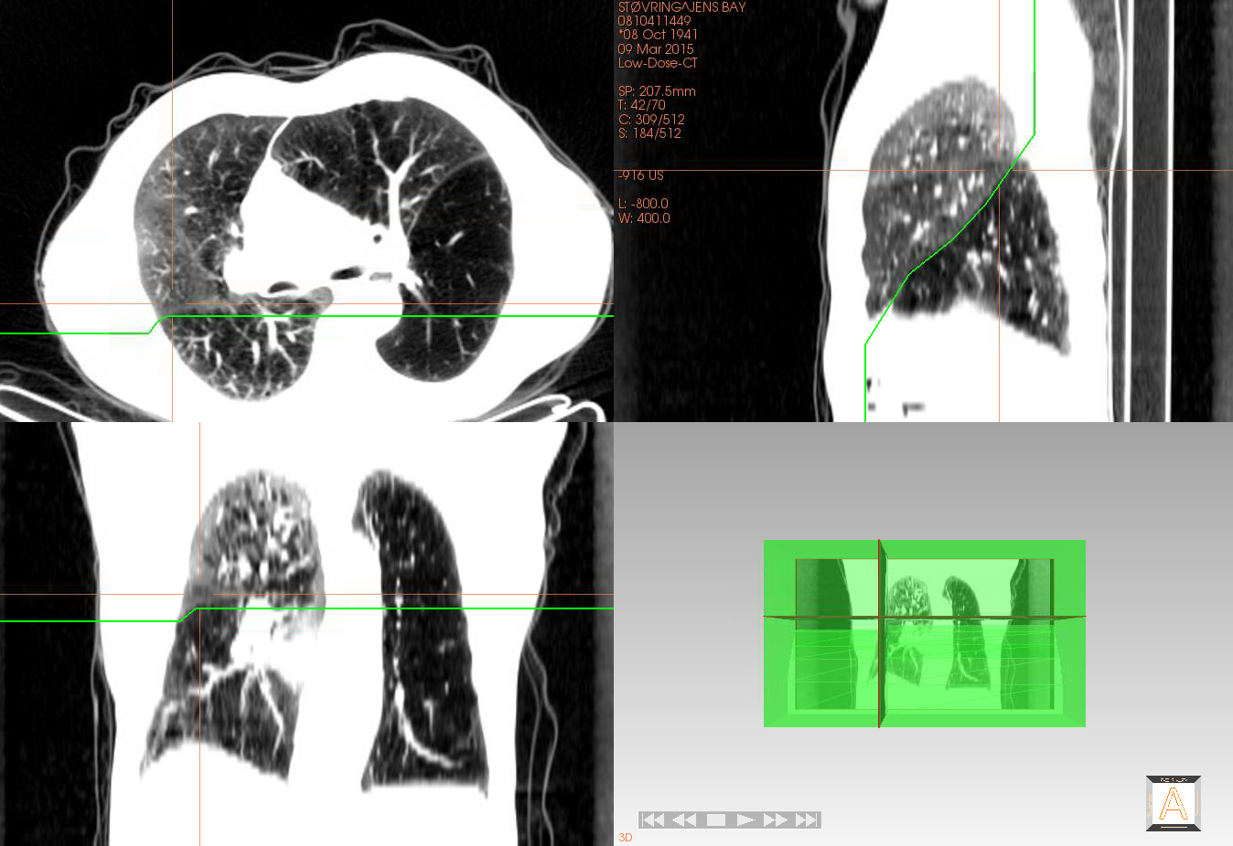
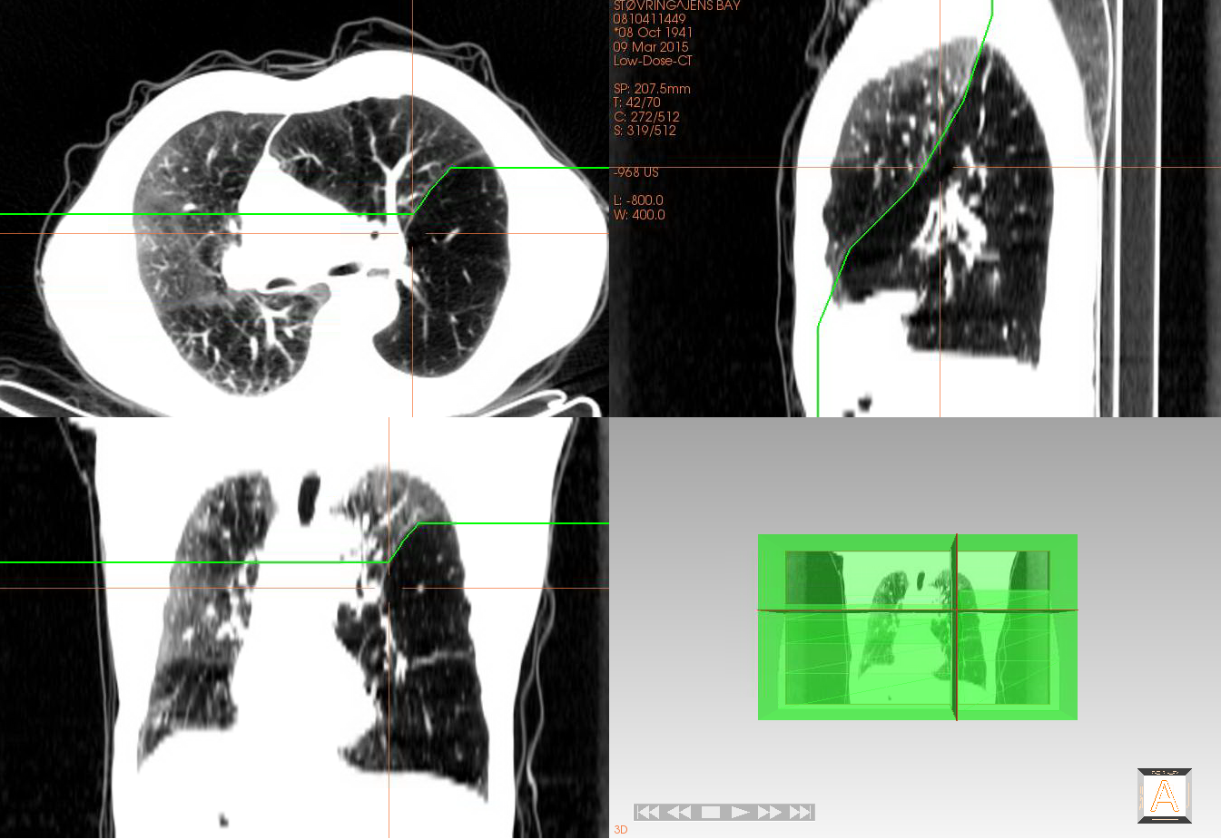 | 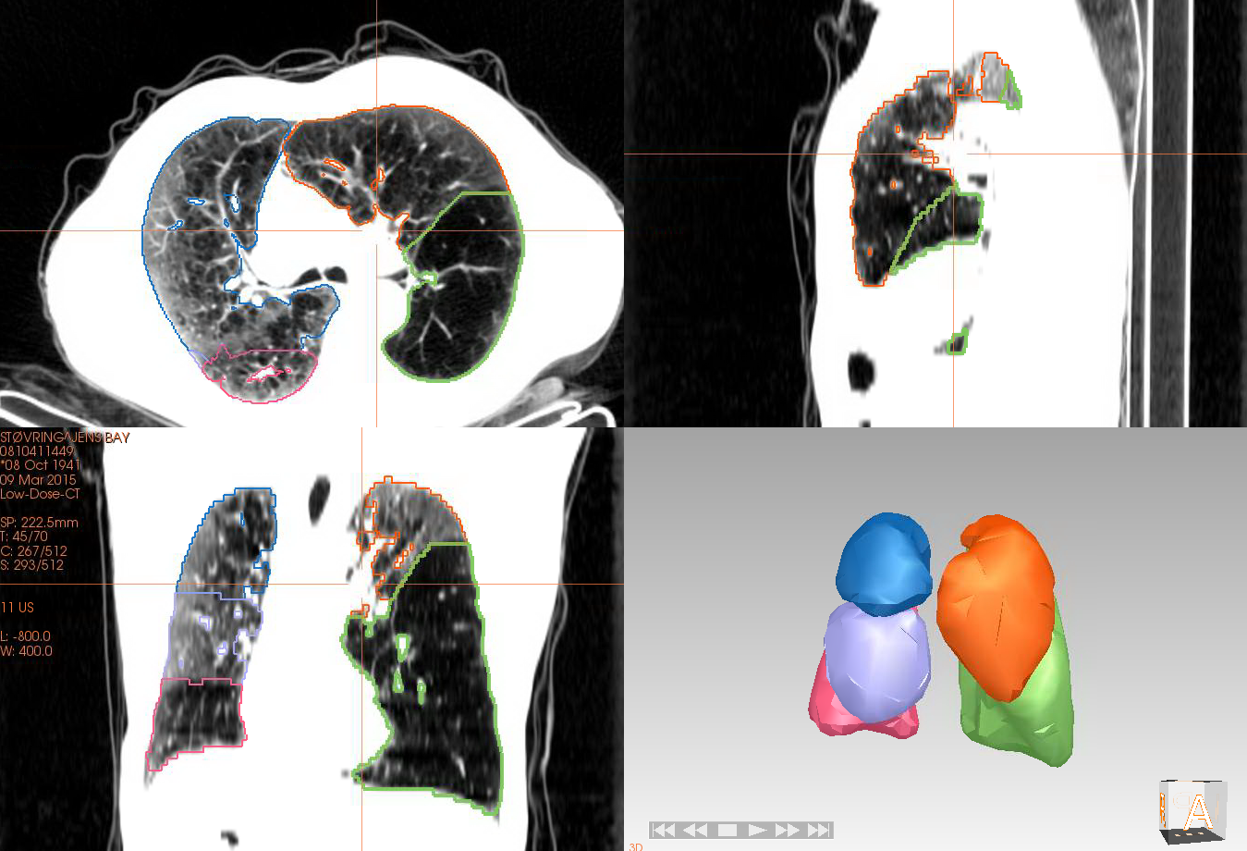

Table B. Overview of pulmonary volumes assessed using SPECT/CT scans and FRC. (%) Indicates the fraction of the total lung volume. #: The relative change within the investigated area, and in relation to the total lung volume. *=Significant, p<0.05.
 | Baseline  (mean ± SD) | Post-intervention  (mean ± SD) | Absolute change following intervention (mean percentage ± 95% CI) | Relative change  following intervention  (mean percentage ± 95% CI)#
Volume of target lobe  (SPECT/CT) (mL, %) | 1393±413 mL  24.5±5.4 % | 998±2.6 mL  18.3±7.1 % | -395±199 mL*  -6.2±3.2 %* | -26.8±13.1 %*  -23.7±11.8 %*
Volume of Non-targeted lobes on ipsilateral side to intervention  (SPECT/CT) (mL, %) | 1587±614 mL  27.4±6.3 % | 1609±591 mL  30.2±7.8 % | 21.8±139 mL  2.8±1.8 %* | 3.5±9.7 %  10.2±6.9 %
Volume of Contralateral lung to intervention  (SPECT/CT) (mL, %) | 2781±864 mL  48.7±4.6 % | 2680±753 mL  51±8.5 % | -101±219 mL  2.3±2.7 % | -0.24±10 %  4.6±5.8 %
Total lung volume  (SPECT/CT) (mL) | 5745±1519 mL | 5325±1376 mL | -420±382 mL* | -6.0±6.5 %
FRC  (Body plethysmography) (L, Predicted) | 6.2±2 L  197±49 %P | 6.1±1.3 L  192.5±31.4 %P | -0.008±0.6 L  -1.6±16 %P | -25±47 %  -5.5±13 %

Figure B. Correlations between clinical data and imaging results.
N=13. r= Pearson’s r. Clinical data vs. planar imaging data (red). Clinical data vs. SPECT/CT imaging data (grey).

Clinical data vs. planar imaging results

Clinical data vs. SPECT/CT imaging results
r=-0.61, p=0.03

r=0.78, p=0.002

