ADDITIONAL FILE 1

APPENDIX 1

Figure S1 The FACIT-Fatigue scale
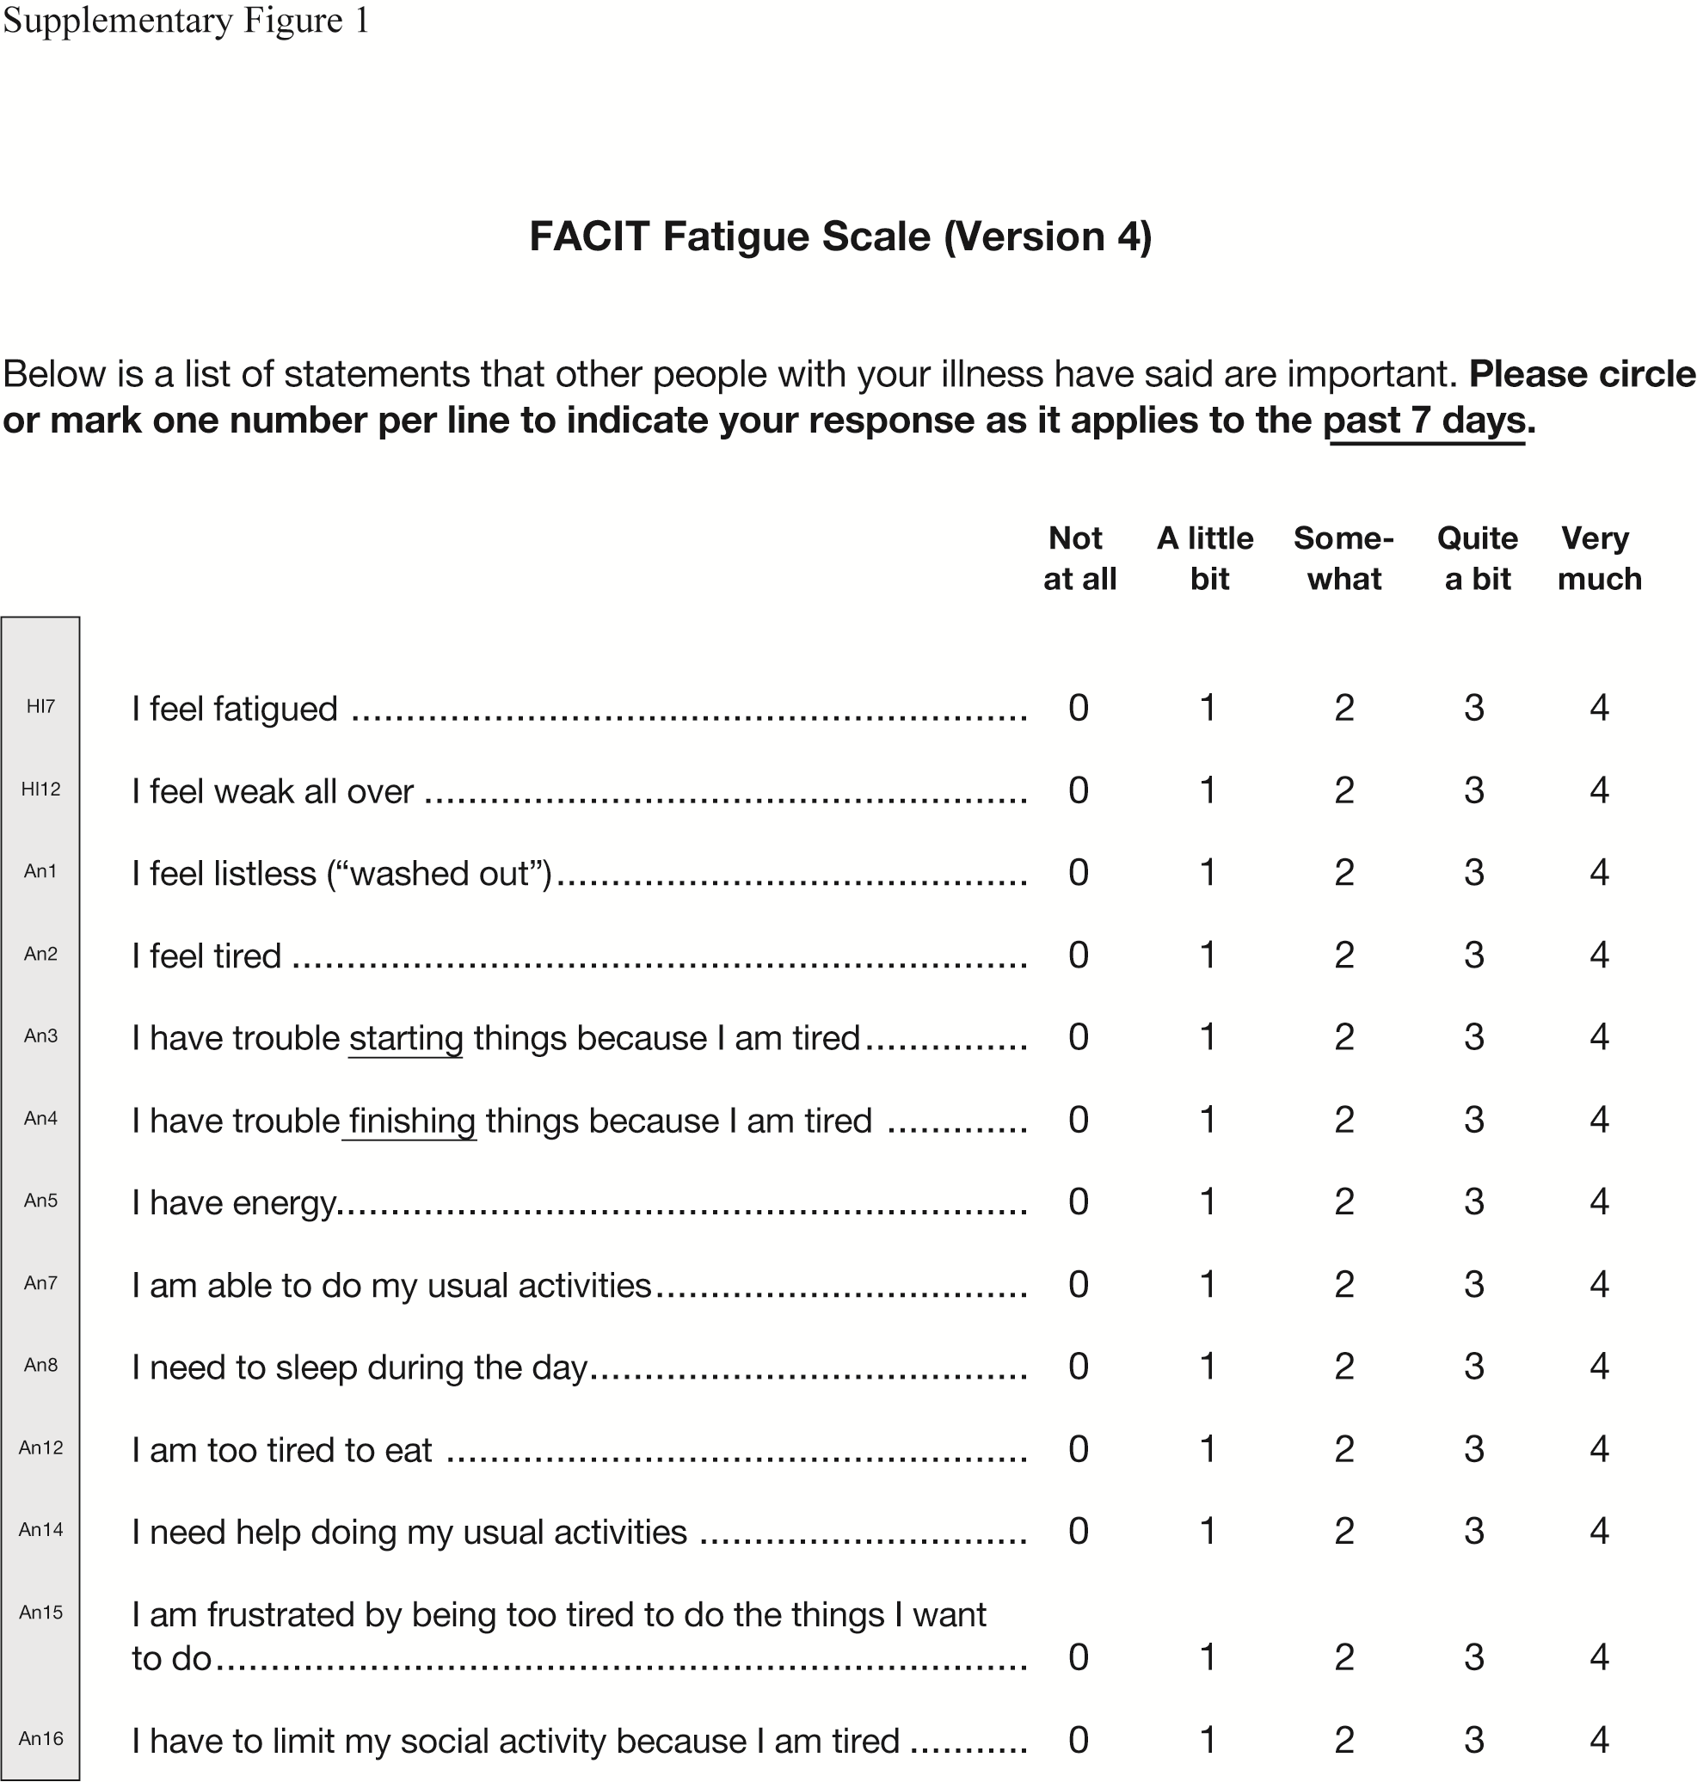
The FACIT-Fatigue scale is owned and copyrighted by, and the intellectual property of, David Cella, PhD. Reproduced with permission from David Cella, PhD
FACIT-Fatigue: Functional Assessment of Chronic Illness Therapy-Fatigue

