- Instrument Contacts: The following individuals should be contacted for detailed questions about a specific instrument data set, including clarification related to instances of “NA” reported below in instrument tables:
CABIN/CASF/CIP/FSSP/CDP/PCASP: Dr. Haflidi Jonsson (hjonsson@nps.edu)
CVI/PILS/Cloud Water: Dr. Armin Sorooshian (armin@email.arizona.edu)
AMS/SMPS: Dr. John H. Seinfeld (seinfeld@caltech.edu) and Dr. Richard C. Flagan (flagan@caltech.edu)
SP2: Dr. Andrew R. Metcalf (ametcal@clemson.edu)
CCN/WIBS: Dr. Athanasios Nenes (nenes@eas.gatech.edu)
LI-COR/LGR: Dr. Ewan C. Crosbie (ewan.c.crosbie@nasa.gov)

- Folder and File Naming Convention: An individual folder is provided for each of the six field campaigns. Within each folder, files are named as follows: “(Field Campaign Name)_(Measurement Type)_(Version Number)”. Any version above “V1” (e.g., “V2”, “V3”, etc.) will be associated with improvements to a particular dataset. These improvements are explained in Section 8 of this ReadMe file. Column header descriptions and notes for each type of file follows below, in addition to a table summarizing instrument performance details for each of the field campaigns.

- A Note About csv Files and UTC: The data set is presented in a comma separated value (csv) format. The csv format has the advantages of being compact and widely used in the scientific community. However, it has the disadvantage of not working well with dates and times. All the csv files contain a column of universal coordinated time (UTC). Upon opening a csv file, it is obvious that the seconds in the UTC column are cut off. In order to ensure that the seconds are seen, select the column with UTC data and format the selection to have a custom format of “mm/dd/yyyy hh:mm:ss”, as seen in the image below. It is recommended to save the csv file into an Excel format (extension .xlsx).
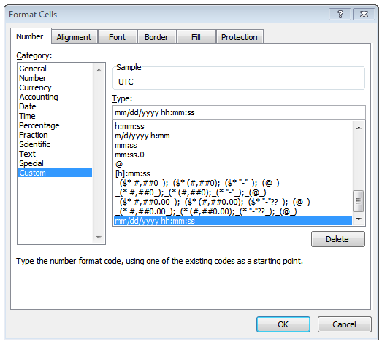

- Matlab Plotting Code: For the Matlab plotting code (“PlottingCode_V3”) to function properly, it must be in the directory that contains the campaign folders in addition to the csv file containing the latitude/longitude of California (“Map_California”). The directory should look like this:
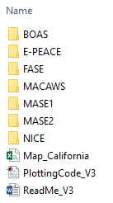
To execute the plotting code, open Matlab and select the aforementioned directory as the working directory, type the command “PlottingCode_V3”, and select the campaign and research flight that you want to visualize in the two prompts that pop up; this will generate many types of plots for data contained in the Cabin file, examples of which are shown below in Figure S1. This code works for Matlab version 2016a and more recent versions.
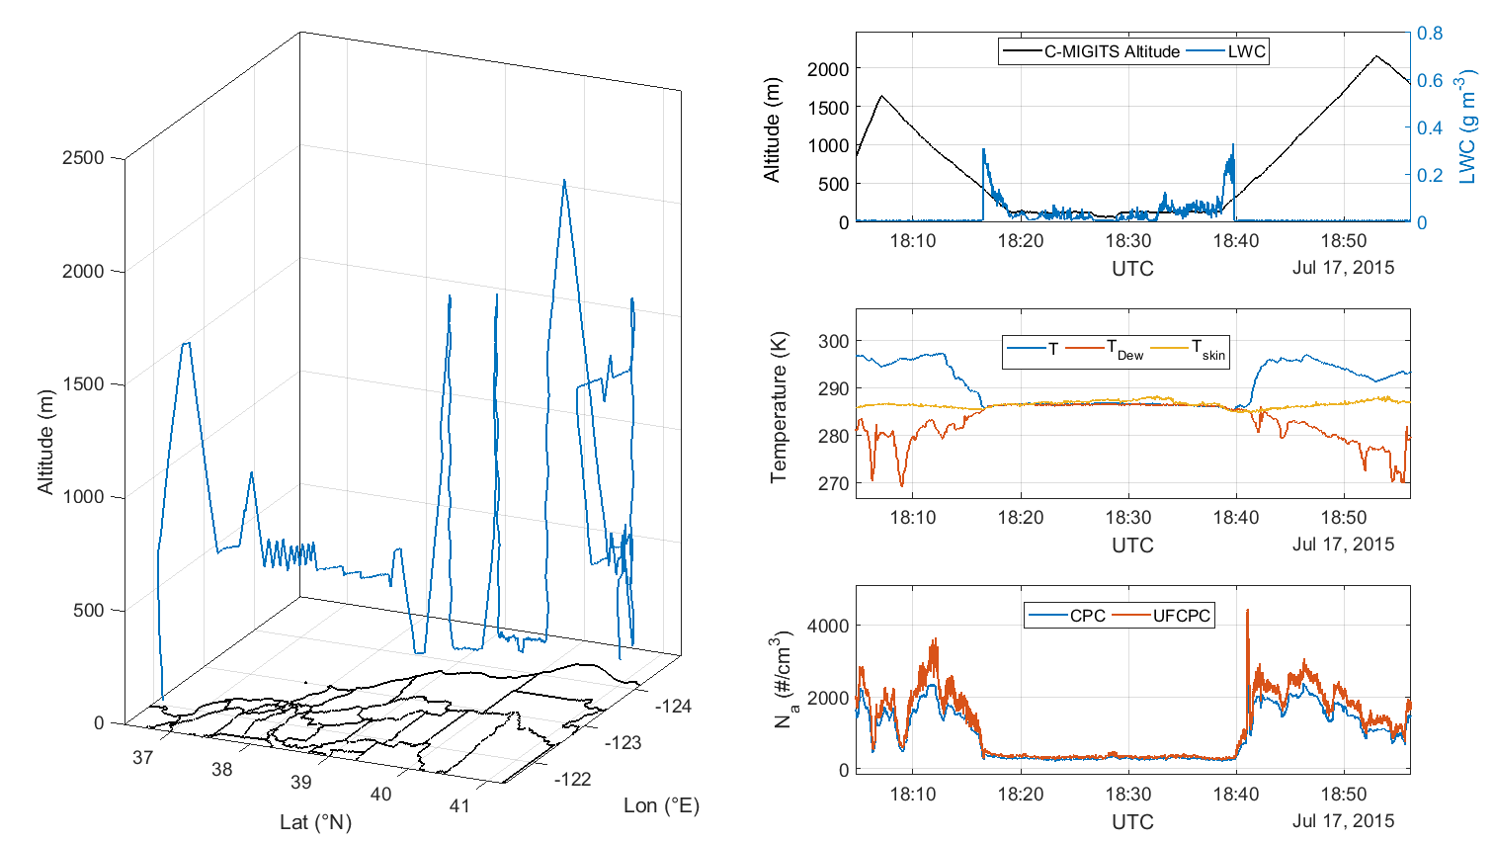
Figure S1. Example of what the Matlab plotting code can produce for each flight. Shown here is a small part of a BOAS flight on 17 July 2015, with the CIRPAS Twin Otter aircraft conducting slant patterns down and then up through a cloud deck.

- General Note About Diameter Bin Bounds: This dataset includes number size distributions from aerosol and cloud probes. All number size distributions are expressed in counts per cm³, and not dN/dlog(D_{p}); the only exception is the scanning mobility particle sizer (SMPS), which presents data as dN/dlog(D_{p}). It is important to point out that the bin bounds of a given instrument change from mission to mission; this is due to the calibration of the instrument. We further note that the bin bounds for light-scattering-based particle sizing suffer from fundamental ambiguity due to the optical (Mie) resonances that make the scattering signal a non-monotonic, and, therefore, non-unique function of particle size. The first two bins of many probes, especially, are subject to uncertainty. Each probe’s csv file contains the bin bounds for that mission in the top left corner. SMPS has 85 bins for MASE I and MASE II, whereas SMPS has 106 bins for E-PEACE, NiCE, and BOAS (it was unavailable for FASE). In order to aid in visualizing the particle diameter range of the instruments onboard the Twin Otter, Figure S2 shows the diameter range and bins for each instrument.

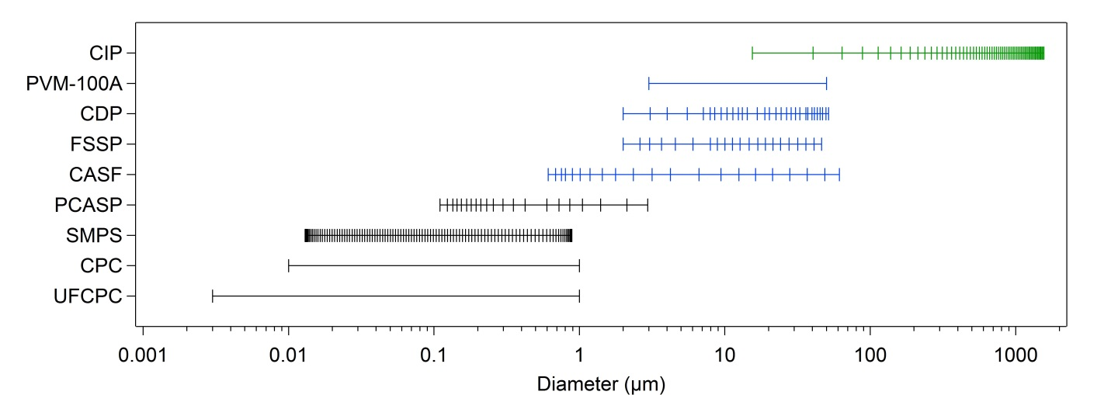
Figure S2. Instrument particle diameter size range and bin bounds for a representative campaign (E-PEACE); FSSP is for BOAS. Black lines are for instruments primarily used for aerosol particle measurements, while blue lines are for instruments primarily used for cloud droplet measurements, and the green line is for the instrument primarily used for rain drops.

- File Descriptions
6.1 Cabin: Note that all meteorological measurements below are for ambient conditions and are not specific to the aircraft (i.e., temperature is not aircraft temperature but rather ambient temperature). The accuracy, precision, and working ranges reported below for various instruments apply for all field campaigns.
Column Header | Description | Units | Precision | Accuracy | Working Range | Ref.
RF | Research flight # | NA | NA | NA | NA
UTC | Self-explanatory | mm/dd/yyyy hh:mm:ss | NA | 1 μs | NA
Lat | Aircraft latitude as measured by C-MIGITS-III GPS/INS system | °N | NA | 3.9 m SEP (Spherical Error Probable) | NA | 1
Lon | Aircraft longitude as measured by C-MIGITS-III GPS/INS system | °E | NA |  | NA
Alt_CMIGITS_m | Aircraft altitude as measured by C-MIGITS-III GPS/INS system | m above ground level (AGL) | NA |  | NA
T | Temperature | K | ± 0.1 K | ± 0.3 K | 223-323 K | 2a, 2b
T_Dew | Dew point temperature | K | ± 0.05 K | ± 0.2 K | 223–323 K | 3
P_mb | Pressure | mbar | 0.01% Working Range (500 mbar) or 0.05 mbar | ± 0.05% Working Range (500 mbar) or 0.25 mbar | 600–1100 mbar | 4
WindHorSpeed | Horizontal wind speed (calculated) | m s⁻¹ | NA | 0.5 m s⁻¹ | NA
WindDir | Wind direction (calculated) | ° | NA | 10 m s⁻¹ | NA
WindVerSpeed | Vertical wind speed (calculated) | m s⁻¹ | NA | 0.25 m s⁻¹ | NA
T_Skin | Skin surface temperature | K | ± 0.1 K | ± 0.5 K + 0.7% of the difference between target temp. and housing temp. | 223–473 K | 5
Alt_P_m | Altitude measured by barometric pressure sensor | m above ground level (AGL) (calculated) | NA | See P_mb | NA
TAS | True air speed | m s⁻¹ (calculated) | NA | NA | NA
LWC | Liquid water content as measured by PVM-100A probe | g m⁻³ | 2% | 5% | D_{p}: 3–50 μm;  LWC: 0.002–10 g m⁻³ | 6
Na_CPC | Particle number concentration measured by CPC 3010 (D_{p} > 10 nm) | # cm⁻³ | NA | Conc: ± 10% | D_{p}: > 10 nm  Conc: 0–10000 # cm⁻³ | 7
Na_UFCPC | Particle number concentration measured by CPC 3025 (D_{p} > 3 nm) | # cm⁻³ | NA | Conc: ± 10% | D_{p}: > 3 nm  Conc: 0–99900 # cm⁻³ | 8

6.2 CASF (Cloud and Aerosol Spectrometer – Forward Scattering): Usage of data from this probe requires a cautionary note that, similar to other optical aircraft probes, there are uncertainties associated with the viewing volume, dead-time, Mie resonances, contamination on optical surfaces, and the suite of electronic and optical tolerances. As a result, accuracy and precision values are not provided, and interested data users are referred to the instrument contact owing to the complex nature of these data. The cloud probes were calibrated before field campaigns and consistency was ensured in the response between independently calibrated instruments. The CSV file provides the working range in terms of the diameter range and number concentration range for each size bin.
Column Header | Description | Units
Dp_LowerBound_um | Lower bin diameter size | µm
Dp_UpperBound_um | Upper bin diameter size | µm
Dp_GeoMean_um | Geometric mean diameter of each CASF bin | µm
RF | Research flight # | NA
UTC | Self-explanatory | mm/dd/yyyy hh:mm:ss
CASF_ch# | Total droplet concentration in each bin (i.e., channel, ch) in order from the smallest bin (# = 1) to the largest bin (# = 20) | # cm⁻³

6.3 CIP (Cloud Imaging Probe): See note above under CASF.
Column Header | Description | Units
Dp_LowerBound_um | Lower bin diameter size | µm
Dp_UpperBound_um | Upper bin diameter size | µm
Dp_GeoMean_um | Geometric mean diameter of each CIP bin | µm
RF | Research flight # | NA
UTC | Self-explanatory | mm/dd/yyyy hh:mm:ss
CIP_ch# | Total droplet concentration in each bin (i.e., channel, ch) in order from the smallest bin (# = 1) to the largest bin (# = 62) | # cm⁻³

6.4 FSSP (Forward Scattering Spectrometer Probe): See note above under CASF.
Column Header | Description | Units
Dp_LowerBound_um | Lower bin diameter size | µm
Dp_UpperBound_um | Upper bin diameter size | µm
Dp_GeoMean_um | Geometric mean diameter of each FSSP bin | µm
RF | Research flight # | NA
UTC | Self-explanatory | mm/dd/yyyy hh:mm:ss
FSSP_ch# | Total droplet concentration in each bin (i.e., channel, ch) in order from the smallest bin (# = 1) to the largest bin (# = 20) | # cm⁻³

6.5 CDP (Cloud Droplet Probe): See note above under CASF.
Column Header | Description | Units
Dp_LowerBound_um | Lower bin diameter size | µm
Dp_UpperBound_um | Upper bin diameter size | µm
Dp_GeoMean_um | Geometric mean diameter of each CDP bin | µm
RF | Research flight # | NA
UTC | Self-explanatory | mm/dd/yyyy hh:mm:ss
CDP_ch# | Total droplet concentration in each bin (i.e., channel, ch) in order from the smallest bin (# = 1) to the largest bin (# = 30) | # cm⁻³

  - PCASP (Passive Cavity Aerosol Spectrometer Probe): See note above under CASF.
Column Header | Description | Units
Dp_LowerBound _um | Lower bin diameter size | µm
Dp_UpperBound_um | Upper bin diameter size | µm
Dp_GeoMean_um | Geometric mean diameter of each PCASP bin | µm
RF | Research flight # | NA
UTC | Self-explanatory | mm/dd/yyyy hh:mm:ss
PCASP_ch# | Total particle concentration in each bin (i.e., channel, ch) in order from the smallest bin (# = 1) to the largest bin (# = 20) | # cm⁻³

6.7 CVI (Counterflow Virtual Impactor Inlet): These files report the start and stop times of when specific instruments were sampling downstream of the CVI or the reverse-facing inlet (only during MASE II). The CVI does not require any accuracy, precision, and working range to be reported owing to is nature of operation. If interested in any details about the cutpoint size and transmissions efficiency details, readers can refer to the relevant instrument characterization manuscript⁹ and/or contact the instrument PI.
Column Header | Description | Units
RF | Research flight # | NA
UTC: CVI start time | Start time of when the CVI was feeding aerosol to those instruments downstream of it | mm/dd/yyyy hh:mm:ss
UTC: CVI end time | End time of when the CVI was feeding aerosol to those instruments downstream of it | mm/dd/yyyy hh:mm:ss
UTC: Reverse-facing inlet start time  (only during MASE II) | Start time of when the reverse-facing inlet was feeding aerosol to those instruments downstream of it | mm/dd/yyyy hh:mm:ss
UTC: Reverse-facing inlet end time  (only during MASE II) | End time of when the reverse-facing inlet was feeding aerosol to those instruments downstream of it | mm/dd/yyyy hh:mm:ss

6.8 AMS (Aerosol Mass Spectrometer): Mass concentrations of sulfate (SO₄), nitrate (NO₃), organic, and ammonium (NH₄) in units of µg m⁻³. AMS data are reported as the difference between signal during chopper cycles between being open (aerosol + gas) and closed (gas); consequently, negative values reflect the noise and precision of the instrument. There is 100% transmission efficiency for particles with aerodynamic diameters between 30 and 600 nm¹⁰. Upper limits of accuracy and precision are 30% and 0.1 µg m⁻³, respectively. The limit of detection (LOD) is calculated as at least two times the standard deviation of the noise for filtered air for each species. The LOD for each species is as follows: 0.19 µg m⁻³ for Organic, 0.03 µg m⁻³ for NO₃, 0.03 µg m⁻³ for SO₄, 0.15 µg m⁻³ for NH₄. The aforementioned details related to quality control apply for all field campaigns that the AMS was used for.
Column Header | Description | Units
RF | Research flight #
UTC | Self-explanatory | mm/dd/yyyy hh:mm:ss
SO4 | Mass concentration of sulfate | µg m⁻³
NO3 | Mass concentration of nitrate | µg m⁻³
Organic | Mass concentration of organics | µg m⁻³
NH4 | Mass concentration of ammonium | µg m⁻³

6.9 PILS (Particle-Into-Liquid Sampler Coupled to Ion Chromatography): Mass concentrations of calcium (Ca), magnesium (Mg), potassium (K), sodium (Na), nitrite (NO₂), chloride (Cl), ammonium (NH₄), nitrate (NO₃), sulfate (SO₄), oxalate, and methanesulfonate (MSA) in units of µg m⁻³. The working range of the instrument was sub-micrometer particles with the following transmission efficiency details as a function of size¹¹: Losses decrease from 2.21 to 0.42% for particles with diameters ranging from 0.01 to 0.08 μm, respectively, with increases in losses from 0.42 to 8.58% for diameters increasing from 0.08 to 1.0 μm, respectively. Upper limits of accuracy and precision are 25% and 0.1 µg m⁻³, respectively. The LOD for each species was computed as the average plus three times the standard deviation of species concentrations for particle-free background samples collected before and during flights. Concentrations below the LOD have been removed: 0.10 µg m⁻³ for inorganic ions (Na, NH₄, K, Mg, Ca, Cl, NO₂, NO₃, SO₄) and 0.01 µg m⁻³ for the organic acids and amines. The aforementioned details related to quality control apply for all field campaigns that the PILS was used for.
Column Header | Description | Units
RF | Research flight # | NA
UTC (Start Time of Collection) | UTC time when a PILS vial began collection. Typical sample times were ~5 min and the end time is marked by the start time of the following sample | mm/dd/yyyy hh:mm:ss
Ca | Mass concentration of calcium | µg m⁻³
Mg | Mass concentration of magnesium | µg m⁻³
K | Mass concentration of potassium | µg m⁻³
Na | Mass concentration of sodium | µg m⁻³
NO2 | Mass concentration of nitrite | µg m⁻³
Cl | Mass concentration of chloride | µg m⁻³
NH4 | Mass concentration of ammonium | µg m⁻³
NO3 | Mass concentration of nitrate | µg m⁻³
SO4 | Mass concentration of sulfate | µg m⁻³
Oxalate | Mass concentration of oxalate | µg m⁻³
MSA | Mass concentration of methanesulfonate | µg m⁻³
Acetate | Mass concentration of acetate | µg m⁻³
Formate | Mass concentration of formate | µg m⁻³
Glyoxylate | Mass concentration of glyoxylate | µg m⁻³
Malonate | Mass concentration of malonate | µg m⁻³
Succinate | Mass concentration of succinate | µg m⁻³
Glutarate | Mass concentration of glutarate | µg m⁻³
Adipate | Mass concentration of adipate | µg m⁻³
Suberate | Mass concentration of suberate | µg m⁻³
Azelate | Mass concentration of azelate | µg m⁻³
Diethylamine | Mass concentration of diethylamine | µg m⁻³
Ethylamine | Mass concentration of ethyalmine | µg m⁻³

6.10 SMPS (Scanning Mobility Particle Sizer): The SMPS in MASE I and MASE II has 85 bins, whereas the SMPS in E-PEACE, NiCE, and BOAS has 106 bins.

Column Header | Description | Units | Precision | Accuracy | Working Range | Ref
Dp_LowerBound_nm | Lower bin diameter size | nm | NA | D_{p}: 3–3.5% | 0.01–0.8 μm | 12
Dp_UpperBound_nm | Upper bin diameter size | nm | NA
Dp_GeoMean_nm | Geometric mean diameter of each SMPS bin | nm | NA | NA | NA
RF | Research flight # | NA | NA | NA | NA
UTC | Start time (UTC) of the SMPS scan | mm/dd/yyyy hh:mm:ss | NA | NA | NA
NumDist# | Particle concentration in each bin coinciding with the geometric mean diameter from the “Dp (nm)” column in order from the smallest bin 1 to the largest bin | dN/dlog(D_{p}) [=] # cm⁻³ | NA | CPC conc: ±10% | 0–10000 # cm⁻³ | 7

6.11 CCN (Cloud Condensation Nuclei Counter): The uncertainty in the instrument supersaturation is related to the accuracy of the concentration values depending on the steepness of the CCN spectrum (at a given supersaturation), which is related to the aerosol size distribution, composition, and mixing state. For this reason, data users are referred to the instrument PI for further details about the accuracy and precision of this instrument dataset.

MASE II, E-PEACE:
Column Header | Description | Units | Precision | Accuracy | Working Range
RF | Research flight # | NA | NA | NA | NA
UTC | Self-explanatory | mm/dd/yyyy hh:mm:ss | NA | NA | NA
Supersaturation (%) | Supersaturation | % | 0.05 supersaturation units (%) | < 15% | 0.07-1.0%
CCN (# cm⁻³) | CCN number concentration | # cm⁻³ | 10-20% | 10% | 0.75 – 10 µm (after OPC and after supersaturation)

NiCE, BOAS, FASE:
Column Header | Description | Units | Precision | Accuracy | Working Range
RF | Research flight # | NA | NA | NA | NA
UTC | Self-explanatory | mm/dd/yyyy hh:mm:ss | NA | NA | NA
Column A: Supersaturation (%) | Supersaturation in one column of the CCNc (called Column A) | % | 0.05 supersaturation units (%) | < 15% | 0.07-1.0%
Column A: CCN (# cm⁻³) | CCN number concentration in Column A | # cm⁻³ | 10% | 10% | Diameter range: 0.75 – 10 µm (after OPC and after supersaturation)  Number concentration range: < 6,000 particles/s at supersaturations below 0.2%; < 20,000 particles/s at supersaturations above 0.3%
Column B: Supersaturation (%) | Supersaturation in the other column of the CCNc (called Column B) | % | 0.05 supersaturation units (%) | < 15% | 0.07-1.0%
Column B: CCN (# cm⁻³) | CCN number concentration in Column B | # cm⁻³ | 10% | 10% | Diameter range: 0.75 – 10 µm (after OPC and after supersaturation)  Number concentration range: < 6,000 particles/s at supersaturations below 0.2%; < 20,000 particles/s at supersaturations above 0.3%
6.12 CloudWater: The working range of the cloud water collector includes any species from the gas- and aerosol-phase that were included into cloud droplets that were collected. The collection efficiency of the collector increases with decreasing aircraft speed and has little correlation with drop diameter up to a mass mean diameter of approximately 35 μm¹³.
Column Header | Description | Units | Precision | Accuracy | Working Range
RF | Research flight # | NA | NA | NA | NA
UTC: Collection Start Time | UTC time when a cloud water vial began to collect cloud water | mm/dd/yyyy hh:mm:ss | NA | NA | NA
UTC: Collection Stop Time | UTC time when a cloud water vial finished collecting cloud water | mm/dd/yyyy hh:mm:ss | NA | NA | NA
Cabin_LAT | Average latitude during the collection of the cloud water sample | degrees | NA | NA | NA
Cabin_LON | Average longitude during the collection of the cloud water sample | degrees | NA | NA | NA
Alt (m) | Average altitude during the collection of the cloud water sample | m | NA | NA | NA
pH | Sample pH | NA | ≤ 0.01 | ± 0.01 | 2-10
“ICPMS_X” | Air-equivalent mass concentration of element “X” as measured via ICP-MS | µg m⁻³ | < 10% | < 10% | NA
“IC_X” | Air-equivalent mass concentration of water-soluble ion “X” as measured via IC | µg m⁻³ | < 10% | < 10% | NA

6.13 WIBS (Waveband Integrated Bioaerosol Sensor):
Column Header | Description | Units | Precision | Accuracy | Working Range
RF | Research flight # | NA | NA | NA | NA
UTC | Self-explanatory | mm/dd/yyyy hh:mm:ss | NA | NA | NA
WIBS Total Concentration | Total number concentration of all detected particles, even if they are not biological | # m⁻³ | < 10% | Approximately 1% of non-fluorescent particles are misclassified as fluorescent; Unknown quantity of biological particles can be classified as non-biological due to their low autofluorescence intensity | Diameter range: 0.5-16 µm  Number concentration range: < 2 × 10⁷ m⁻³
WIBS Concentration 1 | Number concentration underestimate of primary biological aerosol particles (PBAP) | # m⁻³ | <10% | Approximately 1% of non-fluorescent particles are misclassified as fluorescent; Unknown quantity of biological particles can be classified as non-biological due to their low autofluorescence intensity | Diameter range: 0.5-16 µm  Number concentration range: < 2 × 10⁷ m⁻³

6.14 SP2 (Single Particle Soot Photometer):
Column Header | Description | Units | Precision | Accuracy | Working Range
RF | Research flight # | NA | NA | NA | NA
UTC | Self-explanatory | mm/dd/yyyy hh:mm:ss | NA | NA | NA
BC number concentration | Self-explanatory | # cm⁻³ | 5% | 20% | 0.5-100 fg, or approximately 83-478 nm volume-equivalent diameter
BC mass concentration | Self-explanatory | µg m⁻³ | 5% | 40% | 0.5-100 fg, or approximately 83-478 nm volume-equivalent diameter

6.15 LGR (Los Gatos Research): Note that NO₂ was measured instead of NO_{x} during Flights 2 and 4 of BOAS. BOAS has 0.1 Hz time resolution, whereas FASE has 1 Hz resolution.
BOAS:
Column Header | Description | Units | Precision | Accuracy | Working Range
RF | Research flight # | NA | NA | NA | NA
UTC | Self-explanatory | mm/dd/yyyy hh:mm:ss | NA | NA | NA
CO2 | Self-explanatory | ppbv | 1 ppmv | < 5% | Lower limit: < 300 ppmv  Upper limit: > 5000 ppmv
CO | Self-explanatory | ppbv | 5 ppbv | < 5% | Lower limit: < 50 ppbv  Upper limit: > 5 ppmv
NOx | Self-explanatory | ppbv | 0.5 ppbv | < 5% | Lower limit: < 0.5 ppbv  Upper limit: > 100 ppbv
O3 | Self-explanatory | ppbv | 2 ppbv | < 5% | Lower limit: < 2 ppbv  Upper limit: > 200 ppbv
FASE:
Column Header | Description | Units | Precision | Accuracy | Working Range
RF | Research flight # | NA | NA | NA | NA
UTC | Self-explanatory | mm/dd/yyyy hh:mm:ss | NA | NA | NA
CO | Self-explanatory | ppbv | 5 ppbv | < 5% | Lower limit: < 50 ppbv  Upper limit: > 5 ppmv

6.16 LI-COR: Only FASE has LI-COR data. Data with 1 Hz time resolution are presented. Data with 20 Hz time resolution are available upon request.
Column Header | Description | Units | Precision | Accuracy | Working Range
RF | Research flight # | NA | NA | NA | NA
UTC | Self-explanatory | mm/dd/yyyy hh:mm:ss | NA | NA | NA
H2O | Self-explanatory | g/kg | 1 ppmv | < 5% | 0-60000 ppmv
CO2 | Self-explanatory | ppmv | 1 ppmv | < 5% | 0-3000 ppmv

- Instrument Performance Summary For All Seven Field Campaigns: The tables below show the instruments working on each research flight (RF). NA = Not on board; M = Onboard, but malfunctioning for the whole RF; OK = Onboard and working properly most of the time. Instruments marked with “NA” are not included in the csv files. Instruments with a time resolution of 1 Hz resolution that are marked with “M” have “NaN” (not a number) for the whole duration of the flight. Instruments with a time resolution different than 1 Hz resolution (i.e., AMS, PILS, SMPS, and LGR for BOAS) that are marked with “M” have “NaN” for the first 10 seconds of the flight and the rest of the flight is omitted from the csv file.

MASE I (2005):
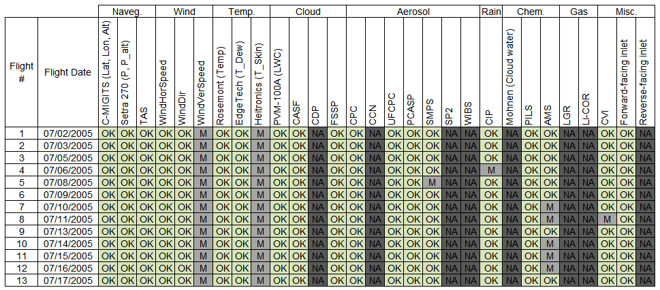

MASE II (2007):
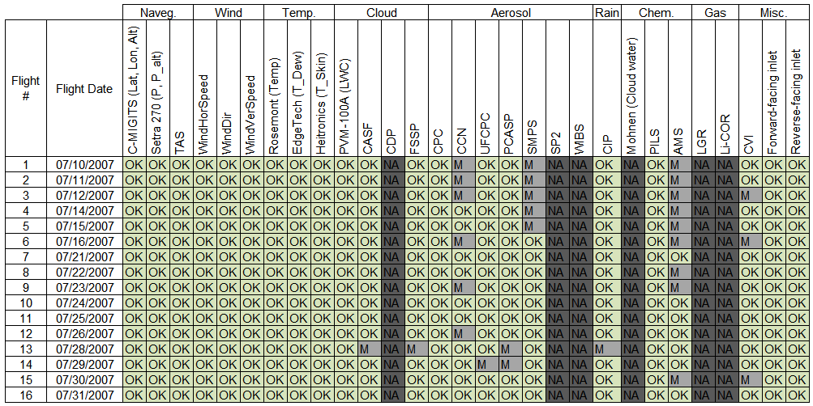
E-PEACE (2011):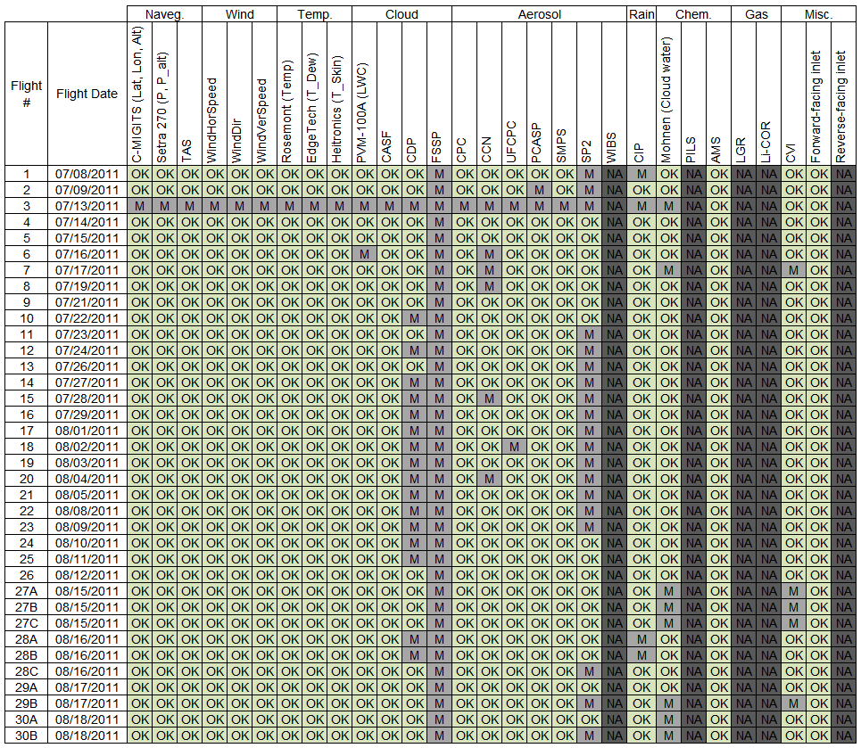

NiCE (2013):
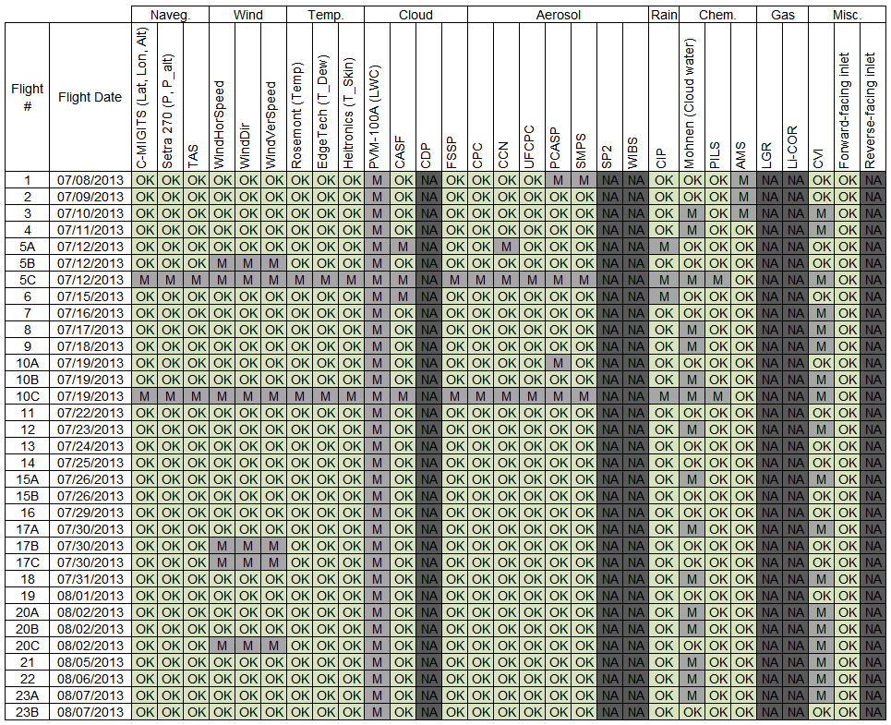

BOAS (2015):
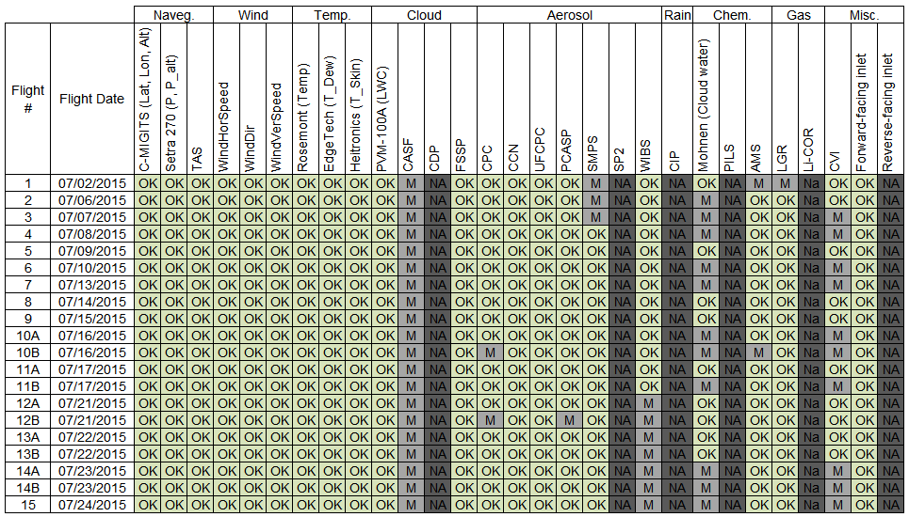

FASE (2016):
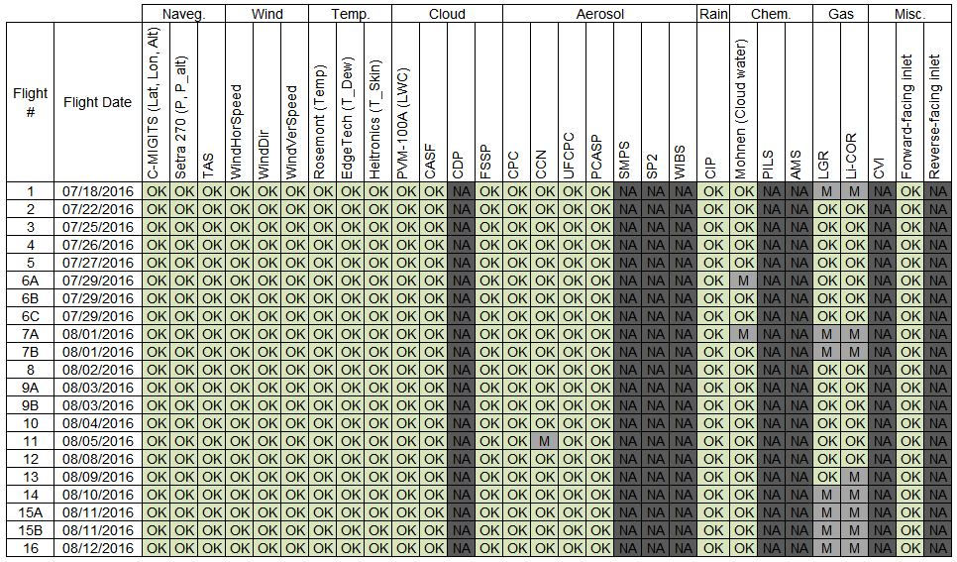

MACAWS (2018)
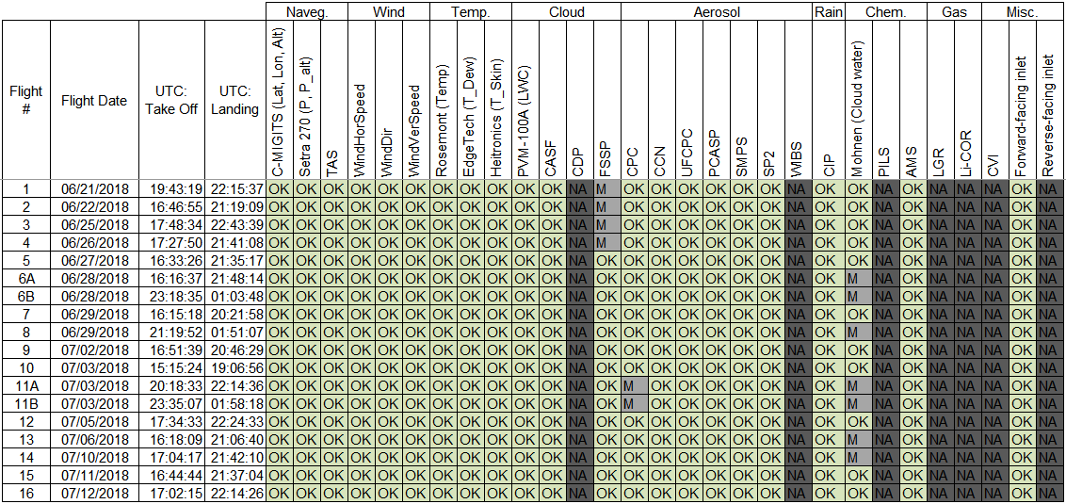

- Difference Between Versions
  - Differences Between Version 1 (V1) and Version 2 (V2) [change made on 27 November 2017]: Version 1 and 2 are shown in Figshare as Version 5 and 6, respectively. Version 2 has the following improvements over version 1:
- A column with “RF” has been added to the left of the UTC column in files that were previously missing it.
- Calculated values (such as relative humidity and potential temperature) have been removed and only measured values remain (with exception of true aircraft speed).
- All blanks in all the files have been substituted with “NaN” (i.e., not a number).
- CASF is now included for MASE I.
- AMS data in MASE I has been updated for more accuracy.
- The Gases file in BOAS has been renamed to LGR.
- The Gases file in FASE has been split into two separate files: LGR and LICOR.
- FASE LI-COR data were previously at 20 Hz; they have been averaged to 1 Hz, and the 20 Hz data have been removed.
- For all files, only data between one minute before takeoff and one minute after landing have been retained; all data outside of this range have been removed.
- The cloud probes CASF, FSSP, and CDP have been synchronized amongst themselves. This was done by calculating number concentration (N_{d}) in overlapping bins and plotting the time series of N_{d} for these probes. The peaks in N_{d} in Version 1 usually had a shift of a few seconds; this shift is removed in Version 2.
- The bin bound headers have been changed to have the format:
Dp_<LowerBound or UpperBound>_<um or nm>.
- Parentheses have been removed from column headers.
- An updated Matlab plotting code was uploaded with the same name as before (“PlottingCode”)
8.2 Differences Between Version 2 (V2) and Version 3 (V3) [change made on 15 May 2019]: In July-August 2018, the Marine Aerosol Cloud And Wildfire Study (MACAWS) field campaign took place in the same region as the previous six campaigns. MACAWS data have been added to the data contained in the previous V2. Quality control was performed in MACAWS in the same way as the previous campaigns. The GUI has been updated to include MACAWS. For clarity, all csv files for all seven campaigns, the ReadMe file, and the GUI have been renamed as Version 3.
9 References
- http://www.unisky.it/assets/files/tecnologie/SystronDONNER.pdf
- a) Lawson, R. P., and W. A. Cooper, Performance of Some Airborne Thermometers in Clouds. J. Atmos. Ocean. Technol. 7(3), 480–494 (1990). b) Stickney, T.R., M.W Shedlow, and D. I. Thompson, Rosemount Aerospace Total Temperature Sensors. Thechnical Report 5755 Revision C, Rosemount Aerospace Inc., 1994
- http://www.edgetechinstruments.com/docs/sensor_selection.pdf
- https://www.setra.com/products/pressure/model-270-setraceram-gauge-pressure-transducer
- http://www.heitronics.com/fileadmin/content/Prospekte/KT19_Serie_II_e_Prospectus.pdf
- www.gerberscience.com/pvmaspecs.html
- http://www.tsi.com/uploadedFiles/_Site_Root/Products/Literature/Spec_Sheets/3010.pdf
- http://www.tsi.com/uploadedFiles/_Site_Root/Products/Literature/Spec_Sheets/3025A.pdf
- Shingler, T. et al. Characterisation and airborne deployment of a new counterflow virtual impactor inlet. Atmos. Meas. Tech. 5, 1259-1269, doi:10.5194/amt-5-1259-2012 (2012).
- Jayne, J. T. et al. Development of an aerosol mass spectrometer for size and composition analysis of submicron particles. Aerosol Sci. Tech. 33, 49-70 (2000).
- Sorooshian, A. et al. Modeling and characterization of a particle-into-liquid sampler (PILS). Aerosol Sci. Tech. 40, 396-409, doi:10.1080/02786820600632282 (2006).
- http://www.tsi.com/differential-mobility-analyzer-3081
- Hegg, D. A., and P. V. Hobbs, Studies of the Mechanisms and Rate with Which Nitrogen Species Are Incorporated into Cloud Water and Precipitation. Second Annual Report on Project CAPA-21-80 to the Coordinating Research Council (1986).

