Data sharing practices among researchers at South African universities

Mathew Moyo https://orcid.org/0000-0003-4418-5011
+27 389-2017 Mathew.Moyo@nwu.ac.za

Siviwe Bangani https://orcid.org/0000-0001-5872-8123 +27 18-3892322 Siviwe.Bangani@gmail.com
+27 18-3892322
Siviwe.Bangani@gmail.com

Fig. 1: Sources of research data for RSA researchers | Fig. 2: Formats of research data produced by RSA researchers
Fig. 3: Establish the size of data produced by South African researchers  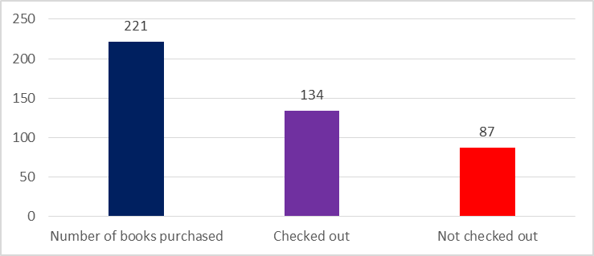 | Fig. 4: Information assigned to research data
Figure 5: Willingness to share data | Figure 6: Concerns about sharing data
Fig. 7: Current data sharing practices

