Supplementary Table 1. Distribution of chromosomal aberrations.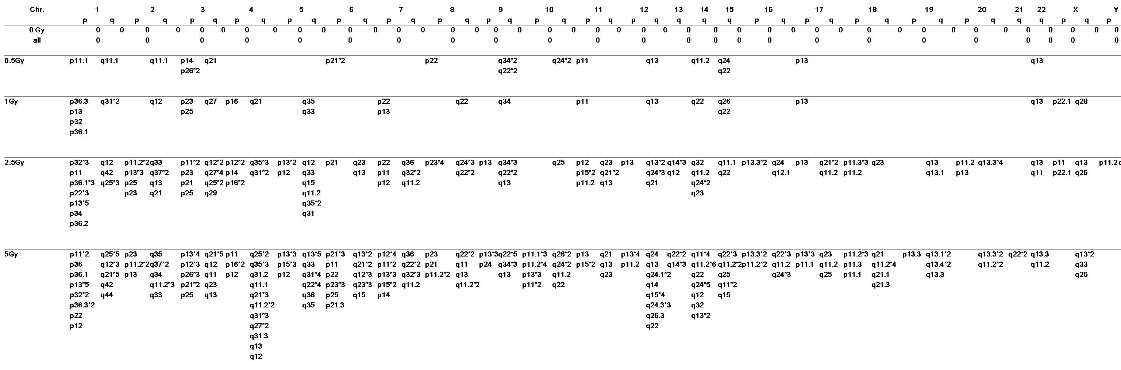
Supplementary Table 2. Genetic associations of diseases related to low-dose radiation exposure (< 1 Gy)
Gene | Genetic association disease | Disease class | OMIM disease
Up-regulation
EPAS1 | Elite endurance, erythropoietin | Normal variation | Erythrocytosis, familial, 4
Down-regulation
IKZF1 |  |  | Leukemia, acute lymphoblastic
KLF6 | - Diabetes type 2  - Lung cancer  - Prostate cancer  - Prostate cancer prostatic hyperplasia | Cancer, metabolic | - Gastric cancer, somatic  - Prostate adenocarcinoma-1  - Prostate cancer, somatic
SMARCA2 | Schizophrenia
F2R | - Coronary heart disease  - Platelet aggregation  - Coagulation, platelet receptor density and the response to SFLLRN | - Cardiovascular  - Hematological
HLA-DRA | - Arthritis  - Rheumatoid  - Carbamazepine hypersensitivity  - Celiac disease  - Crohn's disease  - Diabetes type 1  - Hepatitis  - Fulminant non-A, non-B  - HIV infection  - IgA, IgD, IgG, IgM, latex-fruit syndrome  - Multiple sclerosis  - Myasthenia gravis  - Oral lichen planus  - Sarcoidosis  - Spondyloarthropathies  - Stroke  - Ischemic | - Cardiovascular  - Immune  - Infection | - Risk alleles for multiple sclerosis identified by a genome-wide study  - Sequence variants in IL10  - ARPC2 and multiple other loci contribute to ulcerative colitis susceptibility
SS18 |  |  | Sarcoma, synovial
TNFSF10 | - HIV  - Multiple sclerosis | - Immune  - Infection | - Cytokine-cytokine receptor interaction  - Apoptosis  - Natural killer cell mediated cytotoxicity
VPS13A |  |  | Choreoacanthocytosis
Notes: 1) Classification criteria were FC > 2 and p < 0.005; 2) Gene annotation enrichment analysis, functional annotation clustering, BioCarta & KEGG pathway mapping, gene-disease association, homolog matches, and similar analyses were assessed using DAVID Bioinformatics Resources 6.7.
Supplementary Table 3. Cancer-related genes in chromosome abnormality regions according to array data
Genes implicated in cancer | Related function |  | Related disease |  | Reference
Down-regulated genes
GPR113 | - Neuropeptide signaling pathway  - Orphan receptor |  | Non-small cell lung cancer |  | Lee Y, et al. Carcinogenesis, 2013
CAGE1/(CTAG3) | Protein-coding gene |  | - Lung squamous cell carcinoma  - Urinary bladder carcinomas |  | Park S, et al. Biochim Biophys Acta, 2003  Kunze E, et al. Int J Mol Med, 2007
FEZ1 | Tumor suppressor gene |  | - Ovarian cancer  - Breast carcinoma  - Lung cancer  - Gastric carcinoma |  | Califano D, et al. J Cell Physiol. 2010  Chen L, et al. Breast Cancer Res Treat. 2009  Toyooka S, et al. Clin Cancer Res. 2002  Y, Alder H, et al. Clin Cancer Res. 2001
POLR2F | Responsible for synthesizing messenger |  | - Colorectal cancer  - Adenocarcinoma metastases |  | Antonacopoulou AG, et al. Anticancer Res. 2008  Król M, et al. J Appl Genet. 2010
ZFHX3 | - Myogenic regulation  - Neuronal differentiation  - Negative regulation of c-Myb |  | - Non-small cell lung cancer  - Stomach cancers  - Gastric and colorectal carcinomas  - Skin cancer  - Breast cancer |  | Minamiya Y, et al. Cancer Biomark. 2012  An CH, et al. Pathology. 2010  Nishio E, et al. Acta Dermatovenerol Croat. 2012  Kai K, et al. BMC Cancer. 2008
FYB/(ADAP; PRO0823; SLAP-130) | - Adapter for the FYN protein  - LCP2 signaling cascades  - Platelet activation  - Controlling of interleukin-2 expression |  | - Hemolytic disease  - Acute promyelocytic leukemia |  | Vescio LA, et al. Transfusion. 1987  Moog-Lutz C, et al. J Biol Chem. 2001
NMI | - Interaction with NMYC and CMYC  - STAT-mediated transcription in response to cytokines IL2 and IFN-gamma |  | - Bladder cancer  - Predicting progression of bladder urothelial carcinoma  - Myeloid leukemia  - T-cell acute lymphoblastic leukemia |  | Serretta V, et al. Urologia. 2013  Rosenberg E, et al. BJU Int. 2013  Bao J, et al. Oncogene. 1996  Nagel S, et al. Leuk Lymphoma. 2011
Up-regulated genes
PHLDA1/(TDAG51) | - Anti-apoptotic effects of insulin-like growth factor-1  - Follicular stem cell marker |  | - Oral squamous cell carcinomas  - Basal cell carcinomas  - Breast cancer  - Desmoplastic trichoepithelioma |  | Coutinho-Camillo CM, et al. Virchows Arch. 2013  Sellheyer K, et al. J Cutan Pathol. 2013  Johnson EO, et al. J Cell Sci. 2011  Sellheyer K, et al. Br J Dermatol. 2011
CMTM5/(CKLFSF5) | - Exhibition of tumor suppressor activity  - Inducing apoptosis |  | - Ovarian cancer  - Myeloid leukemia  - Pancreatic cancer |  | Li P, et al. Int J Gynecol Cancer. 2011  Niu J, et al. Leuk Res. 2011  Guo X, et al. Biochem Biophys Res Commun. 2009
PTCRA | Regulation of early T-cell development |  | T-cell leukemia |  | Bellavia D, et al. Proc Natl Acad Sci U S A, 2002
SAPCD2  (p42.3; C9orf140) | Tumor-specific and mitosis phase-dependent expression |  | - Human colorectal cancer  - Gastric cancer |  | Yuan XS, et al. J Cancer Res Clin Oncol, 2013  Zhang J, et al. Theor Biol Med Model, 2012  Xu X, et al. Oncogene, 2007
Notes: 1) Screening criteria were FC > 4 and p < 0.005; 2) Identification of cancer-related genes was conducted using the Cancer Genetics Web, Atlas of Genetics and Cytogenetics in Oncology and Haematology database and the Tumor Gene Family of Databases.

