Supplemental Figure 2.

(a)
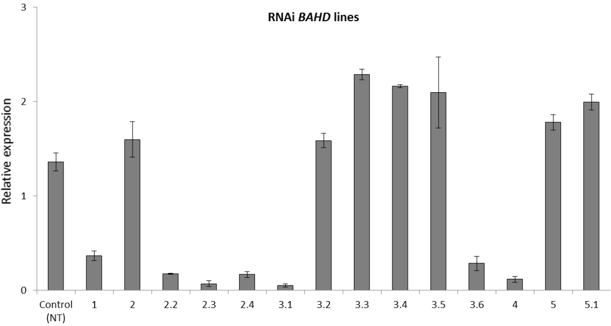

(b)
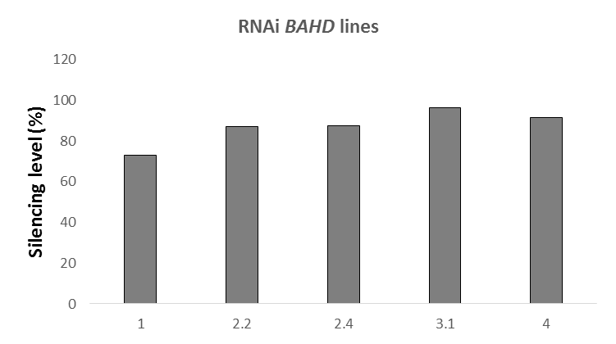

Supplemental Figure 2. Expression analysis and silencing levels of transgenic SacBAHD01 RNAi lines. (a) Real-time qPCR analysis of 14 independent events of transgenic sugarcane transformed with SacBAHD01 RNAi cassette. Leaves of 3-month-old plants were used for expression analysis (n = 5; error bars ± SEM). (b) Silencing levels of the most BAHD01 suppressed lines (events 1, 2.2, 2.4, 3.1 and 4), as observed during RT-qPCR analysis. The silencing levels were represented as the percentage of silencing in transgenic plants compared to non-transformed plants (NT).

