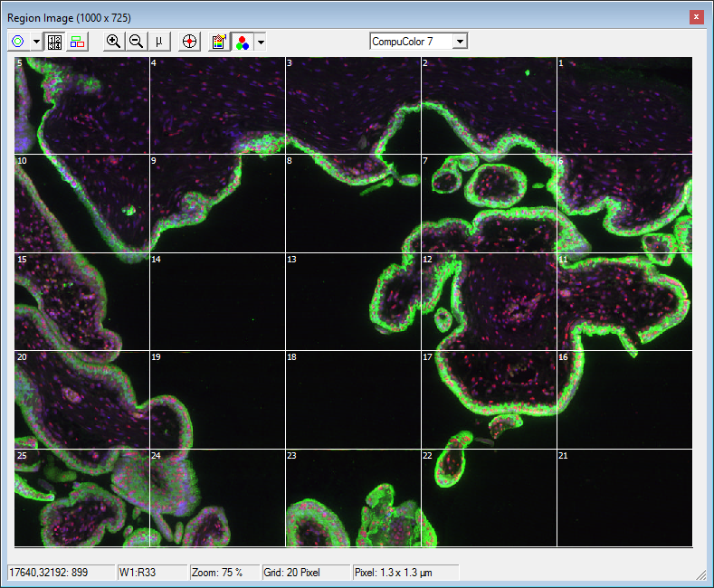
Supplementary Figure 1. A scanned random region of a tissue section by an iCyte® Automated Imaging Cytometer. An image generated by laser scanning cytometry for simultaneous detection of DAPI (blue), 5-hmC (red) and PSG-1 (green).
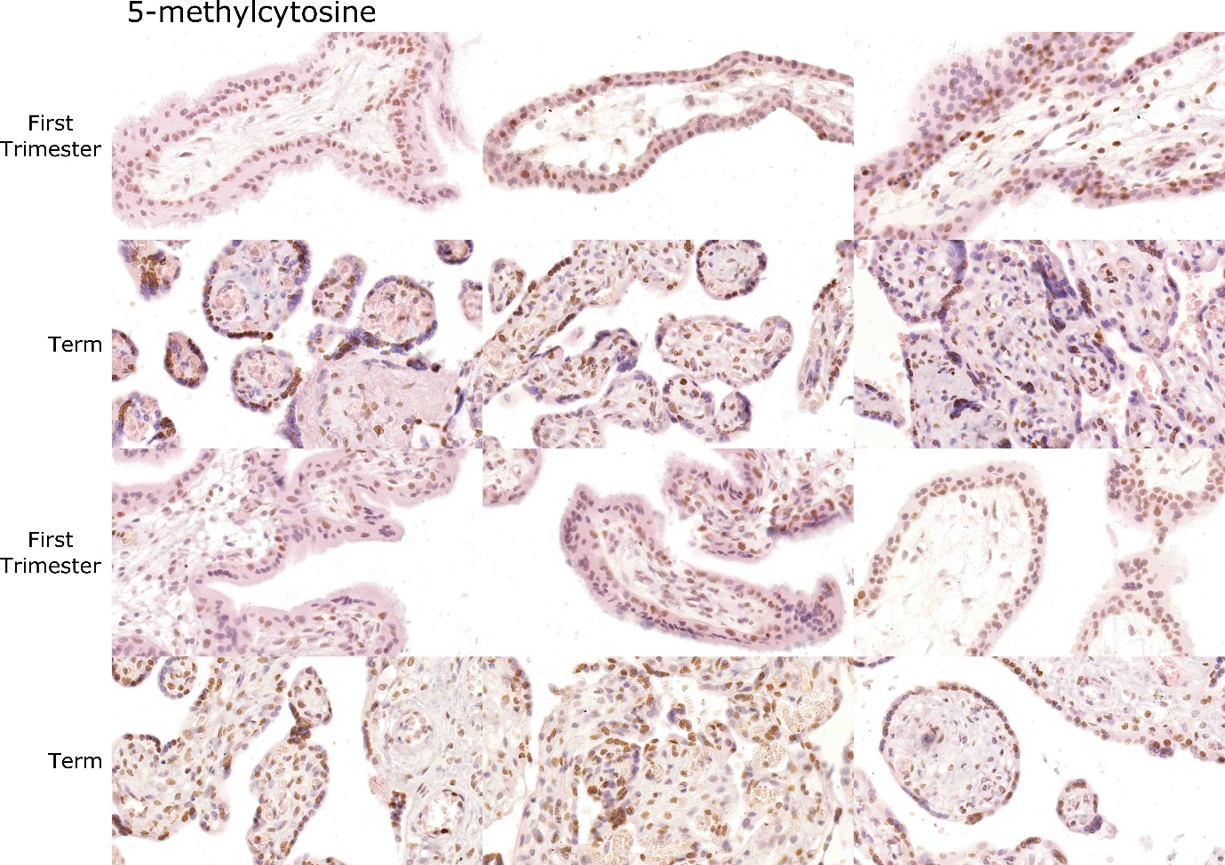
Supplementary Figure 2. Representative images of 5-methylcytosine (5-mC) staining in first trimester (rows 1 and 3; 6 different tissues) and term (rows 2 and 4; 6 different tissues) placenta sections. Localisation of 5-mC was predominantly in the CTB nuclei but stromal cells and STBs stained positively.
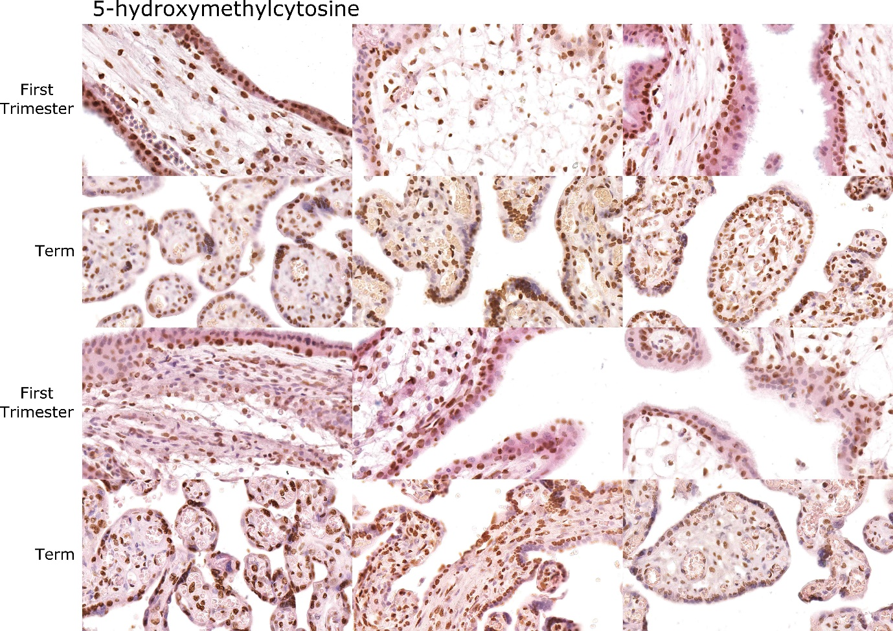
Supplementary Figure 3. Representative images of 5-hydroxymethylcytosine (5-hmC) staining in first trimester (rows 1 and 3; 6 different tissues) and term (rows 2 and 4; 6 different tissues) placenta sections. Localisation of 5-hmC was found throughout the CTB, STB and stromal cells.

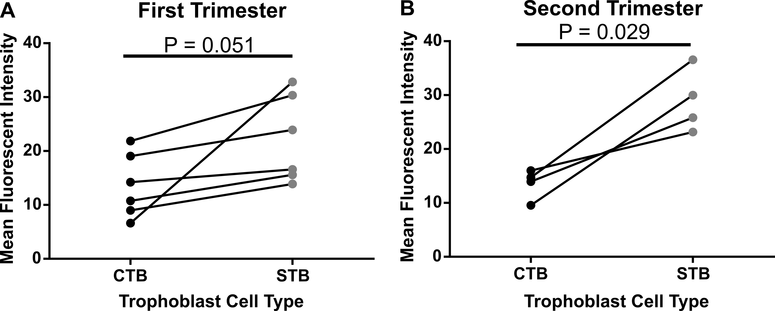
Supplementary Figure 4. Immunofluorescent labelling of 5-hydroxymethylcytosine (5-hmC) in cytotrophoblast (CTB) and syncytiotrophoblast (STB) cells isolated from first (6-12 weeks’ gestation) and second trimester (13-22 weeks’ gestation) tissue. A. Quantification of staining intensity using ImageJ image analysis software comparing 5-hmC in CTBs and STBs from first trimester tissue. B. Comparison of 5-hmC staining intensity between second trimester CTBs and STBs showed a significant increase in STBs. Significance was determined using a Mann-Whitney test.

