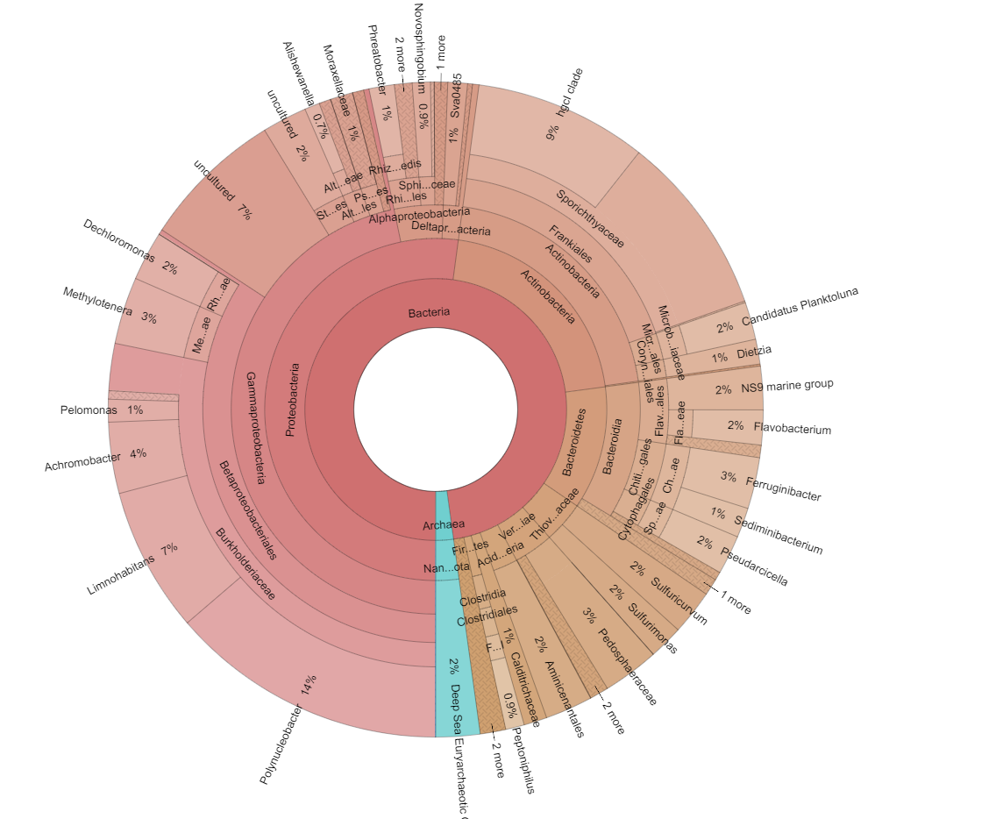
Figure S1. A) Graphic representation (Krona) of the taxonomic assignment of Bacteria and Archaea domains in surface water of Chester Cone Lake. Interactive link: (add link to supplementary interactive Krona chart html).

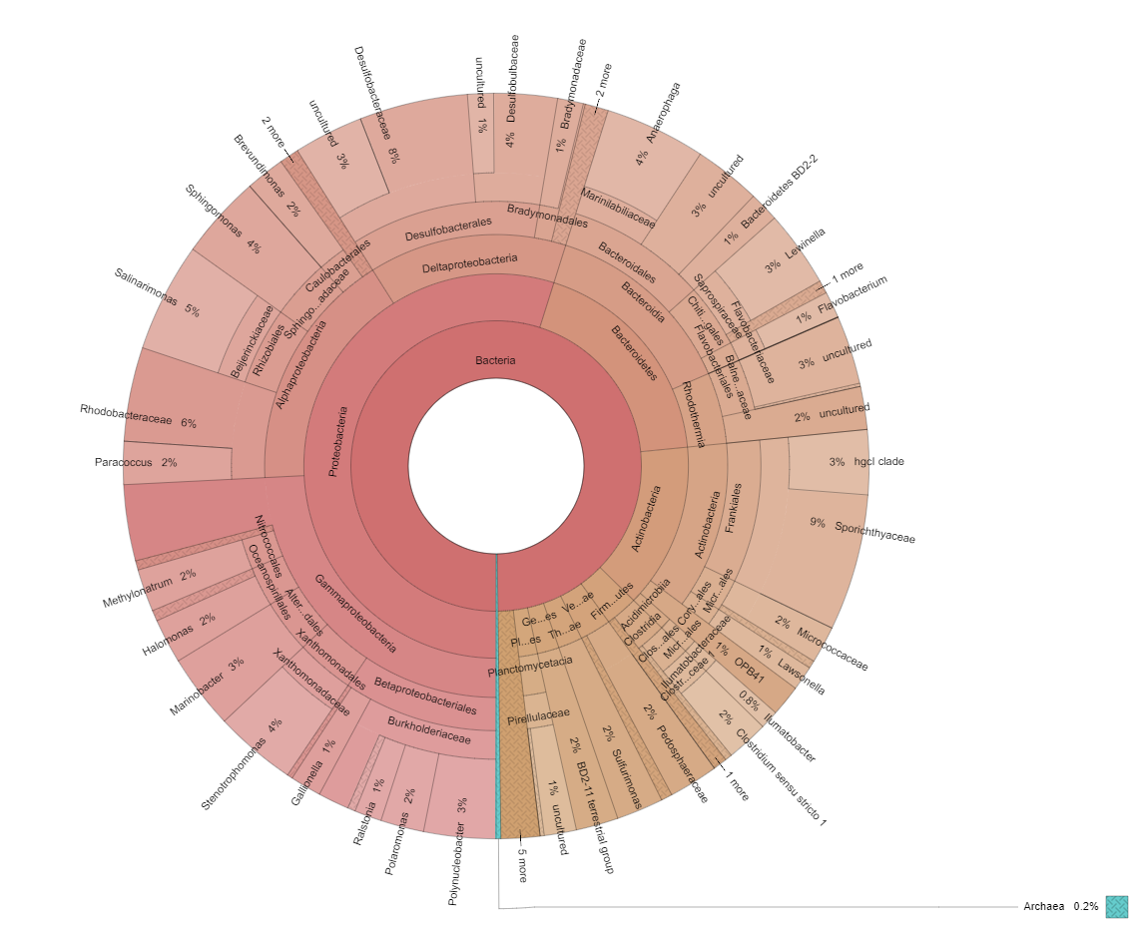
Figure S1. B) Graphic representation (Krona) of the taxonomic assignment of Bacteria and Archaea domains in deep water of Chester Cone Lake. Interactive link: (add link to supplementary interactive Krona chart html).

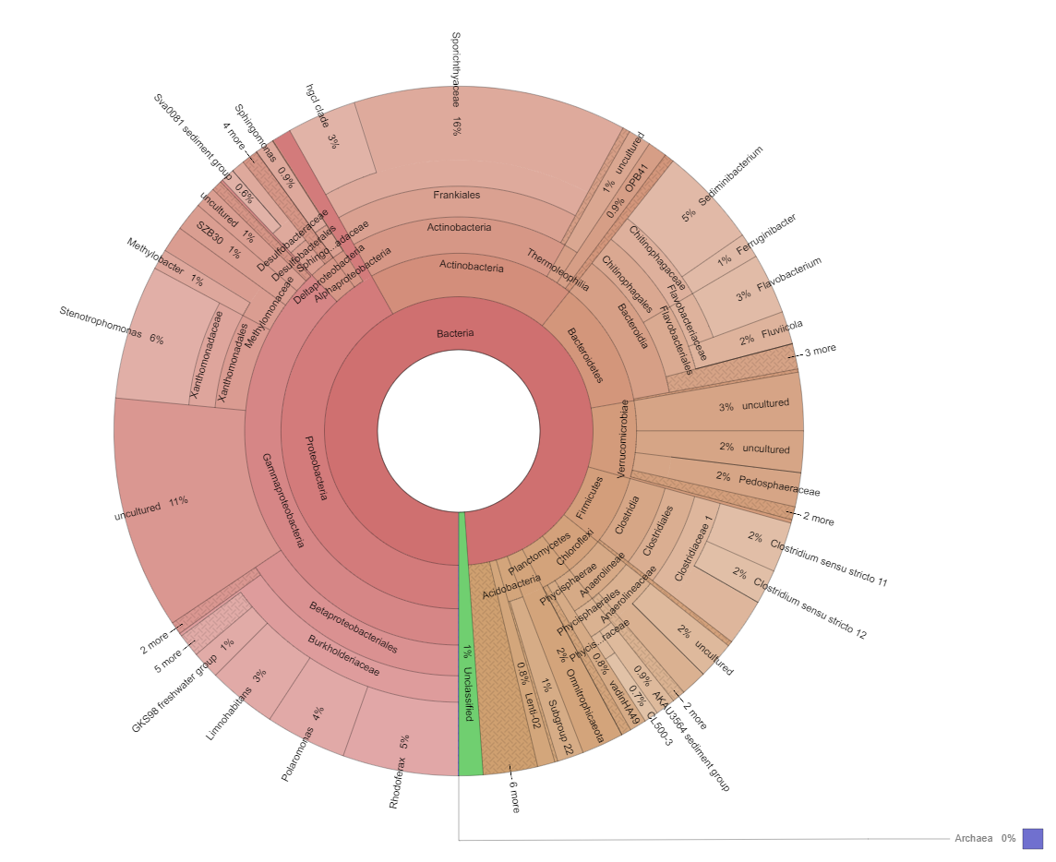

Figure S1. C) Graphic representation (Krona) of the taxonomic assignment of Bacteria and Archaea domains in surface water of Midge Lake. Interactive link: (add link to supplementary interactive Krona chart html).

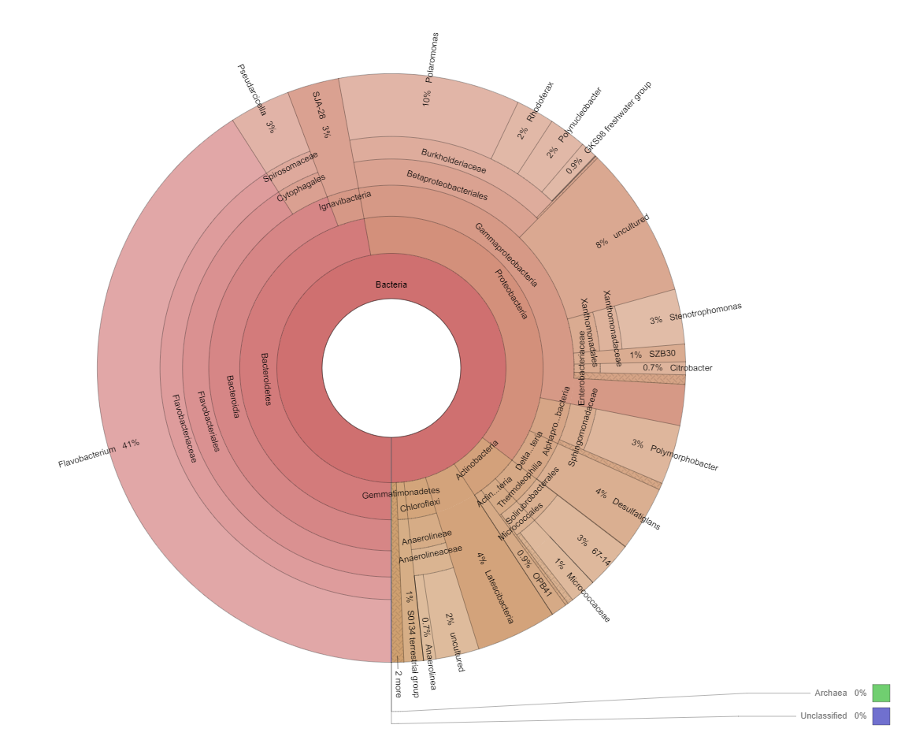

Figure S1. D) Graphic representation (Krona) of the taxonomic assignment of Bacteria and Archaea domains in surface water of Somero Lake. Interactive link: (add link to supplementary interactive Krona chart html).

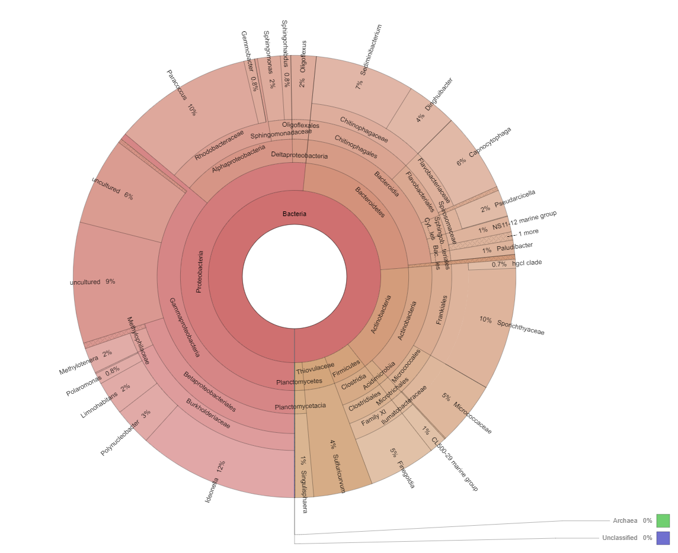

Figure S1. E) Graphic representation (Krona) of the taxonomic assignment of Bacteria and Archaea domains in surface water of Turbio Lake. Interactive link: (add link to supplementary interactive Krona chart html).

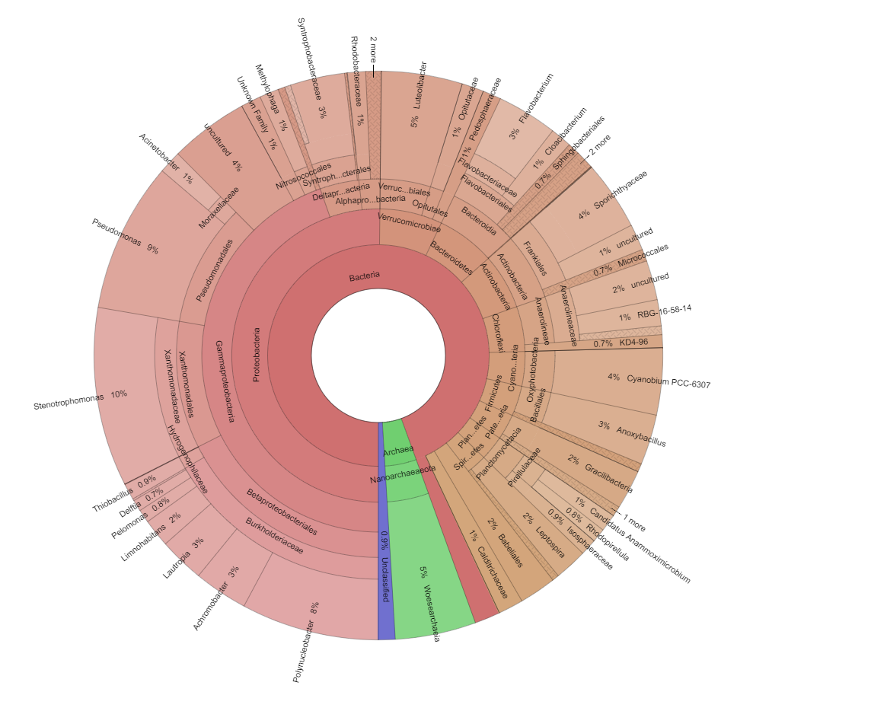

Figure S1. F) Graphic representation (Krona) of the taxonomic assignment of Bacteria and Archaea domains in surface water of Limnopolar Lake. Interactive link: (add link to supplementary interactive Krona chart html).

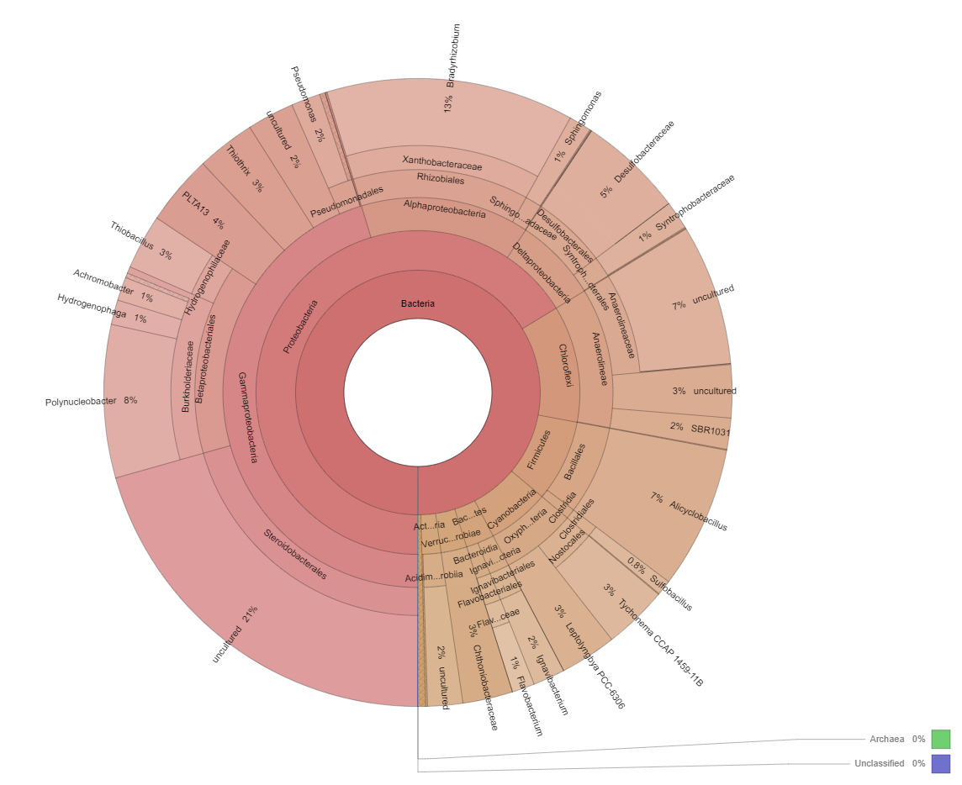

Figure S1. G) Graphic representation (Krona) of the taxonomic assignment of Bacteria and Archaea domains in deep water of Limnopolar Lake. Interactive link: (add link to supplementary interactive Krona chart html).

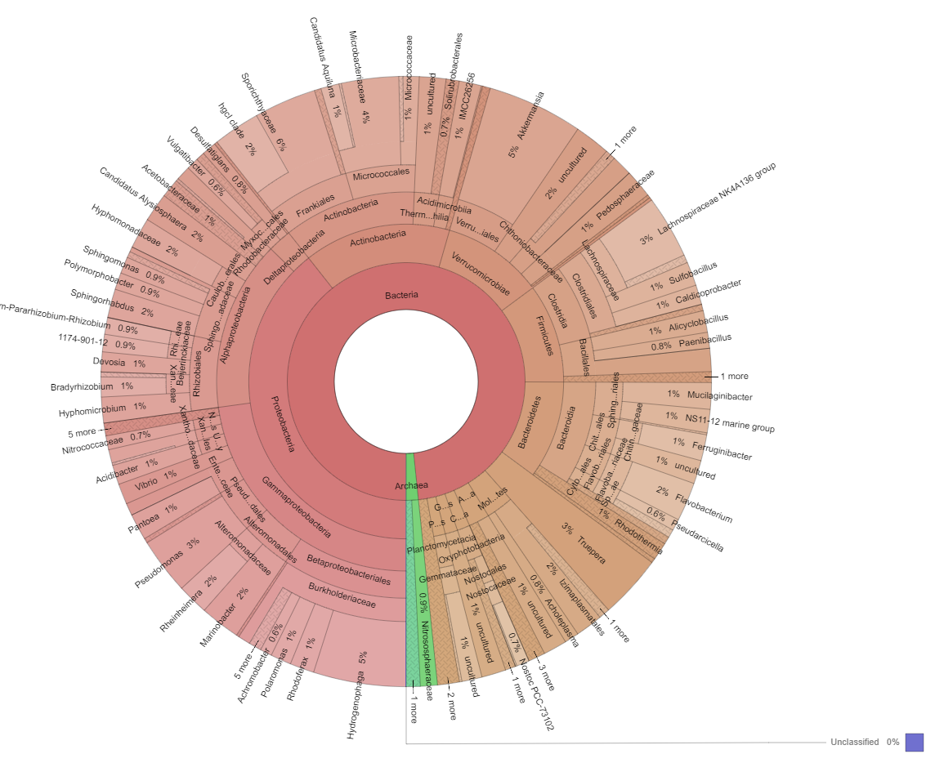
Figure S1. H) Graphic representation (Krona) of the taxonomic assignment of Bacteria and Archaea domains in surface water of Escondido Lake. Interactive link: (add link to supplementary interactive Krona chart html).

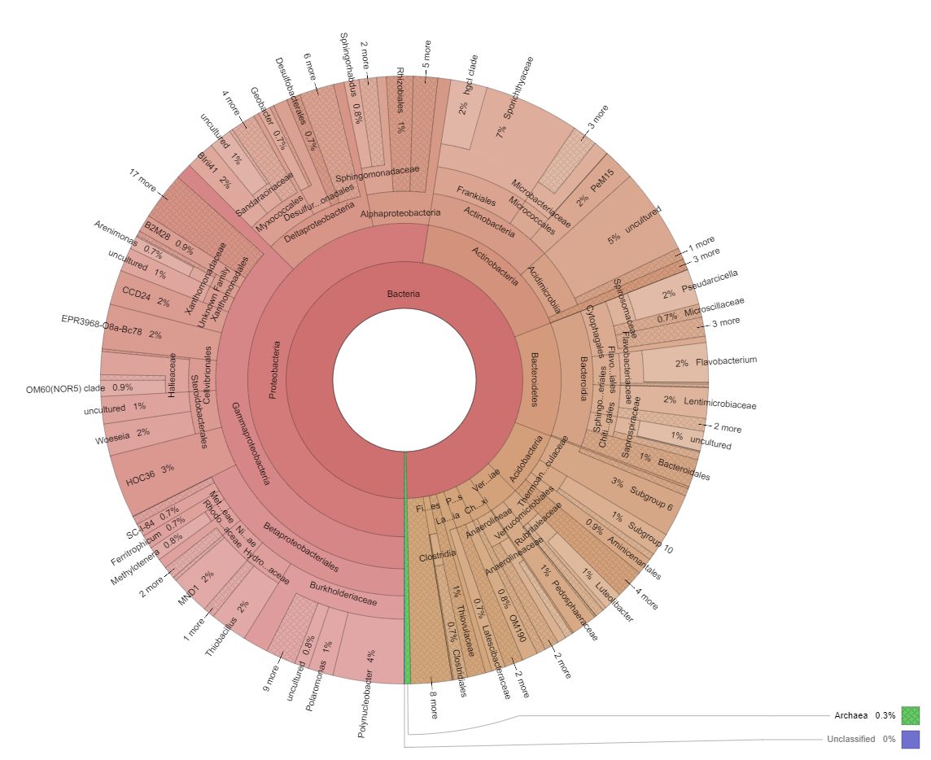
Figure S1. I) Graphic representation (Krona) of the taxonomic assignment of Bacteria and Archaea domains in surface water of Refugio Lake. Interactive link: (add link to supplementary interactive Krona chart html).

