Additional file 2
Peak characteristics of histone methylations of mouse intestinal samples

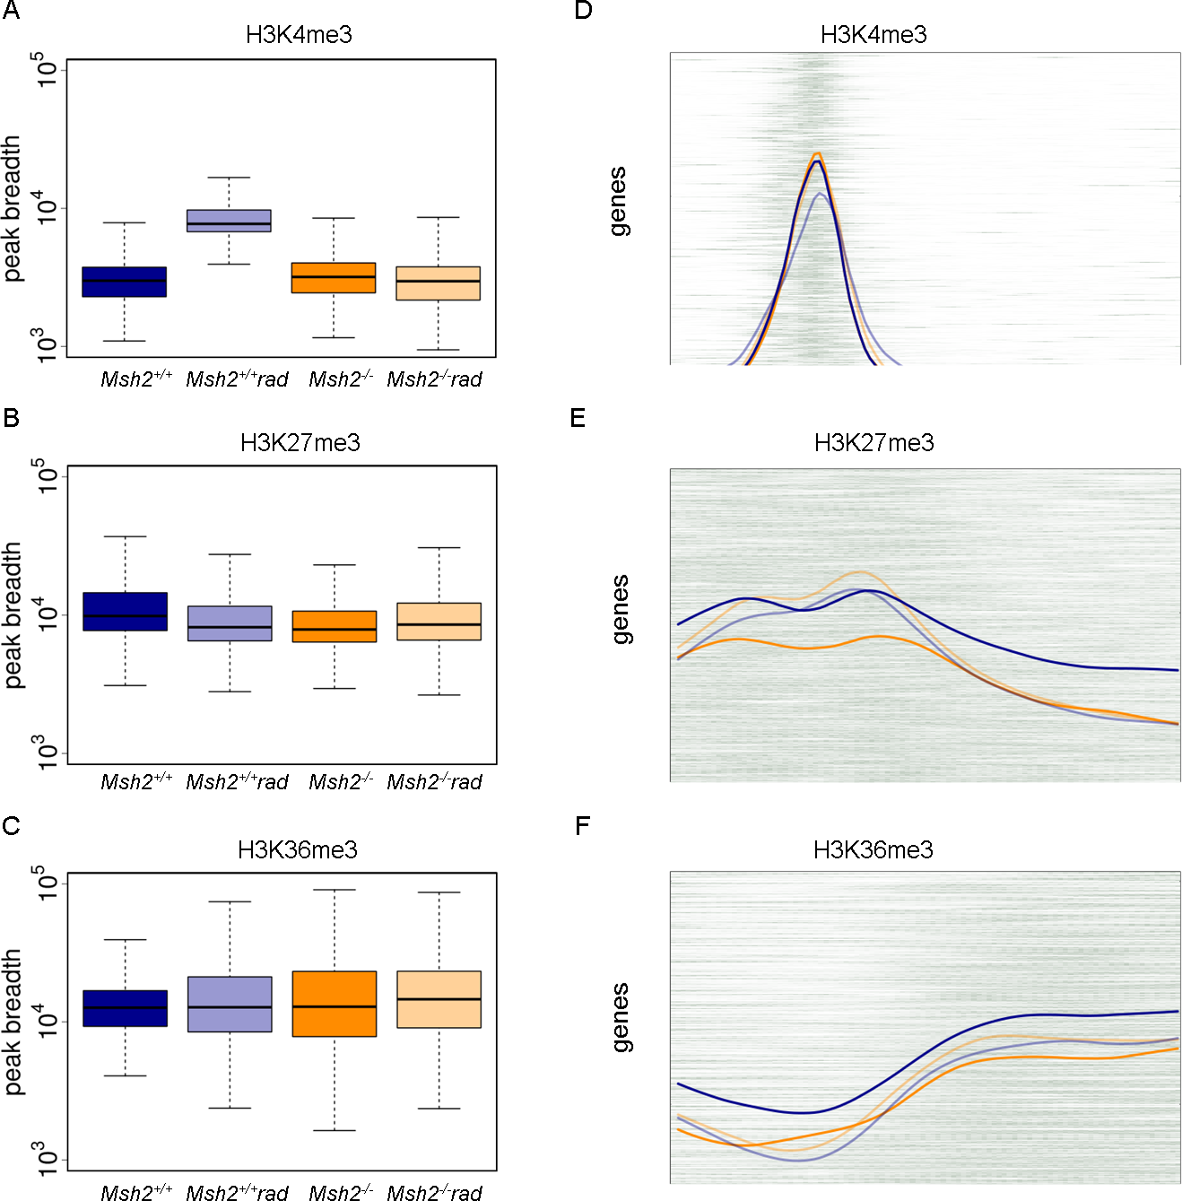

Figure AF2: Peak characteristics of histone methylations of mouse intestinal samples

A-C) Boxplots of peak breadths for all intestinal samples (n=2/genotype/treatment). The breadth distributions of the modification peaks are rather broad ranging from a few hundred to several thousand base pairs, except for radiated Msh2^{+/+} mice, which show very broad peaks (A). In Msh2^{+/+} mice H3K27me3 regions are slightly broader compared to all other mice mice (B). Notably, the variability of H3K36me3 peak breadths is lower in Msh2^{+/+} compared to all other mice (C).
D-F) Heatmaps showing the normalized read density for the histone modifications. Herein, each row corresponds to one gene and each column to a 100 bp window with a position relative to the transcription start site (TSS). The background color indicates the normalized read density at this position for Msh2^{+/+} mice. Lines illustrate the mean read densities. H3K4me3 read densities are sharp and peak next to the TSS (D). In contrast, the H3K27me3 densities show a bimodal distribution (E). In agreement with ChIP-seq measurements in other stem cell systems [54], H3K36me3 read densities are low near the TSS, but establish broad peaks in the gene body (F).

