Supplementary Material

Sulfate-Reducing Bacteria That Produce Exopolymers Thrive in the Calcifying Zone of a Hypersaline Cyanobacterial Mat

Stefan Spring, Dimitry Y. Sorokin, Susanne Verbarg, Manfred Rohde, Tanja Woyke, Nikos C. Kyrpides

Contents Page

Supplementary Tables S1 to S5 2 - 11
Supplementary Figures S1 to S3 12 - 14

TABLE S1. Specifications of genomes used for the reconstruction of phylogenetic relationships within the Desulfovibrionales.
Accession No. ª | Strain Designation ^{b} | G+C  (mol%) | Size  (Mb)
JOMJ00000000 | L21-Syr-AB^{T} | 65.47 | 3.39
JNJP00000000 | Bilophila wadsworthia ATCC 49260^{T} (DsrBD fusion) | 59.22 | 4.63
CM001488 | Desulfobacter postgatei 2ac9^{T} | 47.17 | 3.97
JAEX00000000 | Desulfocurvus vexinensis DSM 17965^{T} | 69.66 | 3.63
CP001734, CP001735 | Desulfohalobium retbaense DSM 5692^{T} | 57.33 | 2.91
CP001629 | Desulfomicrobium baculatum DSM 4028^{T} | 58.65 | 3.94
ACJN00000000 | Desulfonatronospira thiodismutans ASO3-1^{T} | 51.33 | 3.97
JMKT00000000 | Desulfonatronovibrio hydrogenovorans DSM 9292^{T} | 50.33 | 2.94
JAFE00000000 | Desulfonatronum lacustre DSM 10312^{T} | 59.32 | 3.76
FNIN00000000 | Desulfonauticus submarinus DSM 15269^{T} | 32.47 | 2.10
BDFE00000000 | Desulfoplanes formicivorans Pf12B^{T} | 49.81 | 3.00
JIAK00000000 | Desulfovermiculus halophilus DSM 18834^{T} | 56.81 | 3.24
AULZ00000000 | Desulfovibrio africanus subsp. africanus DSM 2603^{T} | 61.10 | 4.41
CP000112 | Desulfovibrio alaskensis G20 | 57.84 | 3.73
JNJA00000000 | Desulfovibrio alcoholivorans DSM 5433^{T} | 64.70 | 5.13
ATHI00000000 | Desulfovibrio alkalitolerans DSM 16529^{T} | 64.48 | 3.11
AUMA00000000 | Desulfovibrio aminophilus DSM 12254^{T} | 66.16 | 3.42
AUCX00000000 | Desulfovibrio bastinii DSM 16055^{T} | 43.06 | 3.91
FUYA00000000 | Desulfovibrio bizertenis DSM 18304^{T} | 52.09 | 3.27
BBCB00000000 | “Desulfovibrio brasiliensis” JCM 12178 | 59.65 | 3.56
AUCY00000000 | Desulfovibrio cuneatus DSM 11391^{T} | 53.50 | 3.36
ATUZ00000000 | Desulfovibrio desulfuricans DSM 642^{T} | 57.36 | 3.39
CP014229 | “Desulfovibrio fairfieldensis” CCUG 45958 | 60.90 | 3.70
FNGA00000000 | Desulfovibrio ferrireducens DSM 16995^{T} | 42.78 | 3.87
JONL00000000 | Desulfovibrio frigidus DSM 17176^{T} | 42.75 | 4.19
AECZ00000000 | Desulfovibrio fructosivorans JJ^{T} | 63.85 | 4.67
CP006585, CP006586 | Desulfovibrio gigas DSM 1382^{T} | 63.63 | 3.79
FUYC00000000 | Desulfovibrio gracilis DSM 16080^{T} | 58.43 | 3.18
IMG 2571042916 | Desulfovibrio halophilus DSM 5663^{T} | 60.96 | 3.38
FO203522, FO203523 | Desulfovibrio hydrothermalis DSM 14728^{T} | 45.09 | 3.66
IMG 2574180452 | Desulfovibrio idahonensis DSM 15450^{T} | 64.99 | 3.57
AUBP00000000 | Desulfovibrio inopinatus DSM 10711^{T} | 49.09 | 5.77
FNBX00000000 | Desulfovibrio legallii KHC7 | 64.80 | 2.70
FRDI00000000 | Desulfovibrio litoralis DSM 11393^{T} | 36.87 | 2.74
ATVA00000000 | Desulfovibrio longus DSM 6739^{T} | 63.64 | 3.70
AP010904, AP010905, AP010906 | Desulfovibrio magneticus RS-1^{T} | 62.67 | 5.32
FZOC00000000 | Desulfovibrio mexicanus DSM 13116^{T} | 65.60 | 3.54
AQXE00000000 | Desulfovibrio oxyclinae DSM 11498^{T} | 59.11 | 3.33
IMG 2571042346 | Desulfovibrio paquesii DSM 16881^{T} | 62.98 | 4.21
LT630450 | Desulfovibrio piger FI11049 | 64.20 | 2.81
AUBQ00000000 | Desulfovibrio putealis DSM 16056^{T} | 62.79 | 4.71
CP001649 | Desulfovibrio salexigens DSM 2638^{T} | 47.09 | 4.29
DIXN00000000 | Desulfovibrio sp. MAG UBA6079 | 67.30 | 4.54
ATHV00000000 | Desulfovibrio sp. X2 | 67.99 | 3.91
AZAO00000000 | Desulfovibrio termitidis HI1^{T} | 66.07 | 4.26
IMG 2574179706 | Desulfovibrio vietnamensis DSM 10520^{T} (D. senezii DSM 8436^{T}) ^{c} | 61.39 | 3.99
AE017285, AE017286 | Desulfovibrio vulgaris Hildenborough^{T} | 63.28 | 3.77
AUDC00000000 | Desulfovibrio zosterae DSM 11974^{T} | 41.75 | 4.10
AULY00000000 | Halodesulfovibrio aestuarii DSM 10141 | 45.02 | 3.41
FSRG00000000 | Halodesulfovibrio marinisediminis DSM 17456^{T} | 44.95 | 3.71
JXMS00000000 | Halodesulfovibrio spirochaetisodalis JC271^{T} | 46.19 | 3.61
CP004029, CP004030, CP004031, CP004032 | Lawsonia intracellularis N343 | 33.08 | 1.72
CP002431 | Pseudodesulfovibrio aespoeensis Aspo-2^{T} | 62.56 | 3.63
LKAQ00000000 | Pseudodesulfovibrio hydrargyri BerOc1^{T} | 63.80 | 4.08
CP014206 | Pseudodesulfovibrio indicus J2^{T} | 63.50 | 3.97
FO203427 | Pseudodesulfovibrio piezophilus C1TLV30^{T} | 49.93 | 3.65
ª All accession numbers are from NCBI GenBank, except IMG numbers, which are from the JGI IMG/M database.
^{b} Superscript T denotes a type strain. Species names in quotation marks have been effectively published but not validly published under the rules of the International Code of Nomenclature of Bacteria.
^{c} It turned out that the determined sequences of the Desulfovibrio senezii dissimilatory sulfite-reductase genes obtained by cloning (JF830006) are 100% identical to the respective genes in the genome deposited under the name Desulfovibrio vietnamensis in the JGI IMG database, which is not possible due to the large phylogenetic distance of both species. Therefore, we conclude that the genomes of both species were mixed up at IMG and use in this study the designation D. senezii for the genome with the IMG ID 2574179706.

TABLE S2. Assembly statistics and sources of genomes representing a clade of sulfate-reducing bacteria containing the newly isolated strain L21-Syr-AB^{T}.
Organism | Unclassified species | Unclassified species | D. alkalitolerans | Metagenome | D. africanus subsp. africanus
Strain | L21-Syr-AB^{T} | X2 | DSM 16529^{T} | UBA6079 | DSM 2603^{T}
Source | hypersaline mat | estuarine sediment | biofilm growing in alkaline waters of a district heating system | oil sand tailings pond | well water
Assembly accession no. | GCA_  000711295 | GCA_  000422205 | GCA_  000422245 | GCA_  002428705 | GCA_  000422545
Total length (bp) | 3,390,909 | 3,912,295 | 3,202,328 | 4,541,696 | 4,402,525
Ungapped length (bp) | 3,390,909 | 3,912,295 | 3,202,328 | 4,541,423 | 4,400,400
Contig count | 5 | 66 | 32 | 78 | 44
Contig N50 | 2,531,670 | 125,439 | 202,204 | 112,272 | 162,267
Contig L50 | 1 | 10 | 6 | 15 | 9
Scaffold count | - | - | - | 72 | 41

TABLE S3. Cellular fatty acid compositions of strain L21-Syr-AB^{T} and the related type strains D. alkalitolerans DSM 16259^{T} and D. africanus subsp. africanus DSM 2603^{T}.
Values are percentages of total fatty acids. Major fatty acids (>5% of total amount) are given in bold; fatty acids that were detected only in trace amounts (<1.0% of the total amount) in all samples are not shown. Abbreviations: -, not detected; tr, trace amounts (<1.0% of the total amount); c, cis isomer; i and ai indicate iso- and anteiso-branched fatty acids, respectively.
Fatty acid | L21-Syr-AB^{T} | DSM 16529^{T} | DSM 2603^{T}
i-C_{14:0} | 1.8 | tr | 1.0
C_{14:0} | 2.6 | tr | 3.6
i-C_{15:1} F ª | - | - | 2.2
ai-C_{15:1} A ª | - | - | 1.2
i-C_{15:0} | 7.1 | 30.4 | 3.0
ai-C_{15:0} | 39.3 | 24.8 | 5.4
i-C_{16:1} H ª | - | - | 7.6
i-C_{16:0} | 10.7 | 1.5 | 1.8
C_{16:1} c9 | - | tr | 23.1
C_{16:1} c11 | - | - | 1.6
C_{16:0} | 21.5 | 7.4 | 8.6
C_{16:0} 10 methyl | 1.9 | - | -
i-C_{17:1} c7 | - | 14.6 | 7.6
ai-C_{17:1} c7 | - | 6.7 | 5.4
i-C_{17:0} | 3.5 | 7.0 | tr
ai-C_{17:0} | 6.3 | 1.1 | tr
C_{17:1} c11 | - | - | 1.2
C_{18:1} c11 | - | tr | 21.2
C_{18:0} | 3.8 | 1.3 | tr
i-C_{17:0} 3OH | 1.0 | 2.8 | -
ª Positions of double bonds were not determined.

TABLE S4. Classification, number and predicted activities of carbohydrate-active protein domains identified in the L21-Syr-AB^{T} genome.
Carbohydrate-active enzymes or modules | No. of sequences ª | Predicted activities
Carbohydrate-Binding Modules
CBM48 | 2 | Glycogen-binding
Carbohydrate Esterases
CE4 | 1 | Polysaccharide deacetylase
CE11 | 1 | UDP-3-O-acyl-N-acetylglucosamine deacetylase
CE14 | 1 | GlcNAc-PI de-N-acetylase
Glycoside Hydrolases
GH3 | 1 | Beta-N-acetylhexosaminidase
GH13_3 | 1 | Alpha-1,4-glucan:maltose-1-phosphate maltosyltransferase
GH13_9 | 2 | 1,4-Alpha-glucan branching protein
GH13_10 | 2 | Malto-oligosyltrehalose trehalohydrolase
GH13_16 | 2 | Trehalose synthase
GH13_26 | 2 | Malto-oligosyltrehalose synthase
GH15 | 1 | Putative glucoamylase
GH23 | 2 | Lytic transglycosylase, Lytic murein transglycosylase C
GH57 | 2 | Alpha-amylase/alpha-mannosidase
GH65 | 1 | Beta-phosphoglucomutase
GH77 | 1 | 4-Alpha-glucanotransferase
GH102 | 1 | Membrane-bound lytic murein transglycosylase A
GH103 | 2 | Membrane-bound lytic murein transglycosylase B
Glycosyltransferases
GT1 | 1 | unknown
GT2 | 6 | Exopolysaccharide biosynthesis polyprenyl glycosylphosphotransferase, Undecaprenyl-phosphate mannosyltransferase
GT4 | 11 | GDP-mannose-dependent alpha-(1-6)-phosphatidylinositol monomannoside mannosyltransferase, Glycosyltransferase involved in cell wall biosynthesis, Alpha-D-QuiNAc alpha-1,3-galactosyltransferase, GDP-mannose-dependent alpha-mannosyltransferase, Trehalose synthase
GT5 | 1 | Glycogen synthase
GT9 | 6 | ADP-heptose:LPS heptosyltransferase, Lipopolysaccharide heptosyltransferase II
GT19 | 1 | Lipid-A-disaccharide synthase
GT20 | 1 | Trehalose 6-phosphate synthase
GT26 | 1 | Exopolysaccharide biosynthesis polyprenyl glycosylphosphotransferase
GT28 | 2 | UDP-2,4-diacetamido-2,4, 6-trideoxy-beta-L-altropyranose hydrolase, UDP-N-acetylglucosamine--N-acetylmuramyl-(pentapeptide) pyrophosphoryl-undecaprenol N-acetylglucosamine transferase
GT30 | 1 | 3-deoxy-D-manno-octulosonic-acid transferase
GT35 | 2 | Alpha-1,4 glucan phosphorylase
GT51 | 1 | Penicillin-binding protein
GT83 | 2 | Dolichyl-phosphate-mannose-mannosyltransferase, Phospholipid carrier-dependent glycosyltransferase
ª Note that the total number is higher than the number of genes due to the occurrence of genes encoding more than one activity.

TABLE S5. Manually annotated genes with a potential function in the energy metabolism of strain L21-Syr-AB^{T}. Assumed operons are highlighted with gray or blue shading. The IMG locus tags of the L21-Syr-AB^{T} genome are labelled with N911DRAFT_.
Predicted protein | Gene Symbol | Amino Acids | IMG Locus Tag
Electron donor utilization
Hydrogen
Heterodisulfide reductase subunit A | hdrA | 669 | 3172
Heterodisulfide reductase subunit C | hdrC | 169 | 3173
Heterodisulfide reductase subunit B | hdrB | 305 | 3174
F420-non-reducing [NiFe] hydrogenase iron-sulfur subunit | mvhD | 139 | 3175
F420-non-reducing [NiFe] hydrogenase small subunit | mvhG | 325 | 3176
F420-non-reducing [NiFe] hydrogenase large subunit | mvhA | 488 | 3177
Hydrogenase maturation protease | hybD | 149 | 3178
Membrane-bound Ech [NiFe] hydrogenase subunit F | echF | 193 | 0900
Membrane-bound Ech [NiFe] hydrogenase subunit E | echE | 358 | 0901
Membrane-bound Ech [NiFe] hydrogenase subunit D | echD | 120 | 0902
Membrane-bound Ech [NiFe] hydrogenase subunit C | echC | 149 | 0903
Membrane-bound Ech [NiFe] hydrogenase subunit B | echB | 282 | 0904
Membrane-bound Ech [NiFe] hydrogenase subunit A | echA | 634 | 0905
Periplasmic [NiFe] hydrogenase small subunit | hynA | 317 | 0964
Periplasmic [NiFe] hydrogenase large subunit | hynB | 569 | 0965
Periplasmic [NiFe] hydrogenase maturation factor | hynC | 178 | 0966
Periplasmic [NiFe] hydrogenase assembly chaperone | hynD | 85 | 0967
Type I cytochrome c₃ | cycA | 132 | 3216
Formate
Formate dehydrogenase maturation protein | fdhE | 292 | 1353
Formate dehydrogenase assembly factor | fdhD | 231 | 1354
Molybdopterin-guanine dinucleotide biosynthesis protein A | mobA | 200 | 1355
Molybdenum cofactor biosynthesis enzyme | moaA | 330 | 1356
Transposase |  | 296 | 1357
Hypothetical protein |  | 67 | 1358
Formate dehydrogenase major subunit | fdhA | 1005 | 1359
Formate dehydrogenase iron-sulfur subunit | fdhB | 239 | 1360
Formate dehydrogenase major subunit | fdhA | 1014 | 2430
Formate dehydrogenase iron-sulfur subunit | fdhB | 248 | 2431
Formate dehydrogenase maturation protein | fdhE | 316 | 2432
Formate dehydrogenase assembly factor | fdhD | 253 | 2433
Ethanol
Aldehyde:ferredoxin oxidoreductase | aor | 489 | 0054
Rubrerythrin | rbr | 162 | 0055
NAD(P)H-flavin reductase | flxA | 282 | 0056
Fe-S oxidoreductase | flxB | 351 | 0057
4Fe-4S ferredoxin iron-sulfur binding domain-containing protein | flxC | 316 | 0058
Methyl-viologen-reducing hydrogenase subunit D | flxD | 154 | 0059
Heterodisulfide reductase subunit A | hdrA | 659 | 0060
Heterodisulfide reductase subunit B | hdrB | 297 | 0061
Heterodisulfide reductase subunit C | hdrC | 185 | 0062
Alcohol dehydrogenase, class IV | adh1 | 393 | 2511
Two-component system response regulator, NtrC family |  | 451 | 2512
PAS domain-containing protein |  | 401 | 2513
Alcohol dehydrogenase, class IV | adh2 | 379 | 2514
Pyruvate and Lactate
L-Lactate utilization protein BA | lutBA | 727 | 1388
L-Lactate utilization protein C | lutC | 210 | 1389
Acetate kinase | ackA | 404 | 1390
Phosphate acetyltransferase | pta | 704 | 1391
D-Lactate dehydrogenase, iron-sulfur-binding domain | glcF | 426 | 1392
D-Lactate dehydrogenase, FAD-binding domain | glcD | 461 | 1393
Lactate permease | lctP | 570 | 1394
Pyruvate:ferredoxin oxidoreductase | por | 1218 | 1395
Two-component system response regulator, NtrC family |  | 477 | 1396
PAS domain-containing protein |  | 848 | 1397
FMN-dependent L-lactate dehydrogenase | lldD | 343 | 1398
Sulfate reduction
Sulfate adenylyltransferase | sat | 426 | 0238
Adenylylsulfate reductase beta subunit | aprB | 169 | 0239
Adenylylsulfate reductase alpha subunit | aprA | 667 | 0240
Quinone-modifying oxidoreductase, subunit A | qmoA | 411 | 0241
Quinone-modifying oxidoreductase, subunit B | qmoB | 764 | 0242
Quinone-modifying oxidoreductase, subunit C | qmoC | 415 | 0243
Hypothetical protein |  | 228 | 0244
Sulfite reductase-associated electron transfer protein DsrP | dsrP | 383 | 1528
Sulfite reductase-associated electron transfer protein DsrO | dsrO | 257 | 1529
Sulfite reductase-associated electron transfer protein DsrJ | dsrJ | 131 | 1530
Sulfite reductase-associated electron transfer protein DsrK | dsrK | 535 | 1531
Sulfite reductase-associated electron transfer protein DsrM | dsrM | 339 | 1532
Hypothetical protein |  | 201 | 1533
Dissimilatory sulfite reductase, subunit A | dsrA | 437 | 1562
Dissimilatory sulfite reductase, subunit B | dsrB | 381 | 1563
Dissimilatory sulfite reductase, subunit D | dsrD | 80 | 1564
Cobyrinate a,c-diamide synthase | cbiA | 475 | 1565
Hypothetical protein |  | 562 | 1566
Sulfur relay protein DsrC | dsrC | 105 | 0568
Membrane complexes involved in energy metabolism
NADH-quinone oxidoreductase-like complex
Subunit A | nuoA | 126 | 2747
Subunit B | nuoB | 181 | 2748
Subunit C | nuoC | 183 | 2749
Subunit D | nuoD | 382 | 2750
Subunit H | nuoH | 324 | 2751
Subunit I | nuoI | 217 | 2752
Subunit J | nuoJ | 169 | 2753
Subunit K | nuoK | 102 | 2754
Subunit L | nuoL | 494 | 2755
Hypothetical protein |  | 87 | 2756
Subunit N | nuoN | 596 | 2757
Subunit M | nuoM | 522 | 2758
Subunit N | nuoN2 | 473 | 2759
Qrc complex
Class III cytochrome c | qrcA | 186 | 2946
Molybdopterin oxidoreductase | qrcB | 714 | 2947
Molybdopterin oxidoreductase, iron-sulfur binding subunit | qrcC | 267 | 2948
Molybdopterin oxidoreductase, membrane subunit | qrcD | 416 | 2949
Tmc complex
Type II cytochrome c₃ | tmcA | 132 | 2787
Iron-sulfur oxidoreductase | tmcB | 448 | 2788
Tmc subunit C | tmcC | 219 | 2789
Tmc subunit D | tmcD | 420 | 2790
Rnf complex (ferrredoxin:NAD⁺ oxidoreductase)
Class III cytochrome c |  | 251 | 0456
Rnf electron transport complex subunit C | rnfC | 395 | 0457
Rnf electron transport complex subunit D | rnfD | 312 | 0458
Rnf electron transport complex subunit G | rnfG | 193 | 0459
Rnf electron transport complex subunit E | rnfE | 242 | 0460
Rnf electron transport complex subunit A | rnfA | 191 | 0461
Rnf electron transport complex subunit B | rnfB | 710 | 0462
Flavin transferase, ApbE-like |  | 324 | 0463
Ohc complex
Iron-sulfur binding subunit | ohcB1 | 335 | 1515
Membran subunit | ohcB2 | 159 | 1516
Octaheme cytochrome c | ohcA | 547 | 1517
Transmembrane cytochrome b | ohcC | 215 | 1518
F-type ATP synthase
F₀ subcomplex membrane subunit b’ | atpF2 | 138 | 2300
F₀ subcomplex membrane subunit b | atpF1 | 191 | 2301
F₁ subcomplex delta subunit | atpH | 183 | 2302
F₁ subcomplex alpha subunit | atpA | 502 | 2303
F₁ subcomplex gamma subunit | atpG | 298 | 2304
F₁ subcomplex beta subunit | atpD | 466 | 2305
F₁ subcomplex epsilon subunit | atpC | 142 | 2306
F₁ subcomplex beta subunit | atpD2 | 461 | 3189
F₁ subcomplex epsilon subunit | atpC2 | 127 | 3190
F-type ATP Synthase membrane subunit I | atpI | 99 | 3191
F-type ATP Synthase membrane subunit 2 | atpR | 96 | 3192
F₀ subcomplex membrane subunit a | atpB | 243 | 3193
F₀ subcomplex membrane subunit c | atpE | 93 | 3194
F₀ subcomplex membrane subunit b | atpF3 | 282 | 3195
F₁ subcomplex alpha subunit | atpA2 | 543 | 3196
F₁ subcomplex gamma subunit | atpG2 | 300 | 3197
V-type proton ATPase
V₁ subcomplex subunit E | ntpE | 230 | 1707
Hypothetical protein |  | 179 | 1708
V₁ subcomplex subunit A | ntpA | 577 | 1709
V₁ subcomplex subunit B | ntpB | 449 | 1710
V₁ subcomplex subunit D | ntpD | 201 | 1711
V₀ subcomplex subunit I | ntpI | 597 | 1712
V₀ subcomplex subunit K | ntpK | 160 | 1713

FIGURE S1. Polar lipid patterns of strain L21-Syr-AB^{T} and two related type strains after two-dimensional thin layer chromatography.
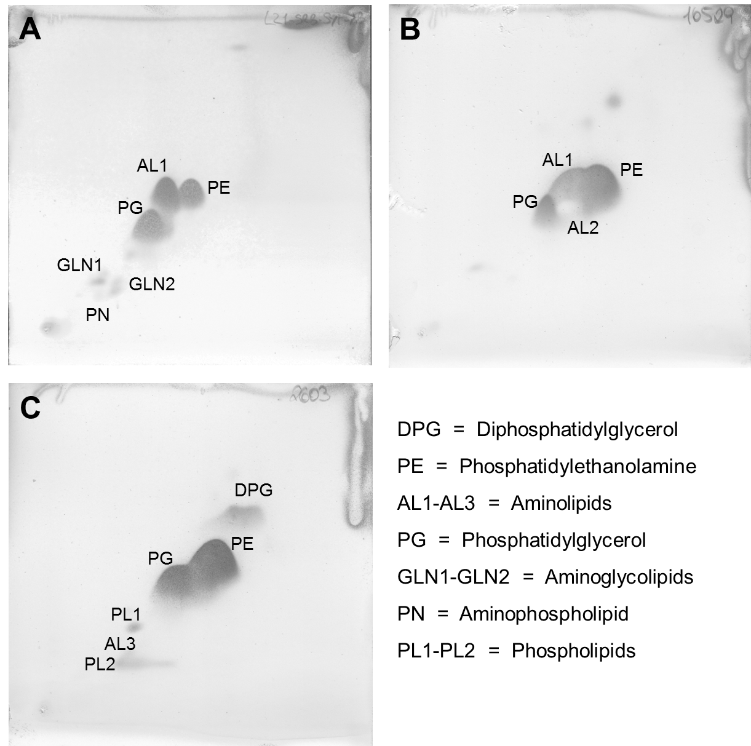
Chromatograms are shown for strain L21-Syr-AB^{T} (A), D. alkalitolerans DSM 16529^{T} (B) and D. africanus subsp. africanus DSM 2603^{T} (C). Staining of the chromatograms was done with molybdatophosphoric acid. Specific spray reagents were used to detect the functional head groups of the lipids.

FIGURE S2. Venn diagrams showing the shared gene content among strains of the L21-Syr-AB^{T} clade and the type species D. desulfuricans.
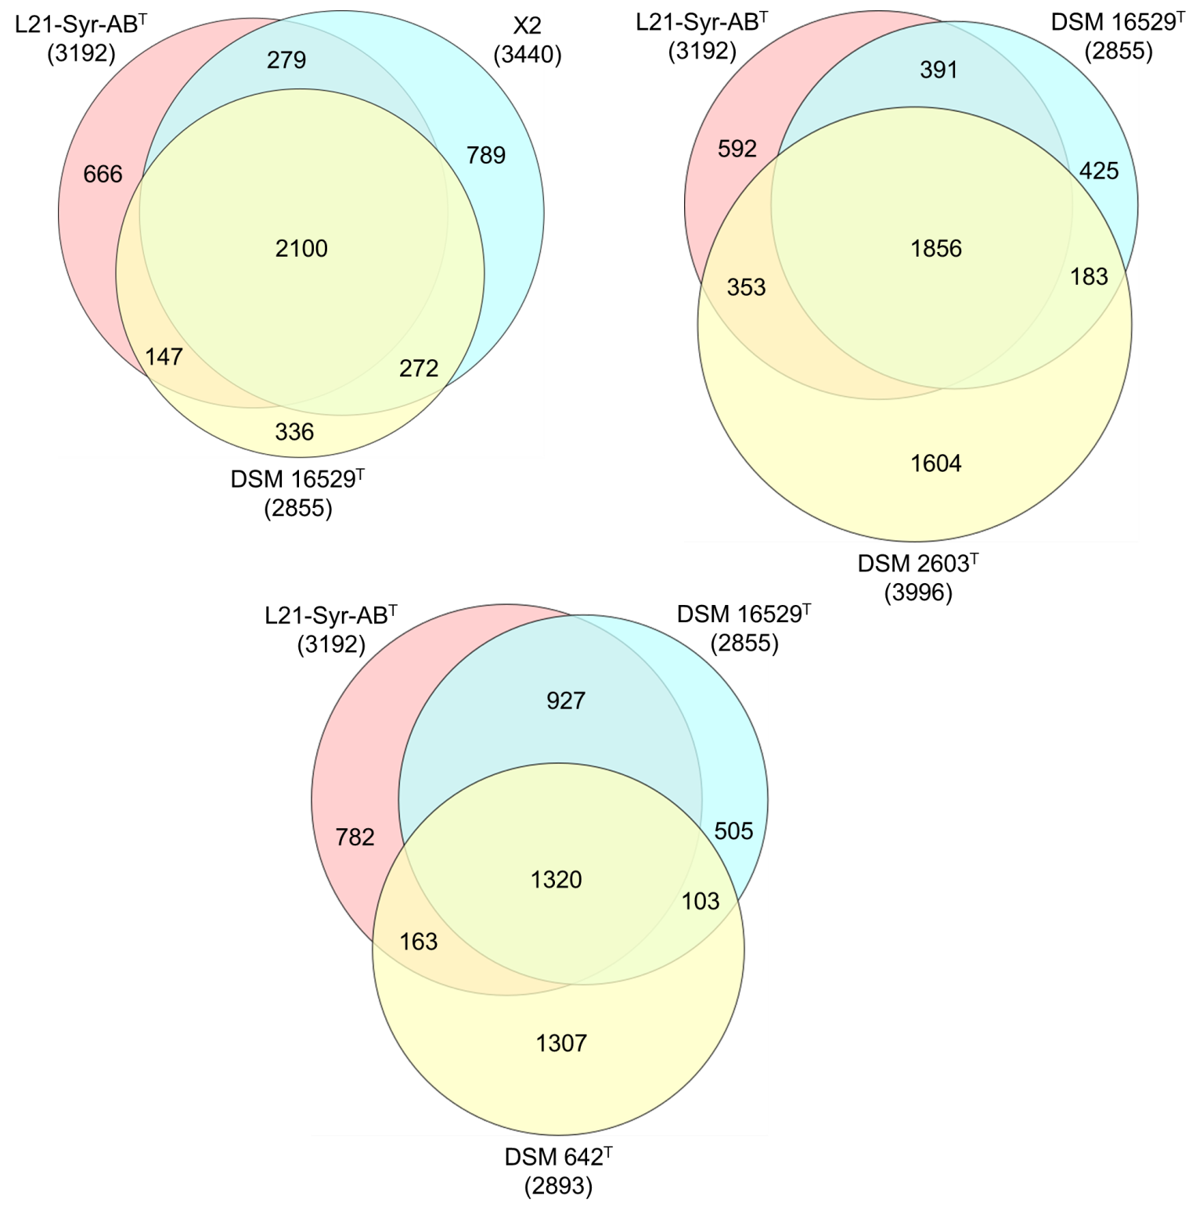
The number of overlapping protein genes is given inside the areas of the circles and the total number of protein genes used for each strain is shown in parentheses. Strain L21-Syr-AB^{T} was compared with Desulfovibrio sp. X2, D. alkalitolerans DSM 16529^{T}, D. africanus subsp. africanus DSM 2603^{T} and D. desulfuricans DSM 642^{T}. Diagrams were created using the Venn diagram plotter available from the Pacific Northwest National Laboratory Software Distribution Centre (https://omics.pnl.gov/software/venn-diagram-plotter).

FIGURE S3. Synteny plots of the L21-Syr-AB^{T} genome against related strains and the type strain of the type species D. desulfuricans.
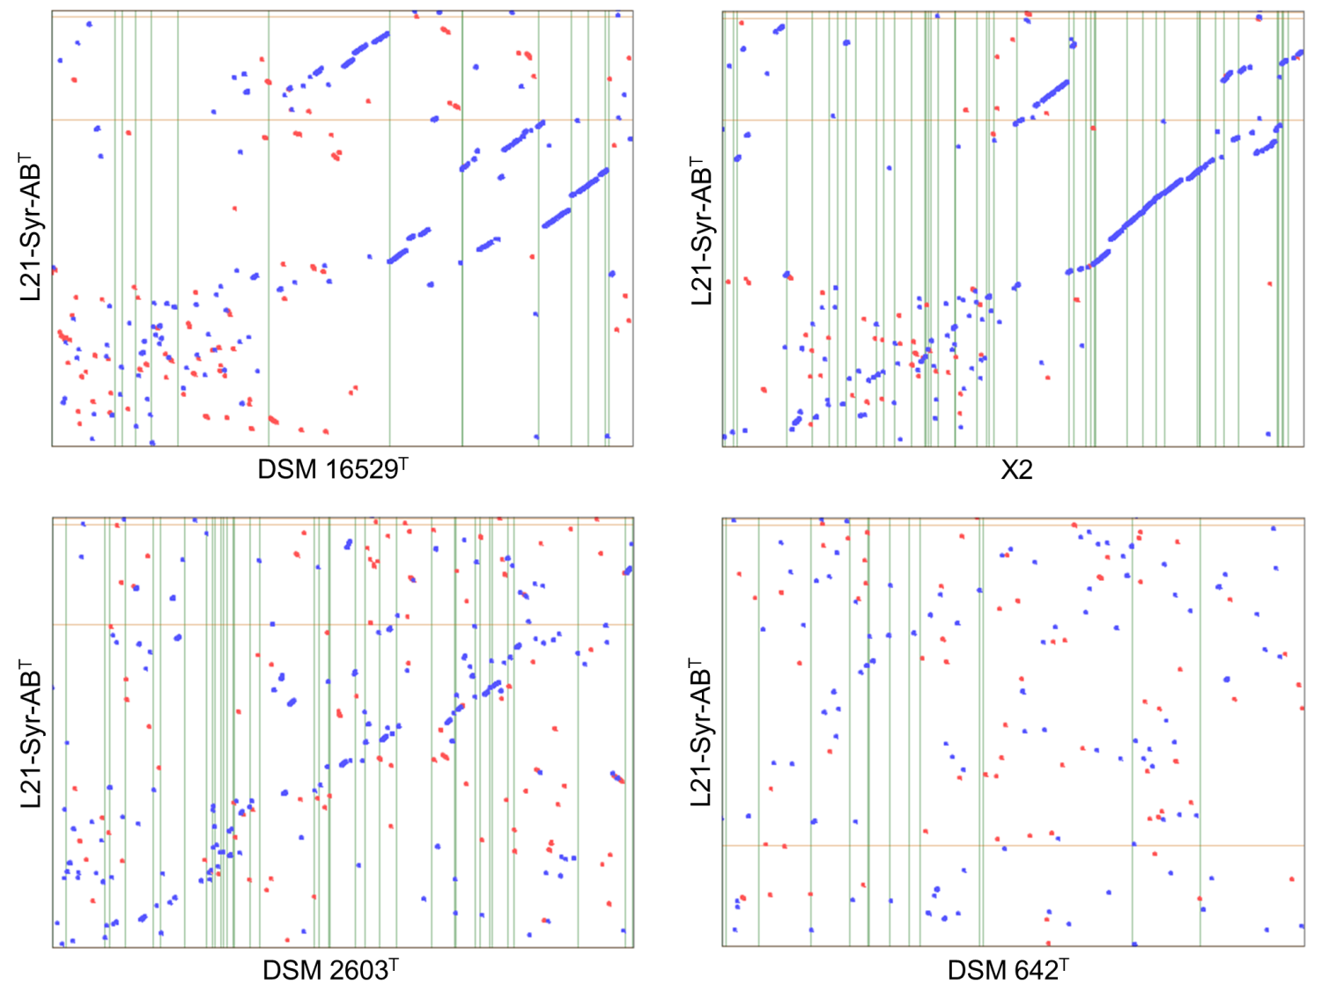
Strain designations given on the x-axis refer to D. alkalitolerans DSM 16529^{T}, strain X2, D. africanus subsp. africanus DSM 2603^{T} and D. desulfuricans DSM 642^{T}. The six frame amino acid translation of the DNA input sequences were used for comparing genomes using PROmer software. Blue dots represent regions of similarity found on parallel strands and red dots show regions of similarity found on anti-parallel strands.

