Supplementary Information for
Human LC3 and GABARAP subfamily members achieve functional specificity via specific structural modulations
Nidhi Jatana¹, David B. Ascher^{2,3,4}, Douglas E.V. Pires^{2,3}, Rajesh S. Gokhale⁵, and Lipi Thukral^{1,6,7,*}

¹CSIR-Institute of Genomics and Integrative Biology, Mathura Road, New Delhi- 110025, India
²Department of Biochemistry and Molecular Biology, Bio21 Institute, University of Melbourne, Melbourne, Victoria 3010, Australia
³Department of Biochemistry, University of Cambridge, Cambridgeshire, CB2 1GA, UK
⁴Centro de Pesquisas René Rachou, FIOCRUZ, Belo Horizonte, MG, Brazil
⁵National Institute of Immunology, Aruna Asif Ali Marg, New Delhi – 110067, India
⁶Academy of Scientific and Innovative Research (AcSIR), CSIR- Institute of Genomics and Integrative Biology, Mathura Road Campus, New Delhi - 110025, India
⁷Interdisciplinary Center for Scientific Computing, University of Heidelberg, Im Neuenheimer Feld 205, Heidelberg 69120, Germany
Corresponding Author*:
Lipi Thukral
CSIR-Institute of Genomics and Integrative Biology, Mathura Road, New Delhi, India.
Email: lipi.thukral@igib.res.in (L.T)

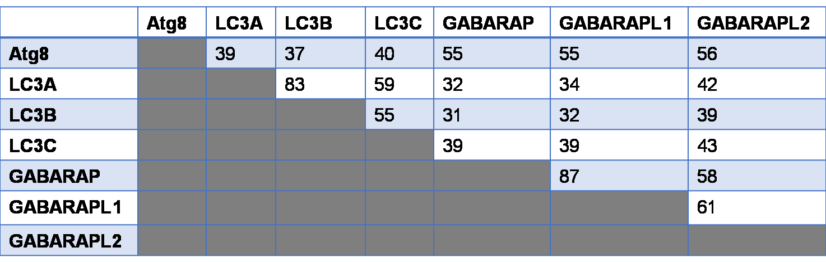
Figure S1. Sequence identity matrix of HsAtg8 orthologs. The sequence conservation in terms of pairwise identity varies from 87% (GABARAP-GABARAPL1) to 31% (LC3B-GABARAP) across proteins.
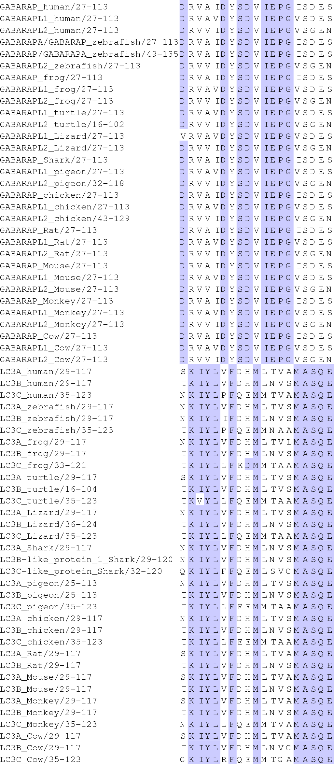

Figure S2. Extract of multiple sequence alignment of LC3 and GABARAP representatives. The figure depicts a selection of residues colored by their predominance in each of the two subfamilies. The residues that represent recognition motif are shown as K30, I31, Y38, L44, F52, M60, M111, A114, S115, Q116, E117 from LC3 and D27, D43, Y49, S53, D54, V57, I68, E73, P85, G92, E112 from GABARAP subfamily.
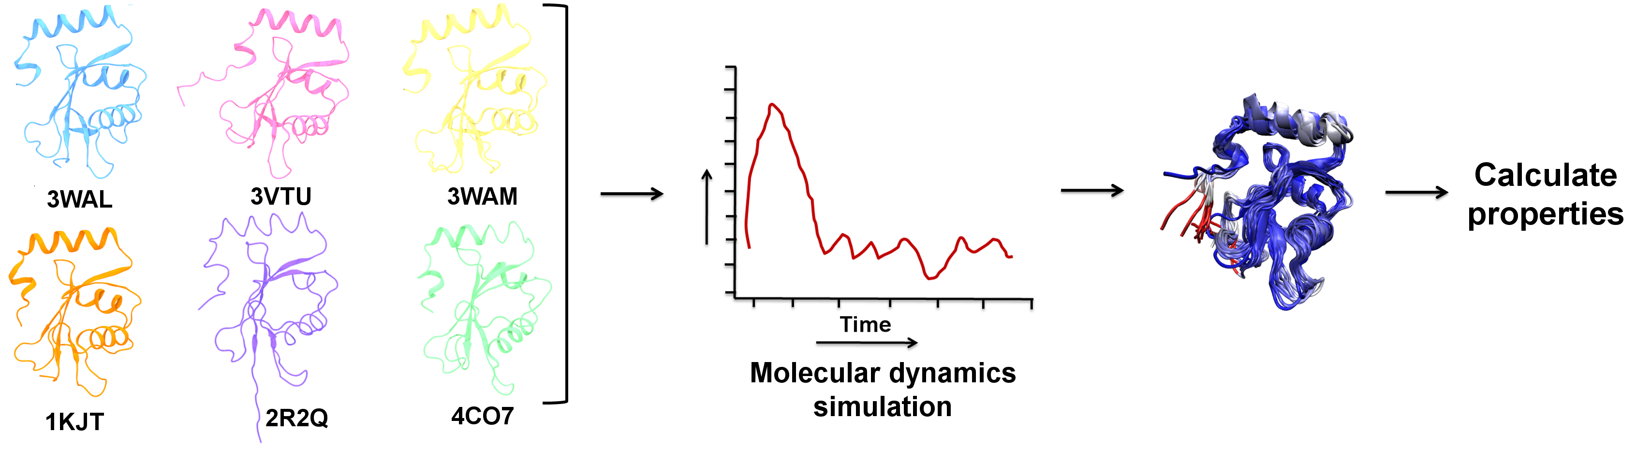
Figure S3. MD workflow utilized for studying unbound HsAtg8 orthologs. The crystal structures of six human Atg8 orthologs were taken as starting structures for MD simulations. The structure of LC3A is shown in cyan color, LC3B in pink, LC3C in yellow, GABARAP in orange, GABARAPL1 in purple and GABARAPL2 in green. The PDB ids are mentioned below the crystal structures. The obtained kinetic trajectories were used to analyze various molecular properties.

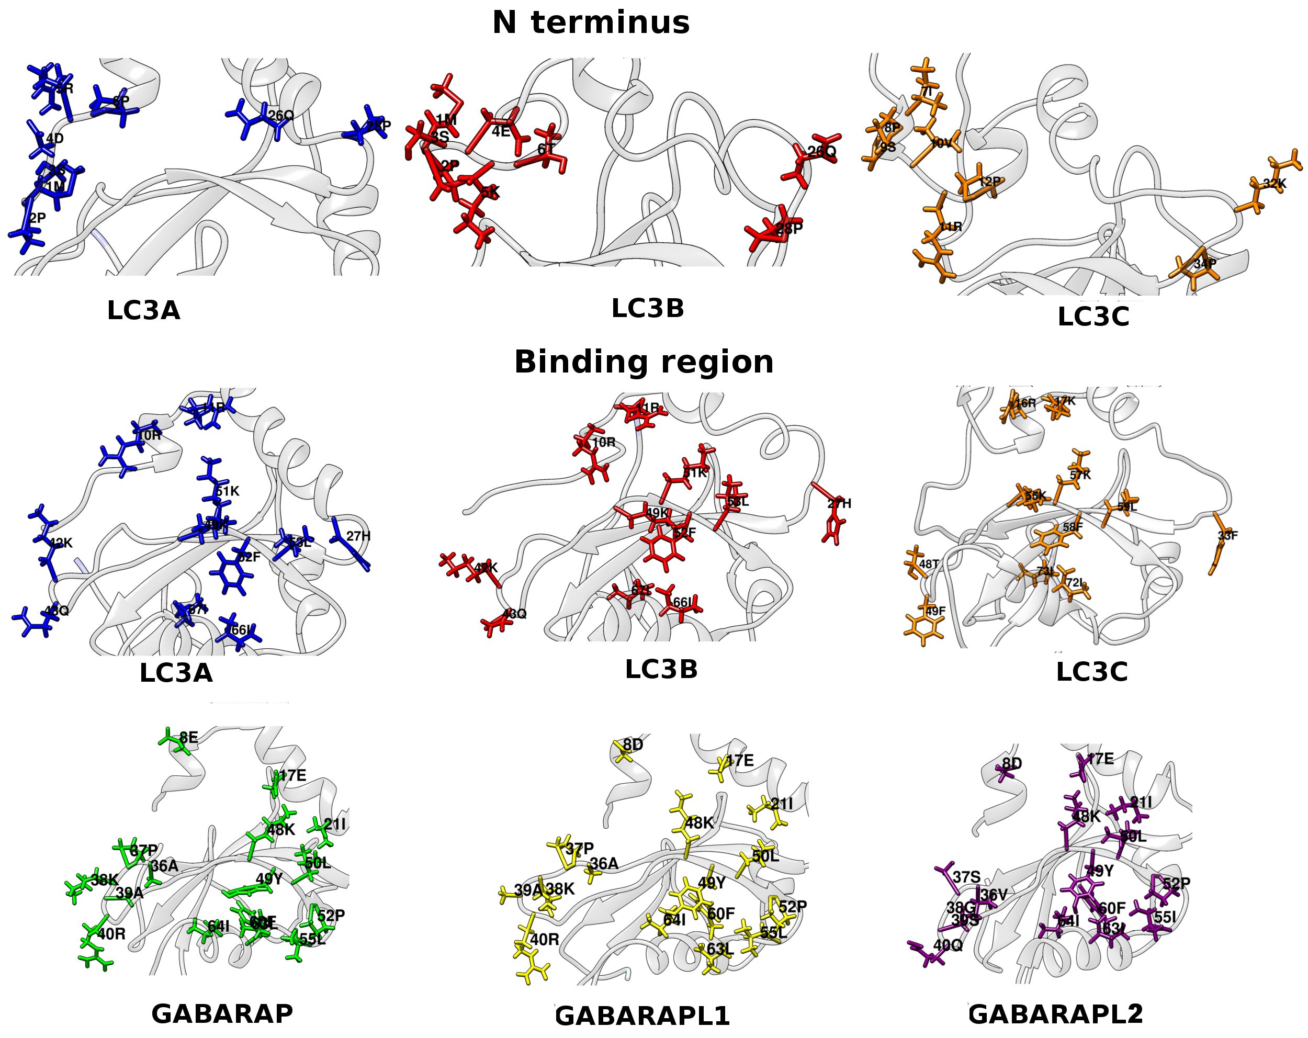
Figure S4. Side-chain orientation of unique residues. Analysis of surface differences in N-terminus and binding region showed unique side chains conferring surface differences. The residues are numbered, individually colored and shown in line representation.
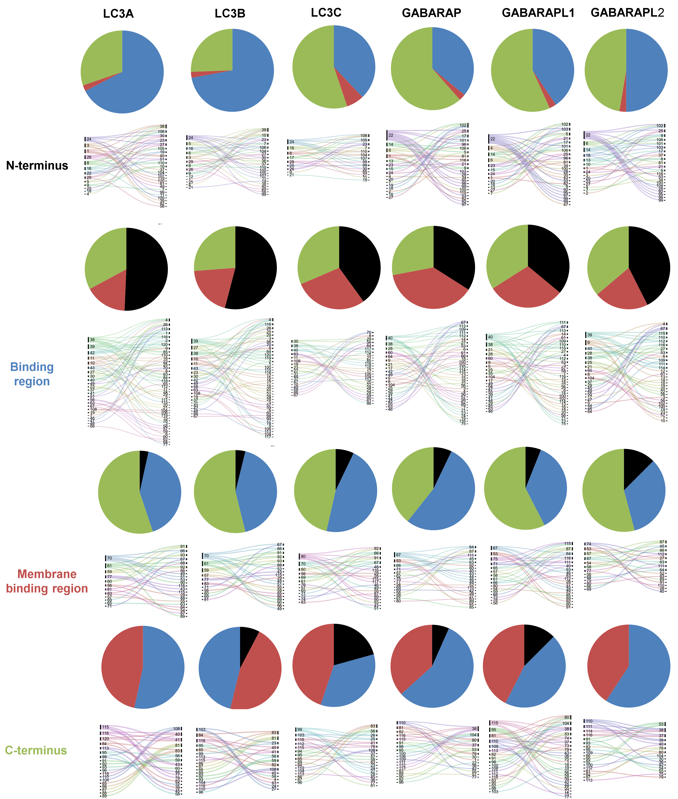
Figure S5. Inter-microcluster hydrogen bonding reveals unique protein network. The hydrogen bond, indicating residue pairs and numbers of H-bonds are represented by alluvial diagram where each line represents a bond. The percentage of hydrogen bonds formed across segments is represented by pie chart for each segment, with N-terminus, binding region, membrane binding region and C-terminus are colored in black, blue, maroon and green, respectively. The residue numbering of LC3C has been modified according to LC3B.

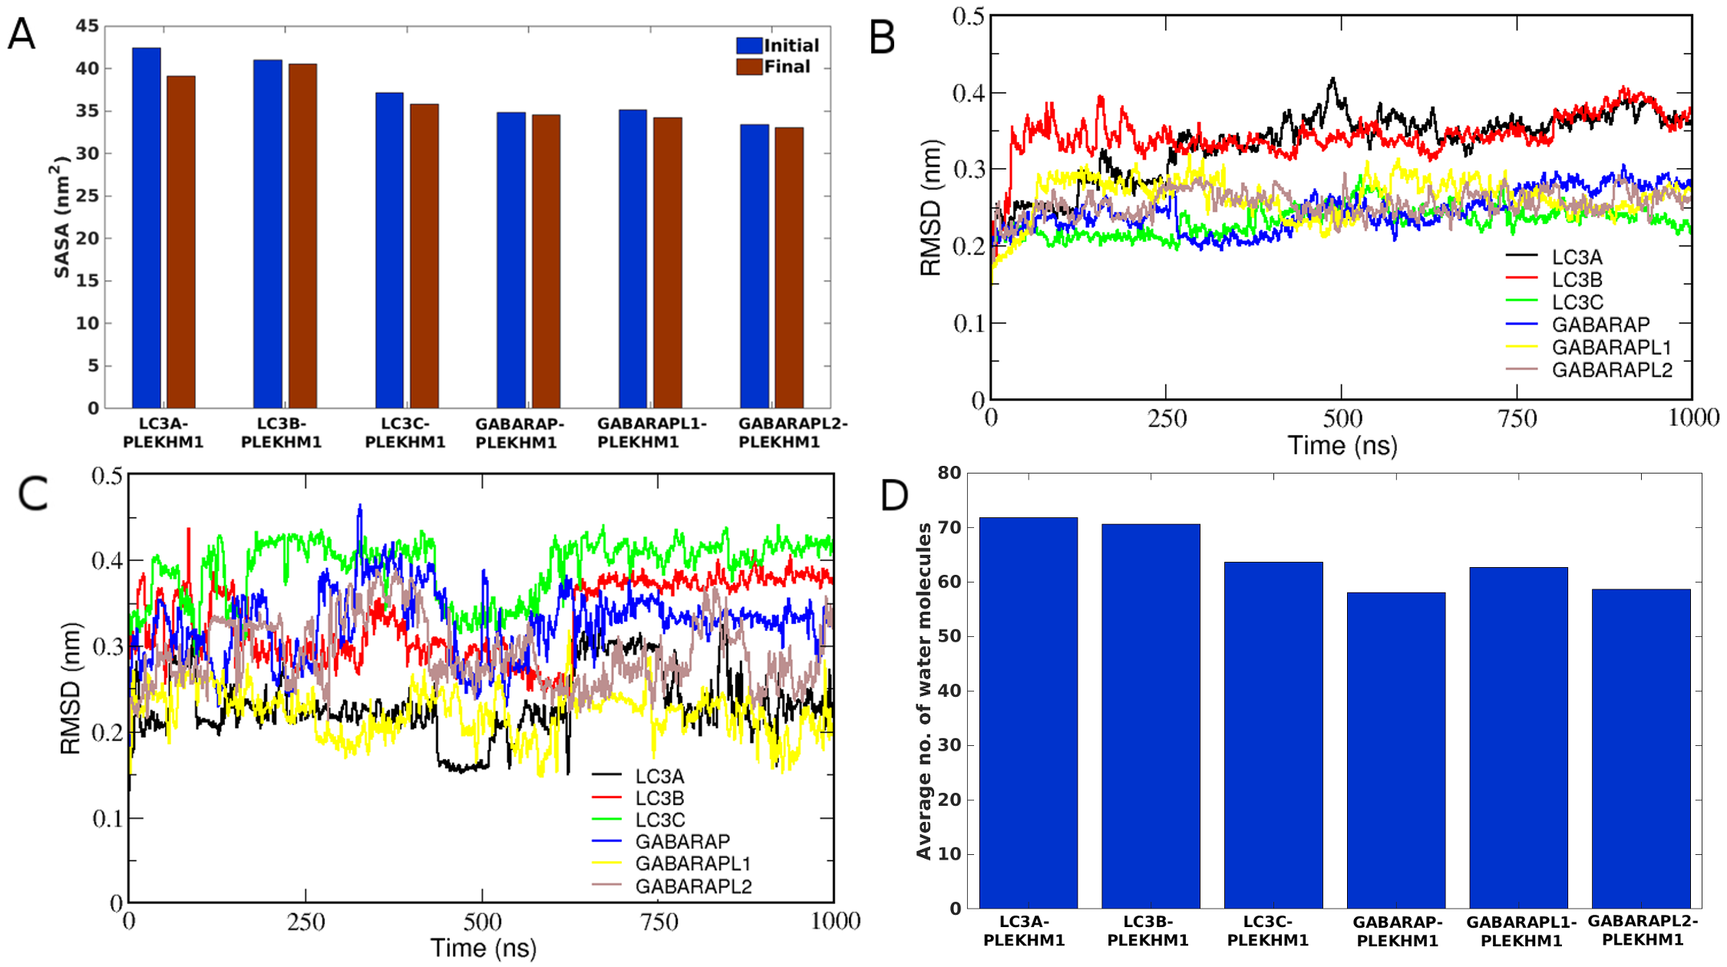
Figure S6. Analysis of functional forms of human Atg8 orthologs. (A) Solvent accessible surface area (SASA) of the binding site in the first and last structures determined in all orthologs. (B) RMSD of only protein in all the PLEKHM1-bound complexes. (C) RMSD of PLEKHM1 peptide in the bound complexes. (D) No. of water molecules within 2 Å of the binding site in all HsAtg8 orthologs in bound-form. The number was averaged throughout the length of the simulation.
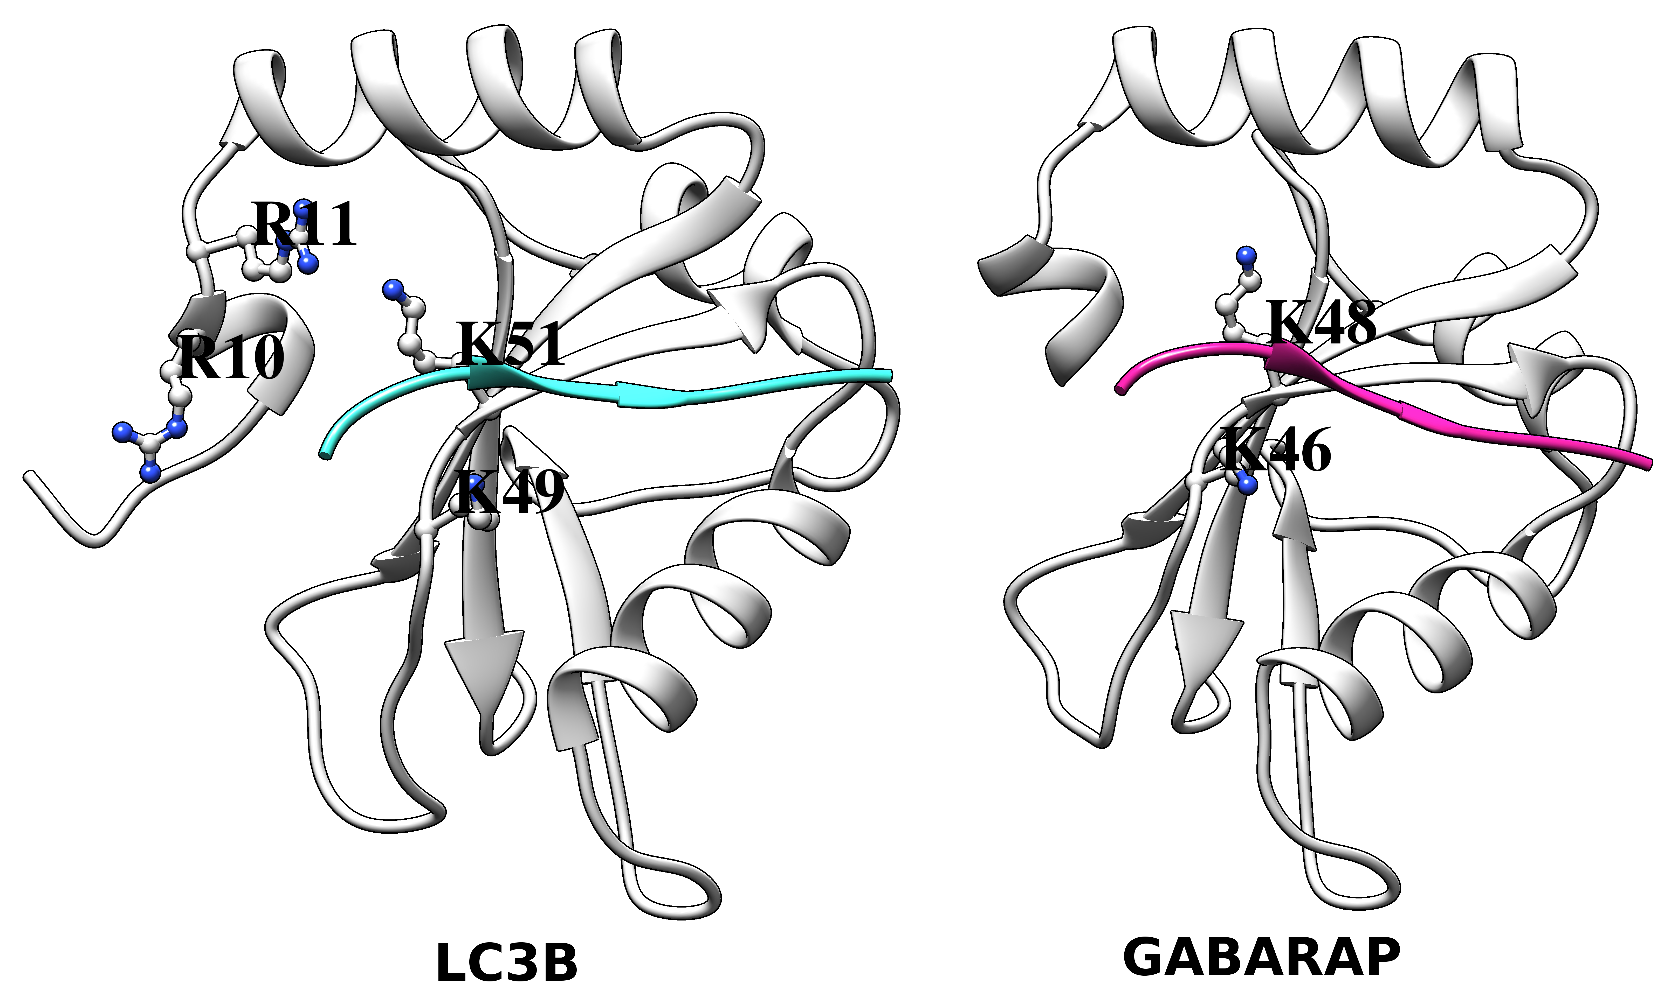

Figure S7. Snapshot showing residues forming salt bridge in LC3B and GABARAP proteins bound to PLEKHM1. The bound peptide (PLEKHM1) is colored in cyan and pink in LC3B- and GABARAP-PLEKHM1 complex, respectively.

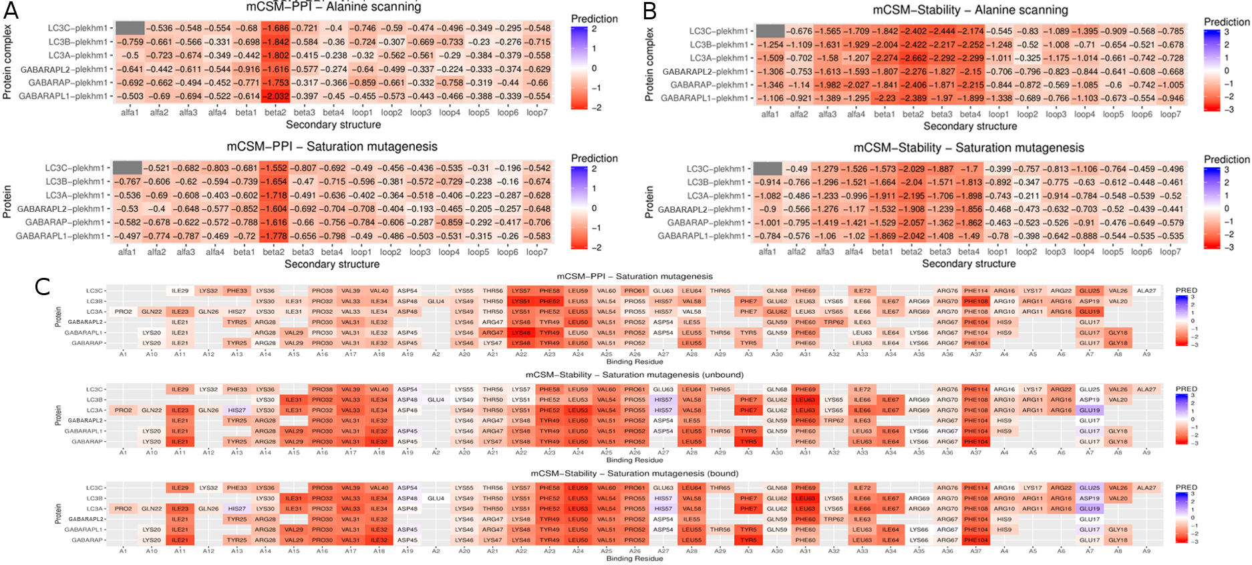Figure S8. In silico mutagenesis analysis. Assessing effects of alanine scanning and saturation mutagenesis on (A) protein-protein affinity and (B) protein stability of bound complexes based on secondary structure. (C) Effect of saturation mutagenesis on protein-protein affinity and protein stability of unbound and bound form of all Atg8 orthologs carried out for binding site residues.

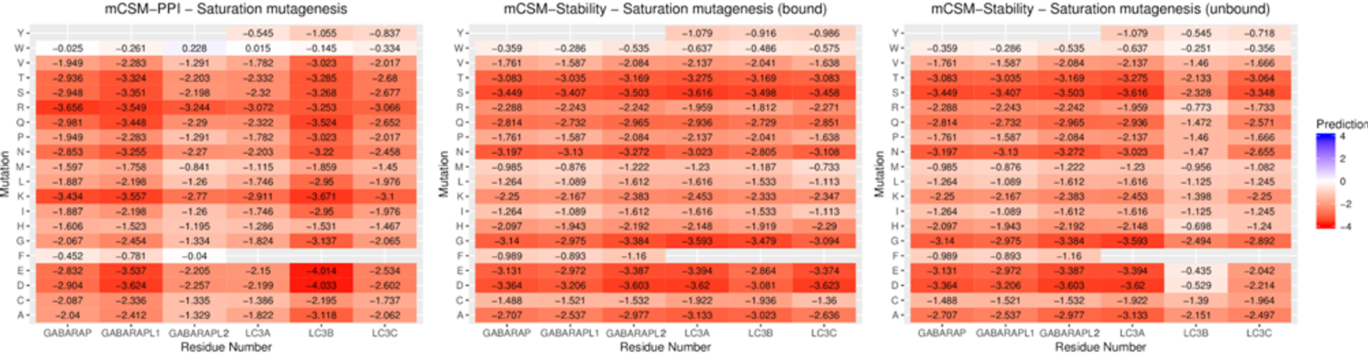
Figure S9. Heatmap of saturation mutagenesis on the F/Y residue transition. Three boxes represent saturation mutagenesis analysis for PPI, stability of bound and unbound complexes for F/Y transition.
Table S1. List of hydrogen bonded residues.
LC3A |  | LC3B | LC3C | GABARAP | GABARAPL1 | GABARAPL2
M1-Y38 | K39-V83 | H27-Q22 | R30-R22 | S16-E17 | Q4-Y5 | H9-M4
M1-G40 | K39-Q85 | H27-D56 | R30-T56 | G42-H69 | Q4-K35 | H9-E12
M1-E41 | G40-M1 | H27-D100 | I37-D112 | G42-Y109 | Q4-D43 | S18-F104
M1-F119 | G40-P2 | R37-P2 | P38-Y86 | Y49-K66 | Q4-R47 | S37-G116
M1-G120 | G40-G120 | Y38-F119 | V40-E117 | F62-F60 | K35-Q4 | S37-F115
S3-Y38 | E41-P2 | Y38-G120 | V40-T118 | I64-F62 | K35-Y109 | S39-K74
S3-K42 | E41-Y113 | K39-P2 | T65-M66 | I64-K66 | R40-Y115 | S39-E112
D4-Y38 | K42-M1 | K39-S3 | F69-T67 | K66-D45 | G58-F60 | S39-T114
F7-Y110 | K42-P2 | G40-E4 | I72-R46 | R67-D43 | E73-R40 | S39-Y109
K8-Y38 | K42-S3 | Q43-A78 | R74-T48 | R67-L44 | N81-F104 | S39-G111
K8-E105 | K42-G120 | N59-V58 | R76-R43 | H69-G42 | Y95-Y25 | S39-F115
R11-Q9 | Q43-T118 | I66-R69 | A99-A27 | Y95-F104 | Y95-R28 | Q40-T114
R11-Q22 | V46-Y113 | K103-I23 | D112-K36 | E112-K38 | Y109-D43 | Q69-D45
R11-R16 | K51-Q22 | K103-H27 | D112-I37 |  | Y115-A39 | K74-Q40
R16-E105 | K51-Q26 |  |  |  | Y109-L44 | S110-K2
K18-E19 | K65-L63 |  |  |  |  | G111-S39
Q22-I23 | I67-K65 |  |  |  |  | G111-Q40
Q22-K51 | Y99-P32 |  |  |  |  | E112-Q40
R24-H27 | Y99-F108 |  |  |  |  | T114-S37
Q26-K30 | Y113-L44 |  |  |  |  | T114-G38
Q26-K51 | S115-Q43
H27-S29 | G120-K39
K30-D25 | G120-G40
R37-Y113 | G120-E41
Y38-D4
Y38-V83
Unique hydrogen bond pairs between binding region and other microclusters in human Atg8 orthologs.
Table S2. Binding site residues among HsAtg8 orthologs bound to PLEKHM1.
LC3A | LC3B | LC3C | GABARAP | GABARAPL1 | GABARAPL2
F7 | F7 | F13 | Y5 | Y5 | F5
R10 | R10 | R16 | E8 (0%) | D8 (12%) | D8 (10%)
R11 | R11 | K17 | H9 (15%) | H9 | H9
E19 | D19 | E25 | E17 | E17 | E17
V20 (12%) | V20 | V26 | G18 | G18 | S18 (6%)
Q22 | L22 (8%) | G28 (3%) | K20 | K20 | K20 (20%)
I23 | I23 (13%) | I29 | I21 | I21 | I21
Q26 | Q26 (0%) | K32 | K24 (18%) | K24 (8%) | K24 (17%)
H27 | H27 (0%) | F33 | Y25 | Y25 (27%) | Y25
K30 | K30 | K36 | R28 | R28 | R28
I31 | I31 | I37 (12%) | V29 | V29 | V29 (7%)
P32 | P32 | P38 | P30 | P30 | P30
V33 | V33 | V39 | V31 | V31 | V31
I34 | I34 | V40 | I32 | I32 | I32
D48 | D48 | D54 | D45 | D45 | D45 (2%)
K49 | K49 | K55 | K46 | K46 | K46
T50 | T50 | T56 | K47 | R47 | R47
K51 | K51 | K57 | K48 | K48 | K48
F52 | F52 | F58 | Y49 | Y49 | Y49
L53 | L53 | L59 | L50 | L50 | L50
V54 | V54 | V60 | V51 | V51 | V51
P55 | P55 | P61 | P52 | P52 | P52
H57 | H57 | E63 | D54 (26%) | D54 | D54
V58 | V58 | L64 | L55 | L55 | I55
E62 | E62 | N68 | Q59 | Q59 | Q59
L63 | L63 | F69 | F60 | F60 | F60
K65 | K65 | S71 (1%) | F62 | F62 (17%) | W62
I66 | I66 | I72 | L63 | L63 | I63
R69 | R69 | S75 (0%) | K66 | K66 | K66 (27%)
R70 | R70 | R76 | R67 | R67 | R67
F108 | F108 | F114 | F104 | F104 | F104

The residues in each column list binding pocket residues that are colored according to conservation where the highly conserved residues are colored in red, medium conserved in orange, less unique in green and unique in blue. The binding site was computed from structures extracted during the first 50 ns of the trajectory and residues displaying >=30% occupancy. The residues colored in black are either not making any contact in the respective Atg8 ortholog with PLEKHM1 or display low occupancy (<30%).

Table S3. List of cancer mutations in all HsAtg8 orthologs.
LC3A |  | LC3B | LC3C |  | GABARAP | GABARAPL1 |  | GABARAPL2
D56H | D56A | R21Q | T100S | M117L | D27G | P42S | Y5H | S18Y
R70H | E36K | Y38H | V115M | D107N | E100D | L105M | R47M | T114P
L53S | T76M | V89F | V10I | Y108H | Q96K | Y95C | P52H | V84F
L82M | A96V | D56N | Y119S | E42V | R22Q | R40M | N81S | G111R
R69H | D48N | Y113C | P4A | A84T | E73K | E34K | K20N | N113D
A96T | E19K | R37Q | K36T | E111K | R65L | T87I | F62L | V84A
G44S | P55S | K65E | R76C | T67I | V83I | S110N | P10L | Q40P
R70C | S8Y | T29A | T82M | A120T | A36T | R67I | G116W | P26L
P6H | F119L | V98A | S71G | F13L | I32L | D102Y | D74G | D100Y
Q9R | G120D | P32Q | P52L | D54N | H69N | H69N |  | P30S
D60H | G120S | G120R | M117I | P38L | R28W | K15E |  | G92E
M3I |  | M60I | S121C | P8S | F60L | D27Y |  | P26H
I98M |  | R21G | R76L | T124I | V29M | E112Q |  | V51A
F108L |  | L123S | E123D | A102T | E73Q | D54H |  | D54G
T50I |  | K39R | G113V | Y44C | A108V | H69Y |  | H9Q
E62K |  | D19Y | P2S | F85L | P30Q | K15T |  | R67M
L47Q |  | K49N | A81T | M77I | P26T | Y115H |  | E96K
L82P |  | I35V | M97I | E24Q | T90I | L55V |  | A58T
Q116K |  | P28L | R46G | S18C | K20N | R67K
G107D |  | R70C | D112H | V115L | K23N | Y49C
D15N |  | L123V | E63V | N35S | E101D | A75T
G107S |  |  | R76H | R74L | M91L | T90A
Q116R |  |  | A81V | A31V | I41T | P52S
Amino acid changes associated with protein is tabulated, with mutations belonging to binding site are colored in red.

Table S4. Summary of Simulations.
Protein | Ligand | Protein Atoms | Solvent atoms | Ions | Total no. of atoms | Simulation Time
LC3A | No | 2019 | 28288 | 2 Cl⁻ | 30309 | 1µs
LC3A | PLEKHM1 | 2155 | 26004 | 1 Na⁺ | 28160 | 1µs
LC3B | No | 2092 | 60668 | 2 Cl⁻ | 62762 | 1µs
LC3B | PLEKHM1 | 2166 | 27004 | 2 Na⁺ | 29122 | 1µs
LC3C | No | 2391 | 83436 | 4 Cl⁻ | 85831 | 1µs
LC3C | PLEKHM1 | 2082 | 23576 | 2 Na⁺ | 25660 | 1µs
GABARAP | No | 1975 | 28236 | 2 Cl⁻ | 30213 | 1µs
GABARAP | PLEKHM1 | 2064 | 26820 | 1 Na⁺ | 28885 | 1µs
GABARAPL1 | No | 1982 | 51244 | 2 Cl- | 53228 | 1µs
GABARAPL1 | PLEKHM1 | 2096 | 26320 | 2 Na⁺ | 28418 | 1µs
GABARAPL2 | No | 1937 | 24920 | 1 Cl- | 26858 | 1µs
GABARAPL2 | PLEKHM1 | 2090 | 25180 | 2 Na⁺ | 27272 | 1µs

All the orthologs in unbound and bound form are simulated with standard MD protocol in solvent environment with the following parameters.

