Supplemental Figure 1. Discontinuation criteria.

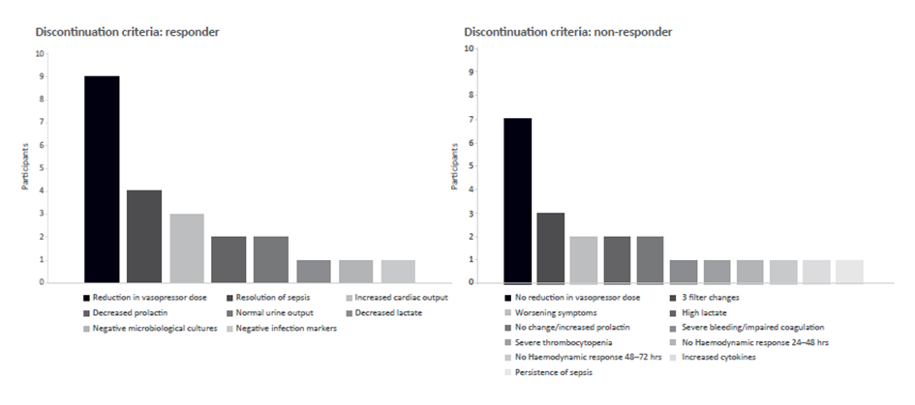

Supplemental Figure 2. Definition of successful treatment and early improvement

