Supplementary Table 1. Comparison of the levels of urinary biomarkers between critically ill neonates with and without acute kidney injury
 | Non-AKI (n=208) | AKI (n=26) | P
Urinary albuminª, g/g uCr | 0.17 [0.11-0.28] | 0.27 [0.17-0.65] | 0.002
Urinary cystatin Cª, μg/mg uCr | 0.52 [0.17-1.31] | 1.56 [0.56-9.56] | 0.001
Urinary nephrinª, μg/mg uCr | 0.18 [0.07-0.36] | 0.47 [0.21-0.99] | <0.001
Urinary albumin^{b}, g/g uCr | 0.23 [0.14-0.38] | 0.30 [0.24-0.91] | 0.004
Urinary cystatin C^{b}, μg/mg uCr | 0.84 [0.34-2.48] | 2.81 [0.67-38.56] | 0.001
Urinary nephrin^{b}, μg/mg uCr | 0.26 [0.11-0.60] | 0.82 [0.26-1.41] | 0.001
Values are median [interquartile range]. Probability values: The Mann-Whitney U test.
ªThe initial values of urinary biomarkers from the samples collected on the first 24 hours admitted to NICU. ^{b}The peak values of urinary biomarkers.

Supplementary Table 2. Comparison of demographic and clinical characteristics between survivors and non-survivors
Characteristics | Survivors (n=210) | Non-survivors (n=24) | P
Gestational age at birth, weeks | 35.7 [32.7-38.3] | 31.6 [30.2-35.8] | 0.001
Birth weight, g | 2500 [1790-3212.5] | 1500 [1110-1900] | <0.001
Male, n | 117 (55.7) | 13 (54.2) | 0.885
SNAP, score | 7 [5-9] | 9 [6.25-11] | 0.007
eGFRª, mL/min/1.73m² | 25.9 [19.7-39.5] | 19.5 [17.1-26.5] | 0.023
CPAP^{b}, n | 82 (39.0) | 13 (54.2) | 0.189
MV^{b}, n | 34 (16.2) | 11 (45.8) | 0.002
MV length, hours | 0 [0-0] | 0 [0-78.5] | 0.001
Apnea^{b}, n | 48 (22.9) | 16 (66.7) | <0.001
AKI^{b}, n | 21 (10.0) | 5 (20.8) | 0.159
AKI stage^{b}, n
Stage 1 | 8 (3.8) | 2 (8.3) | 0.196
Stage 2 | 7 (3.3) | 2 (8.3)
Stage 3 | 6 (2.9) | 1 (4.2)
RDS^{b}, n | 36 (17.1) | 8 (33.3) | 0.092
HIE^{b}, n | 9 (4.3) | 1 (4.2) | 0.727
Sepsis^{b}, n | 17 (8.1) | 8 (33.3) | 0.001
Surfactant^{b}, n | 20 (9.5) | 3 (12.5) | 0.714
Inotrope^{b}, n | 18 (8.6) | 5 (20.8) | 0.069
Furosemide^{b}, n | 10 (4.8) | 3 (12.5) | 0.136
Steroid^{b}, n | 23 (11.0) | 3 (12.5) | 0.737
Aminophylline^{b}, n | 13 (6.2) | 2 (8.3) | 0.685
Antibiotic^{b}, n | 203 (96.7) | 24 (100) | 0.618
Vancomycin^{b}, n | 14 (6.7) | 1 (4.2) | 0.719
Values are median [interquartile range] or numbers (percentage).
AKI, acute kidney injury; CPAP, continuous positive airway pressure; eGFR, estimated glomerular filtration rate; HIE, hypoxic ischemic encephalopathy; MV, mechanical ventilation; NICU, neonatal intensive care unit; RDS, respiratory distress syndrome; SNAP, the score for neonatal acute physiology.
ªBased on Schwartz formula for term or preterm infants. The serum creatinine was taken on the first day of NICU admission in neonates with postnatal age at admission >48h, and on the 3th-5th day in neonates with postnatal age at admission ≤48h. ^{b}Administered or developed during NICU stay.

Supplementary Table 3. Comparison of the levels of urinary biomarkers between survivors and non-survivors
 | Survivors (n=210) | Non-survivors (n=24) | P
Urinary albuminª, g/g uCr | 0.17 [0.11-0.28] | 0.43 [0.25-0.71] | <0.001
Urinary cystatin Cª, μg/mg uCr | 0.50 [0.17-1.15] | 2.70 [1.34-20.47] | <0.001
Urinary nephrinª, μg/mg uCr | 0.17 [0.07-0.33] | 0.76 [0.39-1.35] | <0.001
Urinary albumin^{b}, g/g uCr | 0.17 [0.11-0.28] | 0.45 [0.28-0.89] | <0.001
Urinary cystatin C^{b}, μg/mg uCr | 0.51 [0.18-1.21] | 5.23 [1.34-22.43] | <0.001
Urinary nephrin^{b}, μg/mg uCr | 0.18 [0.07-0.33] | 0.83 [0.39-1.43] | <0.001
Values are median [interquartile range]. Probability values: The Mann-Whitney U test.
ªThe initial values of urinary biomarkers. ^{b}The peak values of urinary biomarkers.

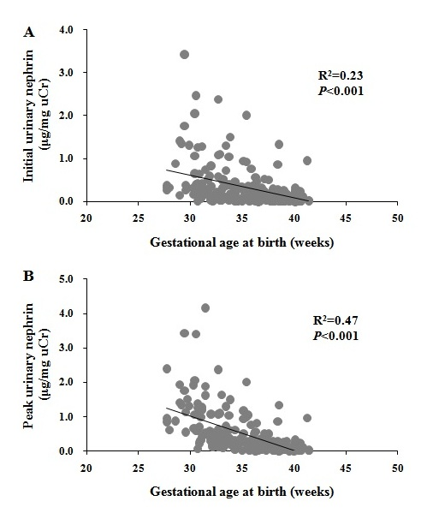
Supplementary Fig 1. Correlation analysis of data from non-AKI neonates (n=208). There was a significant correlation between gestational age at birth and the initial (A: R²=0.23, P<0.001) or peak (B: R²=0.47, P<0.001) urinary nephrin levels. Statistical analysis: Spearman’s test.

Supplementary Fig 2. Comparison of the initial (A) and peak (B) urinary nephrin levels by weeks of gestational age in non-AKI neonates (n=208). Values are medians, boxes represent interquartile ranges and whiskers represent minimums and maximums. Black dots represent outliers. Probability values: Kruskal-Wallis H test. Gestational age ≤29w (n=14), 30w (n=15), 31w (n=15), 32w (n=20), 33w (n=19), 34w (n=11), 35w (n=17), 36w (n=18), 37w (n=13), 38w (n=23), 39w (n=17), ≥40w (n=26).

Supplementary Fig 3. Comparison of the initial (A) peak (B) level of urinary nephrin between non-AKI neonates with (n=32) and without (n=176) antenatal steroids. Values are medians, boxes represent interquartile ranges and whiskers represent minimums and maximums. Black dots represent outliers. Probability values: Mann-Whitney U test.

