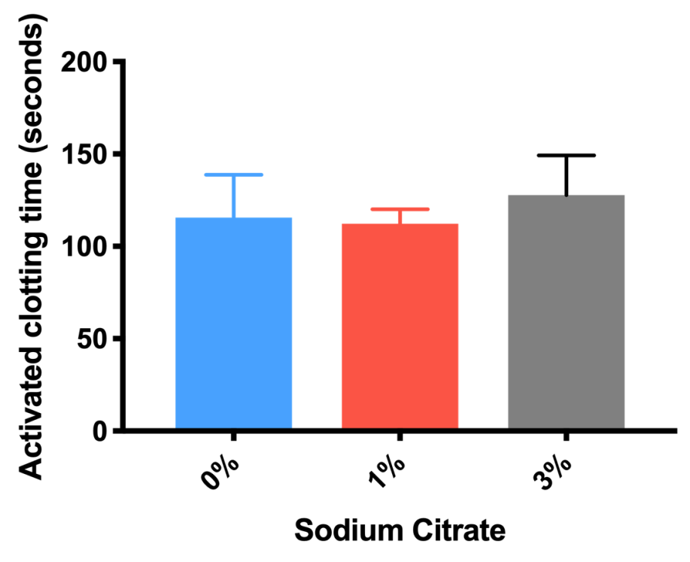
Supplemental Figure 1. Activated clotting time (sec) with differing sodium citrate content. Volunteer blood collected in 0%, 1%, and 3% sodium citrate tubes were measured for activated clotting time. Activated clotting time was similar between three concentration of sodium citrate from 115.5 $±$ 23.2 seconds, 112.3 $±$ 7.7 seconds, and 127.7 $±$ 21.6 seconds, for 0%, 1%, and 3%, respectively (n = 6).

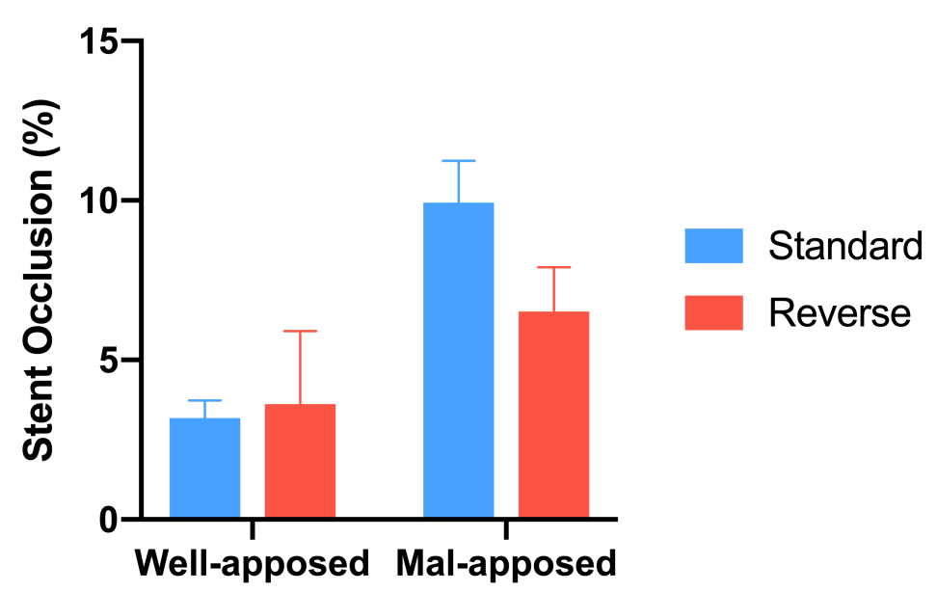
Supplemental Figure 2. Comparison of standard versus reverse perfusion. Blood from volunteers collected in 1% sodium citrate tubes were incubated for 15 minutes prior to perfusion through the bench-top stent thrombosis model in the standard vs. reverse direction (relative to mal-apposed stent section). Well-apposed segment (n = 3) perfused in the opposite direction (reverse) had a thrombus burden of 3.6 $±$ 2.3% compared to standard perfusion which had a thrombus burden of 3.2 $±$ 0.6%. Reverse perfusion through malapposed segment (n = 3) had a thrombus burden of 6.5 $±$ 1.4% whereas perfusion in the standard direction had a thrombus burden of 9.9 $±$ 1.3%. Data was compared using standard student t-test and no difference was observed regardless of the change in direction of perfusion.

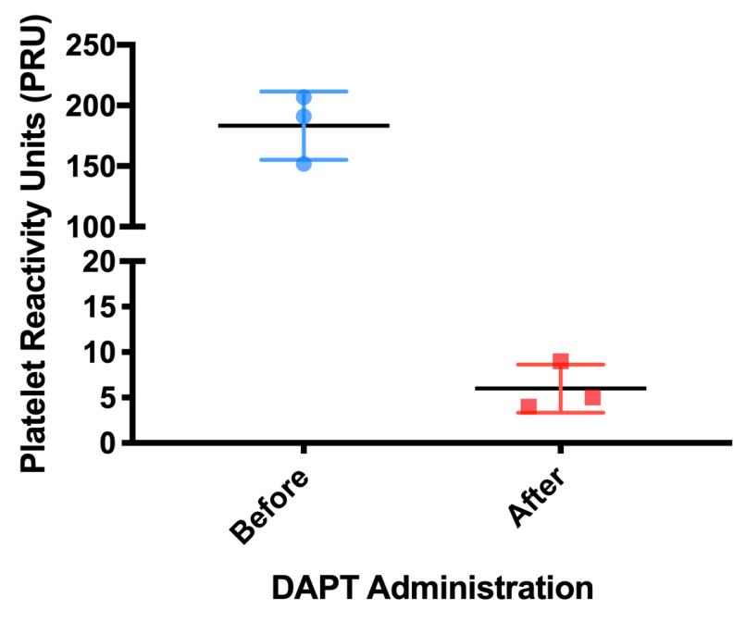
Supplemental Figure 3. Platelet reactivity units (PRU) before and after in vitro DAPT administration. Samples collected in 1% sodium citrate tubes were analyzed using VerifyNow P2Y₁₂ before and after incubation with 20.0 $μ$M ASA and 1.4 $μ$M ticagrelor for 15 minutes. In vitro administration of DAPT had considerable reduction in PRU from 183.3 $±$ 28.3 to 6.0 $±$ 2.6 (n = 3) (p = 0.0004). Data was analyzed using student t-test. P<0.05 is considered statistically significant.

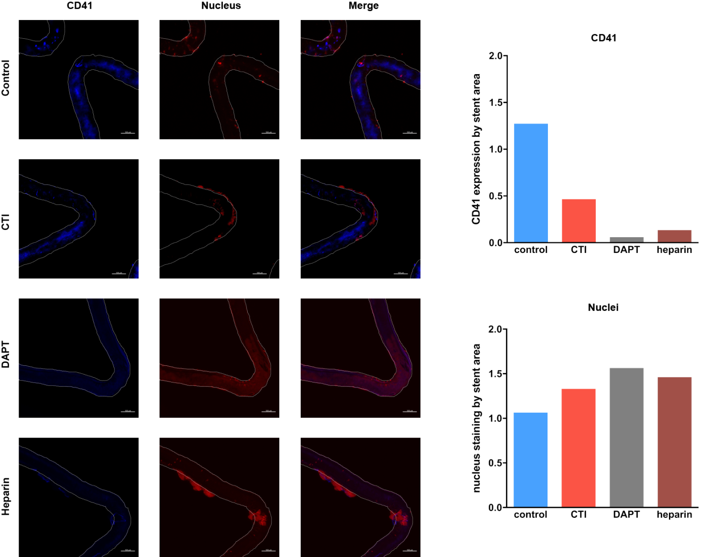
Supplemental Figure 4. Thrombus distribution of platelets and mononuclear cells on stent malapposition. Blood collected in 1% sodium citrate tubes were perfused for 15 minutes on the bench-top stent thrombosis model with control (DMSO), 3.8 $μ$M corn trypsin inhibitor, 20.0 $μ$M ASA and 1.4 $μ$M Ticagrelor, or 1.0 IU/mL unfractionated heparin. Immunofluorescence images of stent strut surface with CD41 and mononuclear cells (monocytes or neutrophils) stained with DAPI are presented with corresponding CD41 or nuclear expression by stent surface area.

