SUPPLEMENTAL DATA

Journal of Vertebrate Paleontology

Reappraisal of ‘Metoposaurus hoffmani’ Dutuit, 1978 and description of new temnospondyl specimens from the Middle–Late Triassic of Madagascar (Morondava Basin)

JOSEP FORTUNY,*^{,1,2} THOMAS ARBEZ,² EUDALD MUJAL,^{1,3} and J.-SÉBASTIEN STEYER²

¹Institut Català de Paleontologia Miquel Crusafont, ICTA-ICP building, c/ de les columnes, s/n, E-08193 Cerdanyola del Vallès, Spain, josep.fortuny@icp.cat;
²Centre de Recherches en Paléontologie de Paris, UMR 7202 CNRS-MNHN-UPMC, Muséum national d'Histoire naturelle, CP38, 8 rue Buffon, F-75005 Paris, France, thomas.arbez@edu.mnhn.fr; jean-sebastien.steyer@mnhn.fr;
³Staatliches Museum für Naturkunde Stuttgart, Rosenstein 1, D-70191 Stuttgart, Germany, eudald.mujalgrane@smns-bw.de

*Corresponding author.
TABLE S1. List of temnospondyl material from Folakara region, Madagascar.
Old catalog number | Current catalog number | Element | Coloration | Description
MAD 1 | MNHN-MAI 1 | Large ornamented bone | Red colored | Large portion of an interclavicle figured as MAD 1 by Dutuit (1978)
MAD 2 | MNHN-MAI 2 | Postorbital fragment | Unknown | Currently lost
MAD 3 | MNHN-MAI 3 | Frontal-Nasal | Unknown | Currently lost
MAD 4 | MNHN-MAI 4 | Pterygoid | Red colored | Large pterygoid figured as MAD 4 by Dutuit (1978); at least 4 bones joined/prepared with glue
MAD 7 | MNHN-MAI 7 | Mandibular/maxilla indet. fragments | Unknown | Currently lost
MAD 8 | MNHN-MAI 8 | Mandibular/maxilla indet. fragments | Unknown | Currently lost
MAD 9 | MNHN-MAI 9 | Mandibular/maxilla indet. fragments | Unknown | Currently lost
MAD 10 | MNHN-MAI 10 | Mandibular/maxilla indet. fragments | Unknown | Currently lost
MAD 580 | MNHN-MAI 66 | Intercentrum | Brown colored | Anterior dorsal intercentrum
MAD 580 | MNHN-MAI 67 | Intercentrum | Brown colored | Anterior dorsal intercentrum
MAD 580 | MNHN-MAI 68 | Intercentrum | Brown colored | Postsacral intercentrum
MAD 580 | MNHN-MAI 69 | Intercentrum | Brown colored | Anterior dorsal intercentrum
MAD 580 | MNHN-MAI 70 | Intercentrum | Brown colored | Postsacral intercentrum
MAD 580 | MNHN-MAI 72 | Intercentrum | Brown colored | Anterior dorsal intercentrum
MAD 580 | MNHN-MAI 73 | Intercentrum | Brown colored | Bad-preserved anterior dorsal intercentrum
MAD 580 | MNHN-MAI 74 | Intercentrum | Brown colored | Anterior dorsal intercentrum
MAD 580 | MNHN-MAI 75 | Intercentrum | Brown colored | Bad-preserved intercentrum
MAD 580 | MNHN-MAI 76 | Intercentrum | Brown colored | Postcervical intercentrum
MAD 580 | MNHN-MAI 77 | Intercentrum | Brown colored | Anterior dorsal intercentrum
MAD 580 | MNHN-MAI 78 | Intercentrum | Brown colored | Badly preserved anterior dorsal intercentrum
TABLE S1. (Continued)
MAD 580 | MNHN-MAI 79 | Intercentrum | Brown colored | Anterior dorsal intercentrum
MAD 580 | MNHN-MAI 80 | Intercentrum | Brown colored | Anterior dorsal intercentrum
MAD 580 | MNHN-MAI 81 | Intercentrum | Brown colored | Mid dorsal intercentrum
MAD 580 | MNHN-MAI 82 | Intercentrum | Brown colored | Anterior dorsal intercentrum
MAD 580 | MNHN-MAI 83 | Intercentrum | Brown colored | Anterior dorsal intercentrum
MAD 580 | MNHN-MAI 84 | Intercentrum | Brown colored | Badly preserved anterior dorsal intercentrum
MAD 580 | MNHN-MAI 85 | Intercentrum | Brown colored | Anterior dorsal intercentrum
MAD 580 | MNHN-MAI 86 | Intercentrum | Brown colored | Postcervical intercentrum
MAD 580 | MNHN-MAI 87 | Intercentrum | Brown colored | Mid dorsal intercentrum
MAD 580 | MNHN-MAI 93 | Occipital condyle | Brown colored | Large occipital condyle
MAD 575 | MNHN-MAI 94 | Ornamented bone | White colored | Badly preserved thick bone
– | MNHN-MAI 95 | Ornamented bone | White colored | Well-preserved thick bone
MAD 11 | MNHN-MAI 96 | Interclavicle | Brown colored | Fragment of interclavicle
– | MNHN-MAI 97 | Partly ornamented bone | White colored | Badly preserved thick bone
– | MNHN-MAI 98 | Occipital condyle | White - orange colored | Well-preserved
– | MNHN-MAI 99 | Ornamented bone | White-orange colored | Preserves lateral bone margins
– | MNHN-MAI 100 | Partly ornamented bone | White-orange colored | Well-preserved
– | MNHN-MAI 101 | Ornamented bone | Orange-black colored | Foramina inside each polygonal ornamentation
– | MNHN-MAI 102 | Fragment of cylindric bone | Orange-black colored | Potential cultriform process
– | MNHN-MAI 103 | Postparietal | White - orange colored | Foramina inside each polygonal ornamentation
– | MNHN-MAI 104 | Ornamented bone | White - orange colored | Foramina inside each polygonal ornamentation

TABLE S1. (Continued)
– | MNHN-MAI 105 | Ornamented bone | White - orange colored | No polygon ornament, thick bone
– | MNHN-MAI 106 | Ornamented bone | White colored | Well-preserved
– | MNHN-MAI 107 | Ornamented bone | White colored | Foramina inside each polygonal ornamentation
– | MNHN-MAI 108 | Ornamented bone | White - gray colored | Foramina inside each polygonal ornamentation
– | MNHN-MAI 109 | Ornamented bone | White - orange colored | Badly preserved, potential margin bone
– | MNHN-MAI 110 | Ornamented bone | White - orange colored | Badly preserved, potential margin bone
– | MNHN-MAI 111 | Ornamented bone | Red colored | Well-preserved, polygon ornamented thick bone
– | MNHN-MAI 112 | Ornamented bone | Red colored | Well-preserved, radially ornamented thick bone
MAD 580 | MNHN-MAI 113 | Postparietal | Brown colored | Posterior part of a skull roof
– | MNHN-MAI 114 | Intercentrum | White colored | Anterior dorsal intercentrum
– | MNHN-MAI 115 | Interclavicle | Brown colored | Fragment of interclavicle, very similar in color, thickness and ornamentation to MAD 11 of Dutuit (1978)

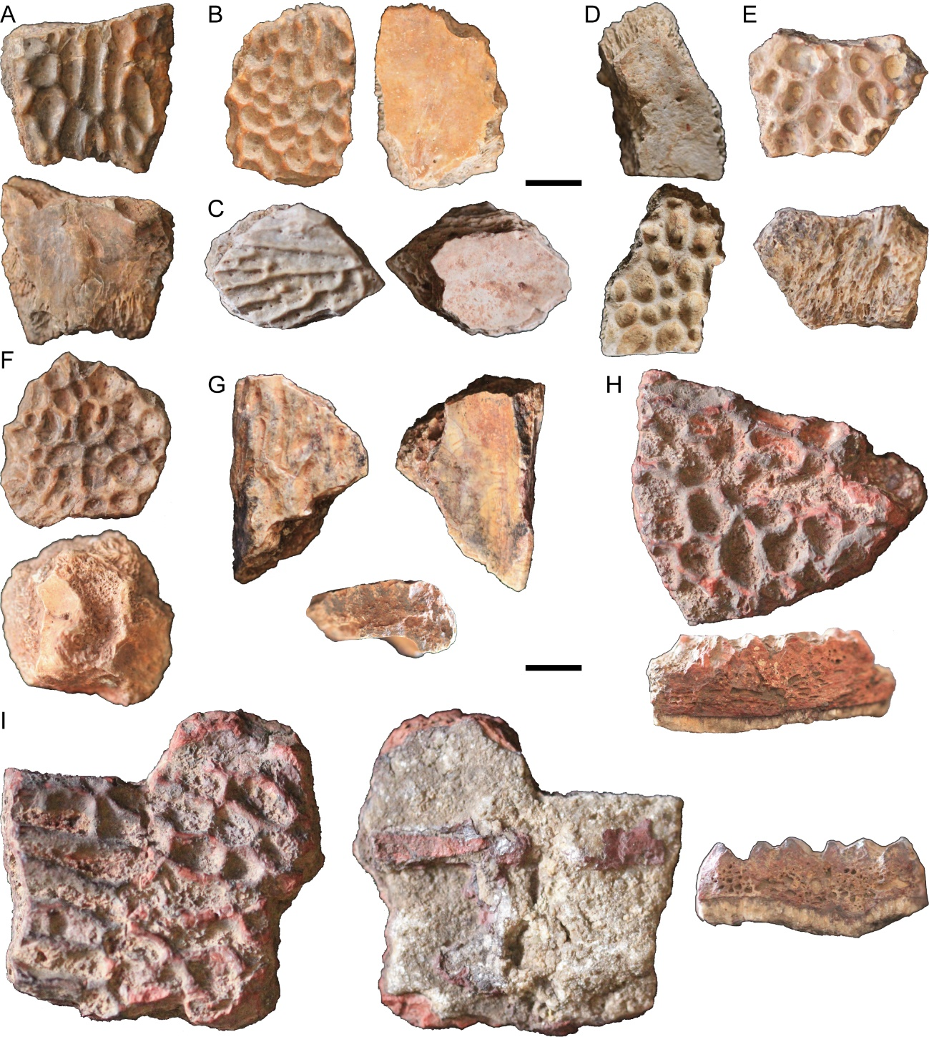
FIGURE S1. Temnospondyl indeterminate cranial remains. A, MNHN-MAI-101. B, MNHN-MAI-104. C, MNHN-MAI-105. D, MNHN-MAI-106. E, MNHN-MAI-107. F, MNHN-MAI-108. G, MNHN-MAI-109. H, MNHN-MAI-111. I, MNHN-MAI-112. Each specimen in dorsal and ventral views, except in H; G–I include lateral view. Scale bars equal 10 mm.

