Supplementary Material

Rapid microbial dynamics in response to an induced wetting event in Antarctic Dry Valley soils
Thomas D. Niederberger, Jill A. Sohm, Troy Gunderson, Alex Parker, Eric M. Bottos, Kathryn J. Coyne, Douglas G. Capone, Edward J. Carpenter, S. Craig Cary*
- Correspondence: caryc@udel.edu

Supplemental Figure S1 – Soil temperatures at 1 and 12 meters.

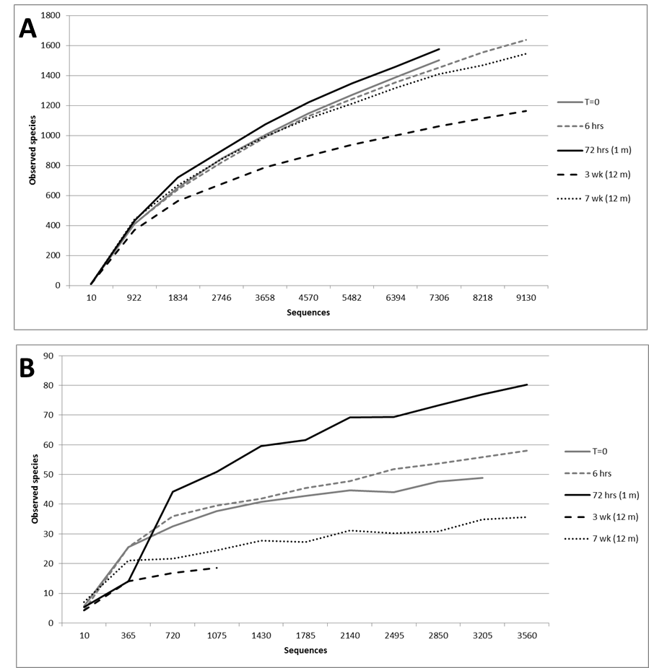
Supplemental Figure S2 – Rarefaction analysis. A, bacterial community sequencing. B, eukaryotic communities sequencing

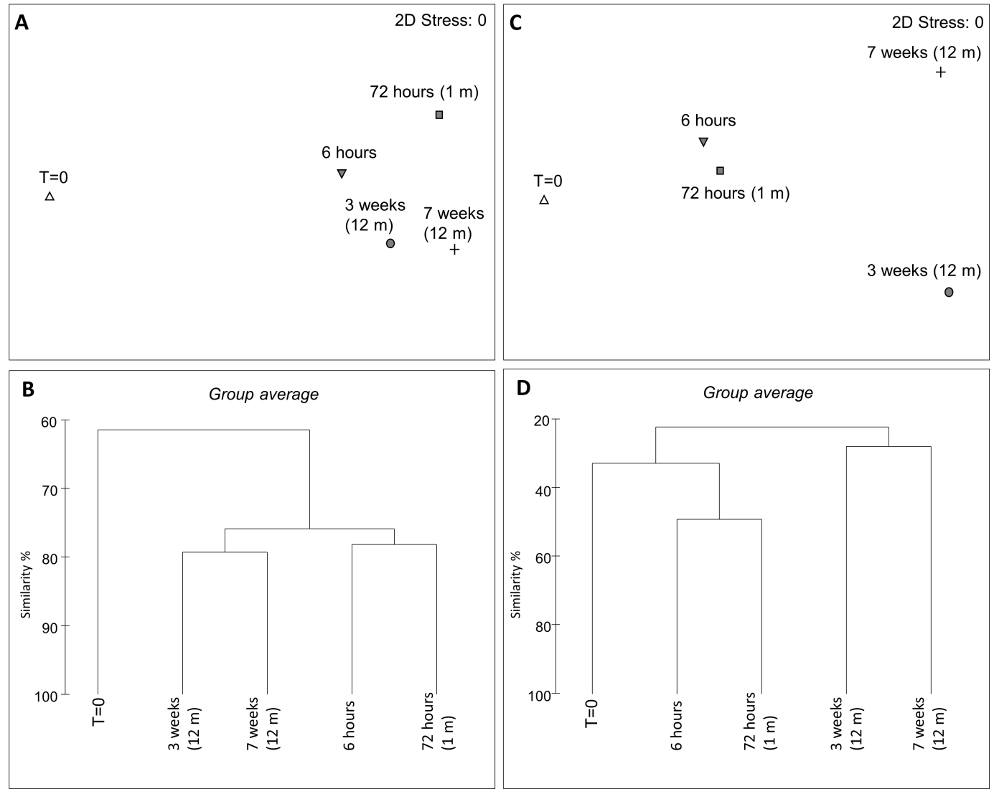
Supplementary Fig. S3 - Multidimensional scaling (MDS) plots of pyrosequencing abundance data for (A) bacterial and (C) eukaryotic sequences and associated cluster plots (resemblance:S17 Bray Curtis similarity) for (B) bacterial and (D) eukaryotic sequences.

Sample | S  (total species, OTUs at 95%) | N  (number of sequences) | d  (species richness)
Bacteria
T = 0 | 60 | 8213 | 6.546
6 hours | 88 | 9137 | 9.539
72 hours (1 m) | 109 | 7575 | 12.09
3 weeks (12 m) | 105 | 10633 | 11.22
7 weeks (12 m) | 132 | 10361 | 14.17
Eukaryotes
T = 0 | 50 | 3452 | 6.015
6 hours | 58 | 3563 | 6.97
72 hours (1 m) | 92 | 5171 | 10.64
3 weeks (12 m) | 19 | 1126 | 2.562
7 weeks (12 m) | 45 | 6335 | 5.026

Supplemental Table S2. Statistics from the sequencing of both bacterial and eukaryotic communities.

Rank | Name | T = 0 | % of total seqs. | T ≠ 0 | % of total seqs. | Significance
phylum | Cyanobacteria | 4 | 0.049 | 2542 | 6.74 | 8.36E-209
family | Comamonadaceae | 2 | 0.024 | 784 | 2.08 | 1.32E-63
order | Flavobacteriales | 0 | 0 | 645 | 1.71 | 1.04E-55
class | Flavobacteria | 0 | 0 | 645 | 1.71 | 1.04E-55
family | Flavobacteriaceae | 0 | 0 | 566 | 1.50 | 5.97E-49
genus | Flavobacterium | 0 | 0 | 520 | 1.38 | 5.16E-45
family | Family I | 3 | 0.037 | 414 | 1.10 | 4.35E-31
genus | GpI | 3 | 0.037 | 414 | 1.10 | 4.35E-31
family | Chloroplast sequences | 0 | 0 | 326 | 0.86 | 2.07E-28
genus | Polaromonas | 0 | 0 | 317 | 0.84 | 1.22E-27
order | Xanthomonadales | 4 | 0.049 | 375 | 0.99 | 1.22E-26
family | Xanthomonadaceae | 4 | 0.049 | 373 | 0.99 | 1.77E-26
family | Oxalobacteraceae | 0 | 0 | 287 | 0.76 | 4.50E-25
family | Rhodobacteraceae | 1 | 0.012 | 280 | 0.74 | 9.17E-23
order | Rhodobacterales | 1 | 0.012 | 280 | 0.74 | 9.17E-23
family | Sphingomonadaceae | 3 | 0.037 | 296 | 0.79 | 2.04E-21
family | Caulobacteraceae | 0 | 0 | 233 | 0.62 | 1.88E-20
order | Caulobacterales | 0 | 0 | 233 | 0.62 | 1.88E-20
genus | Duganella | 0 | 0 | 196 | 0.52 | 2.76E-17
genus | Flavisolibacter | 1 | 0.012 | 200 | 0.53 | 4.64E-16
suborder | Micrococcineae | 2 | 0.024352 | 205 | 0.54368 | 3.38E-15

Supplemental Table S3. Library comparison (myRDP) of T= 0 bacterial sequences (total sequences = 8213) vs. T ≠ 0 combined bacterial sequences (total sequences = 37706). Only the most significant (<6.00E-14) differences are presented

