Supplemental Information:
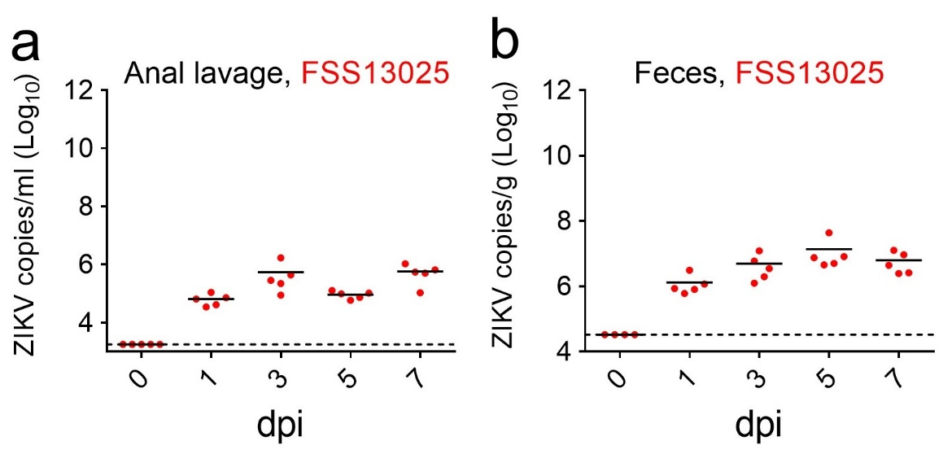
Figure S1. Viral loads in anal lavage fluid and feces of Ifnar1^{-/-} mice. 3-4 week-old male Ifnar1^{-/-} mice were infected with 10⁵ PFU ZIKV (FSS13025 strain) by the i.p. route (n=5 for each group). Viral loads in anal lavage fluid (a) and feces (b) were detected by qRT-PCR.
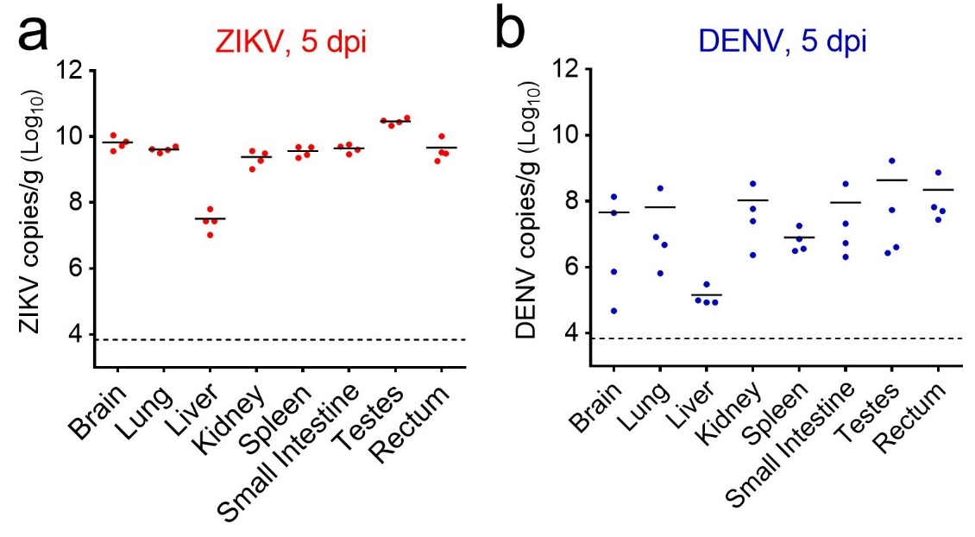
Figure S2. Viral loads in selected organs of ZIKV- or DENV- infected Ifnar1^{-/-} mice. Ifnar1^{-/-} mice were infected with ZIKV (a) or DENV (b) by the i.p. route as shown in Fig. 1 (n=4 per group). Viral loads in organs were detected by qRT-PCR.

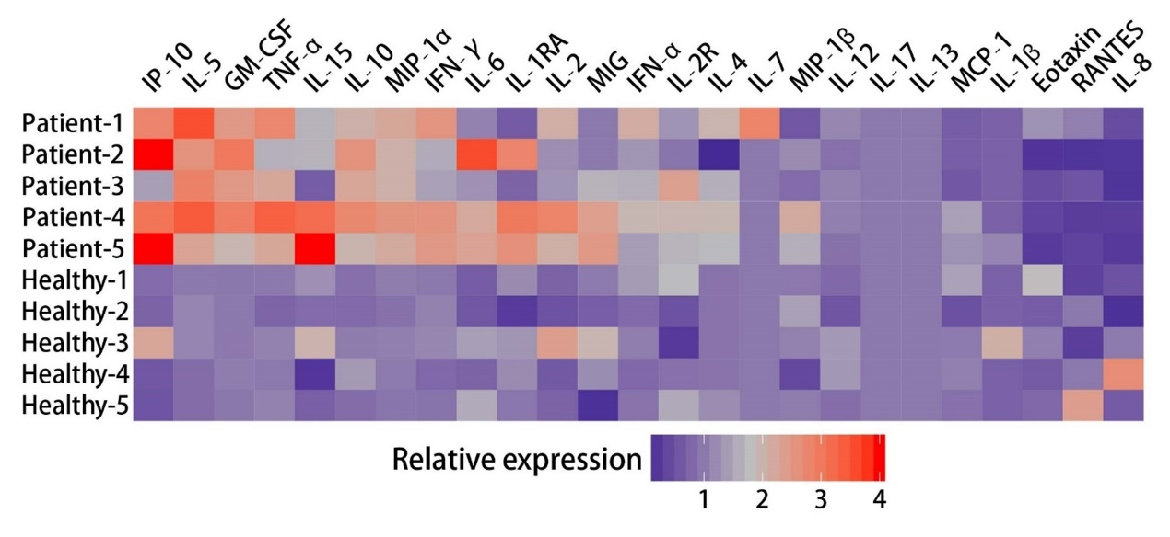
Figure S3. Cytokine levels in the serum of five healthy and five ZIKV-infected patients. Luminex assay was used to determine the cytokine level (n=5 per group). The average expression levels of different cytokines from the 5 healthy individuals were termed as “1”, respectively.

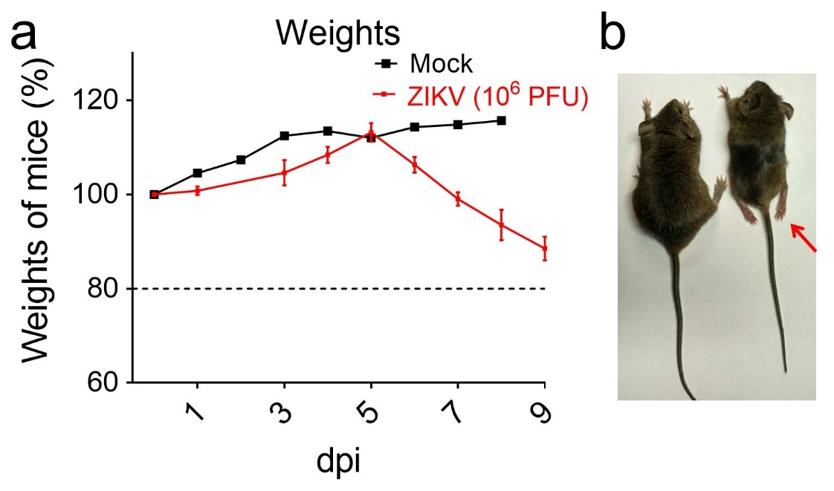
Figure S4. ZIKV infection through i.a. route leads to body weight loss and neurological symptoms in Ifnar1^{-/-} mice. (a) Weights over time of Ifnar1^{-/-}mice that were mock-infected (n=3) or infected i.a. with ZIKV (10⁶ PFU GZ01/mouse) (n=6), whose survival is graphed in Fig. 3b. (b) Comparison of uninfected (left) and ZIKV-infected (right) mice, with the latter displaying hindlimb paralysis (as indicated) from one representative experiment.

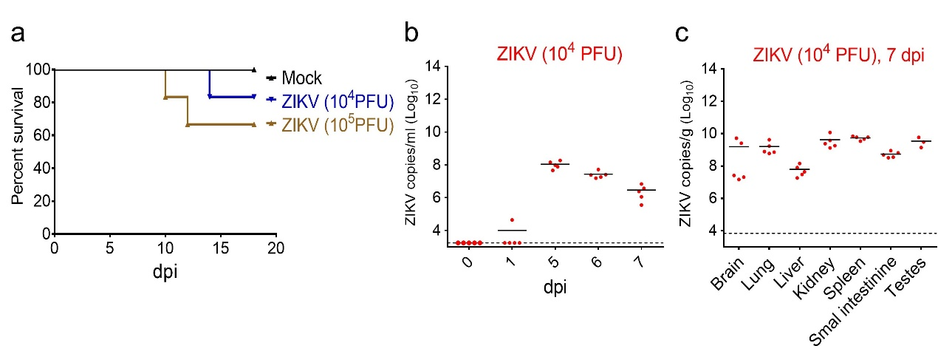
Figure S5. Survival and viral loads in mice infected with ZIKV by the i.a. infection. (a) Survival of Ifnar1^{-/-} mice infected with 10⁴ or 10⁵ PFU of GZ01 by the i.a. route (n=6 per group). ZIKV copies in sera (b) and organs (c) from Ifnar1^{-/-} mice infected with 10⁴ PFU of GZ01 by the i.a. route at the indicated time points (n=5 per time point, n=3 for testes).

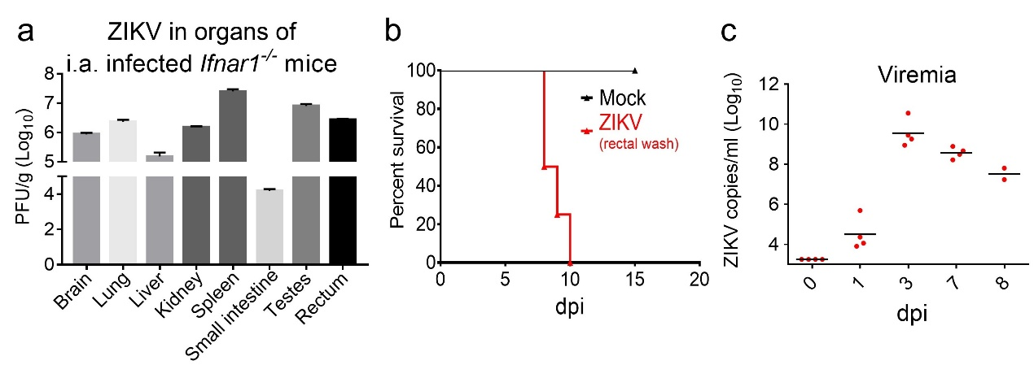
Figure S6. Viral loads in organs and infectivity of rectal wash samples from ZIKV i.a.-infected Ifnar1^{-/-} mice. (a) The viral burden in organs from Ifnar1^{-/-} mice that was measured by qRT-PCR in Fig. 3d was also quantified by plaque assay at 5 dpi, showing persistence of infectious virus. Data are shown as mean ± SD from two mice for each organ. (b-c) Survival (b) and viremia (c) of Ifnar1^{-/-} mice infected with rectal wash samples by the i.p. route. To prepare wash samples, 2 cm of rectal tissue was isolated from Ifnar1^{-/-} mice at 5 dpi, infected as shown in Fig. 3b, then washed with 500 μl of PBS. 200 μl of sample was used to infect naive Ifnar1^{-/-} mice by the i.p. route. n=4 per group.

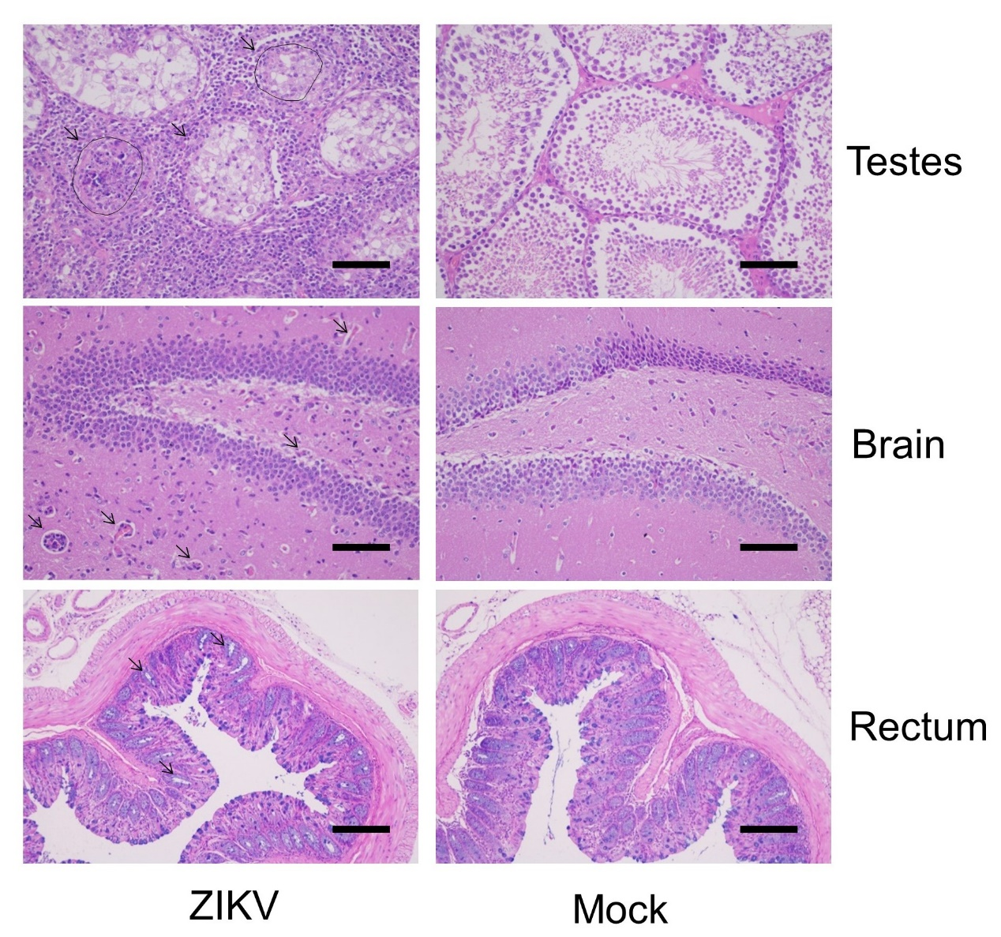
Figure S7. Histopathological analysis of testes, brain and rectal tissue from the ZIKV i.a-infected Ifnar1^{-/-} mice. Testicular damage and vascular cuffing and inflammatory cell infiltration in the brain and rectum of mice whose organ burden is graphed in Fig. 3d, magnification at 200X. The data are representative of two independent experiments with at least two animals per group at 15 dpi.

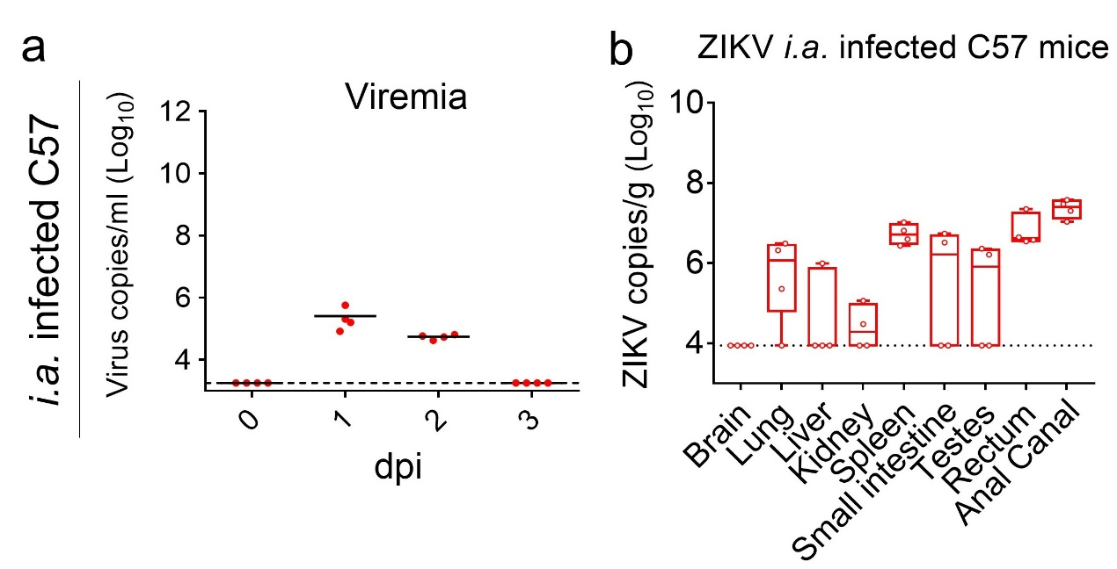
Figure S8. The infectivity of ZIKV to immunocompetent mice through i.a. route. (a-b) 3-4 week-old male C57 mice were infected i.a. with ZIKV (10⁵ PFU/mouse). ZIKV RNA in blood at 1-3 dpi (a) and organs (b) at 1 dpi were detected using qRT-PCR (n=4 per group).

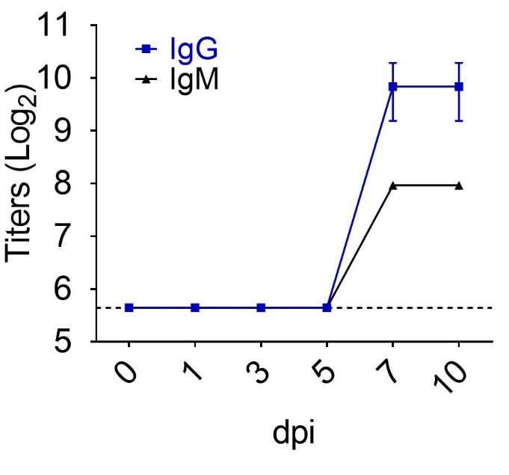
Figure S9. Antibody response of ZIKV i.a. infection in Ifnar1^{-/-} mice. Mice were infected with the GZ01 strain as shown in Fig. 3b. ZIKV-specific IgG and IgM in sera from ZIKV-infected mice at the indicated time points were measured by ELISA. Data was shown as mean ± SD (n=3 per time point).

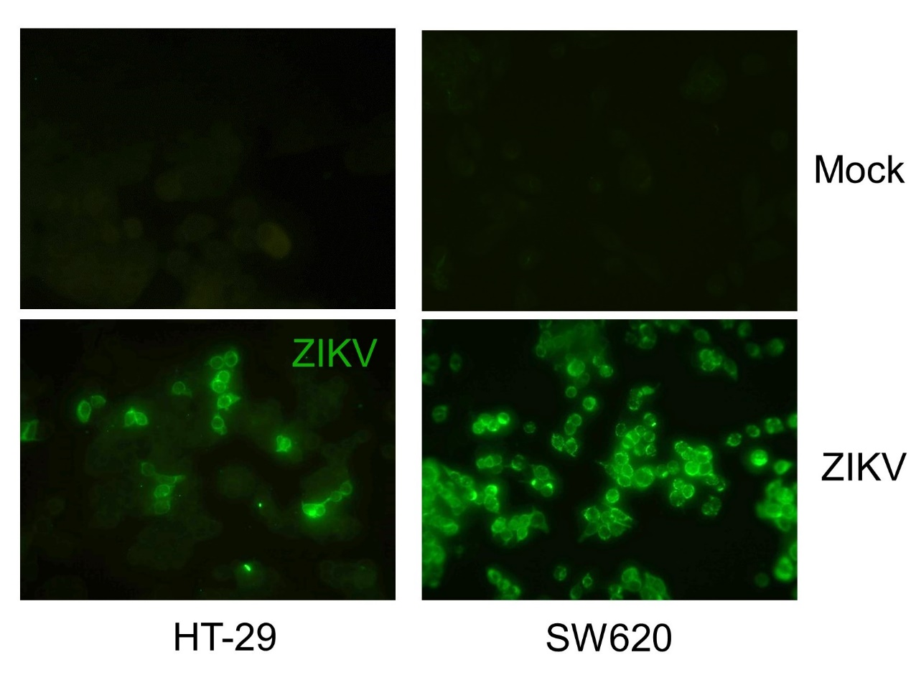
Figure S10. ZIKV infection in human colon epithelial cells. HT-29 and SW620 cells were infected with ZIKV (GZ01 strain, MOI 0.5) for 48 hrs. Infection efficacy of ZIKV was detected by IFA assay with 4G2 antibody targeting the ZIKV E protein. The data are representative of two independent experiments with at least two repeats per group.

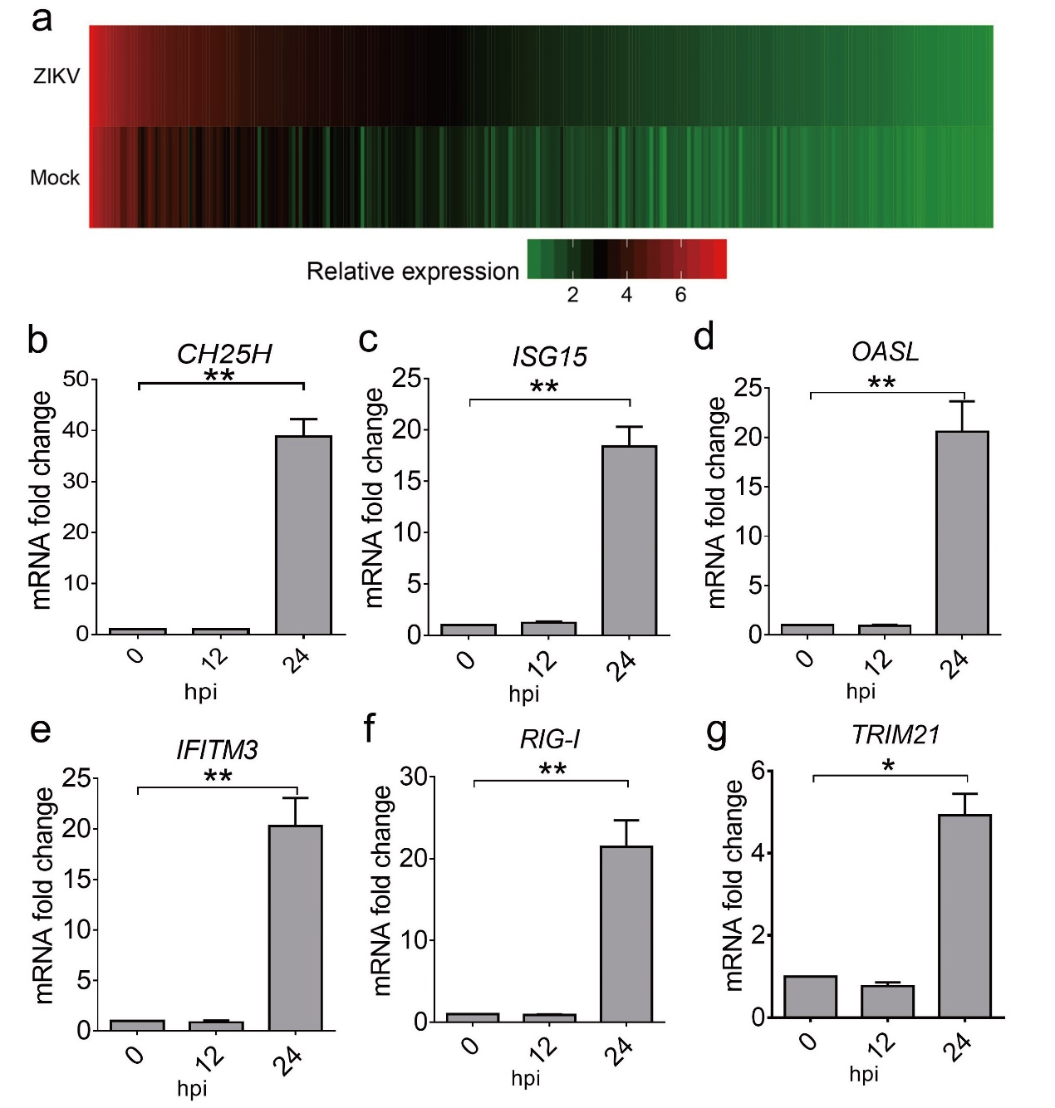
Figure S11. Innate immune responses in human colon cells induced by ZIKV infection. (a-g) HT-29 cells were infected with ZIKV at MOI=0.5 (a) or MOI=1 (b-g). (a) Relative expression of innate immune response genes in ZIKV-infected versus uninfected HT-29 cells was measured by RNA-seq. (b-g) Expression levels of CH25H, ISG15, OASL, IFITM3, RIG-I and TRIM21 were quantified using qRT-PCR at 12 and 24 hpi. All data are shown as mean ± SEM. *p<0.05, **p<0.01, unpaired student t test.

