Supplementary Information

In vitro intestinal toxicity of copper oxide nanoparticles in rat and human cell models
Taylor E. Henson¹, Jana Navratilova², Alan H. Tennant³, Karen D. Bradham⁴, Kim R. Rogers⁴, Michael F. Hughes³

¹Student Services Contractor, Research Triangle Park, NC 27711
²National Research Council, Research Triangle Park, NC 27711
³National Health and Environmental Effects Research Laboratory and ⁴National Exposure Research Laboratory, Office of Research and Development, U.S. Environmental Protection Agency, Research Triangle Park, NC 27711

Supplementary Table 1 Dose of copper oxide nanoparticles based on copper

Nominal Dose (µg/mL) | CuO NPs (µg Cu/mL) | Cu₂O-PVP (µg Cu/mL)
0.1 | 0.08 | 0.09
1 | 0.8 | 0.9
5 | 4 | 4
10 | 8 | 9
25 | 20 | 22
50 | 40 | 44
100 | 80 | 89

Supplementary Information – Henson et al.

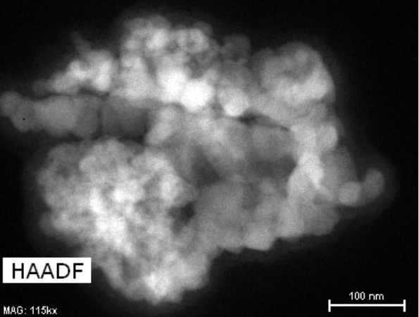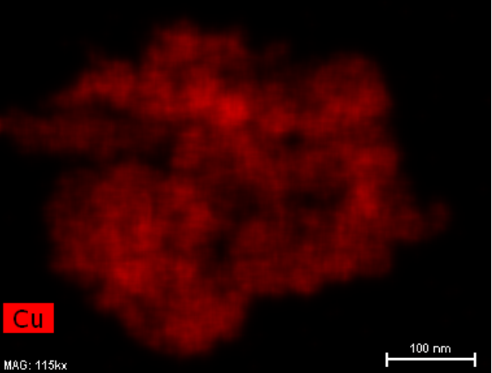

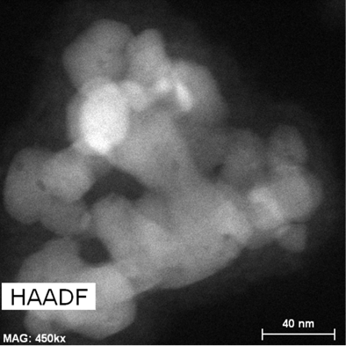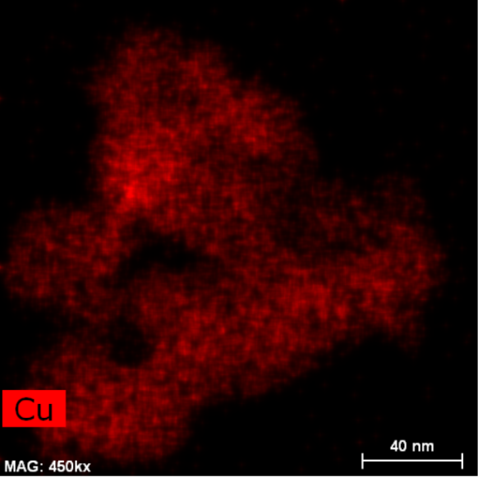

Supplementary Figure 1 High-angle annular dark-field (HAADF) transmission electron microscopy images of copper (II) oxide (CuO) nanoparticles at scales at 100 and 40 nm. The nanoparticles were incubated in Dulbecco’s Modified Eagle Medium with 4 mM L-glutamine, 1.5 g/L sodium bicarbonate, 4.5 g/L glucose, and 10% by volume fetal bovine serum for 12 hr before imaging. The false color images in red were generated by energy dispersive X-ray spectroscopy at scales of 100 and 40 nm.

Supplementary Information – Henson et al.

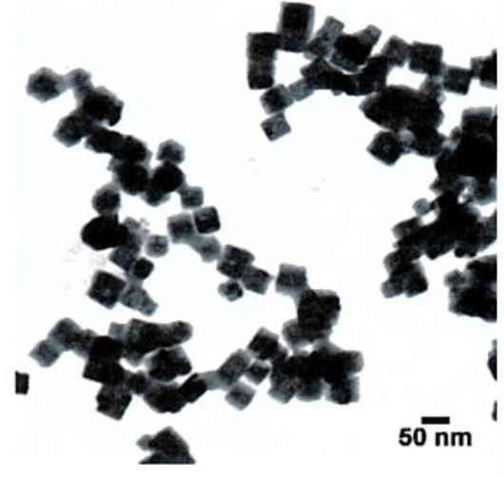

Supplementary Figure 2 Transmission electron microscopy image of copper (I) oxide (cuprous oxide, Cu₂O) polyvinylpyrrolidone nanoparticle suspension in water (nanocomposix.com).

Supplementary Information – Henson et al.

Supplementary Figure 3 Morphology of untreated IEC-6 cells. Images of morphology of IEC-6 cells were captured with a Nikon Diaphot microscope with phase contrast using a Leica 40x objective and a Paxcam 2 microscope camera.

Supplementary Information – Henson et al.

Supplementary Figure 4 Morphology of IEC-6 cells exposed to 22 µg Cu/mL of Cu₂O-PVP NPs for 24 h.

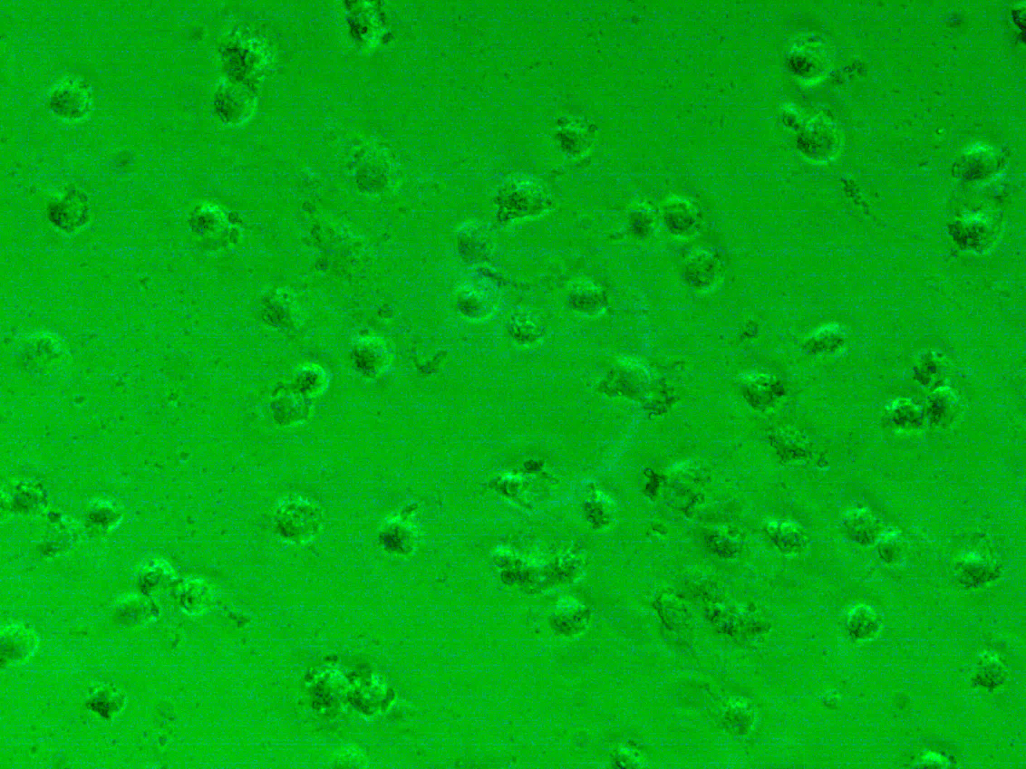
Supplementary Figure 5 Morphology of IEC-6 cells exposed to 20 µg Cu/mL of CuO NPs for 24 h.
Supplementary Information – Henson et al.
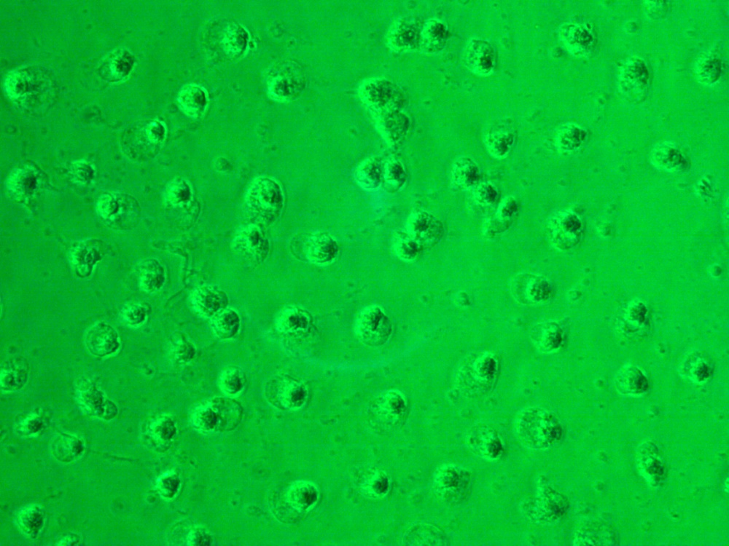
Supplementary Figure 6 Morphology of IEC-6 cells exposed to 89 µg Cu/ml of Cu₂O-PVP NPs for 24 h.

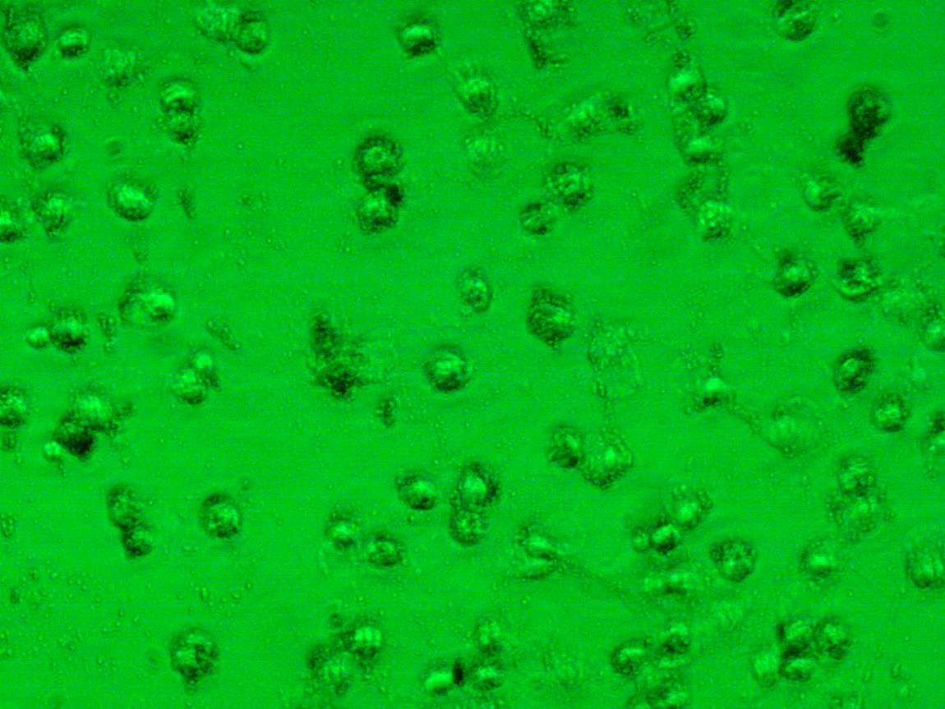
Supplementary Figure 7 Morphology of IEC-6 cells exposed to 80 µg Cu/mL of CuO NPs for 24 h.

