Supplementary Information

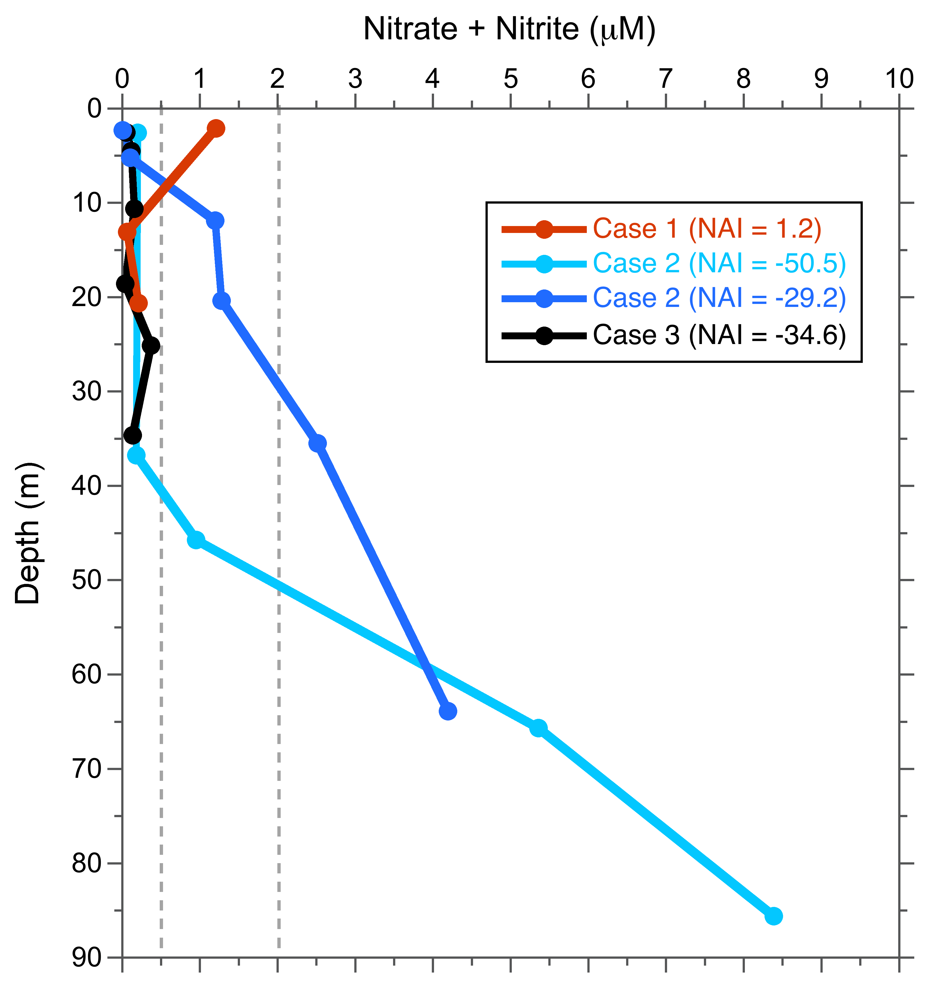
Figure S1: Exemplar profiles of nitrate + nitrite concentrations demonstrating how the nitrate availability index (NAI) was calculated, where the three cases correspond to the methods description in the main text. Grey dashed lines denote the case boundaries (0.5 and 2 µM NO_{2/3}). Note that there are two profiles for Case 2. The deepest measured nutrient sample for all profiles was collected either between 85-100m or just above bottom (whichever was deeper). Exemplar profiles are from FK160603 CTD casts 11.03 (red), 18.03 (light blue), 7.03 (dark blue), and 8.02 (black) from the SCS.

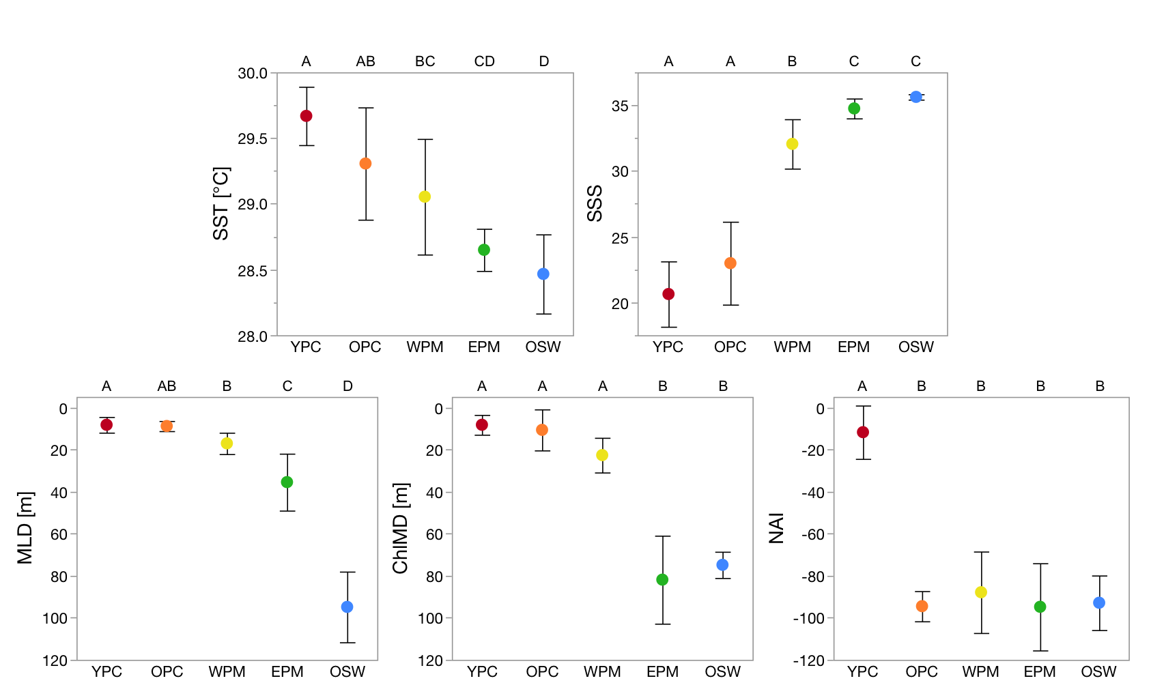
Figure S2: Graphical representations of WTNA habitat-defining variables grouped by habitat, as in Table 1. Note that the y-axis is flipped for MLD and ChlMD. Error bars represent the standard deviation of the mean. Letters at the top of each plot indicate significant differences for a given variable between habitats, where habitats with different letters are significantly different (Tukey-Kramer tests, p<0.05).

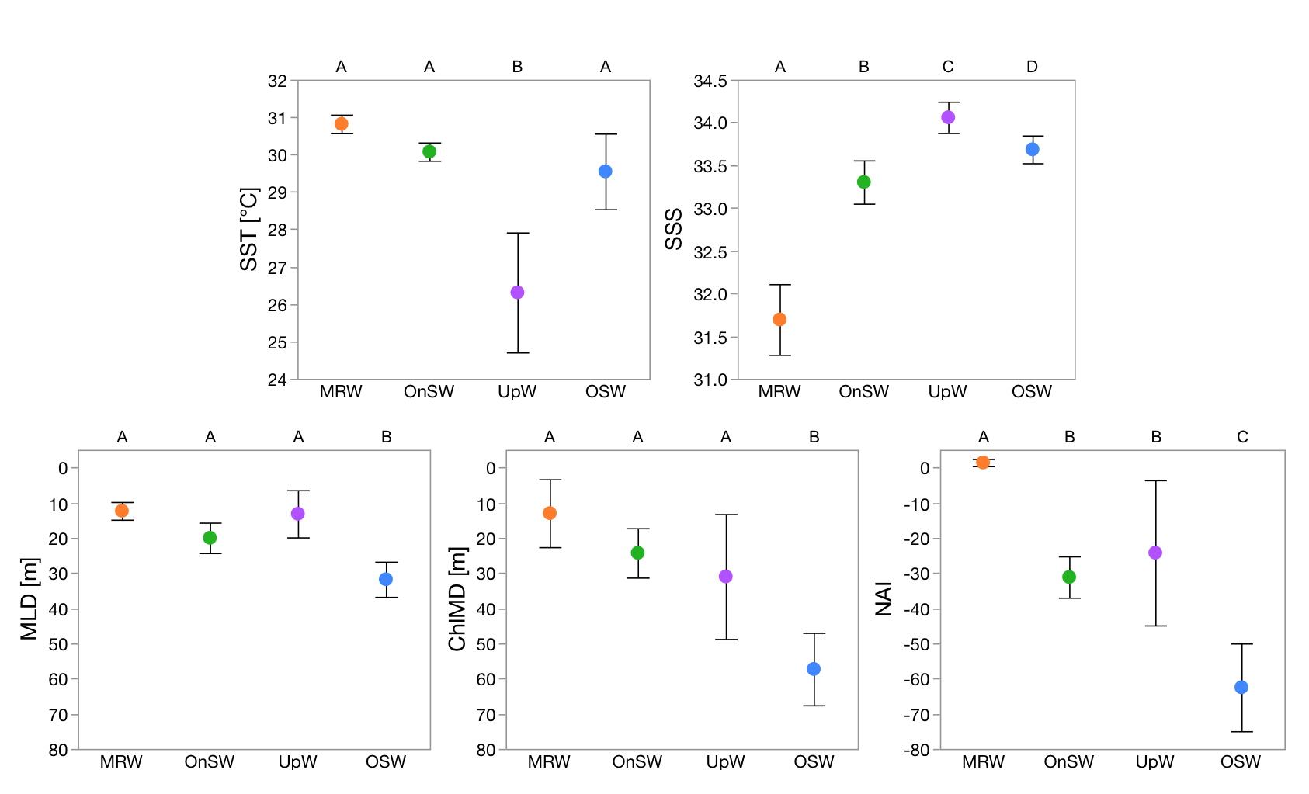
Figure S3: Graphical representations of SCS habitat-defining variables grouped by habitat, as in Table 2. Note that the y-axis is flipped for MLD and ChlMD. Error bars represent the standard deviation of the mean. Letters at the top of each plot indicate significant differences for a given variable between habitats, where habitats with different letters are significantly different (Tukey-Kramer tests, p<0.05).

