Supplemental File

Supplemental Methods

Patient Demographics
Table 1a. Control Study participants demographics and psychiatric assessments
ID | diagnosis | Anxiety | Sex | Age | yrs since | current | current | current mood | family history | MMSE | MADRS | YMRS
 |  |  |  |  | diagnosis | antipsychotic | antidepressant | stabilizer | (M, P) | total
13 | Healthy control |  | M | 31 |  |  |  |  |  | 30 | 0
33 | Healthy control |  | F | 29 |  |  |  |  | Y,N | 30 | 3
48 | Healthy control |  | F | 30 |  |  |  |  | Y,N | 30 | 2
49 | Healthy control |  | F | 28 |  |  |  |  |  | 29 | 1
93 | Healthy control |  | F | 62 |  |  |  |  | Y,Y | 30 | 4
94 | Healthy control |  | M | 61 |  |  |  |  |  | 28 | 2
112 | Healthy control |  | F | 23 |  |  |  |  | Y,Y | 30 | 2
124 | Healthy control |  | F | 49 |  |  |  |  | Y,Y | 30 | 0
128 | Healthy control |  | M | 41 |  |  |  |  |  | 28 | 2
136 | Healthy control |  | F | 24 |  |  |  |  |  | 30 | 2
140 | Healthy control |  | M | 25 |  |  |  |  | N,Y | 29 | 7
152 | Healthy control |  | F | 27 |  |  |  |  | Y,Y | 30 | 4
165 | Healthy control |  | F | 24 |  |  |  |  | Y,Y | 30 | 0
173 | Healthy control |  | F | 22 |  |  |  |  | Y,Y | 30 | 0
209 | Healthy control |  | F | 32 |  |  |  |  |  | 30 | 5
211 | Healthy control |  | F | 37 |  |  |  |  |  | 29 | 0
214 | Healthy control |  | M | 66 |  |  |  |  |  | 28 | 0
216 | Healthy control |  | M | 31 |  |  |  |  |  | 30 | 0
233 | Healthy control |  | F | 25 |  |  |  |  |  | 30 | 3
240 | Healthy control |  | F | 23 |  |  |  |  |  | 30 | 1
282 | Healthy control |  | F | 24 |  |  |  |  |  | 26 | 1
320 | Healthy control |  | F | 57 |  |  |  |  |  | 27 | 0
322 | Healthy control |  | F | 43 |  |  |  |  | Y,N | 30 | 0
323 | Healthy control |  | M | 53 |  |  |  |  | N,Y |  | 2
317 | Healthy control |  | M | 66 |  |  |  |  |  | 29 | 6
332 | Healthy control |  | M | 68 |  |  |  |  | N,Y | 29 | 2
341 | Healthy control |  | M | 38 |  |  |  |  |  | 30 | 2
AVG | Control n=27 |  | 10M | 38.48 |  |  |  |  |  | 29.31 | 1.89
STDEV |  |  |  | 15.74 |  |  |  |  |  | 1.09 | 1.95

Table 1. Study participant’s demographics and psychiatric assessments. (a). Control Subjects (b). BD subjects. (c) MDD subjects. The presence of Anxiety (A) and ADHD was based on the M.I.N.I. assessment and the Adult ADHD self-report scale respectively. ADHD subjects were taking Dextroamphetamine. S-valproate: sodium valproate.

Table 1b. BD study participants demographics and psychiatric assessments
ID | diagnosis | Anxiety | Sex | Age | yrs since | current | current | current mood | family history | MMSE | MADRS | YMRS
 |  |  |  |  | diagnosis | antipsychotic | antidepressant | stabilizer | (M, P) | total
178 | BD-A type II |  | F | 62 | 10 |  | Mirtazapine | S-valproate | Y,N | 29 | 6 | 10
236 | BD-A type II | A | F | 49 | 29 | Quetiapine | Duloxetine | S-valproate | Y,Y | 29 | 6 | 11
287 | BD-A type II |  | F | 44 | 20 | Quetiapine |  | Lithium |  |  | 5 | 2
172 | BD-A type II |  | F | 26 | 0 | Quetiapine | Escitalopram oxalate |  | N,Y | 29 | 4 | 0
325 | BD-A type II |  | F | 35 | 4 | Quetiapine |  | Lithium |  | 30 | 4 | 1
239 | BD-A type II |  | M | 65 | 8 | Quetiapine | Venlafaxine | Lithium | Y,Y | 28 | 4 | 4
231 | BD-A type II | A | F | 49 | 0 |  | Desvenlafaxine |  | Y,N | 30 | 3 | 0
248 | BD-A type II |  | M | 48 | 32 |  |  | Lithium | N,Y | 29 | 3 | 2
123 | BD-A type II |  | M | 62 | 40 |  |  | S-valproate | N,Y | 29 | 2 | 6
319 | BD-A type II |  | M | 43 | 7 |  |  |  |  |  | 2 | 10
297 | BD-A type II |  | M | 27 | 7 | Amisulpride |  |  | Y,Y | 30 | 1 | 0
89 | BD-A type II |  | M | 24 | 11 | Olanzapine |  | S-valproate | N,Y | 28 | 0 | 0
72 | BD-A type II |  | M | 75 | 7 | Olanzapine | Citalopram | S-valproate | N,Y | 25 | 0 | 0
AVG | n=13 | N=2 | 7M | 46.85 | 13.46 |  |  |  |  | 28.73 | 3.08 | 4.18
STDEV | MADRS<=6 |  |  | 16.09 | 12.77 |  |  |  |  | 1.42 | 2.02 | 4.35
63 | BD-M type I |  | F | 30 | 14 | Aripiprazole |  |  | Y, N | 30 | 17 | 0
201 | BD-M type I | A | F | 42 | 7 | Quetiapine |  | Lithium |  | 30 | 17 | 8
241 | BD-M type II |  | F | 45 | 22 |  | Imipramine | S-valproate |  | 27 | 17 | 13
315 | BD-M type II |  | F | 45 | 8 |  | Escitalopram oxalate | S-valproate |  | 30 | 14 | 10
286 | BD-M type II | A, ADHD | M | 28 | 4 | Ziprasidone | Duloxetine | S-valproate | Y, Y | 30 | 13 | 1
247 | BD-M type II | A | F | 37 | 12 | Aripiprazole | Duloxetine | Lithium, Lamotrigine |  | 29 | 13 | 3
251 | BD-M type II | A | F | 48 | 12 |  | Moclobemide | Lithuim | N, Y | 29 | 11 | 11
274 | BD-M type II | A | F | 27 | 6 |  |  | Lithium | Y, N | 29 | 10 | 11
158 | BD-M type II |  | M | 26 | 4 |  | Venlafaxine |  | N, Y | 29 | 10 | 0
245 | BD-M type II | A | M | 45 | 5 |  |  |  | N, Y | 30 | 9 | 3
210 | BD-M type II |  | F | 51 | 4 |  | Paroxetine |  | N, Y | 30 | 8 | 4
81 | BD-M type I | A | M | 63 | 35 | Olanzapine | Sertraline | S-valproate, Lithium | N, Y | 28 | 8 | 7
57 | BD-M type I | A | M | 35 | 21 | Amisulpride |  | S-valproate, Lithium | N, Y | 29 | 7 | 3
AVG | n=13 | N=8 | 5M | 40.15 | 11.85 |  |  |  |  | 29.23 | 11.85 | 5.69
STDEV | all MADRS 7 to 19 |  |  | 10.94 | 9.27 |  |  |  |  | 0.93 | 3.60 | 4.53
AVG | n=26 (BD-R) | N=10 | 12M | 42.72 | 12.50 |  |  |  |  | 27.93 | 7.48 | 5.01
STDEV | all MADRS <=19 |  |  | 13.74 | 10.57 |  |  |  |  | 5.62 | 5.23 | 4.25
53 | BD-S type I | A | F | 49 | 9 |  | Escitalopram oxalate |  | Y, N | 30 | 42 | 0
258 | BD-S type II |  | F | 52 | 30 |  | Venlafaxine |  | N, Y | 30 | 37 | 3
56 | BD-S type I | A | F | 32 | 17 |  | Sertraline, Reboxitine | Lamotrigine | Y, N | 29 | 35 | 0
30 | BD-S type I | A | F | 54 | 16 | Amisulpride | Duloxetine |  |  | 28 | 34 | 0
167 | BD-S type II | A | F | 35 | 11 | Aripiprazole | Citalopram |  | Y, Y | 30 | 34 | 0
99 | BD-S type I |  | F | 60 | 10 | Trifluoperazine | Sertraline | Lithium | Y, N | 26 | 31 | 0
314 | BD-S type II |  | M | 59 | 26 | Quetiapine | Mirtazapine |  | Y, N | 26 | 29 | 2
318 | BD-S type II | A | M | 29 | 1 | Olanzapine | Venlafaxine | Lithium | Y, N | 29 | 29 | 8
151 | BD-S type II |  | F | 67 | 10 | Quetiapine, Aripiprazole |  |  | N, Y | 28 | 29 | 0
92 | BD-S type I | A | M | 41 | 2.5 | Olanzapine, Quetiapine |  |  |  | 28 | 27 | 0
122 | BD-S type II |  | F | 37 | 5 |  | Fluoxetine | Carbamazepine |  | 27 | 26 | 4
284 | BD-S type II | A | F | 39 | 20 | Quetiapine |  | S-valproate | N, Y | 30 | 26 | 11
85 | BD-S type II | A | M | 71 | 19 |  | Venlafaxine | Lithium | Y, N | 30 | 24 | 0
285 | BD-S type II |  | F | 55 | 32 | Resperidone |  | S-valproate | Y, Y | 28 | 21 | 6
261 | BD-S type II |  | F | 63 | 26 |  | Sertraline |  | Y, Y | 30 | 21 | 13
46 | BD-S type I | A | F | 45 | 27 | Quetiapine | Doxepin | S-valproate, Lithium | N, Y | 30 | 21 | 0
53b | BD-S type I | A | F | 49 | 9 |  | Escitalopram oxalate |  | Y, N | 30 | 42 | 0
AVG | n=17 | N=10 | 4M | 49.24 | 15.91 |  |  |  |  | 28.76 | 29.88 | 2.76
STDEV | MADRS >= 20 |  |  | 12.51 | 9.75 |  |  |  |  | 1.44 | 6.70 | 4.25
AVG | n=43 | N=20 | 16M | 45.77 | 13.94 |  |  |  |  | 28.90 | 16.33 | 4.07
STDEV | all MADRS |  |  | 13.52 | 10.51 |  |  |  |  | 1.28 | 12.53 | 4.44

Table Ic. MDD participants demographics and psychiatric assessments
ID | diagnosis | Anxiety | Sex | Age | yrs since | current | current | current mood | family history | MMSE | MADRS | CORE
 |  |  |  |  | diagnosis | anti psychotic | anti depressant | stabilizer | (M, P) | total
254 | MDD – no symptom |  | F | 62 | 42 |  | Venlafaxine | Lithium |  | 30 | 6 | 6
125 | MDD - very mild |  | F | 57 | 13 | Olanzapine | Venlafaxine, Mitrazapine |  | Y,Y | 28 | 9 | 13
164 | MDD – very mild |  | F | 62 | 38 |  | Notriptyline | Lithium | Y,Y | 29 | 9 | 6
171 | MDD – very mild |  | F | 53 | 13 |  | Venlafaxine | Carbamazepine | Y,Y | 29 | 8 | 2
175 | MDD – very mild |  | F | 49 | 4 |  |  |  | Y,Y | 28 | 8 | 0
244 | MDD – very mild | A | M | 35 | 10 | Olanzapine | Citalopram |  | Y,Y | 30 | 8 | 8
292 | MDD – very mild |  | F | 61 | 17 | Droperidol |  |  | Y,N | 30 | 9 | 0
299 | MDD – very mild | A | M | 47 | 30 |  |  |  | Y,Y | 27 | 4 | 2
AVG | n=8 |  | 2M | 53.25 | 20.88 |  |  |  |  | 28.88 | 7.63 | 4.63
STDEV | MADRS<=9 |  |  | 8.79 | 13.06 |  |  |  |  | 1.05 | 1.65 | 4.21
83 | MDD-mild |  | M | 64 | 8 |  |  |  | Y,Y | 27 | 16 | 6
113 | MDD-mild | A | F | 69 | 26 |  | Paroxetine |  | Y,Y | 29 | 10 | 2
130 | MDD-mild |  | F | 35 | 15 |  | Desvenlafaxine |  | Y,Y | 30 | 17 | 4
163 | MDD-mild | A | M | 51 | 3 |  | Escitalopram, Fluoxetine |  |  | 29 | 14 | 5
219 | MDD-mild |  | M | 74 | 5 |  |  |  | N,Y | 30 | 15 | 1
220 | MDD-mild | A | M | 26 | 2 |  |  |  | Y,N | 29 | 17 | 12
227 | MDD-mild | A | M | 27 |  |  |  |  |  | 29 | 16 | 17
255 | MDD-mild |  | F | 40 | 15 |  |  |  | Y,N | 29 | 18 | 4
278 | MDD-mild | ADHD | F | 37 |  |  |  |  |  |  | 12
290 | MDD-mild | A | M | 59 | 5 |  | Sertraline |  |  | 29 | 19 | 5
291 | MDD-mild |  | F | 49 | 21 |  | Sertraline |  | Y,Y | 30 | 16 | 2
316 | MDD-mild | A | M | 36 | 15 |  | Escitalopram | Lomotrigine | Y,N | 30 | 17 | 6
AVG | n=12 |  | 7M | 47.25 | 11.50 |  |  |  |  | 29.18 | 15.58 | 5.82
STDEV | all MADRS 10 to 19 |  |  | 16.29 | 8.14 |  |  |  |  | 0.87 | 2.54 | 4.73
AVG | n=20 |  | 9M | 49.65 | 15.67 |  |  |  |  | 29.05 | 12.40 | 5.32
STDEV | all MADRS <=19 |  |  | 13.97 | 11.76 |  |  |  |  | 0.97 | 4.57 | 4.55
31a | MDD mod-severe | A | M | 41 | 19 |  | Mirtazapine, Escitalopram |  | Y,N | 29 | 27 | 3
52 | MDD mod-severe | A | F | 22 | 7 | Quetiapine | Reboxetine |  | Y,N | 30 | 33 | 0
60a | MDD mod-severe |  | F | 54 | 21 |  | Reboxetine |  |  | 26 | 32 | 0
84 | MDD mod-severe |  | F | 46 | 20 | Olanzapine, Quetiapine | Mirtazapine |  | Y,Y | 29 | 27 | 5
104 | MDD mod-severe | A | F | 50 | 8 |  |  |  | Y,N | 29 | 43 | 17
106 | MDD mod-severe | A | M | 33 | 12 |  | Paroxetine |  | Y,Y | 29 | 22 | 8
137 | MDD mod-severe |  | F | 30 | 13 |  |  |  | Y,Y | 29 | 25 | 11
176 | MDD mod-severe | A | M | 50 | 20 |  |  |  | Y,Y | 30 | 23 | 11
181a | MDD mod-severe | A | F | 30 | 18 |  |  |  | Y,Y | 30 | 28 | 13
195a | MDD mod-severe |  | F | 48 | 28 |  |  |  | Y,Y | 29 | 21 | 0
221 | MDD mod-severe | A | F | 47 | 22 |  | Escitalopram |  |  | 30 | 34 | 8
230 | MDD mod-severe | A | F | 52 | 20 |  | Venlafaxine |  |  | 30 | 34 | 20
249 | MDD mod-severe | A | F | 41 | 25 |  | Mirtazapine |  | N,Y | 29 | 32 | 17
257 | MDD mod-severe |  | F | 27 | 5 | Droperidol |  |  |  | 30 | 23 | 17
279 | MDD mod-severe | A | M | 39 | 15 |  | Venlafaxine |  | Y,Y | 30 | 22 | 11
281 | MDD mod-severe | ADHD | M | 56 |  |  | Escitalopram |  | Y,N |  | 40 | 0
288 | MDD mod-severe | A | F | 43 | 19 |  | Venlafaxine |  | Y,N | 30 | 20 | 17
289 | MDD mod-severe | A | F | 50 | 17 |  | Duloxetine |  | N,Y | 29 | 28 | 24
298 | MDD mod-severe | A | F | 65 | 25 |  |  |  | Y,Y | 29 | 24 | 6
AVG | n=19 |  | 5M | 43.37 | 17.44 |  |  |  |  | 29.28 | 28.32 | 9.89
STDEV | MADRS >= 20 |  |  | 11.08 | 6.38 |  |  |  |  | 0.96 | 6.49 | 7.46
AVG | n=39 |  |  | 46.59 | 16.56 |  |  |  |  | 29.16 | 20.15 | 7.61
STDEV | all MADRS |  |  | 12.88 | 9.37 |  |  |  |  | 0.96 | 9.76 | 6.52

NEER
To remove muscle interference, high-pass filtering with 300Hz corner frequency was applied to the recorded signal. To detect the spontaneous and driven FPs and their firing patterns from the noise floor in the recorded signals, a wavelet-based analysis of phase signal processing technique called the Neural Event Extraction Routine (NEER) (1) was used. Inclusion or exclusion of the SP point eliminate module in fig 3 of Lithgow 2012 (1) made very little difference to the analysis given the SNR of the recorded signal herein. EVestG detects a direct rather than indirect vestibular response, which, is an advantage over other measures of vestibular function such as the vestibular ocular reflex.
There were 4 BGi segments recorded for each participant (before the supine upward translation, before the downward supine translation, and two associated with a right and left supine rotation stimuli—the dynamic phase of the rotation analysis was not used in this study). If the first BGi segment was corrupted by artefact (muscle, movement, interference etc.) the nearest in time (20 seconds and about 3 minutes delayed respectively) artefact free BGi segment of the 4 was selected for analysis.

Normalization
As most classification techniques assume a normal distribution for the features used, all extracted features were tested for distribution normality using
Z = skew / SEskew and Z = kurtosis / SEkurtosis; α=0.05, Z test > 1.96, SE = standard error
These tests showed all features used met the normal distribution criteria defined above.

NPC Classifier
Given the limitations of some feature distributions with respect to Normality and for comparison a non-parametric classifier was additionally applied for combinations of up to 3 features. A non-parametric classifier using a threshold which is much less constrained by the need for normal feature distribution was applied using a leave one out method for classification of groups (X) and (Y) as follows:
If (median (X) < median (Y))
threshold = median (X) + (95% confidence range (X) / 95% confidence range (Y)) * (median (Y) – median (X))
If (median (X) > median (Y))
threshold = median (Y) + (95% confidence range (Y) / 95% confidence range (X)) * (median (X) – median (Y))
The voting component of this non-parametric ad hoc classifier is based on (2). Once the individual feature for each subject was determined as belonging to group (X) or (Y) that features outcome (a vote 1 or -1) was weighted by the area under the region of convergence (ROC) curve (Table 1a) for that feature. This was repeated for each feature and the feature outcomes summed in a voting schema for various combinations of features. This method is best suited for 3 or more features as for fewer features the outcome is dominated by the feature with the largest area under the ROC curve.

ROC Curves
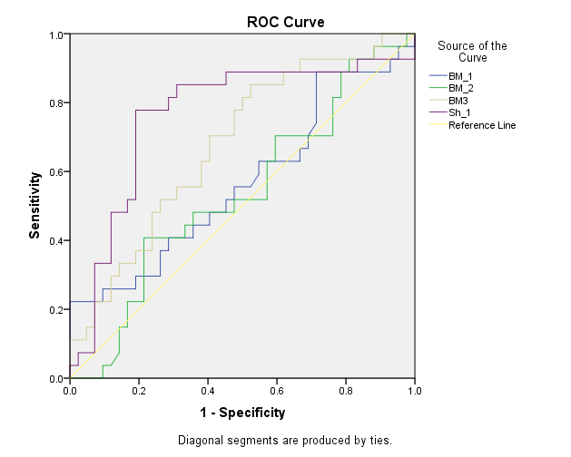
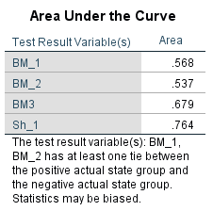

Control versus MDD

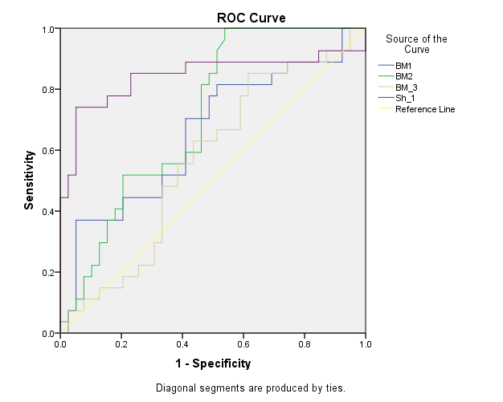
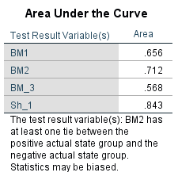

B. Control versus BD

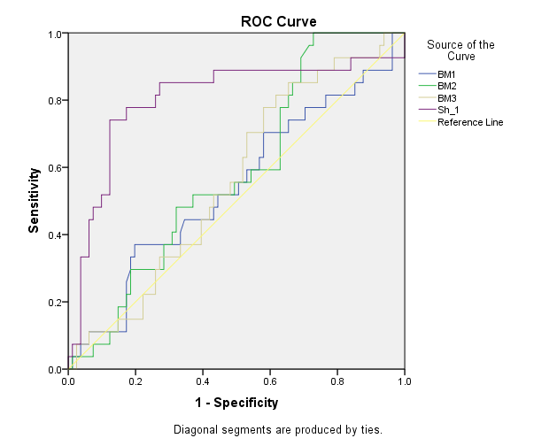
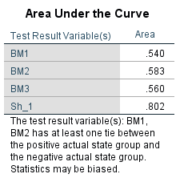

C. Control versus Depression

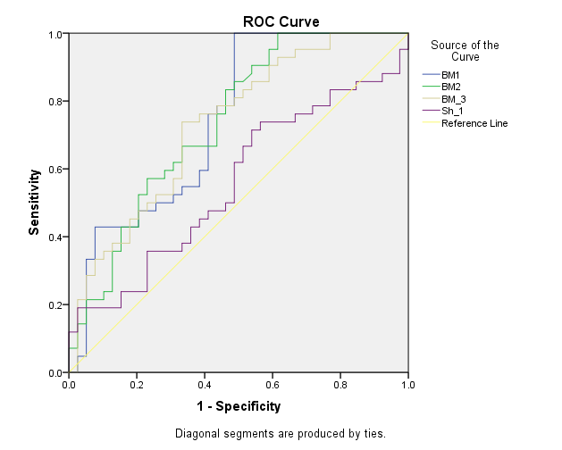
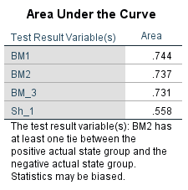

D. MDD versus BD

Medication Effects
Determining the effects of medications on BD subjects was more difficult as only 2 were not an any antipsychotic (AP), antidepressant (AD) or mood stabilizer (MS) medication. Using the same indicative method applied as in (3) we analysed the effect on mean feature loci of being on drug X (e.g. ‘MS’, which includes MS, MS&AP, MS&AD, MS&AP&AD) versus not being on drug X (e.g. ‘notMS’, which includes AP, AD, AP & AD, no medication (NM)). This means, for example, the MS-medicated group could contain subjects on all 3, 2 of the 3 (one must be MS) or only MS medication. This also means, for example, the non-MS medicated group could contain subjects on AP or AD or AP&AD or NM medications. The SE range for each of the means for each of the medicated and non-medicated groups was calculated. If the medicated and non-medicated SE ranges overlapped, the medication effect was considered non-significant. The use of the SE range is a more stringent test when testing for small differences.
The 4 average feature loci for BD subjects were compared and found, with the exceptions of BM1/2 AP and BM3 AD, not to be significantly different with and without medication (Table S2a). For BM1 AP and BM3 AD the medication brought the BM1 feature’s average loci for BD and MDD closer i.e. reduced the BD/MDD feature separation. BM2 AP did however enhance the MDD BD group separation.

Table S2a. Medication Versus No medication (feature mean loci + SE)
Average | MDD (N=26,13) | BD (N = 19, 23; 16, 26; 17, 25) | Depression  (BD&MDD) | Significant feature medication effect  (MDD, BD (AP, AD, MS), Depression)  (Control mean N=27)
BM1 (med)  (nomed) | -12.7 + 5.6  -13.7 + 8.1 | AP: 7.4 + 0.9  notAP: 11.1 + 1.8  AD: 12.7 +1.5  notAD: 10.5 + 1.7  MS: 11.9 + 1.5  notMS: 11.8 + 1.8 | 2.2 + 2.8  -10.2 + 7.6 | (no, (yes, no, no), no), 19.6 + 4.8  For BD’s the AP medication brings the BM1 feature’s average loci for BD and MDD closer i.e. lessens BD/MDD feature separation. Control to BD or MDD loci separation unaffected.
BM2 (med)  (nomed) | -1.0 + 7.1  2.0 + 11.2 | AP: 20.5 + 2.2  notAP: 27.5 + 1.9  AD: 30.5 + 1.9  notAD: 32.2 +1.9  MS: 31.6 + 2.0  notMS: 30.4 + 1.7 | 18.3 + 3.5  6.8 + 10.4 | (no, (yes, no, no), no), 30.9 + 1.3  For BD’s the AP medication brings the BM2 feature’s average loci for BD and MDD closer i.e. lessens BD/MDD feature separation. For AP, Control to BD loci separation increased significantly*.
BM3 (med)  (nomed) | 8.8 + 5.0  13.9 + 7.2 | AP: -1.8 + 3.5  notAP: -8.5 + 4.8  AD: -5.1 + 4.3  notAD: -16.8 + 5.2  MS: -8.0 + 4.9  notMS: -12.0 + 4.6 | -2.4 + 3.1  11.0 + 6.7 | (no, (no, yes, no), no), 5.0 + 4.2  For BD’s the AD medication brings the BM3 feature’s average loci for BD and MDD closer i.e. lessens BD/MDD feature separation. Control to BD or MDD loci separation unaffected.
Sh1 (med)  (nomed) | 21.4 + 4.2  15.8 + 5.0 | AP: 16.7 + 2.5  notAP: 8.9 + 6.3  AD: 10.8 + 5.5  notAD: 13.5 + 6.9  MS: 12.9 + 5.9  notMS: 10.1 + 6.1 | 14.5 + 3.2  19.9 + 4.6 | (no, (no, no, no), no), -16.2 + 5.7  Control to BD or MDD loci separation unaffected.

Table S2a. Table of (mean + standard error) feature values for 1. MDD with and without medications (column 2); 2. BD with and without Antipsychotic (AP), Antidepressant (AD) and Mood stabilizer (MS) medications (column 3); 3. Combined MDD and BD populations (Depression) with and without medications (column 4). The BD population was divided into those not on drug type X (e.g MS) and those on drug type X which could be any combination of the other drug groups (e.g. AP, AD or no medication). See (3) supplemental file for details of BD subgroupings and analysis. Only right-handed subjects were included. The last column indicated whether there was any significant effect on BD versus MDD classification features with (each) medication. No drug was observed to enhance BD versus MDD classification. The control feature loci are included for comparison. No drug was observed to enhance Control versus BD or MDD classification with one exception*, for AP the BD to control feature BM2 loci separation increased. BM2 was not used for the Control vrs Depressed classification (Table 1b) however, it was used in one of the two 3-way MDD vrs BD vrs Control classifications in Table 1b.

Anxiety Effects
Table S2b. Anxiety Versus Non-Anxiety (mean + SE)
Average | MDD (N=18,21) | BD (N=20,20) | Depression  (BD&MDD) | Significant (MDD, BD, Depression), control average (N=27)
BM1 (Anx)  (no Anx) | -7.4 + 5.4  -19.6 + 7.3 | 12.9 + 1.8  9.9 + 1.5 | 0.8 + 3.2  1.7 + 4.4 | (no, no, no)  2.1 + 4.5
BM2 (Anx)  (no Anx)) | 0.4 + 8.5  -0.4 + 8.3 | 32.7 + 2.3  30.1 + 1.8 | 15.7 + 5.2  16.1 + 4.7 | (no, no, no)  30.7 + 1.3
BM3 (Anx)  (no Anx)) | 13.3 + 5.2  7.3 + 6.3 | -14.4 + 5.2  -7.4 + 4.8 | - + 4.2  -1.3 + 3.9 | (no, no, no)  5.0 + 4.2
Sh1 (Anx)  (no Anx) | 19.7 + 4.6  19.4 + 4.6 | 9.4 + 6.9  13.7 + 5.7 | 14.8 + 4.1  16.3 + 3.8 | (no, no, no)  10.8 + 4.1

Table S3. Table of mean feature values for BD, MDD, BD&MDD as well as Control average + SE feature values. There were no significant differences between sub-groups with and without anxiety for each feature. Nor were there any significant differences between BD and MDD or BD and Control or MDD and Control anxiety and non-anxiety loci. Standard Error (SE) was selected as this is a more stringent test for testing differences.

Supplemental References
1. Lithgow BJ. A methodology for detecting field potentials from the external ear canal: NEER and EVestG. Ann BME 2012;40(8):1835-50.
2. Dastgheib Z, Lithgow B, Moussavi Z. Diagnosis of Parkinson's Disease using Electrovestibulography Med Biol Eng Comp. 2012;50(5):483-91.
3. Lithgow BJ, Moussavi Z, Gurvich C, Maller JJ, Kulkarni J, Fitzgerald PB. Bipolar Disorder in the Balance. Europ Arch Psychiat Clin Neurosci [Internet]. 2018; DOI: 10.1007/s00406-018-0935-x:[15 p.].

