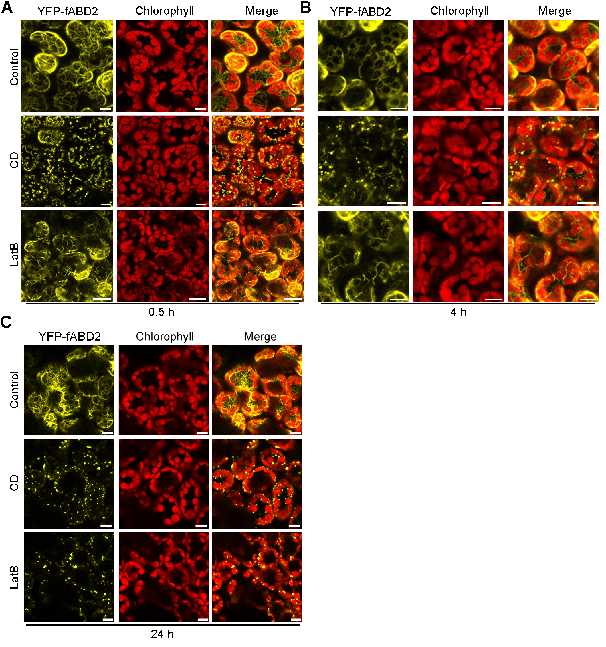
Figure S1. Disruption of actin filaments in mesophyll cells treated with 20 μM CD or 25 μM LatB for 0.5 h, 4 h and 24 h. Representative images of actin filaments configuration in leaves after 0.5 h (A), 4 h (B) and 24 h (C) of treatment with actin polymerization inhibitors. YFP-fABD2 is in yellow and chloroplasts are in red. Scale bars: 10 μm.

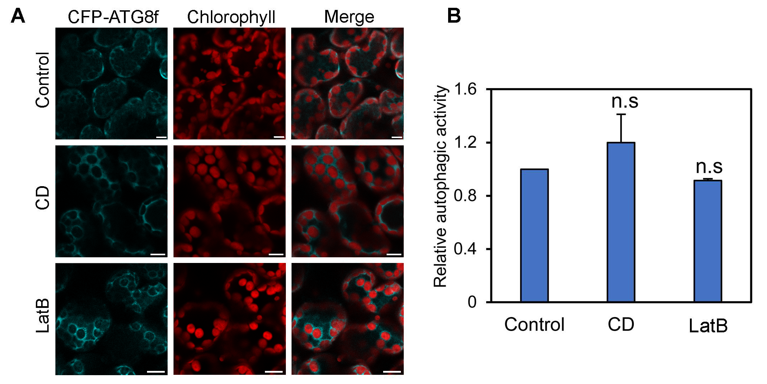
Figure S2. A 4-h treatment of leaves with 20 μM CD or 25 μM LatB has no effect on basal autophagy. (A) Representative confocal images of CFP-ATG8f-labeled autophagic structures in drug-treated leaves. Confocal images were taken at the end of the day (dark 8 h). CFP-ATG8f is in cyan and chloroplasts are in red. Scale bars: 10 μm. (B) Relative autophagic activity in leaves treated with CD and LatB for 4 h which was normalized to that of in control leaves (set to 1.0). More than 150 cells were quantified in each treatment. Values represent means ± SE from 3 independent experiments. n.s means no significant difference (student’s t test, p > 0.05).

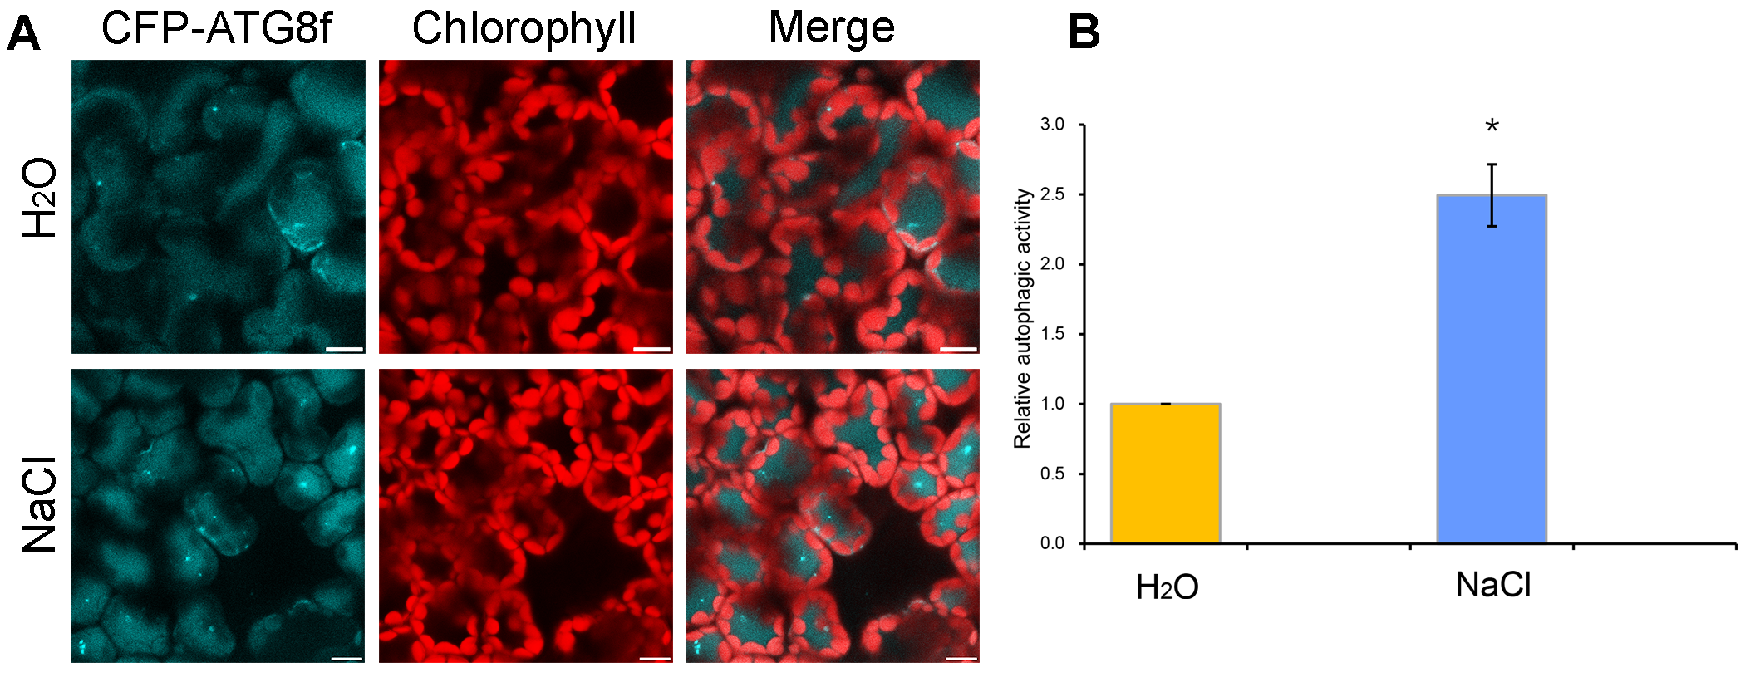
Figure S3. Autophagy is induced by salt stress within 1 h in N. benthamiana leaves. (A) Representative confocal images of CFP-ATG8f-labeled autophagic structures in leaves treated with 150 mM NaCl for 1 h. CFP-ATG8f is in cyan and chloroplasts are in red. 100 μM E-64d was pre-infiltrated into leaves for 12-h inhibition. Scale bars: 10 μm. (B) Relative autophagic activity in leaves treated with 150 mM NaCl for 1 h. The autophagic activity in leaves treated solely with H₂O was set to 1.0.

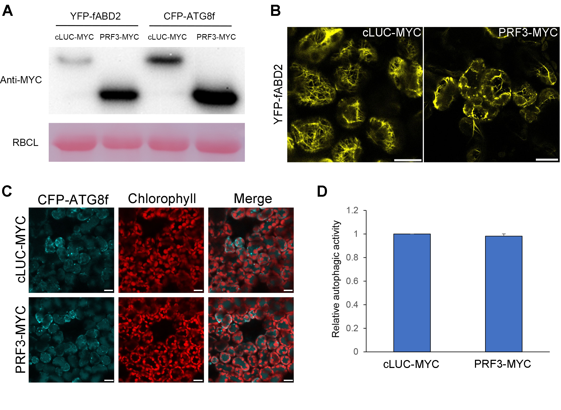
Figure S4. Overexpression of PRF3-MYC does not affect basal autophagy. (A) Protein level of PRF3-MYC and cLUC-MYC in the experiments above were detected by western blot using Anti-MYC antibody (upper panel). RBCL was stained by Ponceau to indicate equal loading (lower panel). (B) Overexpression of PRF3-MYC disrupted actin filaments. Representative images of actin filaments configuration in cLUC-MYC- or PRF3-MYC-expressing leaves. Actin filaments marker YFP-fABD2 was co-expressed with cLUC-MYC (control) or PRF3-MYC in leaves for 2 days before imaging. YFP-fABD2 is in yellow and chloroplasts are in red. Scale bars: 10 μm. (C) Representative confocal images of CFP-ATG8f-labeled autophagic structures in cLUC-MYC- or PRF3-MYC-expressing plants. CFP-ATG8f was co-expressed with cLUC-MYC (as control) or PRF3-MYC for 2 days. Confocal images were taken at the end of the day (dark 8 h). CFP-ATG8f is in cyan and chloroplasts are in red. Scale bars: 10 μm. (D) Relative autophagic activity in PRF3-MYC-expressing leaves showed no significant difference with control (student’s t test, p > 0.05). The autophagic activity in control was set to 1.0. More than 180 cells were quantified in each treatment. Values indicate means ± SE from 3 independent experiments.

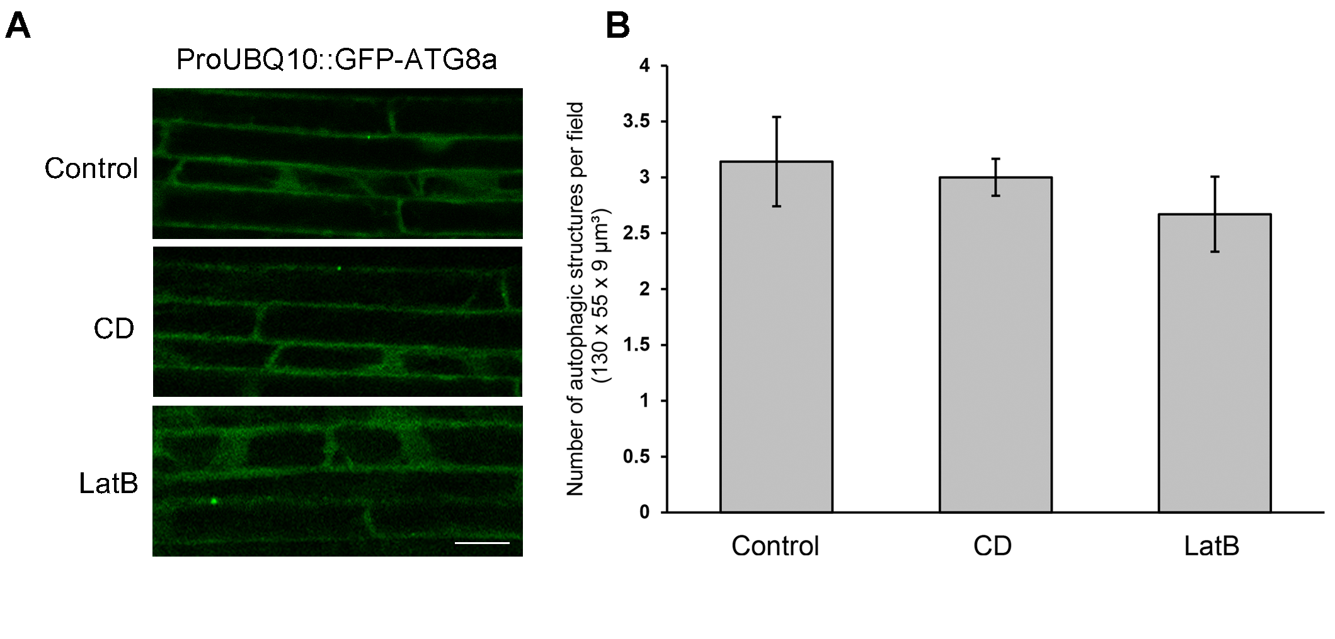Figure S5. Treatment of Arabidposis roots with anti-microfilament drugs for 1 h has no influence on basal autophagy. (A) Representative confocal images of GFP-ATG8a-labeled autophagic structures in drug-treated root cortex cells. Scale bars: 20 μm. (B) The number of autophagic structures per field in drug-treated cells. More than 40 cells were quantified in each treatment. Values represent means ± SE from 3 independent experiments. n.s means no significant difference (student’s t test, p > 0.05).

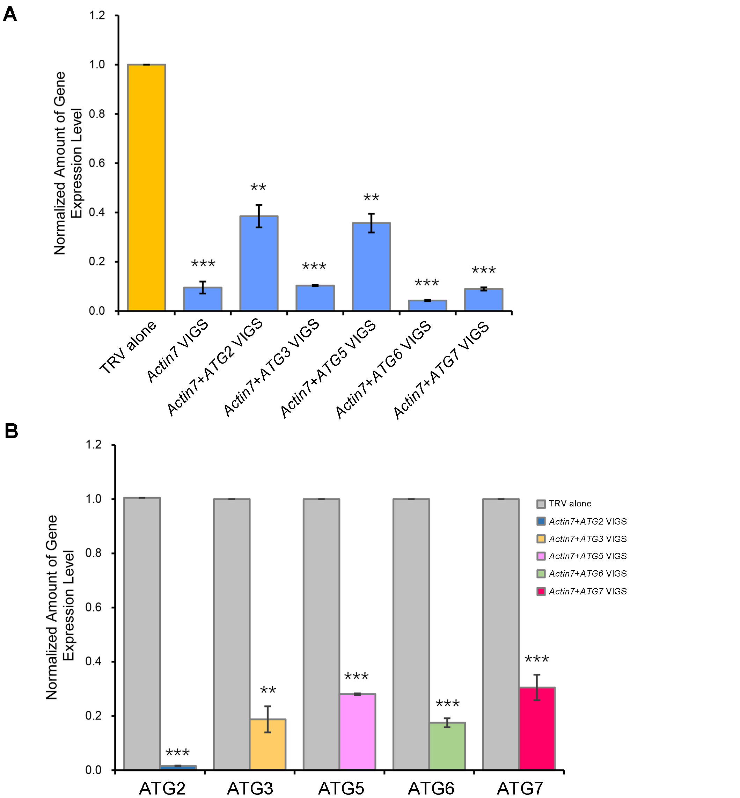
Figure S6. Actin7 (A) and ATG genes (B) are silenced in the individual VIGS plants. mRNA levels of Actin7, ATG2, ATG3, ATG5, ATG6 and ATG7 was tested by real-time RT-PCR and normalized to EF1α. The expression data of TRV control was set to 1.0. Values indicate means ± SE from 3 independent experiments. Student’s t test was performed to indicate significant difference (** 0.001 < p < 0.01, *** p < 0.001).

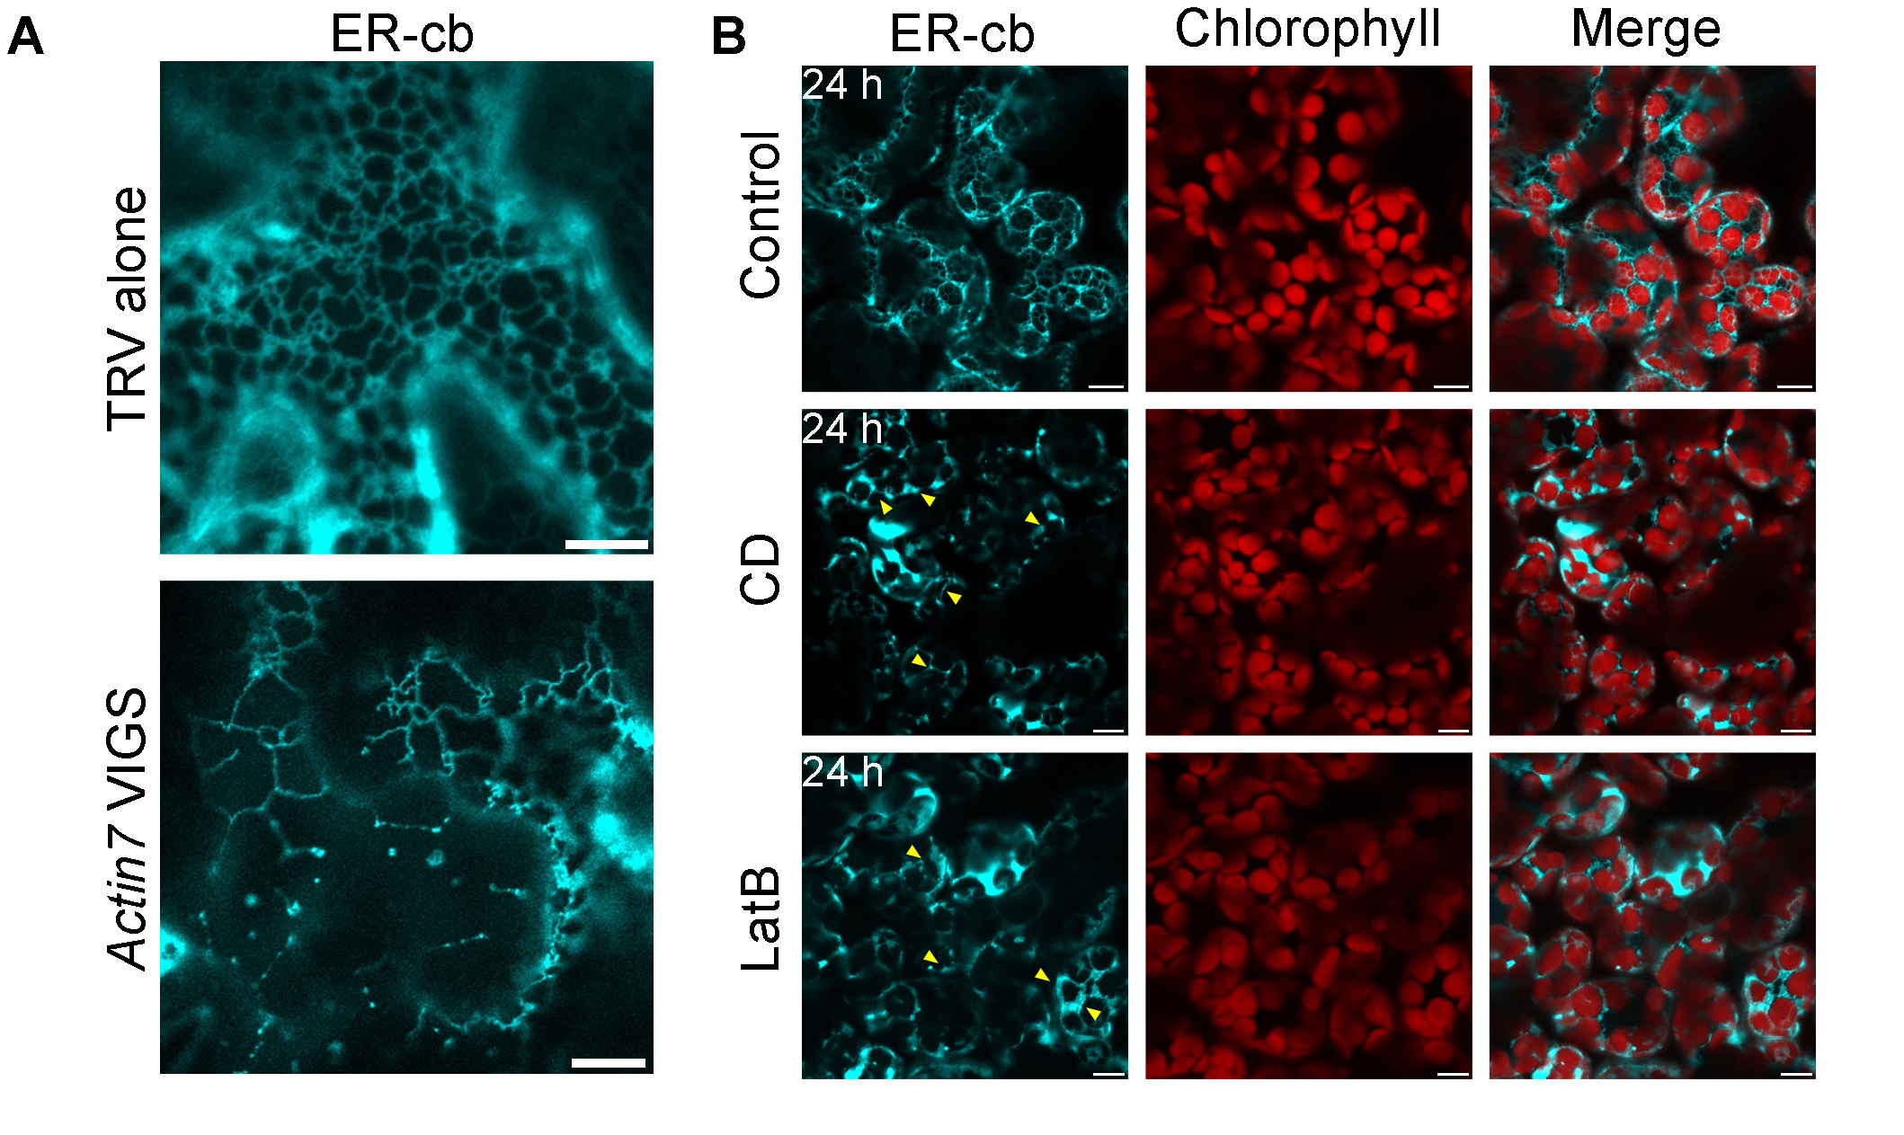
Figure S7. Silencing Actin7 (A) or 24 h-treatment of anti-microfilament drugs (B) caused ER disorganization. ER-cb was used to label ER network. Representative confocal images in (A) and (B) were taken in epidermis and mesophyll cells respectively. ER-cb is in cyan and chloroplasts are in red. Scale bars: 10 μm.

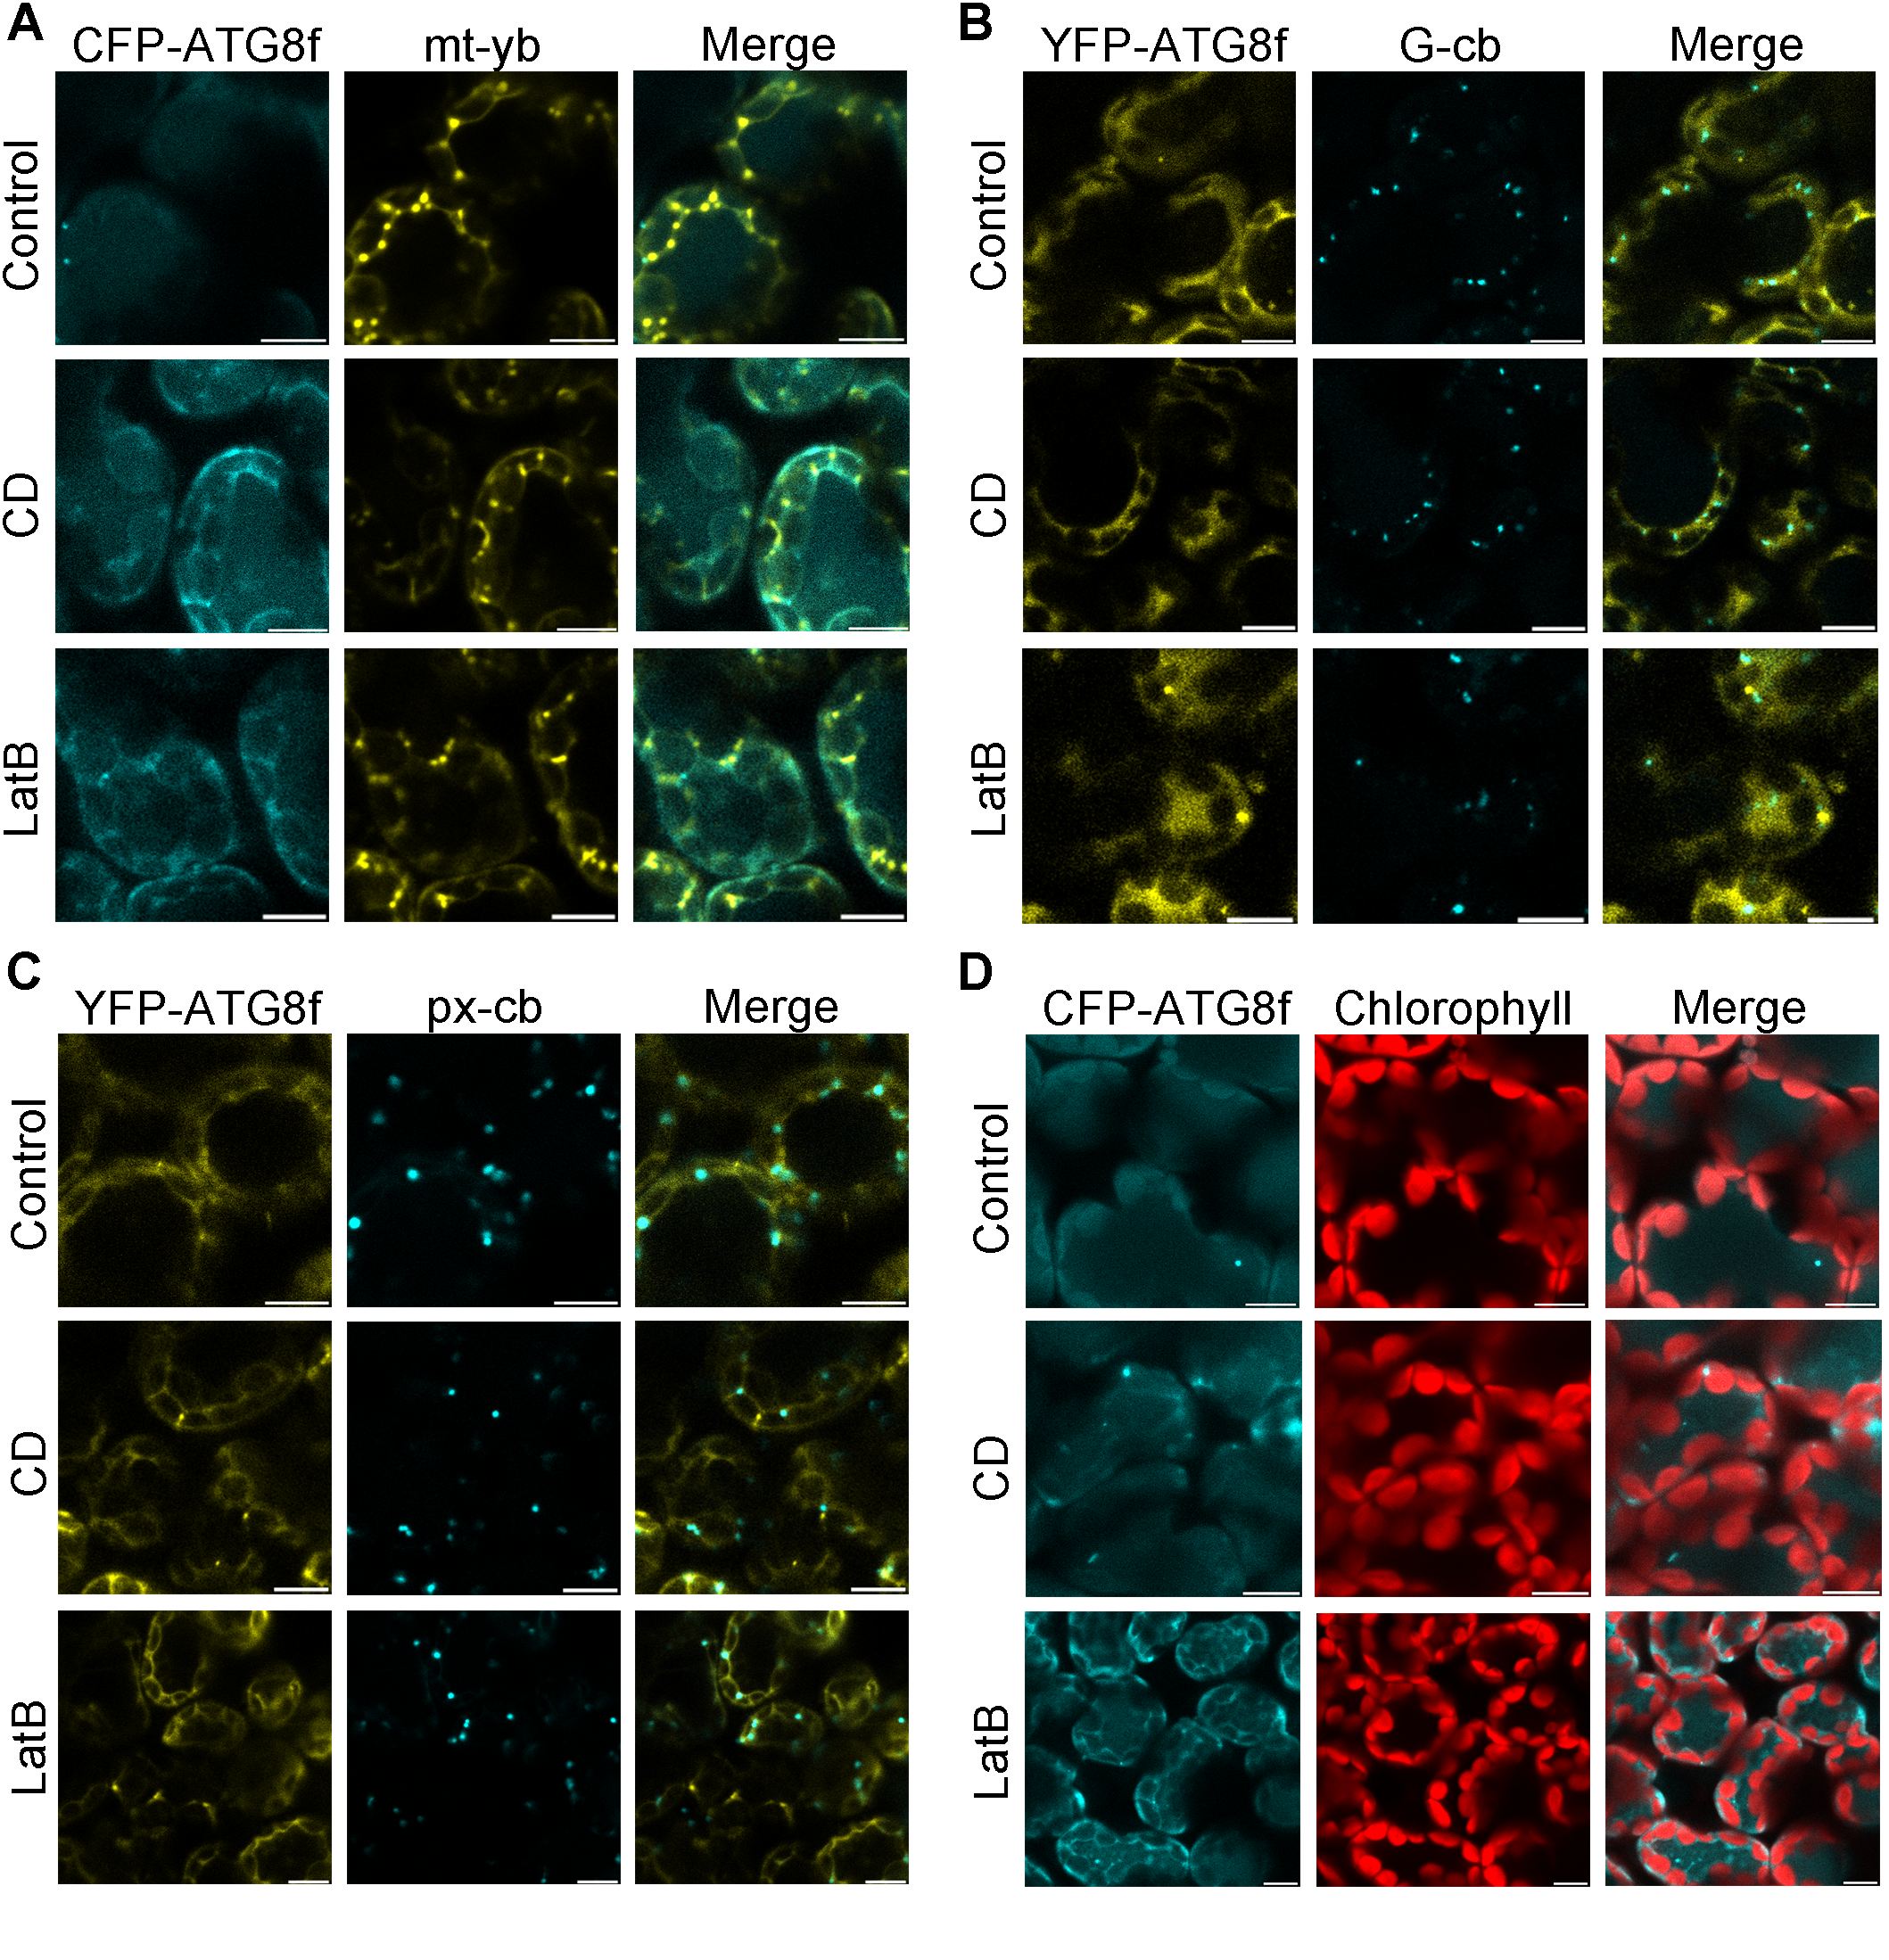
Figure S8. Rare colocalization of autophagic structures with mitochondria (A), Golgi (B), peroxisomes (C) or chloroplasts (D) was observed in leaves treated with anti-microfilament drugs for 24 h. Mitochondria, Golgi and peroxisomes were labeled by mt-yb, G-cb and px-cb respectively. Chloroplasts were verified by chlorophyll autofluorescence. Autophagic structures were labeled by CFP-ATG8f in (A) (D) and YFP-ATG8f in (B) (C), respectively. Mt-yb is in yellow, G-cb and px-cb are in cyan and chloroplasts are in red. Scale bars: 10 μm.
Table S1. Primers used for plasmid construction and RT-PCR.
Purpose | Name | Primer name | Primer sequence (5' to 3')
Plasmid construction | YFP-fABD2 | LIC1-YFP-F | CGACGACAAGACCGTGACCATGGTGAGCAAGGGCGAG
 |  | YFP-fABD2 fusion-R | CTTGTACAGCTCGTCCATGCCGAGAG
 |  | YFP-fABD2 fusion-F | GACGAGCTGTACAAGATGGATCCTCTTGAAAGAGCTG
 |  | LIC2-fABD2-R | GAGGAGAAGAGCCGTCTATTCGATGGATGCTTCCTCTGAG
 | YFP-ATG8f | LIC1-YFP-F | see above
 |  | YFP-ATG8f fusion-R | CTTGTACAGCTCGTCCATGCCGAGAG
 |  | YFP-ATG8f fusion-F | GACGAGCTGTACAAGATGGCAAAGAGTTCATTCAAGCAAG
 |  | LIC2-ATG8f-R | GAGGAGAAGAGCCGTCTACACTAAGTTGAGGTCGCCAAAT
 | RFP-ATG8f | LIC1-RFP-F | CGACGACAAGACCGTGACCATGGTGAGCAAGGGCGAGGAGGAT
 |  | RFP-ATG8f fusion-R | CTTGTACAGCTCGTCCATGCCGCCGGT
 |  | RFP-ATG8f fusion-F | GACGAGCTGTACAAGATGGCAAAGAGTTCATTCAAGCAAG
 |  | LIC2-ATG8f-R | see above
 | TRV2-ATG2+ACTIN7 | LIC1-ATG2-F | CGACGACAAGACCGTATGCACAGCGATCAACAGGAACTTG
 |  | ATG2+ACTIN7 fusion-R | TGGTTCTCTTTGCTACTATGTCCGA
 |  | ATG2+ACTIN7 fusion-F | TAGTAGCAAAGAGAACCAATGGCAGAAGGTGAGGATATTCAAC
 |  | LIC2-ACTIN7-R | GAGGAGAAGAGCCGTGGTACGACCACTGGCATAGAGCGAG
 | TRV2-ATG3+ACTIN7 | LIC1-ATG3-F | CGACGACAAGACCGTGAAGAGGAGGACATACCTGACATGG
 |  | ATG3+ACTIN7 fusion-R | TTCAATTGTTGGAATAACGGAAGCC
 |  | ATG3+ACTIN7 fusion-F | GTTATTCCAACAATTGAAATGGCAGAAGGTGAGGATATTCAAC
 |  | LIC2-ACTIN7-R | see above
 | TRV2-ATG5+ACTIN7 | LIC1-ATG5-F | CGACGACAAGACCGTTGGGAACTGCAAAAATGTAATGAAT
 |  | ATG5+ACTIN7 fusion-R | ACCTCAACTTCCTCTCCAGAAACGT
 |  | ATG5+ACTIN7 fusion-F | TGGAGAGGAAGTTGAGGTATGGCAGAAGGTGAGGATATTCAAC
 |  | LIC2-ACTIN7-R | see above
 | TRV2-ATG6+ACTIN7 | LIC1-ATG6-F | CGACGACAAGACCCTTTGGGAAGGCTATGGAAGAATC
 |  | ATG6+ACTIN7 fusion-R | GTTCGGCAGTGACTACGGCACATTG
 |  | ATG6+ACTIN7 fusion-F | CCGTAGTCACTGCCGAACATGGCAGAAGGTGAGGATATTCAAC
 |  | LIC2-ACTIN7-R | see above
 | TRV2-ATG7+ACTIN7 | LIC1-ATG7-F | CGACGACAAGACCGTTGCATCAGCCTTGCTAAAACAATGG
 |  | ATG7+ACTIN7 fusion-R | TGAATTAATCAAATCAGACAAATGT
 |  | ATG7+ACTIN7 fusion-F | TCTGATTTGATTAATTCAATGGCAGAAGGTGAGGATATTCAAC
 |  | LIC2-ACTIN7-R | see above
 | TRV2-ACTIN7 | LIC1-Luciferase-F | CGACGACAAGACCGTGACCGAAGACGCCAAAAACATAAAGAAAG
 |  | Luciferase+ACTIN7-R | GATAATAATTTTTTGGATGATTGGG
 |  | Luciferase+ACTIN7-F | ATCCAAAAAATTATTATC ATGGCAGAAGGTGAGGATATTCAAC
 |  | LIC2-ACTIN7-R | see above
RT-PCR for confirming gene silencing | ACTIN7 | ACTIN7-F | CCCAGAGAGGAAATACAGTG
 |  | ACTIN7-R | CAATAGACGGACCAGATTCG
 | EF1α | EF1α-F | CTGGTGTCCTCAAGCCTGGTATGG
 |  | EF1α-R | TGGCTGGGTCATCCTTGGAGTTTG
 | ATG2 | ATG2-F | GCAATTGGGCTTGGAGTGCATTTG
 |  | ATG2-R | CCTGTCGGGCATCTCTAGGTTGAT
 | ATG3 | ATG3-F | AGGACAATGATGGTTGGCTGGCA
 |  | ATG3-R | TCCTCTTCCTCTTCCTCGCCTCC
 | ATG5 | ATG5-F | GCTCCTCGAATAGGTTACCTGCCT
 |  | ATG5-R | CCGTCAGATTCCAAGGACGTTCAG
 | ATG6 | ATG6-F | ACCTGCGTAAAGGAGTTTGCTGAC
 |  | ATG6-R | AGAGCTTTGGTCCAACTTTCCTGC
 | ATG7 | ATG7-F | CTCGTTGGTCACGCTTCAACTTGT
 |  | ATG7-R | TCCCAGTCCAGCATGTAAGATCCC

