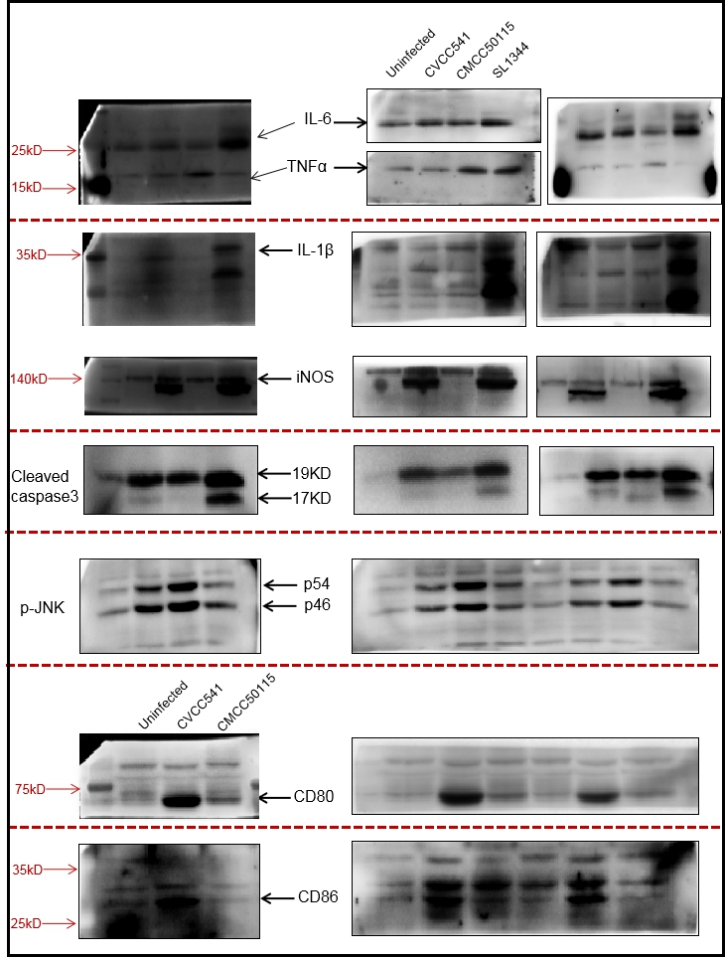

Fig. S1. The entire images for Western blots.

Table S1. The SNP and amino acid change of mutant protein coding genes
 | Gene | start | end | SNP-position | Reference | Mutation | Amino acid (reference) | Amino acid (mutation)
CVCC541 (SPI1) | avrA | 3032477 | 3033382 | 3032927 | T | TAAA | / | Insert L (Leucine)
 | sipD | 3049331 | 3050362 | 3049545 | G | T | A (Alanine) | E (Glutamic acid)
 | spaS | 3054109 | 3055179 | 3055076 | G | A | T (Threonine) | M (Methionine)
CVCC541 (SPI2) | ssaU | 1457283 | 1458341 | 1457952 | C | T | H (Histidine) | Y (Tyrosine)
 | sifB | 1649034 | 1649984 | 1649898 | A | G | T (Threonine) | A (Alanine)
CMCC50115 (SPI1) | avrA | 3032477 | 3033382 | 3032927 | T | TAAA | / | Insert L (Leucine)
 | steB | 1676474 | 1676875 | 1676682 | C | T | P (Proline) | L (Leucine)
 | spaR | 3055166 | 3055957 | 3055452 | G | A | P (Proline) | L (Leucine)
CMCC501115 (SPI2) | sifB | 1649034 | 1649984 | 1649898 | A | G | T (Threonine) | A (Alanine)
CVCC541 | phoP | 1275542 | 1276216 | 1275747 | G | A | T (Threonine) | I (Isoleucine)
 | phoQ | 1274079 | 1275542 | 1275022 | G | C | T (Threonine) | S(Serine)
CMCC50115 | ompR | 3681128 | 3681847 | 3681179 | C | A | Q (Glutamine) | H (Histidine)

Table S2. Metabolic pathway involving mutant protein coding genes in CVCC541and CMCC50115
 | Category | Term | Count | PValue | Genes | Fold Enrichment
CVCC541 | stm00500 | Starch and sucrose metabolism | 7 | 0.007376723 | AMYA, TREC, TREF, OTSB, GLGX, YAJF, YIHQ | 3.854605263
 | stm02020 | Two-component system | 16 | 0.040920237 | RCSA, TTRC, CITC, UHPT, ARCA, CITF, KDPB, UHPB, CYDB, BAER, NARH, PHOQ, PSTS, PHOP, YEGB, ACRD | 1.688244564
 | stm05132 | Salmonella infection | 5 | 0.053887754 | NRFA, AVRA, SIPD, YGAA, HMPA | 3.388663968
 | stm00020 | Citrate cycle (TCA cycle) | 4 | 0.175987981 | SUCC, ACEE, SDHC, FUMA | 2.710931174
 | stm03070 | Bacterial secretion system | 5 | 0.256103342 | SECD, FTSY, SSAU, SPAS, FFH | 1.915331808
 | stm03060 | Protein export | 3 | 0.289480644 | SECD, FTSY, FFH | 2.782271468
 | stm01200 | Carbon metabolism | 9 | 0.315391148 | SUCC, ACEE, SDHC, YBHE, PTA, FBA, FUMA, KATE, FOLD | 1.379038902
 | stm00190 | Oxidative phosphorylation | 4 | 0.438447333 | CYDB, SDHC, CYOE, NDH | 1.639167687
 | stm01220 | Degradation of aromatic compounds | 2 | 0.471475186 | HPAG, HPAB | 3.203827751
 | stm00071 | Fatty acid degradation | 2 | 0.529552554 | FADD, FADI | 2.710931174
 | stm00670 | One carbon pool by folate | 2 | 0.529552554 | FOLA, FOLD | 2.710931174
 | stm01120 | Microbial metabolism in diverse environments | 15 | 0.531608671 | NRFA, ARGD, TTRC, YBHE, PTA, FUMA, SUCC, ACEE, SDHC, NARH, FBA, HPAG, HPAB, FOLD, FADI | 1.070104411
 | stm00780 | Biotin metabolism | 2 | 0.556176311 | BIOH, BIOF | 2.517293233
 | stm01130 | Biosynthesis of antibiotics | 12 | 0.601784897 | GPH, SUCC, ARGD, ACEE, SDHC, YBHE, FBA, FUMA, KATE, PURD, ARGH, FADI | 1.041638579
 | stm00220 | Arginine biosynthesis | 2 | 0.648560318 | ARGD, ARGH | 1.957894737
 | stm02010 | ABC transporters | 10 | 0.651167261 | PROW, PROX, ARGT, BTUD, LIVK, ARTI, OPPA, FEPC, PSTS, HISM | 1.018557956
 | stm00920 | Sulfur metabolism | 3 | 0.654753485 | DMSA, TTRC, DMSC | 1.355465587
 | stm00010 | Glycolysis / Gluconeogenesis | 3 | 0.654753485 | ACEE, FBA, CELF | 1.355465587
 | stm01212 | Fatty acid metabolism | 2 | 0.687337066 | FADD, FADI | 1.762105263
 | stm00350 | Tyrosine metabolism | 2 | 0.687337066 | HPAG, HPAB | 1.762105263
 | stm00910 | Nitrogen metabolism | 2 | 0.752635312 | NRFA, NARH | 1.468421053
 | stm01110 | Biosynthesis of secondary metabolites | 16 | 0.756303538 | GPH, ARGD, GLPA, YBHE, FUMA, PURD, HISG, TRPB, SUCC, ACEE, SDHC, CYOE, FBA, KATE, ARGH, FADI | 0.927423823
 | stm00970 | Aminoacyl-tRNA biosynthesis | 6 | 0.762222289 | PHET, SELA, GLNS, TYRS, CYSS, ILES | 0.952489331
 | stm00550 | Peptidoglycan biosynthesis | 2 | 0.766727603 | MRCB, DACA | 1.409684211
 | stm03440 | Homologous recombination | 2 | 0.792572231 | DNAE, RECD | 1.305263158
 | stm00052 | Galactose metabolism | 2 | 0.815580585 | GALT, YIHQ | 1.215245009
 | stm00564 | Glycerophospholipid metabolism | 2 | 0.815580585 | GLPA, YBHO | 1.215245009
 | stm00680 | Methane metabolism | 2 | 0.826118838 | PTA, FBA | 1.174736842
 | stm00230 | Purine metabolism | 4 | 0.827305102 | DGT, DNAE, PURD, PNP | 0.903643725
 | stm00620 | Pyruvate metabolism | 3 | 0.834536324 | ACEE, PTA, FUMA | 0.943984962
 | stm00520 | Amino sugar and nucleotide sugar metabolism | 3 | 0.841910562 | GALT, NANA, YAJF | 0.927423823
 | stm00630 | Glyoxylate and dicarboxylate metabolism | 2 | 0.854288417 | GPH, KATE | 1.067942584
 | stm01503 | Cationic antimicrobial peptide (CAMP) resistance | 2 | 0.877935049 | PHOQ, PHOP | 0.978947368
 | stm02040 | Flagellar assembly | 2 | 0.884939997 | FLGA, FLHB | 0.952489331
 | stm00640 | Propanoate metabolism | 2 | 0.884939997 | SUCC, PTA | 0.952489331
 | stm00860 | Porphyrin and chlorophyll metabolism | 2 | 0.897778394 | CBID, CYOE | 0.903643725
 | stm00030 | Pentose phosphate pathway | 2 | 0.914424649 | YBHE, FBA | 0.839097744
 | stm00051 | Fructose and mannose metabolism | 2 | 0.940086976 | FBA, YAJF | 0.734210526
 | stm01100 | Metabolic pathways | 35 | 0.942564961 | PNTB, GPH, DNAE, YBHE, FUMA, BIOF, YIHQ, ACEE, GLNS, FADI, YBHO, CBID, ARGD, TREF, GALT, PTA, FADD, DACA, PURD, HISG, AMYA, TRPB, FOLA, BIOH, SUCC, CYDB, SDHC, GLGX, OTSB, CYOE, FBA, YAJF, ARGH, FOLD | 0.848331282
 | stm01230 | Biosynthesis of amino acids | 5 | 0.944918443 | HISG, TRPB, ARGD, FBA, ARGH | 0.677732794
 | stm00240 | Pyrimidine metabolism | 2 | 0.958110595 | DNAE, PNP | 0.652631579

 | Category | Term | Count | PValue | Genes | Fold Enrichment
CMCC50115 | stm00500 | Starch and sucrose metabolism | 9 | 5.11E-04 | GLGB, RFBF, TREA, MALZ, OTSB, GLGX, BCSA, PGM, YAJF | 4.483928571
 | stm00561 | Glycerolipid metabolism | 4 | 0.033973871 | GLPK, GLDA, PLSB | 5.314285714
 | stm01100 | Metabolic pathways | 54 | 0.067501074 | FRDD, GLDA, FUMA, EUTB, GLPK, NUOE, ACNB, PDXA, PGM, PNCA, GLGB, TREA, ARGD, MALZ, NUON, PURD, TRPC, TRPB, NIFJ, TRPE, SUCC, OTSB, GLGX, YAJF, RFBF, USHA, DNAE, YBHE, FBAB, BCSA, BIOF, YADI, SPEA, NAGB, GLNS, SDAA, NRDE, LDCC, YBHO, CBID, CBIF, GALT, PLSB, HISG, FOLA, GLMU, LEUB, DEOD, LEUD, DEOA, FOLD | 1.184201218
 | stm00564 | Glycerophospholipid metabolism | 5 | 0.100915007 | GLPB, GLPA, EUTB, PLSB, YBHO | 2.748768473
 | stm00520 | Amino sugar and nucleotide sugar metabolism | 7 | 0.137907914 | RFBF, GLMU, NAGB, GALT, NANA, PGM, YAJF | 1.957894737
 | stm02010 | ABC transporters | 15 | 0.177977774 | BTUF, YOJI, BTUD, YEJA, FTSE, ARTI, MODA, RBSB, UGPE, PROW, MGLC, LIVK, LIVM, YEHY, FHUB | 1.382328654
 | stm00640 | Propanoate metabolism | 5 | 0.193881275 | SUCC, PDUQ, ACNB, GLDA | 2.154440154
 | stm00020 | Citrate cycle (TCA cycle) | 4 | 0.216303402 | SUCC, FRDD, ACNB, FUMA | 2.452747253
 | stm02020 | Two-component system | 14 | 0.230451973 | GLNG, RCSA, FRDD, DNAA, CITE, TTRC, CITC, UHPT, CITF, KDPB, ARCB, RCSC, OMPR, PGTB | 1.336526946
 | stm01110 | Biosynthesis of secondary metabolites | 23 | 0.242197451 | GLGB, USHA, ARGD, FRDD, GLPB, GLPA, YBHE, FBAB, FUMA, PURD, PLSB, HISG, TRPC, TRPB, TRPE, SUCC, ACNB, LEUB, DEOD, SDAA, LEUD, PGM, LDCC | 1.206203008
 | stm00660 | C5-Branched dibasic acid metabolism | 3 | 0.261718043 | SUCC, LEUB, LEUD | 2.989285714
 | stm01210 | 2-Oxocarboxylic acid metabolism | 4 | 0.267357119 | ARGD, ACNB, LEUB, LEUD | 2.199014778
 | stm00760 | Nicotinate and nicotinamide metabolism | 3 | 0.309066536 | USHA, DEOD, PNCA | 2.657142857
 | stm00230 | Purine metabolism | 7 | 0.355103179 | USHA, DNAE, DEOD, NRDE, PURD, AMN, PGM | 1.430769231
 | stm01230 | Biosynthesis of amino acids | 10 | 0.418442129 | HISG, TRPC, TRPB, TRPE, ARGD, ACNB, LEUB, FBAB, SDAA, LEUD | 1.226373626
 | stm00400 | Phenylalanine, tyrosine and tryptophan biosynthesis | 3 | 0.423693886 | TRPC, TRPB, TRPE | 2.079503106
 | stm01200 | Carbon metabolism | 9 | 0.423870177 | NIFJ, SUCC, FRDD, ACNB, FBAB, YBHE, SDAA, FUMA, FOLD | 1.247701863
 | stm00240 | Pyrimidine metabolism | 5 | 0.435298794 | USHA, DNAE, DEOD, NRDE, DEOA | 1.476190476
 | stm01120 | Microbial metabolism in diverse environments | 17 | 0.470633997 | ARGD, FRDD, TTRC, RHAA, YBHE, FBAB, FUMA, YADI, NIFJ, SUCC, PHSC, ACNB, ASRA, DLD, HPAB, PGM, FOLD | 1.097281666
 | stm00052 | Galactose metabolism | 3 | 0.547298971 | MALZ, GALT, PGM | 1.649261084
 | stm00670 | One carbon pool by folate | 2 | 0.566960832 | FOLA, FOLD | 2.452747253
 | stm00620 | Pyruvate metabolism | 4 | 0.688728922 | NIFJ, FRDD, DLD, FUMA | 1.13877551
 | stm00053 | Ascorbate and aldarate metabolism | 2 | 0.706384829 | LYXK, YADI | 1.678195489
 | stm00920 | Sulfur metabolism | 3 | 0.709810607 | PHSC, ASRA, TTRC | 1.226373626
 | stm00290 | Valine, leucine and isoleucine biosynthesis | 2 | 0.724835571 | LEUB, LEUD | 1.594285714
 | stm00030 | Pentose phosphate pathway | 3 | 0.748101456 | FBAB, YBHE, PGM | 1.13877551
 | stm00330 | Arginine and proline metabolism | 2 | 0.75836099 | SPEA, ARGD | 1.449350649
 | stm00190 | Oxidative phosphorylation | 3 | 0.75987736 | NUOE, FRDD, NUON | 1.112292359
 | stm00051 | Fructose and mannose metabolism | 3 | 0.811910994 | RHAA, FBAB, YAJF | 0.996428571
 | stm01130 | Biosynthesis of antibiotics | 11 | 0.83249371 | GLMU, SUCC, ARGD, FRDD, ACNB, FBAB, YBHE, SDAA, FUMA, PURD, PGM | 0.863898663
 | stm00260 | Glycine, serine and threonine metabolism | 2 | 0.896563439 | TRPB, SDAA | 0.911020408
 | stm02040 | Flagellar assembly | 2 | 0.90927751 | FLIF, FLHB | 0.861776062
 | stm00010 | Glycolysis / Gluconeogenesis | 2 | 0.920441992 | FBAB, PGM | 0.817582418
 | stm00860 | Porphyrin and chlorophyll metabolism | 2 | 0.920441992 | CBID, CBIF | 0.817582418
 | stm00970 | Aminoacyl-tRNA biosynthesis | 4 | 0.975147098 | PHET, SELA, GLNS, ILES | 0.574517375
 | stm02060 | Phosphotransferase system (PTS) | 2 | 0.977339713 | PTSP, YADI | 0.549753695
 | stm00750 | Vitamin B6 metabolism | 2 | 0.474387599 | PDXA, STM0163 | 3.188571429

