A B
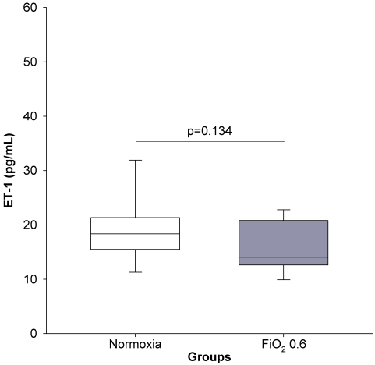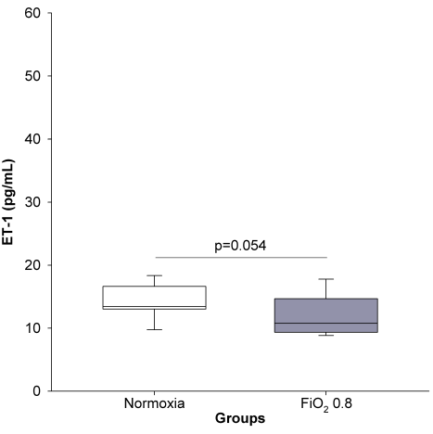
Figure S1. ET-1 concentration in plasma. Normoxic and hyperoxic study groups are illustrated with white and grey box plots, respectively. A: ET-1 concentration in the normoxic (n=13) and FiO₂ 0.6 groups (n=14). B: ET-1 concentration in normoxia (n=15) and hyperoxia (FiO₂ 0.8) (n=14). Data are expressed as vertical box plots with median, 10th, 25th, 75th, and 90th percentiles.

