Supplementary Information
Figures SI 1 to 4 below show the average of projected presence among the CES members, for each quadrant in which the domain was divided to. Colored (blue tone) graph bars are distinguished for the two time horizons and the two RCPs, and the historical presence is indicated by the black outline of the bars. As explained in the main text, only those species with overall SDM performance greater than 0.95 (Birch, Larch, Pine and Spruce) where considered.
For that concerning Birch (Figure SI 1), a strong reduction is expected, from the average of projected presences, within those sectors historically hosting a great part of the species. The highest historical presence was in the Western sector, and here reductions in the future range from 25% under the intermediate scenario (2060 RCP4.5) to 83% in the worst scenario (2080 RCP8.5). The Central and Southern regions, also significantly populated by Birch along the historical period, are expected to suffer from reductions of up to 58% and 66% in 2080 RCP8.5, respectively. In the remaining quadrants, the already low presence of Birch will drop further, remaining in very few map units. In the South-West a total disappearance is projected.
Larch species (Figure SI 2), practically absent in the North-West and South-West sectors, is mostly concentrated in the Central quadrant, and secondarily in the Eastern and Southern quadrants. While a reduction is projected in the Center and South, up to 57% and 81%, respectively, for 2080 under RCP8.5, the expected presence in the Eastern quadrant oscillates around the historical presence. The South-Eastern, Western and Northern sectors host historically very similar amounts of Larch. For the first two quadrants, a strong reduction is expected (up to 76% and 100%, respectively, in 2080 under RCP8.5). Contrarily, a very strong increase is projected in the North, with future presences more than doubling. Finally, in the North-East, the projected Larch presence reaches around 10 times that of the historical period.
For Pine (Figure SI 3), the spatial distribution shows an overall decrease, in particular across the Southernmost quadrants, from around 50\% in the South, to 85% and 92% on average in the South-West and South-East, respectively. In the Western and Central sectors, reductions reach 70% and 35%, respectively, in 2080 under RCP8.5. An increase is expected only to the East (from 8% in 2060 under RCP4.5, to 76% in 2080 under RCP8.5).
Spruce (Figure SI 4) is historically mostly concentrated in the Western sector, and here a moderate reduction is expected, except in 2080 under RCP8.5, when the presence is projected to drop by 61%. The other two quadrants with important occurrences of Spruce are those in the Center and South-East, which are expected to experience increased and decreased presence, respectively, by 45% on average, and both more evident in the long-term RCP8.5. Due to the low initial presence or small changes, the remaining quadrants are not noteworthy, except for the East side, where the limited presence in the historical period increases by 10 to 20 times in the future.

Supplementary Image 1: Average of projected presences (pp.) (y-axis, in number of pixels) among CES members compared to historical presences (black rectangle) for each quadrant for Birch.
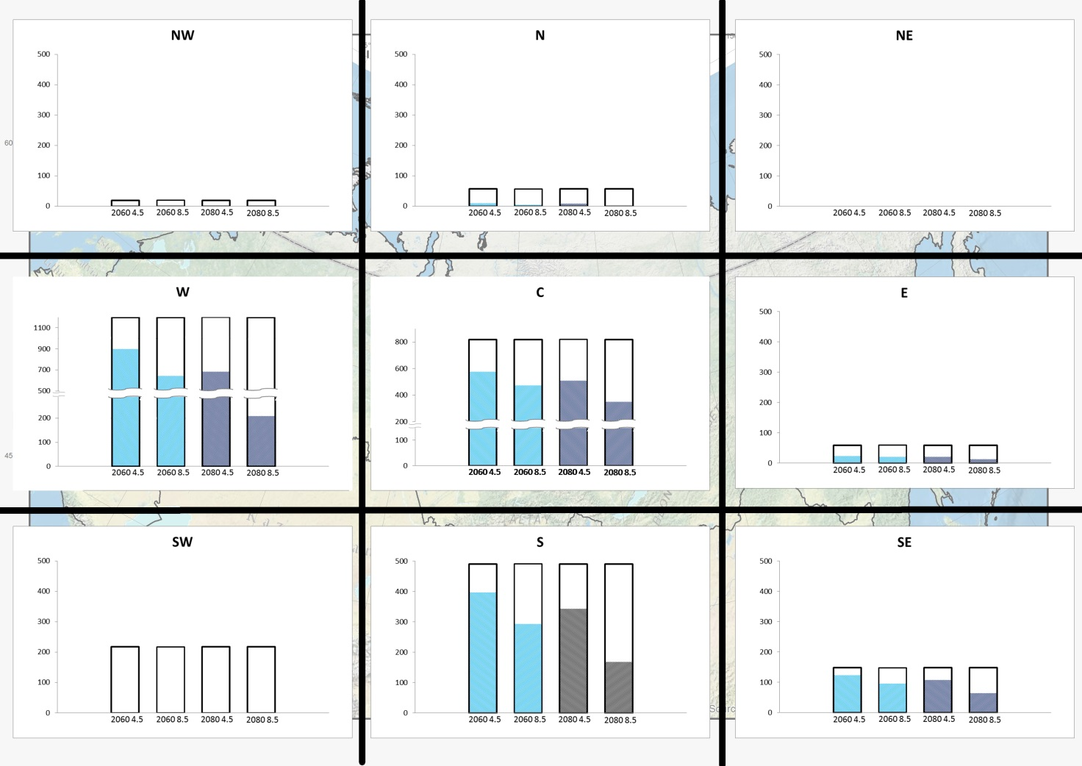

Supplementary Image 2: Average of projected presences (pp.) (y-axis, in number of pixels) among CES members compared to historical presences (black rectangle) for each quadrant for Larch.
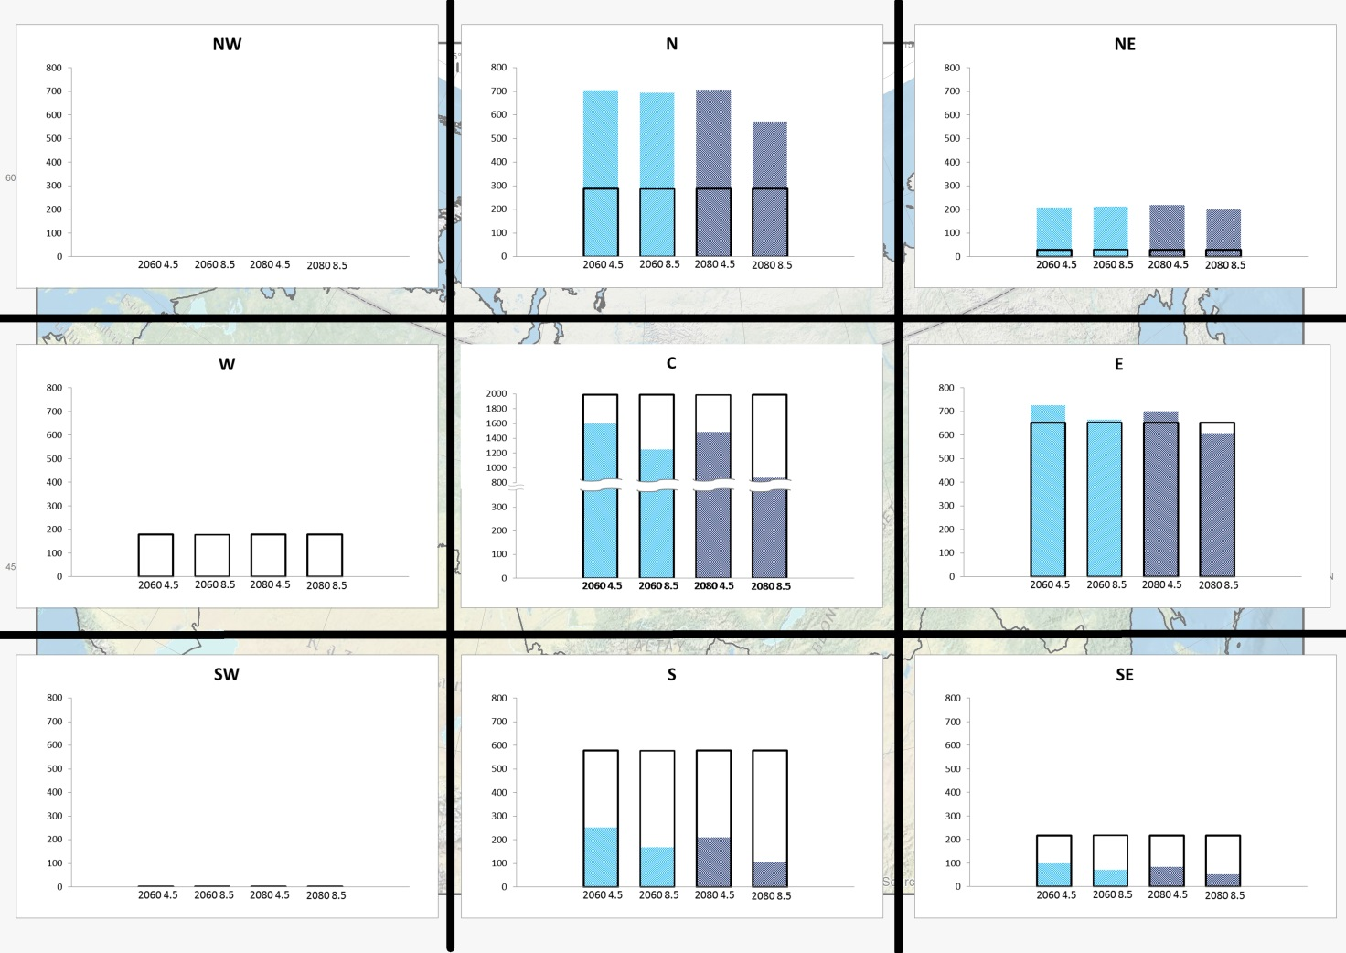

Supplementary Image 3: Average of projected presences (pp.) (y-axis, in number of pixels) among CES members compared to historical presences (black rectangle) for each quadrant for Pine.
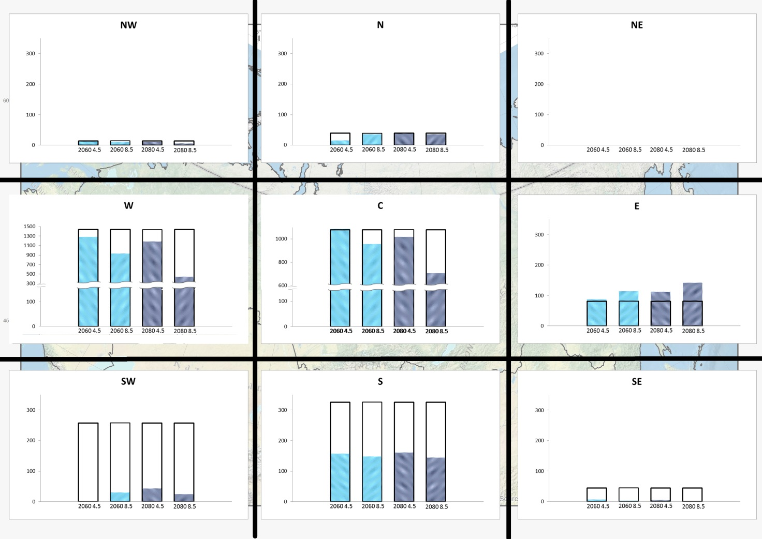

Supplementary Image 4: Average of projected presences (pp.) (y-axis, in number of pixels) among CES members compared to historical presences (black rectangle) for each quadrant for Spruce.

