**Supplemental Figure 1**



Influence analysis of psyllium supplementation on body weight

**Supplemental Figure 2**



Influence analysis of psyllium supplementation on BMI.

**Supplemental Figure 3**



Influence analysis of psyllium supplementation on WC.

**Supplemental Figure 4**

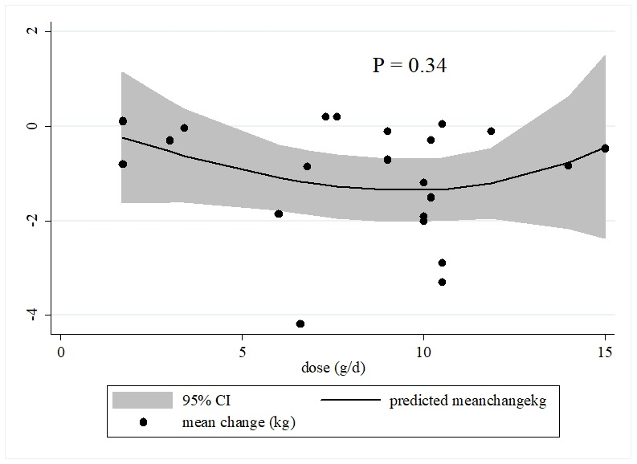

Non-linear dose-responses between psyllium supplementation and unstandardized mean difference in body weight

**Supplemental Figure 5**

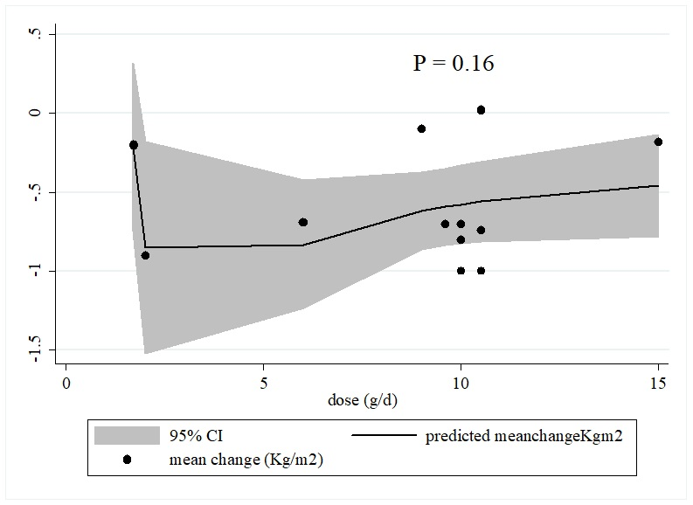

Non-linear dose-responses between psyllium supplementation and unstandardized mean difference in BMI

**Supplemental Figure 6**

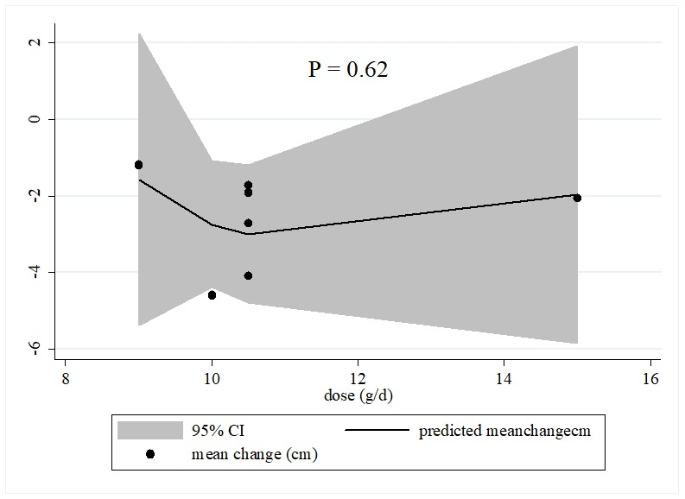

Non-linear dose-responses between psyllium supplementation and unstandardized mean difference in WC

**Supplemental Figure 7**

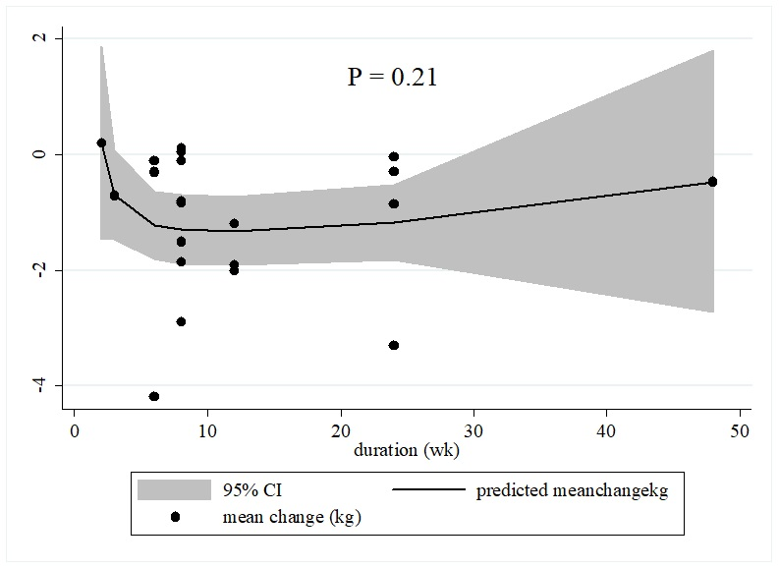

Non-linear dose-responses between duration of psyllium supplementation and unstandardized mean difference in body weight

**Supplemental Figure 8**

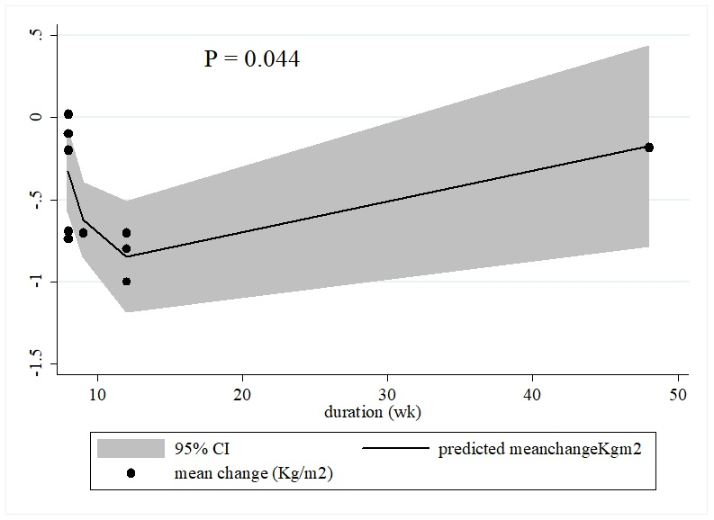

Non-linear dose-responses between duration of psyllium supplementation and unstandardized mean difference in BMI

**Supplemental Figure 9**

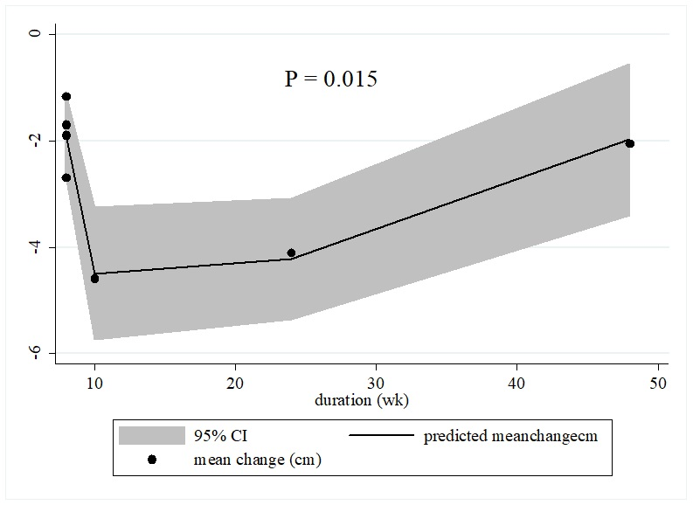

Non-linear dose-responses between duration of psyllium supplementation and unstandardized mean difference in WC

**Supplemental Figure 10**

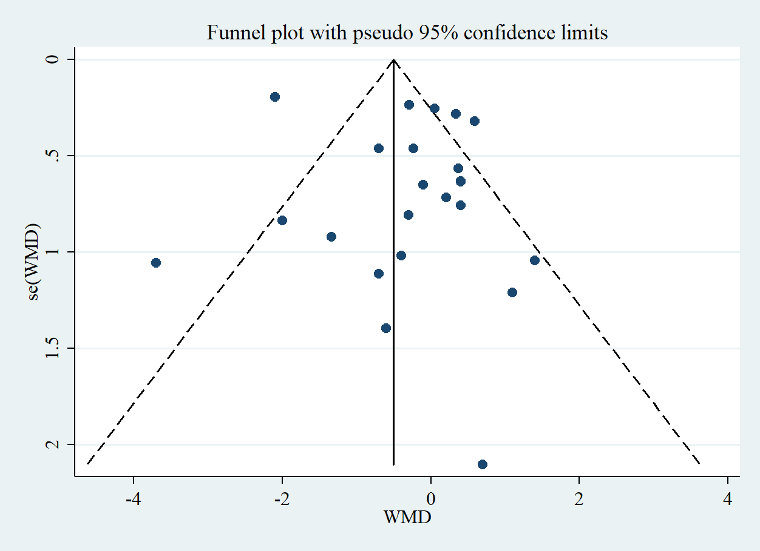

Funnel plot for assessing publication bias in the studies reporting the effect of psyllium on body weight

**Supplemental Figure 11**

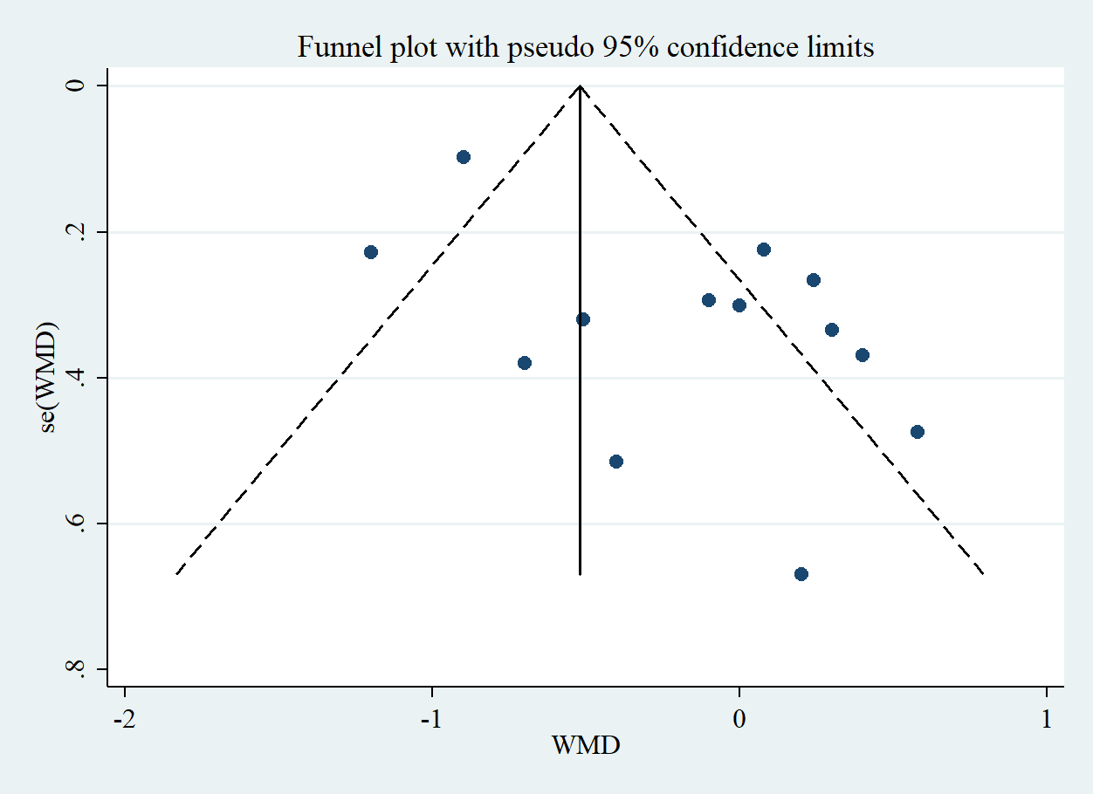

Funnel plot for assessing publication bias in the studies reporting the effect of psyllium on BMI

**Supplemental Figure 12**

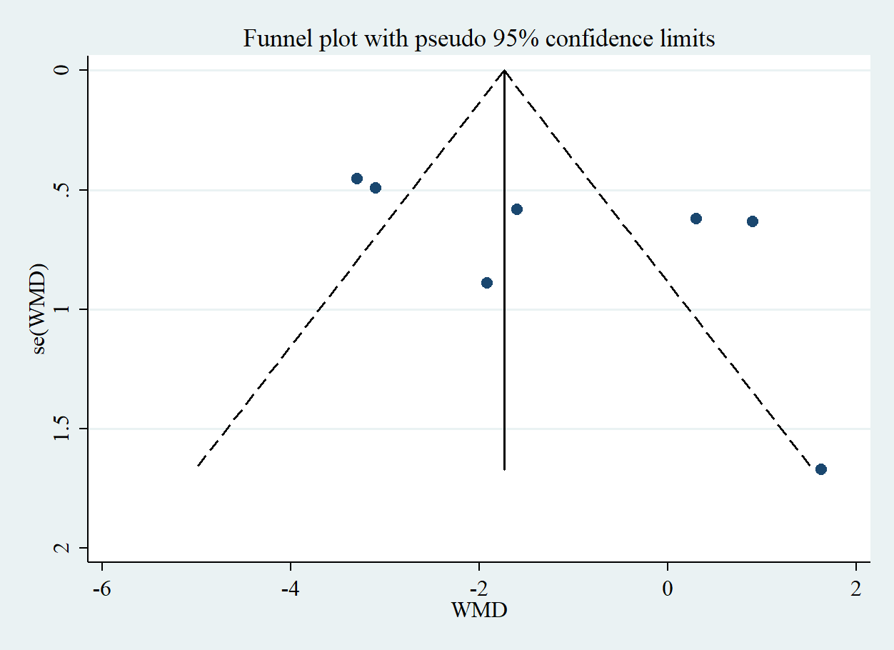

Funnel plot for assessing publication bias in the studies reporting the effect of psyllium on WC